R CODES USED
Note that some lines wrap around.
CONTENTS
CHAPTER 1: OVERVIEW
MODEL 1………………………………………………….1
MODEL 2……………..….………………………………..2
MODEL 3………………………………………………….3
MODEL 4………………………………………………….4
MODEL 5 WITH CARRYING CAPACITY……………5
MODEL 5 WITH CONTOUR AND 3D PLOTS……..…6
MODEL 6………………………………………………….8

CHAPTER 2: “FISHERIAN” OPTIMALITY ANALYSIS
Quadratic example ………………………………………………………..…....……..10
Scenario 1: Plotting the Fitness Function…………………….…………….....……...10

Scenario 3: Effect of varying the length of the summation on weight…….....…...…11
Scenario 3: Plotting the Fitness Function………………………………..…….…...…11
Scenario 3: Finding the maximum using a numerical approach………..…….…..…12

Scenario 4: Plotting the fitness function…………………………………..………..….12
Scenario 4: Finding the maximum using the calculus…………………….……….…13
Scenario 4: Finding the maximum using a numerical approach……….……….…...13

Scenario 5: Plotting the fitness function: Letting the program do the integration…14
Scenario 5: Plotting the fitness function: Supplying the integral solution…………..14
Scenario 5: Finding the maximum using the calculus
1. Use of uniroot…………………………………………………………………15
2. Use of nlm………………………………………………………..……………15
3. Use of optimize………………………………………………..………………15
Scenario 5: Finding the maximum using a numerical method
1. Using the integrated function…………………..........................……………15
2. Using numerical integration of the function…............................…………..16

Scenario 6: Plotting the fitness function…………………..........................…………..16
Scenario 6: Finding the maximum using the calculus……..........................…………17

Scenario 6: Finding the maximum using a numerical approach.........................……17

Scenario 7: Plotting the fitness function……………………........................…………18
Scenario 7: Calculating the optimum using equation 2.52…......................…………18
Scenario 7: Computing the derivative using the fitness function directly….………19
Scenario 7: Finding the maximum using a numerical approach……………..……..19

Scenario 8: Plotting the fitness function……………………………………...……….19
Scenario 8: Finding the maximum using a numerical approach…………...……….20

Scenario 9: Plot of reduction in survival versus vigilance or foraging rate…......…21
Scenario 9: Contour and 3D plots……………………………………………….....…22
Scenario 9: Finding the maximum using the calculus………………………....……23
Scenario 9: Finding the maximum using a numerical approach…………….....…..23

Scenario 11: Plotting the fitness function…………………………………………….……..23
Scenario 11: Using the derivative directly…………………………………….……..24
Scenario 11: Using R to get the derivative…………………………………………..24
Scenario 11: Finding the optimum using a numerical approach…………….…….24
Scenario 12: Plotting the fitness surface……………………..……………….……..25
Scenario 12: Optima given the differential………………………..………….……..26
Scenario 12: Using R to do the calculus…………………………..…………………26
Scenario 12: Find the maximum using nlm……………….....………….…………..27
Scenario 12: Find the maximum using ‘brute force’……………………………….28
Scenario 13 : Plotting the fitness function…………………………….…………….29
Scenario 13 : Brute force using many values………………………….……………30
Scenario 13 : Brute force using iteration……………………………………………31
Scenario 14 : Numerical method…………………………………………………….32

CHAPTER 3 : INVASIBILITY ANALYSIS
Age- or stage-structured models………………………..33
Figure 3.2…………………………………………………35

Scenario 1 : Solving using the methods of chapter 2…..36

Scenario 1 : Solving using a numerical method………..36
Scenario 1 : Solving using the eigenvalue………….……36

Scenario 2: Solving using R₀……………………….…….37
Scenario 2: Pairwise invasibility analysis……………….37
Scenario 2: Elasticity analysis……………………………39

Scenario 3: Fig. 3.7………………………………………..42
Scenario 3: Invasibility analysis…………………………43
Scenario 3: Elasticity analysis……………………………44
Scenario 3: Multiple invasibility analysis……….………46

Scenario 4: Pairwise invasibility analysis………….……48
Scenario 4: Elasticity analysis……………………………50

Scenario 5: Fig. 3.13……………………………………….52
Scenario 5: Elasticity analysis………………………….…53

Scenario 6: Pairwise invasibility analysis……………..…54
Scenario 6: Elasticity analysis………………………….....56
Scenario 6: Population dynamics (Fig. 3.18)………….....58
Scenario 6: Multiple invasibility analysis…..……………60

CHAPTER 4: GENETIC MODELS
Figure 4.1………………......62
Scenario 1……………….…63
Scenario 2……………….…64
Scenario 3………………….65
Scenario 4………………….66
Scenario 5………………….69
Scenario 6………………….70
Scenario 7……………….....72

CHAPTER 5: GAME-THEORETIC MODELS
Scenario 1: Plotting the fitness curves.............................................................................75
Scenario1: Finding the ESS using the calculus - using the derivative directly...........76
Scenario1: Finding the ESS using the calculus - Getting the derivative using R........76
Scenario 1: Finding the ESS using a numerical approach.............................................76

Scenario 2............................................................................................................................77

Scenario 3: A graphical analysis.......................................................................................78
Scenario 3: Finding the ESS using a numerical approach..............................................80

Scenario 4: A graphical analysis........................................................................................82
Scenario 4: Finding the ESS using a numerical approach...............................................83

Scenario 5: Finding the ESS using a numerical approach...............................................85

Scenario 6: A graphical analysis........................................................................................87
Scenario 6: Finding the ESS using a numerical approach...............................................90

Scenario 7: Finding the ESS using a numerical approach...............................................93

Scenario 8: Finding the ESS analytically – equal number of males................................95
Scenario 8: Finding the ESS analytically – binomial distribution of males....................96
Scenario 8: Finding the ESS using a numerical approach................................................97

Scenario 9: Learning the ESS..............................................................................................98

CHAPTER 6 DYNAMIC PROGRAMMING
An algorithm for constructing the Decision Matrix...................101
Using the Decision Matrix: Individual prediction.......................101
Using the Decision Matrix: Expected State..................................104
Scenario 2........................................................................................104
Scenario 3: Calculating the Decision Matrix................................107
Scenario 4: Figure 6.4.....................................................................110
Scenario 4: Calculating the Decision matrix................................111
Scenario 4: Using the Decision Matrix: Individual Prediction...113
Scenario 5: Figure 6.9.....................................................................115
Scenario 5: Calculating the Decision matrix................................117

MATLAB CODES
MATLAB CODE FOR CHAPTER 2
18.1 Scenario 1: Plotting the Fitness Function.................................................122

18.2 Scenario 1: Finding the Maximum using the Calculus...........................122

18.3 Scenario 1: Finding the Maximum using a Numerical Approach..........122

18.4 Scenario 3: Plotting the Fitness Function..................................................122

18.5 Scenario 3: Finding the Maximum by the Calculus.................................123

18.6 Scenario 3: Finding the Maximum using a Numerical Approach..........123

18.7 Scenario 4: Plotting the Fitness Function..................................................123

18.8 Scenario 4: Finding the Maximum using the Calculus............................124
18.9 Scenario 4: Finding the Maximum using a Numerical Approach..........124

18.10 Scenario 5: Plotting the Fitness Function................................................124
18.11 Scenario 5: Finding the Maximum using the Calculus...........................125

18.12 Scenario 5: Finding the Maximum using a Numerical Approach.........125

18.13 Scenario 6: Plotting the Fitness Function.................................................125

18.14 Scenario 6: Finding the Maximum using the Calculus...........................126

18.15 Scenario 6: Finding the Maximum using a Numerical Approach.........126

18.16 Scenario 7: Plotting the Fitness Function.................................................127
18.17 Scenario 7: Finding the Maximum using the Calculus...........................127
18.18 Scenario 7: Finding the Maximum using Numerical Methods..............127

18.19 Scenario 8: Plotting the Fitness Function.................................................128

18.20 Scenario 8: Finding the Maximum using a Numerical Approach..........128

18.21 Scenario 9: The derivative can also be determined using MATLAB.....128

18.22 Scenario 9: Plotting the Fitness Function .................................................128

18.23 Scenario 9: Finding the Maximum using the Calculus............................129

18.24 Scenario 9: Finding the Maximum using a Numerical Approach...........129

18.25 Scenario 11: Plotting the Fitness Function................................................129

18.26 Scenario 11: Finding the Optimum using the Calculus............................129
18.27 Scenario 11: Finding the Optimum using a Numerical Approach..........130

18.28 Scenario 12: Plotting the Fitness Function.................................................130

18.29 Scenario 12: Finding the Maximum using the Calculus...........................131
18.30 Scenario 12: Finding the Maximum using a Numerical Approach..........133

18.31 Scenario 13: Plotting the Fitness Function.................................................134
18.31 Scenario 13: Plotting the Fitness Function.................................................135

18.33 Scenario 14: Finding the Maximum using a Numerical Approach..........136

MATLAB CODE FOR CHAPTER 6
9.1 An Algorithm for Constructing the Decision Matrix....................................137
9.2 Using the Decision Matrix: Individual Prediction.........................................139
9.3 Using the Decision Matrix: Expected State....................................................139
9.4 Scenario 2: Calculating the Decision Matrix..................................................140
9.5 Scenario 3: Calculating the Decision Matrix..................................................142
9.6 Scenario 4: Calculating the Decision Matrix..................................................144
9.7 Scenario 4: Using the Decision Matrix: Individual Prediction.....................146
9.8 Scenario 5: Calculating the Decision Matrix..................................................147

CHAPTER 1
MODEL 1
rm(list=ls()) # Clear memory
MAXGEN <- 100 # Set maximum number of generations
N.init <- 20 # Initial population size
LAMBDA <- 1.1 # Rate of increase
Generation <- seq(from=1, to=MAXGEN) # Generation vector
Npop <- matrix(0,MAXGEN,1) # Generation vector
Npop[1] <- N.init # Store initial population size
# Iterate over generations
for (i in 2: MAXGEN){ Npop[i] <- LAMBDA*Npop[i-1]}
plot(Generation, Npop, xlab='Generation', ylab='Population size', type='l')
print(Npop[MAXGEN]) # Print last population size
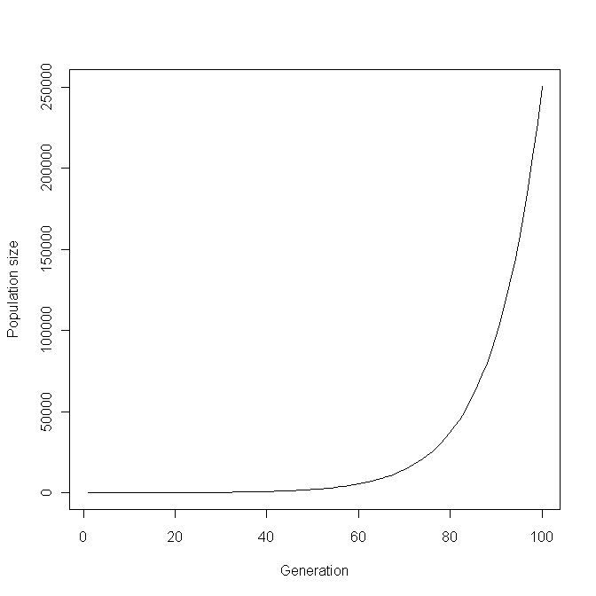

MODEL 2
rm(list=ls()) # Clear memory
set.seed(100) # set seed
MAXGEN <- 100 # Set maximum number of generations
N.init <- 20 # Initial population size
MAX.LAMBDA <- 2.2 # Maximum rate of increase
LAMBDA <- runif(MAXGEN, min=0, max= MAX.LAMBDA) # Random lambdas
Generation <- seq(from=1, to=MAXGEN) # Generation vector
Npop <- matrix(0,MAXGEN,1) # Generation vector
Npop[1] <- N.init # Store initial population size
for (i in 2: MAXGEN){ Npop[i] <- LAMBDA[i-1]*Npop[i-1]}
plot(Generation, Npop, xlab='Generation', ylab='Population size', type='l')
print(Npop[MAXGEN]) # Print last population size
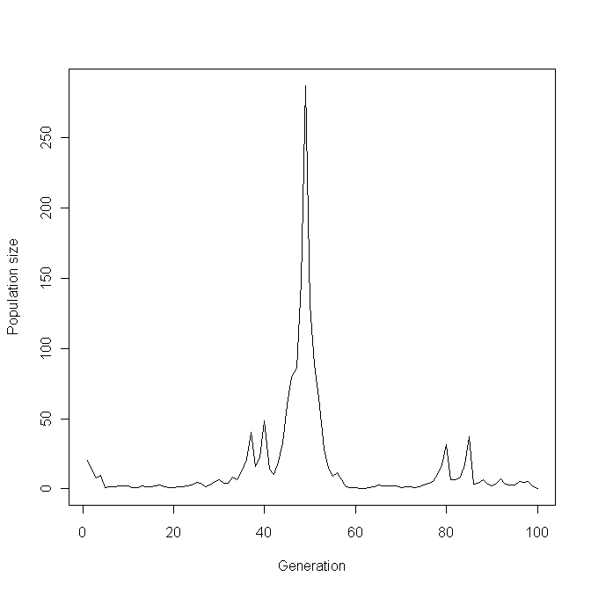

MODEL 3
rm(list=ls()) # Clear memory
POP <- function( MAX.Lambda, Npop, N.patches ) # Population function
{
LAMBDA <- runif(N.patches, min=0, max= MAX.Lambda) # Generate lambdas
Npop <- Npop*LAMBDA # Generate new population size for all patches
Npop[Npop<1] <- 0 # Check for extinction
return (Npop) # Return the vector of new population sizes
} # End of function
#################### MAIN PROGRAM ####################
set.seed(100) # set seed
MAXGEN <- 100 # Set maximum number of generations
N.init <- 20 # Initial population size
MAX.LAMBDA <- 2.2 # Maximum value of lambda
N.patches <- 10 # Number of patches
Npop <- matrix(N.init, N.patches, 1) # Initialise populations
Npop.Sizes <- matrix(0,MAXGEN) # Pre-assign storage for mean popn size
Npop.Sizes[1] <- mean(Npop) # Store first generation mean popn size
N.extinct <- matrix(0,N.patches,1) # Storage for nos of extinct popns
Igen <- 1 # Initialize generation counter
while ( Igen<MAXGEN && Npop.Sizes[Igen]>0)# Start while loop
{
Igen <- Igen+1 # Increment generation
Npop <- POP(MAX.LAMBDA, Npop, N.patches) # New population sizes
Npop.Sizes[Igen] <- mean(Npop) # Store mean population size
N.extinct[Igen] <- length(Npop[Npop==0]) # Store number of extinct popns
} # End of while loop
par(mfcol=c(1,2)) # Divide graphics page into two
# Plot Mean population size over generations and nos extinct per generation
plot(seq(1, Igen), Npop.Sizes[1:Igen], xlab="Generation", ylab="Mean population size", type="l")
plot(seq(1, Igen), N.extinct[1:Igen], xlab="Generation", ylab="Mean population size", type="l", ylim=c(0,N.patches))
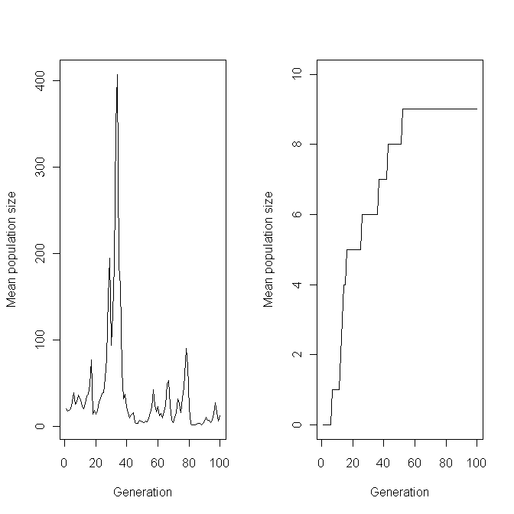
MODEL 4
rm(list=ls()) # Clear memory
POP <- function( MAX.Lambda, Npop, N.patches,P.mig, P.surv ) # Pop func
{
LAMBDA <- runif(N.patches, min=0, max= MAX.Lambda) # n random lambdas
Emigrants <- Npop*P.mig # Nos leaving
Immigrants <- sum(Emigrants)*P.surv/N.patches # Immigrants per patch
Npop <- Npop - Emigrants + Immigrants # Distribute migrants
Npop <- Npop*LAMBDA # new population sizes Npop[Npop<1] <- 0 # Check for extinction
return (Npop) # Return the vector of new population sizes
} # End of function
#################### MAIN PROGRAM ####################
set.seed(100) # set seed
MAXGEN <- 1000 # Set maximum number of generations
N.init <- 20 # Initial population size
MAX.LAMBDA <- 2.2 # Maximum value of lambda
N.patches <- 10 # Number of patches
P.mig <- 0.5 # Proportion migrating
P.surv <- 0.95 # Survival rate of migrants
Npop <- matrix(N.init, N.patches, 1) # Initialise populations
Npop.Sizes <- matrix(0,MAXGEN) # Pre-assign storage
Npop.Sizes[1] <- mean(Npop) # Store first generation mean population size
N.extinct <- matrix(0,N.patches,1) # Storage for nos extinct popns
Igen <- 1 # Initial generation
while ( Igen<MAXGEN && Npop.Sizes[Igen]>0) # Start while loop
{
Igen <- Igen+1 # Increment generation
Npop <- POP(MAX.LAMBDA, Npop, N.patches, P.mig, P.surv) # New popn sizes
Npop.Sizes[Igen] <- mean(Npop) # Store mean population size
N.extinct[Igen] <- length(Npop[Npop==0]) # Number of extinct populations
} # End of while loop
par(mfcol=c(1,2)) # Split page into two
plot(seq(1, Igen), log10(Npop.Sizes[1:Igen]), xlab="Generation", ylab="Mean population size", type="l")
plot(seq(1, Igen), N.extinct[1:Igen], xlab="Generation", ylab="Number of pops extinct", type="l", ylim=c(0,N.patches))
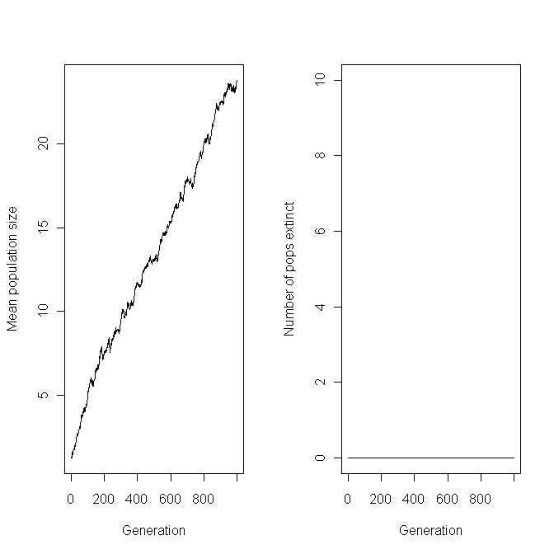
MODEL 5 WITH CARRYING CAPACITY
rm(list=ls()) # Clear memory
POP <- function( MAX.Lambda, Npop, N.patches,P.mig, P.surv ) # Population function
{
LAMBDA <- runif(N.patches, min=0, max= MAX.Lambda) # n random lambdas
Emigrants <- Npop*P.mig # Nos leaving
Immigrants <- sum(Emigrants)*P.surv/N.patches # Nos of immigrants
Npop <- Npop - Emigrants + Immigrants # Distribute migrants
Npop <- Npop*LAMBDA # new population sizes Npop[Npop<1] <- 0 # Check for extinction
Npop[Npop<1] <- 0 # Check for extinction
Npop[Npop>1000] <- 1000
return (Npop) # Return the vector of new population sizes
} # End of function
POP.DYNAMICS <- function(Propn.dispersing)
{
set.seed(100) # set seed
MAXGEN <- 1000 # Set maximum number of generations
N.init <- 20 # Initial population size
MAX.LAMBDA <- 2.2 # Maximum value of lambda
N.patches <- 10 # Number of patches
P.mig <- Propn.dispersing #0.8 # Proportion migrating
P.surv <- 0.95 # Survival rate of migrants
Npop <- matrix(N.init, N.patches, 1) # Initialise populations
Npop.Sizes <- matrix(0,MAXGEN) # Pre-assign storage
Npop.Sizes[1] <- mean(Npop) # Store first generation mean population size
N.extinct <- matrix(0,N.patches,1)
Igen <- 1
while ( Igen<MAXGEN && Npop.Sizes[Igen]>0)
{
Igen <- Igen+1 # Increment generation
Npop <- POP(MAX.LAMBDA, Npop, N.patches, P.mig, P.surv) # New population sizes
Npop.Sizes[Igen] <- mean(Npop) # Store mean population size
N.extinct[Igen] <- length(Npop[Npop==0]) # Number of extinct populations
} # End of while loop
par(mfcol=c(2,1)) # Split page into two
plot(seq(1, Igen), Npop.Sizes[1:Igen], xlab="Generation", ylab="Mean population size", type="l")
plot(seq(1, Igen), N.extinct[1:Igen], xlab="Generation", ylab="Number of pops extinct", type="l", ylim=c(0,N.patches))
mean(Npop.Sizes[900:1000])
}
#################### MAIN PROGRAM ####################
POP.DYNAMICS(0.8)

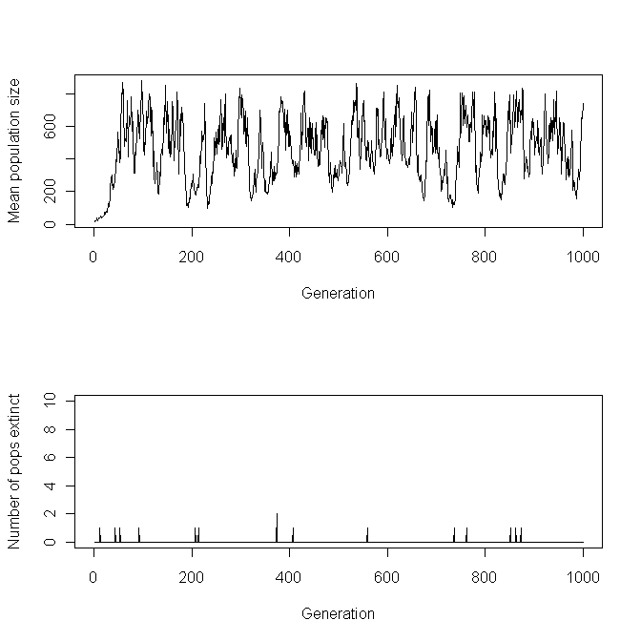

MODEL 5 WITH CONTOUR AND 3D PLOTS
rm(list=ls()) # Clear memory
POP <- function( MAX.Lambda, Npop, N.patches,P.mig, P.surv ) # Population function
{
LAMBDA <- runif(N.patches, min=0, max= MAX.Lambda) # n random lambdas
Emigrants <- Npop*P.mig # Nos leaving
Immigrants <- sum(Emigrants)*P.surv/N.patches # Nos of immigrants
Npop <- Npop - Emigrants + Immigrants # Distribute migrants
Npop <- Npop*LAMBDA # new population sizes Npop[Npop<1] <- 0 # Check for extinction
Npop[Npop<1] <- 0 # Check for extinction
Npop[Npop>1000] <- 1000
return (Npop) # Return the vector of new population sizes
} # End of function
#################### MAIN PROGRAM FUNCTION ####################

MAIN.PROG <- function(D)
{
P.mig <- D[1]
P.surv <- D[2]
set.seed(100) # set seed
MAXGEN <- 1000 # Set maximum number of generations
N.init <- 20 # Initial population size
MAX.LAMBDA <- 2.2 # Maximum value of lambda
N.patches <- 10 # Number of patches
Npop <- matrix(N.init, N.patches, 1) # Initialise populations
Npop.Sizes <- matrix(0,MAXGEN) # Pre-assign storage
Npop.Sizes[1]<- mean(Npop) # Store first generation mean population size
N.extinct <- matrix(0,N.patches,1)
Igen <- 1
while ( Igen<MAXGEN && Npop.Sizes[Igen]>0)
{
Igen <- Igen+1 # Increment generaqtion
Npop <- POP(MAX.LAMBDA, Npop, N.patches, P.mig, P.surv) # New popn sizes
Npop.Sizes[Igen] <- mean(Npop) # Store mean population size
N.extinct[Igen] <- length(Npop[Npop==0]) # Number of extinct populations
} # End of while loop
mean(Npop.Sizes[900:1000])
}
################### MAIN PROGRAM FUNCTION ####################
P.mig <- seq(from=0.1, to=0.9, length=10) # Proportion migrating
P.surv <- seq(from=0.8, to=0.9, length=10) # Survival rate of migrants
d <- expand.grid(P.mig,P.surv)
#z <- MAIN.PROG(d[,1],d[,2]) # Alternate coding
z <- apply(d, 1, MAIN.PROG)
z.matrix <- matrix(z, length(P.mig), length(P.surv))
#z.matrix <- outer(P.mig, P.surv, MAIN.PROG) # Alternate coding
par(mfrow=c(1,2))
contour(P.mig, P.surv,z.matrix, xlab ="P.mig", ylab="P.surv")
persp(P.mig, P.surv, z.matrix, theta=20, phi=20)
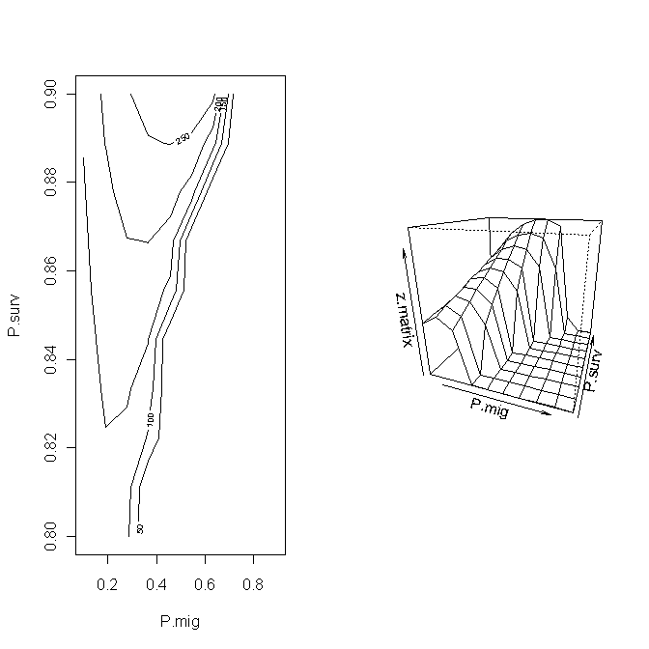

MODEL 6
rm(list=ls()) # Clear memory
# Population and inheritance function
POP <- function( MAX.Lambda, Npop, N.patches, Mu, P.surv, P.mig )
{
h2 <- 0.5; Cost<- 0.6 # parameters
LAMBDA <- runif(N.patches, min=0, max= MAX.Lambda) # random lambdas
P <- pnorm( 0, mean= -Mu, sd=1) # Proportion of nonmigrants
Y.nonmigrants <- Mu + dnorm(0,mean=Mu, sd=1)*h2/(2*P)
Y.migrants <- Mu - dnorm(0, mean=Mu, sd=1)*h2/(2*(1-P))
Emigrants <- P.mig*Npop*(1-P) # vector of surviving emigrants
Nos.migrants <- P.surv*sum(Emigrants) # =N(t,T)
Y.star <- P.mig*sum(Npop*P.surv*Y.migrants*(1-P))
Mu <- (Npop*(Y.nonmigrants*P+Y.migrants*(1-P)*(1-P.mig)*Cost) + (Y.star/N.patches))/(Npop*(P+ (1-P)*(1-P.mig)*Cost) + Nos.migrants/N.patches)# Calculate Nos in new populations
Npop <- Npop - Emigrants + Nos.migrants/N.patches
Npop <- Npop*LAMBDA # Population size before constraints Npop[Npop<1] <- 0 # Check for extinction
Npop[Npop>1000] <- 1000 # Carrying capacity
return (c(Npop,Mu)) # Return the vector of new popn sizes and means
} # End of function
#################### MAIN PROGRAM ####################
set.seed(100) # set seed
MAXGEN <- 2000 # Set maximum number of generations
N.init <- 20 # Initial population size
MAX.LAMBDA <- 2.2 # Maximum value of lambda
N.patches <- 10 # Number of patches
P.surv <- 0.95 # Survival rate of migrants
P.mig <- .8 # Proportion of potential migrants migrating
Mu <- matrix(0,N.patches,1) # Initial mean liability values
Npop <- matrix(N.init, N.patches, 1) # Initialise populations
Npop.Sizes <- matrix(0,MAXGEN) # Pre-assign storage for means
Npop.Sizes[1] <- mean(Npop) # Store 1st generation mean population size
N.extinct <- matrix(0,N.patches,1) # Assign storage for nos extinct
# Pre-assign space for mean propn non-migrants
Mean.nonmig <- matrix(0,MAXGEN) # Storage for propn nonmigrants
# Mean propn nonmigrants
Mean.nonmig[1] <- mean(pnorm( 0, mean= -Mu, sd=1))
Mean.mig <- matrix(0, MAXGEN) # Storage for propn migrants
Mean.mig[1] <- 1-Mean.nonmig[1] # Proportion migrants
Igen <- 1 # Initial generation number
while ( Igen<MAXGEN && Npop.Sizes[Igen]>0) # Enter while loop
{
Igen <- Igen+1 # Increment generation counter
# Get new population sizes and mean liabilities
OUT <- POP(MAX.LAMBDA, Npop, N.patches, Mu, P.surv, P.mig)
Npop <- OUT[1:N.patches] # Vector of Population sizes
n1 <- N.patches+1; n2 <-2*N.patches # Range for mean liabilities
Mu <- OUT[n1:n2] # Mean liabilities
P.nonmigrants <- pnorm( 0, mean=-Mu, sd=1) # Vector of prop nonmigrants
# Mean proportion of nonmigrants in metapopulation
Mean.nonmig[Igen] <- sum(Npop*P.nonmigrants)/sum(Npop)
# mean proportion of population migrating
Mean.mig[Igen] <- sum(Npop*(1-P.nonmigrants)*P.mig)/sum(Npop)
Npop.Sizes[Igen] <- mean(Npop) # Store mean population size
N.extinct[Igen] <- length(Npop[Npop==0]) # Store nos of extinct popns
}
par(mfcol=c(2,2)) # Divide graphics page into four quadrants
Gen <- seq(1,Igen) # vector of generation numbers
plot(Gen, Npop.Sizes[1:Igen], xlab="Generation", ylab="Mean population size", type="l") # Mean population size over generations
plot(Gen, N.extinct[1:Igen], xlab="Generation", ylab="Number of pops extinct", type="l", ylim=c(0,N.patches)) # Nos extinct over generations
plot(Gen, Mean.nonmig[1:Igen], xlab="Generation", ylab="Mean Proportion of nonmigrants", type='l') # Mean proportion of nonnonmigrants over generations
plot(Gen, Mean.mig[1:Igen], xlab="Generation", ylab="Mean Proportion of migrants", type='l') # Mean proportion of migrants over generations

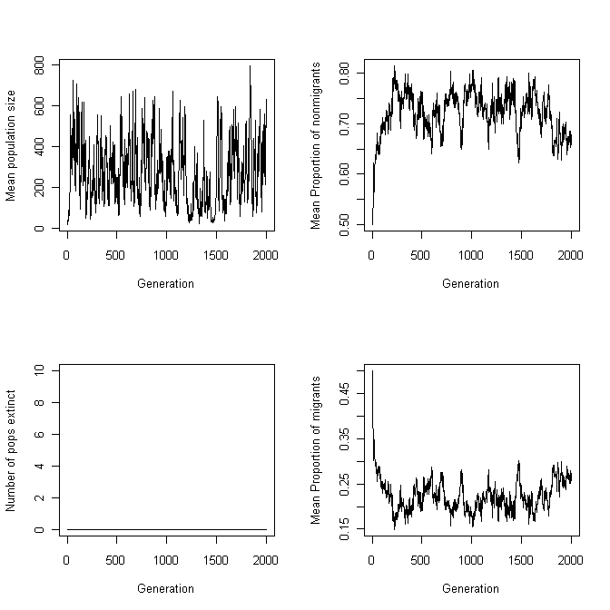
CHAPTER 2: FISHERIAN OPTIMALITY ANALYSIS
Quadratic example
rm(list=ls()) # Remove all objects from memory
FITNESS <- function(x){ W= 4*x-2*x^2} # Fitness given x
WDIFF <- function (x, Step) # W for x and x+Step
{
W1 <- FITNESS(x) # Fitness given x
W2 <- FITNESS(x+Step) # Fitness given x+Step
Wdiff2 <- W2-W1 # Diff between fitnesses
return (Wdiff2) # x will eventually be the best x
}
# MAIN PROGRAM
x <- 0 # Set initial x
Step <- 0.001 # Set Step length
DIFF <- WDIFF(x, Step) # Calculate difference between W at two x
while (DIFF>0) # If DIFF > 0 then W still increasing
{
x <- x + Step # Increment x
DIFF <- WDIFF(x, Step) # Calculate difference in fitness
}
# Out of loop and thus x is taken to be optimal
print(c(x,DIFF)) # Print out x and Difference in fitnesses at end

Scenario 1: Plotting the Fitness Function
rm(list=ls()) # remove all objects from memory
x <- seq(0,2,length=1000) # Create a vector of length 1000 between 0, 2
W <- (-2*x^2 + 4*x) # Create a vector W using the fitness function
# Plot the data using 'l' to designate a line
# las=number orientation on axes, lwd = line width
plot(x,W,type='l',xlab='Body size, x', ylab='Fitness, W',las=1,lwd=3)

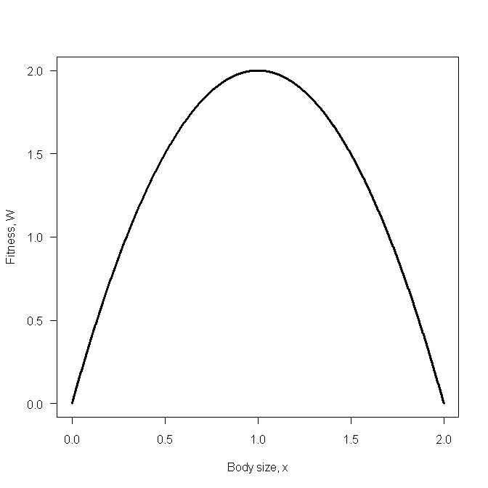
Scenario 3: Effect of varying the length of the summation on weight
rm(list=ls()) # remove all objects from memory
# Function to calculate the summation of equation (2.19)
SUMMATION <- function(n)
{
x <- 1 # As before we set x = 1
Age <- seq(from=1, to=n) # Sequence from 1 to n
Wt <- 4*x*exp(-(1+0.5*x)*Age) # Vector of fitness at age t
return(sum(Wt)) # Return the summed value
}
# MAIN PROGRAM
nmax <- 20 # Set maximum value for n
n <- matrix(seq(from=1, to=nmax)) # Vector of n values
W <- apply(n,1,SUMMATION) # Apply function SUMMATION to each row
# Plot W vs n using 'l' to designate a line
# las=number orientation on axes, lwd = line width
plot(n,W,type='l', xlab='Age, n', ylab='Weight, Wt', las=1, lwd=3)
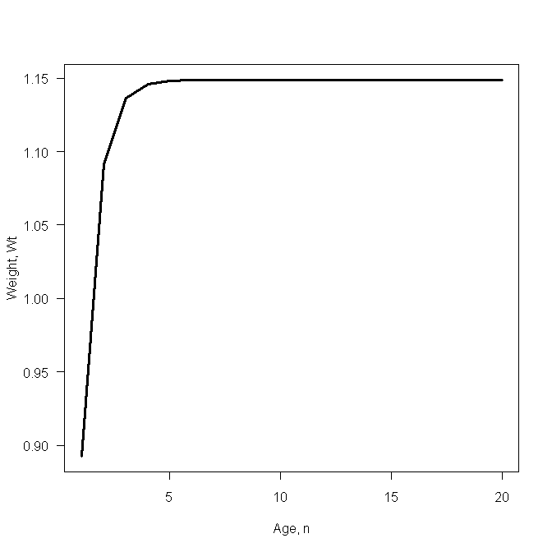
Scenario 3: Plotting the Fitness Function
rm(list=ls()) # Remove all objects from memory
# Function to calculate the summation as a function of x
SUMMATION <- function(x)
{
Age <- seq(from=1, to=20) # Sequence from 1 to 20
Wt <- 4*x*exp(-(1+0.5*x)*Age) # Vector of fitness at age t
return(sum(Wt)) # Return the summed value
}
# MAIN PROGRAM
x <- matrix(seq(from=0, to=5, length=100)) # Vector from 0-5 of length 100
W <- apply(x,1,SUMMATION) # Apply function SUMMATION to each row
# Plot W vs x using 'l' to designate a line
# las=number orientation on axes, lwd = line width
plot(x,W,type='l', xlab='Body size, x', ylab='Fitness, W',las=1,lwd=4)
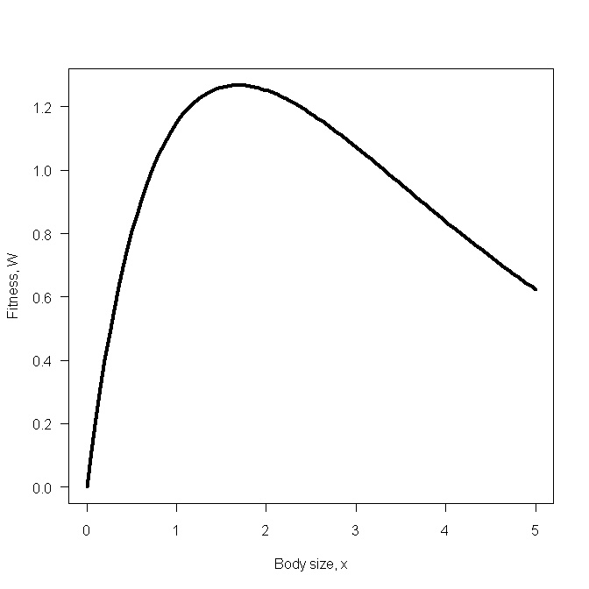

Scenario 3: Finding the maximum using a numerical approach
rm(list=ls()) # Remove all objects from memory
# Function to calculate the summation as a function of x
SUMMATION <- function(x)
{
Age <- seq(from=1, to=20) # Sequence from 1 to n
Wt <- 4*x*exp(-(1+0.5*x)*Age) # Vector of fitness at age t
return(-sum(Wt)) # Return the negative summed value
}
# Main program
nlm(SUMMATION, p=1)$estimate # Call nonlinear routine nlm

Scenario 4: Plotting the fitness function
rm(list=ls()) # Remove all objects from memory
# Function to do numerical integration
INTEGRAND <- function(age,x)
{
Af <- 0; Bf <- 8 ; As <- 1 ;Bs <- 0.5 # parameter values
return ((Af-Bf*x)*exp(-(As+Bs*x)*age)) # return function
}
# MAIN PROGRAM
n <- 100 # Number of points
z <- seq(0,3,length=n) # Create a vector for z 0 to 3
W <- matrix(0,n,1) # Create a vector W to hold results
for (i in 1:n) # Iterate over n "body sizes"
{
x <- z[i] # Set value of x
# Integrate from 1 to infinity and add to W
W[i] <- integrate(INTEGRAND,1,Inf,x)$value
}
plot(z,-W,type='l', xlab='Body size, x', ylab='Fitness, W',las=1,lwd=4)
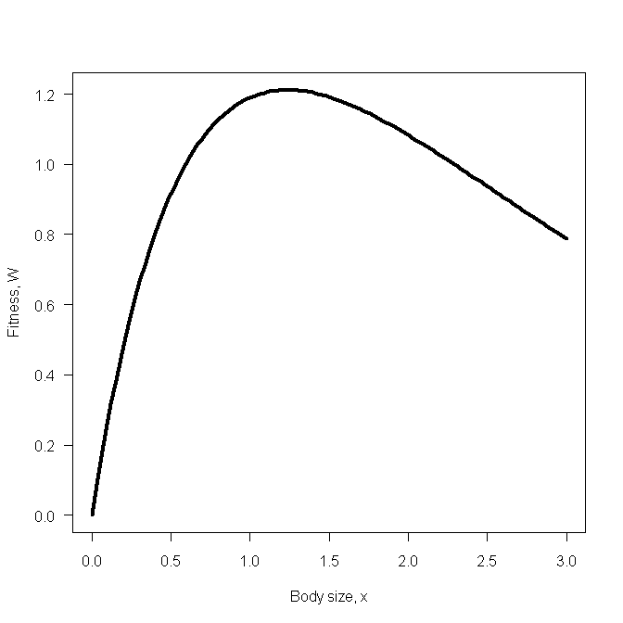

Scenario 4: Finding the maximum using the calculus
rm(list=ls()) # Remove all objects from memory
# Function to evaluate {} in eqn (2.29)
FUNC <- function(x){4+0.5*(0-4*x)-(0+4*x)*0.5/(1+0.5*x)}
B <- uniroot(FUNC, interval= c(0,4))# Set lower interval = 0
B$root # Print out the value found
OR
# Using R to obtain the derivative
rm(list=ls()) # Remove all objects from memory
# Function to obtain the gradient at a value w
FUNC <- function(w)
{
y <- deriv(~(0+4*x)*exp(-(1+0.5*x))/(1+0.5*x),"x") # Get the derivative
x <- w # Set x equal to w
z <- eval(y) # Evaluate the derivative at w
d <- attr(z,"gradient") # Assign the gradient value to d
return(d) # Return d to the main program
}
# MAIN PROGRAM
# Root must be enclosed by the limits set by the user, here set at 0 to 4
B <- uniroot(FUNC, interval= c(0,4))
B$root # Print out the value found

Scenario 4: Finding the maximum using a numerical approach
rm(list=ls()) # Remove all objects from memory
# Function to supply components for numerical integration
INTEGRAND <- function(age,x) # Calculate function value
{
Af <- 0; Bf <- 4 ; As <- 1 ;Bs <- 0.5 # parameter values
return (-(Af+Bf*x)*exp(-(As+Bs*x)*age))# return function value
}
# Function to call integration routine
FUNC <- function(x){integrate(INTEGRAND,1,Inf,x)$value}
# Minimization routine
nlm(FUNC,p=1)$estimate

Scenario 5: Plotting the fitness function: Letting the program do the integration
rm(list=ls()) # Remove all objects from memory
# Function to output function to be integrated
INTEGRAND <- function(age,x,r)
{
Af <- 0; Bf <- 4*4 ; As <- 1 ;Bs <- 0.5 # parameter values
return ((Af+Bf*x)*exp(-(As+Bs*x+r)*age)) # return function
}
# Function to integrate characteristic equation and return 1-its value
INTEGRAL <- function(r,x)
{ 1-integrate(INTEGRAND,1,Inf,x,r)$value} # 1-Characteristic equation
# Function to find r given x
RCALC <- function(x){uniroot(INTEGRAL, interval=c(1e-7,10),x)$root}
# MAIN PROGRAM
x <- matrix(seq(0.5,3, length=100)) # x ranging from 0.5 to 3 length=100
r <- apply(x,1,RCALC) # Calculate r for given x
plot(x,r,type='l', xlab='Body size, x', ylab='Fitness, r',las=1,lwd=4)

Scenario 5: Plotting the fitness function: Supplying the integral solution.
rm(list=ls()) # Remove all objects from memory
# Function to evaluate equation (2.36)
FUNC <- function(r,x)
{
Af <- 0; Bf <- 4*4 ; As <- 1 ;Bs <- 0.5 # Parameter values
S <- exp(-(r+As+Bs*x))*(Af+Bf*x)/(As+Bs*x+r)# RHS of equation
return(1-S) # Subtract 1
}
# Function to find r given x using uniroot
RCALC <- function(x){uniroot( FUNC, interval=c(1e-07,10),x)$root}
# MAIN PROGRAM - same as previous
x <- matrix(seq(0.5,3, length=100)) # X ranging from 0.5 to 3
r <- apply(x,1,RCALC) # Calculate r for given x and store
plot(x, r, type='l', xlab="Size,x", ylab="Fitness, r",las=1,lwd=4)
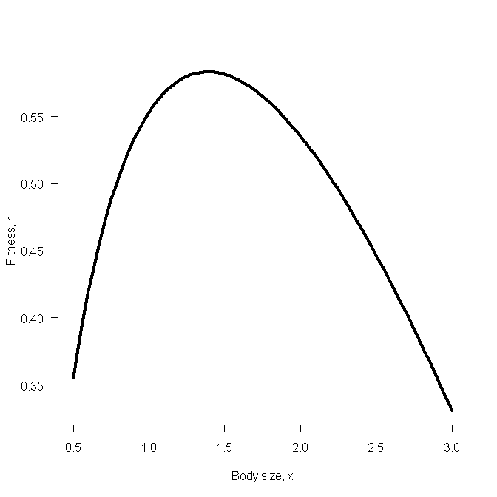

Scenario 5: Finding the maximum using the calculus
1. Use of uniroot
rm(list=ls()) # Remove all objects from memory
# Function to calculate value of equation (2.41) for a given value of x
RFUNC <- function(x)
{
Af <- 0;Bf<-4*4;As<-1;Bs<-0.5 # Set parameter values
r <- Bs*(Af+Bf*x)/(Bf-Bs*Af-Bs*Bf*x)-Bs*x-As # r from eqn (2.40)
return(log(Af+Bf*x)-(As+Bs*x+r)-log(As+Bs*x+r))
}
# MAIN PROGRAM
uniroot(f=RFUNC,interval=c(1.2,1.8))$root

2. Use of nlm
rm(list=ls()) # Remove all objects from memory
# Function to calculate value of equation (2.41) for a given value of x
RFUNC <- function(x)
{
Af<-0;Bf<-4*4;As<-1;Bs<-0.5 # Set parameter values
r <- Bs*(Af+Bf*x)/(Bf-Bs*Af-Bs*Bf*x)-Bs*x-As # r from eqn (2.40)
return(abs(log(Af+Bf*x)-(As+Bs*x+r)-log(As+Bs*x+r)))
}
# MAIN PROGRAM
nlm(RFUNC, p=1.2)$estimate

3. Use of optimize
rm(list=ls()) # Remove all objects from memory
# Function to calculate value of equation (2.41) for a given value of x
RFUNC <- function(x)
{
Af<-0;Bf<-4*4;As<-1;Bs<-0.5 # Set parameter values
r <- Bs*(Af+Bf*x)/(Bf-Bs*Af-Bs*Bf*x)-Bs*x-As # r from eqn (2.40)
return(abs(log(Af+Bf*x)-(As+Bs*x+r)-log(As+Bs*x+r)))
}
optimize(f = RFUNC, interval = c(1.2,1.8),maximum = FALSE)$minimum

Scenario 5: Finding the maximum using a numerical method
1. Using the integrated function
rm(list=ls()) # Remove all objects from memory
# Function to get integral value
FUNC <- function(r,x)
{
Af <- 0; Bf <- 4*4 ; As <- 1 ;Bs <- 0.5 # parameter values
S <- exp(-(r+As+Bs*x))*(Af+Bf*x)/(As+Bs*x+r) # Function value
return(1-S)
}
# Function to find r given x
RCALC <- function(x){uniroot( FUNC, interval=c(1e-07,10),x)$root}
# MAIN PROGRAM
# Use optimize which allows us to constrain the search
# Tell optimize that we want the maximum
optimize(f = RCALC, interval = c(.5,3),maximum = TRUE)$maximum

2. Using numerical integration of the function
rm(list=ls()) # Remove all objects from memory
# Function to do numerical integration of eqn (2.34)
INTEGRAND <- function(age,x,r)
{
Af <- 0; Bf <- 4*4 ; As <- 1 ;Bs <- 0.5 # parameter values
return ((Af+Bf*x)*exp(-(As+Bs*x+r)*age)) # return function
}
# Function to integrate characteristic equation
FUNC <- function(r,x){1-integrate(INTEGRAND,1,Inf,x,r)$value}
# Function to find r given x
RCALC <- function(x){uniroot( FUNC, interval=c(1e-07,10),x)$root}
# MAIN PROGRAM
optimize(f = RCALC, interval = c(1.2,1.8),maximum = TRUE)$maximum

Scenario 6: Plotting the fitness function
rm(list=ls()) # Remove all objects from memory
Af <- 2; Bf <- 2 # Invariant parameter values
Amin <- 0.3; Amax <- 1 # Min and max values of aS
Bmin <- 0; Bmax <- 0.2 # Min and max values of bS
Amean <- (Amax+Amin)/2 # Mean value of aS
Bmean <- (Bmax+Bmin)/2 # Mean value of bS
# Calculate n parameter combinations
n <- 1000 # Number of values of aS and bS to generate
# We are assuming a uniform distribution of values
set.seed(10) # Set the random number seed
# Generate n random numbers from Bmin to Bmax
Bs <- runif(n, min=Bmin, max=Bmax)
# Generate n random numbers from Amin to Amax
As <- runif(n, min=Amin, max=Amax)
x <- seq(from=0, to=6, length=100) # Body sizes from 0 to 6
W <- matrix(0,100,2) # Matrix to take fitness values
for ( i in 1: 100) # Iterate over x values
{
Surv <- As-Bs*x[i] # Vector of survivals
# Check that no survival < 0. If so then set to zero
Surv[Surv<0] <- 0
# Check that no survival > 1. If so then set to 1
Surv[Surv>1] <- 1
# Column 1 contains fitness for variable parameters
W[i,1] <- mean((Af+Bf*x[i])*Surv)
# Col 2 contains fitness using mean parameter values
W[i,2] <- (Af+Bf*x[i])*(Amean-Bmean*x[i])
}
# Plot fitness=W vs x for both columns on same graph
plot(x,W[,1], xlab='Body size, x', ylab='Fitness, W',las=1,lwd=4) # Dots
lines(x,W[,2], lwd=4) # Line
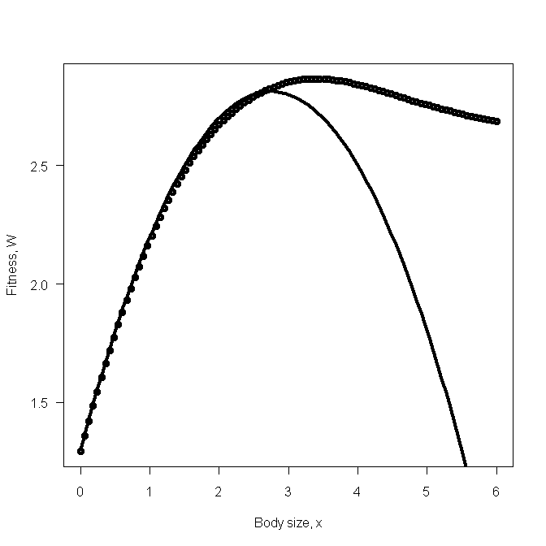

Scenario 6: Finding the maximum using the calculus

rm(list=ls()) # Remove all objects from memory

library(adapt) # Make sure that adapt is loaded

INTEGRAND <- function(Y,x) # Define function to be integrated

{

Af <- 2; Bf <- 2 # Invariant parameter values

Ca <- 1/0.7; Cb <- 5

# Y[1] = As and Y[2] = Bs

Surv <- Y[1]-Y[2]*x # Vector of survivals

# Check that no survival < 0. If so then set to zero

Surv[Surv<0] <- 0

# Check that no survival > 1. If so then set to 1

Surv[Surv>1] <- 1

return((Af+Bf*x)*Surv*Cb*Ca )

}

FITNESS<- function(x) # Function that calls adapt for a given x

{

Amin <- 0.3; Amax <- 1 # Min and max values of a_{S}

Bmin <- 0; Bmax <- 0.2 # Min and max values of b_{S}

W <- adapt(2, lo=c(Amin,Bmin), up=c(Amax,Bmax), minpts = 1000, functn=INTEGRAND, x=x)

return(-W$value) # Return negative of fitness

}

# MAIN PROGRAM

nlm(FITNESS,p=1,steptol = 1e-5)# Note change in steptol

optimize(f=FITNESS,interval=c(1,4), maximum=FALSE) # Alternate method

Scenario 6: Finding the maximum using a numerical approach
rm(list=ls()) # Remove all objects from memory
FITNESS <- function(x,As,Bs)
{
Af <- 2; Bf <- 2 # Invariant parameter values
Surv <- As-Bs*x # Vector of survivals
# Check that no survival < 0. If so then set to zero
Surv[Surv<0] <- 0
# Check that no survival > 1. If so then set to 1
Surv[Surv>1] <- 1
W <- mean((Af+Bf*x)*Surv)
return(-W)
}
# MAIN PROGRAM
Amin <- 0.3; Amax <- 1 # Min and max values of aS
Bmin <- 0; Bmax <- 0.2 # Min and max values of bS
# Calculate n parameter combinations
n <- 10000 # Number of values of aS and bS to generate
# We are assuming a uniform distribution of values
# Make several runs. Here we use 10
REP <- matrix(0,10) # Create matrix to hold replicate
set.seed(10) # Set seed for random number generator
for(i in 1:10) # Iterate over replicates
{
Bs <- runif(n, min=Bmin, max=Bmax) # Vector of values of Bf
As <- runif(n, min=Amin, max=Amax) # Vector of values of As
REP[i]<- nlm(FITNESS,p=REP[i],As,Bs)$estimate # Optimum for this run
}
print(c(mean(REP), sd(REP))) # Print mean and standard deviation
Scenario 7: Plotting the fitness function
rm(list=ls()) # Remove all objects from memory
FITNESS <- function(x) # Function to calculate log of fitness
{
Af <- 2; Bf <- 2 ; As <- 0.6 # Parameter values
pBs <- c(0.1,0.3,0.4,0.2) # Vector of probabilities for Bs
Bs <- c(0.1,0.12,0.14,0.2) # Vector of Bs values
W.ind <- (Af+Bf*x)*(As-Bs*x) # Fitness values for each Bs value
log.W <- -sum(pBs*log(W.ind)) # log Fitness
return(log.W)
}
# MAIN PROGRAM
x <- matrix(seq(0,2.99,length=100))# Values. Note W =INF at x=3
LOG.W <- apply(x,1,FITNESS) # Calc log(fitness) values
# Plot fitness=exp(-W) vs x
plot(x,exp(-LOG.W),xlab="Body size, x",ylab="Fitness, W",type='l' ,las=1, lwd=3)

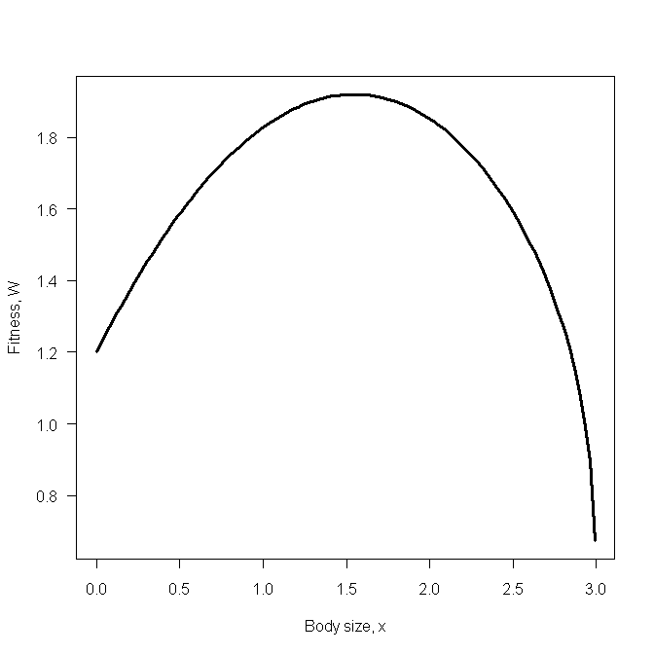
Scenario 7: Calculating the optimum using equation 2.52
rm(list=ls()) # Remove all objects from memory
DERIV <- function(x) # Function to calculate value of derivative
{
Af <- 2; Bf <- 2 ; As <- 0.6 # Parameter values
pBs <- c(0.1,0.3,0.4,0.2) # Vector of probabilities for Bs
Bs <- c(0.1,0.12,0.14,0.2) # Vector of Bs values
# Derivative
D <- sum(pBs*(As*Bf-Af*Bs-Bf*Bs*2*x)/((Af+Bf*x)*(As-Bs*x)))
return(D)
}

Scenario 7: Computing the derivative using the fitness function directly
rm(list=ls()) # Remove all objects from memory
FUNC <- function(w) # Function to obtain the gradient at a value w
{
Af <- 2; Bf <- 2 ; As <- 0.6 # Parameter values
pBs <- c(0.1,0.3,0.4,0.2) # Vector of probabilities for Bs
Bs <- c(0.1,0.12,0.14,0.2) # Vector of Bs values
# Iterate over values of Bs and sum values of derivatives
d <- 0 # Derivative value
for( i in 1:4)
{
Bsi <- Bs[i] # Value of Bs
pBsi <- pBs[i] # Probability of this Bs
y <- deriv(~pBsi*log((Af+Bf*x)*(As-Bsi*x)),"x") # Get the derivative
x <- w # Set x equal to w
z <- eval(y) # Evaluate the derivative at w
d <- d+attr(z,"gradient") # Assign the gradient value to summed d
}
return(d) # Return d to the main program
}
# MAIN PROGRAM
# Root must be enclosed by the limits set by the user, here set at 1 to 2
uniroot(f, interval= c(1,2))$root

Scenario 7: Finding the maximum using a numerical approach
rm(list=ls()) # Remove all objects from memory
FITNESS <- function(x) {
Af <- 2; Bf <- 2 ; As <- 0.6 # Parameter values
pBs <- c(0.1,0.3,0.4,0.2) # Vector of probabilities for Bs
Bs <- c(0.1,0.12,0.14,0.2) # Vector of Bs values
W.ind <- (Af+Bf*x)*(As-Bs*x) # Fitness values for each Bs value
log.W <- -sum(pBs*log(W.ind)) # log Fitness
return(log.W)
}
# MAIN PROGRAM
nlm(FITNESS, p=1)
optimize(f=FITNESS,interval=c(1,2), maximum=FALSE)

Scenario 8: Plotting the fitness function
rm(list=ls()) # Remove all objects from memory
INTEGRAND <- function(Bs,x) # Function to do numerical integration
{
Af <- 2; Bf <- 2 ; As <- 0.6; c<- 5 # Parameter values
return (c*log((Af+Bf*x)*(As-Bs*x))) # return function
}
# MAIN PROGRAM
n <- 100 # Number of points
z <- seq(1.0,3,length=n) # Create a vector for from 1 to 3
log.W <- matrix(0,n,1) # Create a vector log.W to hold results
Bmin <- 0; Bmax <- 0.2 # Limits of integration
for (i in 1:n) # Iterate over n "body sizes"
{
x <- z[i] # Set value of x (body size)
# Integrate from Bmin to Bmax and add to W
log.W[i] <- integrate(INTEGRAND,Bmin,Bmax,x)$value
}
# Plot fitness=exp(log.W) vs x
plot(z,exp(log.W),type='l', xlab='Body size, x', ylab='Fitness, W',las=1,lwd=4)

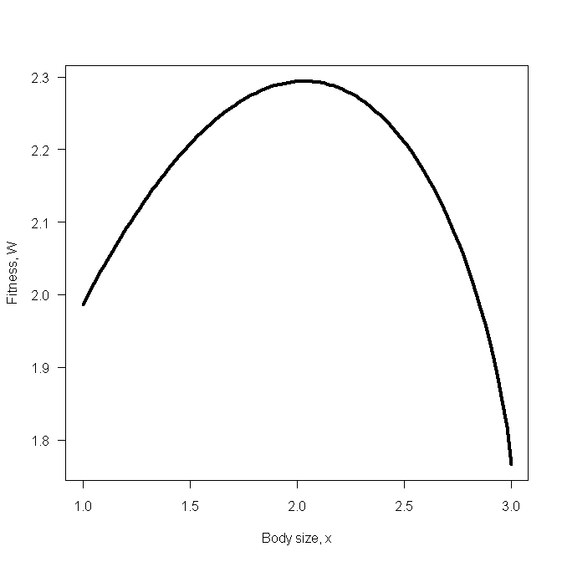

Scenario 8: Finding the maximum using a numerical approach
rm(list=ls()) # Remove all objects from memory
INTEGRAND <- function(Bs,x) # Function for numerical integration
{
Af <- 2; Bf <- 2 ; As <- 0.6; c<- 5 # Parameter values
return (c*log((Af+Bf*x)*(As-Bs*x))) # return function
}
# Fitness function integrates over limits
FITNESS <- function(x) # Calculate -log fitness
{
Bmin <- 0; Bmax <- 0.2 # Limits of integration
W <- integrate(INTEGRAND,Bmin,Bmax,x)$value # Value of integral
return(-W)
}
# MAIN PROGRAM Using two routines
nlm(FITNESS, p=1)
optimize(f=FITNESS,interval=c(1,3), maximum=FALSE)

Scenario 9: Plot of reduction in survival versus vigilance or foraging rate.
rm(list=ls()) # remove all objects from memory
# Set parameter values
A0 <-Bxy <-Byx <- 0.8
Axy <-Cxy <-Cyx <- 0.4
x <- seq(from=0, to=3,length=100) # vector of x
Sxy <- -Bxy*x+Cxy*x^2 # Vector of reduction in survival
plot(x,Sxy, xlab='Vigilance or Foraging rate',ylab='Effect on survival', type='l',las=1,lwd=3)

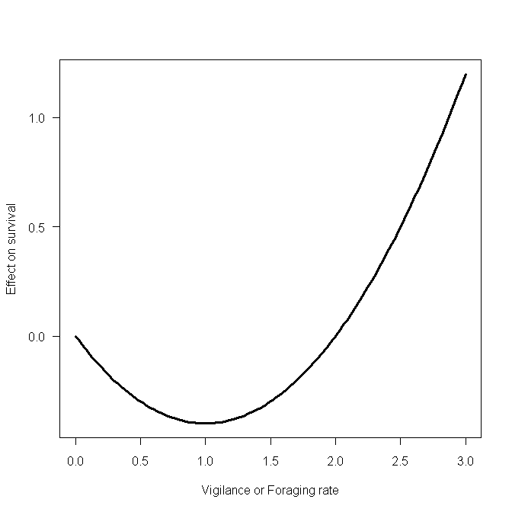

Scenario 9: Contour and 3D plots
# CONTOUR PLOT
rm(list=ls()) # Remove all objects from memory
# Function to calculate fitness, passing parameters to it
FITNESS <- function(X,Axy,A0,Bxy,Cxy,Byx,Cyx)
{
x <- X[1] # x = Vigilance
y <- X[2] # y = Foraging
S0 <- Axy*x*y-A0 # Eqn (2.57)
Sxy <- -Bxy*x+Cxy*x^2 # Eqn (2.58)
Syx <- -Byx*y+Cyx*y^2 # Eqn (2.59)
W <- S0-Sxy-Syx # Fitness function (2.60)
return(W)
}
# MAIN PROGRAM
# Parameter values
A0 <- Bxy<-Byx<-0.8 # Assign parameter values
Axy <- Cxy<-Cyx<-0.4 # Assign parameter values
n <- 20 # Matrix for contour plot=nxn
x <- seq(from=1, to=3, length=n)# Generate Vigilance values
y <- seq(from=1, to=3, length=n)# Generate foraging values
d <- expand.grid(x,y) # Expand to all combinations
# Create a vector of fitness values for all combinations
Wtemp <- apply(d,1, FITNESS, 0.4,0.8,0.8,0.4,0.8,0.4)
# Convert into matrix
W <- matrix(Wtemp,n,n,byrow=T)
# Set plotting page to put graphs side by side and not distorted
# Make plotting surface consist of four panels
par(mfrow=c(2,2))
# Plot contour. las=orientation of axis labels
# lwd= line width, labcex=size of contour labels
contour(x,y,W, xlab='Foraging, x', ylab='Vigilance, y',las=1,lwd=3,labcex=1)
# Plot perspective plot
persp(x,y,W,xlab='Foraging, x', ylab='Vigilance, y', zlab='Fitness, W',theta = 50, phi = 25,lwd=2)
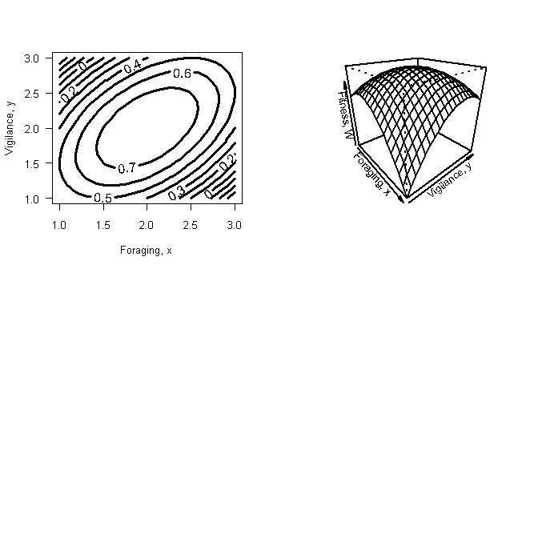

Scenario 9: Finding the maximum using the calculus
FUNC <- function(x) {abs( 0.4*x[2]+0.8-2*0.4*x[1])+abs(0.4*x[1]+0.8-2*0.4*x[2])}
nlm(FUNC,p=c(1,1))$estimate # Call nlm to find minimum

Scenario 9: Finding the maximum using a numerical approach
rm(list=ls()) # Remove all objects from memory
# Fitness function
FITNESS <- function(x,Axy,A0,Bxy,Cxy,Byx,Cyx)
{
W <- Axy*x[1]*x[2]-A0+Bxy*x[1]-Cxy*x[1]^2+Byx*x[2]-Cyx*x[2]^2
return(-W) # Return -W so nlm can find minimum
}
# MAIN PROGRAM
# Find estimates and store in vector called Traits
# Note that the coefficient values are passed as extra parameters
Traits <- nlm(FITNESS,p=c(.5,.5),0.4,0.8,0.8,0.4,0.8,0.4)$estimate
# Calculate fitness at the optimum combination
Wmax <- -FITNESS(Traits,0.4,0.8,0.8,0.4,0.8,0.4)
print(c(Traits, Wmax)) # Print out estimates and fitness value

Scenario 11: Plotting the fitness function
rm(list=ls()) # Remove all objects from memory
FITNESS <- function(x1) # Fitness function
{
# Parameter values
S1 <- 0.005; S2 <- 0.002; Fmax <- 2; a <- 1; N <- 100; R <- 400
ExpFec1 <- Fmax*(1-exp(-a*x1)) # Expected fecundity from 1st clutch
x2 <- (R/N)-x1 # Propagule size in 2nd clutch
x2 <- max(x2,0) # If x2 <0 set x2=0
ExpFec2 <- Fmax*(1-exp(-a*x2)) # Expected fecundity from 2nd clutch
W <- N*(S1*ExpFec1+S2*ExpFec2) # Fitness
# Check to see if x1 is acceptable size
Xmax <- N*x1
if(Xmax>R) {W<-0 } # if x1 too big set fitness to zero
return(W) # Return fitness
}
# MAIN PROGRAM
x <- matrix(seq(from=0, to=4, length=100)) # Vary x1 from 0 to 4
W <- apply(x,1,FITNESS) # Calculate and store W
# Plot results
plot(x,W, type='l', xlab='Propagule size, x1', ylab='Fitness, R0' ,las=1,lwd=3)

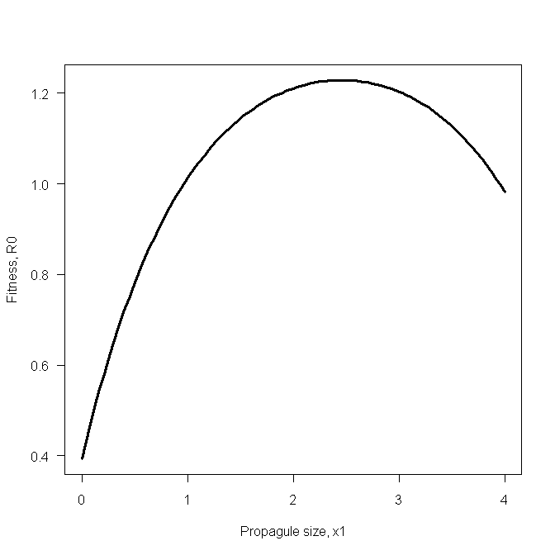

Scenario 11: Using the derivative directly
rm(list=ls()) # Remove all objects from memory
DFUNC <- function(x) # Derivative function
{
# Parameter values
S1 <- 0.005; S2 <- 0.002; a <- 1; N <- 100; R <- 400
return(S1*exp(-a*x)-S2*exp(-a*(R/N-x))) # Return deriv value
}
X1 <- uniroot(DFUNC,interval=(c(0,3)))$root # Call uniroot to find root
# Calculate x2 for optimum x1
N <- 100; R<- 400 # Parameter values
X2 <- (R/N)-X1 # Size of 2nd propagule
print(c(X1,X2))

Scenario 11: Using R to get the derivative
rm(list=ls()) # Remove all objects from memory
FUNC <- function(w)
{
# Set parameter values
S1 <- 0.005; S2 <- 0.002;a <- 1; N <- 100; R <- 400; Fmax<- 2
# Get the derivative of equation (2.77)
y <- deriv(~ N*(S1*Fmax*(1-exp(-a*x))+S2*Fmax*(1-exp(-a*(R/N-x)))),"x")
x <- w # Set x equal to w
z <- eval(y) # Evaluate the derivative at w
d <- attr(z,"gradient") # Assign the gradient value to d
return(d) # Return d to the main program
}
# MAIN PROGRAM
# Root must be enclosed by the limits set by the user, here set at 0 to 3
X1 <- uniroot(FUNC, interval= c(0,3))$root
# Calculate x2 for optimum x1
N <- 100; R<- 400 # Parameter values
X2 <- (R/N)-X1 # Size of 2nd propagule
print(c(X1,X2))

Scenario 11: Finding the optimum using a numerical approach
rm(list=ls()) # Remove all objects from memory
FITNESS <- function(x1) # Fitness function
{
# Parameter values
S1 <- 0.005; S2 <- 0.002; Fmax <- 2; a <- 1; N <- 100; R <- 400
ExpFec1 <- Fmax*(1-exp(-a*x1)) # Expected fecundity from 1st clutch
x2 <- (R/N)-x1 # Propagule size in 2nd clutch
x2 <- max(x2,0) # If x2 <0 set x2=0
ExpFec2 <- Fmax*(1-exp(-a*x2)) # Expected fecundity from 2nd clutch
W <- N*(S1*ExpFec1+S2*ExpFec2) # Fitness
# Check to see if x1 is acceptable size
Xmax <- N*x1
if(Xmax>R) {W<-0 } # if x1 too big set fitness to zero
return(W) # Return fitness
}
# MAIN PROGRAM
# Calculate the optimum x1 using optimize
X1 <- optimize(f = FITNESS, interval = c(1,8),maximum = TRUE)$maximum

# Calculate x2 for optimum x1
N <- 100; R<- 400 # Parameter values
X2 <- (R/N)-X1 # Size of 2nd propagule
print(c(X1,X2))

Scenario 12: Plotting the fitness surface.
rm(list=ls()) # Remove all objects from memory
FITNESS <- function(x) # Function to calculate fitness
{
# x[1] = Propagule size in 1st clutch
# x[2] = Propagule size in 2nd clutch
# Set parameter values
N <- 100; R <- 400
S1 <- 0.035; S2 <- 0.030; S3 <- 0.025
Fmax <- 2; a <- 0.1
W1<-W2<-W3<-0 # Set fitnesses to zero. This is not necessary.
# Check if first clutch mass exceeds reserves
if(N*x[1]>R) W <- 0 # Propagule too large
else{
# Calculate first fecundity
W1 <- N*S1*Fmax*(1-exp(-a*x[1]))
# Calculate size of propagules in 2nd clutch and see if reserves exceeded
if(N*(x[1]+x[2])>R) W <- W1 # Propagules in 2nd clutch too large
else{
W2 <- N*S2*Fmax*(1-exp(-a*x[2])) # Calculate 2nd fecundity
# Calculate the size of Propagules in 3rd clutch
# Note that there must be reserves remaining at this stage
x3 <- (R-N*(x[1]+x[2]))/N
W3 <- N*S3*Fmax*(1-exp(-a*x3)) # Calculate 3rd fecundity
W <- W1+W2+W3
} # End 2nd else
} # End 1st else
return(-W) # Return negative of fitness
}
# MAIN PROGRAM
n <- 20 # Number of rows and columns
x <- seq(from=1, to=5, length=n) # Range for propagule sizes
d <- expand.grid(x,x) # Create a matrix of all combinations
W <- apply(d,1,FITNESS) # Apply FITNESS to each combination
W <- matrix(W,n,n) # Convert W from a vector into a matrix
contour(x,x,-W,xlab= 'Propagule size in 1st clutch',ylab='Propagule size in 2nd clutch') # Plot contour making W positive
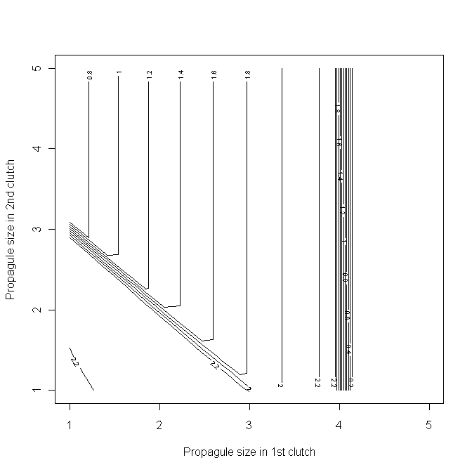

Scenario 12: Optima given the differential
rm(list=ls()) # Remove all objects from memory
setwd("C:/Documents and Settings/Administrator/My Documents/Computer modelling/Chapter 2") # Set the folder into which to put the data
FITNESS <- function(x2) # Function to calculate fitness.
# Differs from that used in plotting in only a single variable being input
{
# Set parameter values
N <- 100; R <- 400
S1 <- 0.035; S2 <- 0.030; S3 <- 0.025
Fmax <- 2; a <- 0.1
x1 <- 10*log(S1/S2)+x2 # x1 given the value of x2
x3 <- (R-N*(x1+x2))/N # Value of x3
if (x3<0) W<-0 # Check that x3 exists
else{
# Check if first clutch mass exceeds reserves
if(N*x1 > R) W <- 0 # Propagule too large
else{
W1 <- N*S1*Fmax*(1-exp(-a*x1)) # Calculate first fecundity
# Calculate size of propagules in 2nd clutch and see if reserves exceeded
if(N*x2 > R) W <- W1 # Propagules in 2nd clutch too large
else{
W2 <- N*S2*Fmax*(1-exp(-a*x2)) # Calculate 2nd fecundity
# Calculate the size of Propagules in 3rd clutch
# Note that there must be reserves remaining at this stage
W3 <- N*S3*Fmax*(1-exp(-a*x3)) # Calculate 3rd fecundity
W <- W1+W2+W3
} # End 3rd else
} # End 2nd else
} # End 1st else
# print(c(x1,x2,x3))
write(c(x1,x2,x3), file="PROPAGULE.txt") # Print results into file
return(-W) # Return negative of fitness
}
# MAIN PROGRAM
# Locate optimum x2 and calculate x1 and x3
# Note that parameter values are given within function FITNESS
# Find optimum values of propagules
nlm(FITNESS, p=1) # Use nlm to find optimum x2
Propagules <- read.table(file="PROPAGULE.txt") # Read in results
print(Propagules)

Scenario 12: Using R to do the calculus
rm(list=ls()) # Remove all objects from memory
setwd("C:/Documents and Settings/Administrator/My Documents/Computer modelling/Chapter 2") # Set the folder into which to put the data
# Function to obtain the gradient at a value w for a given value of y
GRADIENT <- function(w,y)
{
# Set parameter values
N <- 100; R <- 400
S1 <- 0.035; S2 <- 0.030; S3 <- 0.025
Fmax <- 2; a <- 0.1
# Calculate derivative, called Dx1x2, with respect to both x1 and x2
# x1 is 1st propagule x2 is 2nd propagule
Dx1x2 <- deriv(~(N*S1*Fmax*(1-exp(-a*x1))+N*S2*Fmax*(1-exp(-a*x2))
+N*S3*Fmax*(1-exp(-a*(R/N-(x1+x2))))),c("x1","x2"))
x1 <- w # Set x1 equal to w
x2 <- y # Set x2 equal to y
z <- eval(Dx1x2) # Evaluate the derivative at w
G <- attr(z,"gradient") # Assign the gradient values to AbsDiff
AbsDiff <- abs(G[1]-G[2])# Calculate the absolute difference
return(AbsDiff) # Return AbsDiff to the main program
}
# Fitness function given x2, and calling nlm to find x1
FITNESS <- function(x2)
{
# Set parameter values
N <- 100; R <- 400
S1 <- 0.035; S2 <- 0.030; S3 <- 0.025
Fmax <- 2; a <- 0.1
# Find value of x1 given x2 using nlm to set derivatives to zero
# This line is the only difference from the previous FITNESS function
x1 <- nlm(GRADIENT,p=1,x2)$estimate
# Now calculate x3 and fitness
x3 <- (R-N*(x1+x2))/N # Determine x2
if (x3<0) W<-0 # Check if x3 exists(>0)
else{
# Check if first clutch mass exceeds reserves
if(N*x1 > R) W <- 0 # Propagule too large
else{
W1 <- N*S1*Fmax*(1-exp(-a*x1)) # Calculate first fecundity
# Calculate size of propagules in 2nd clutch and see if reserves exceeded
if(N*x2 > R) W <- W1 # Propagules in 2nd clutch too large
else{
W2 <- N*S2*Fmax*(1-exp(-a*x2)) # Calculate 2nd fecundity
# Calculate the size of Propagules in 3rd clutch
# Note that there must be reserves remaining at this stage
W3 <- N*S3*Fmax*(1-exp(-a*x3)) # Calculate 3rd fecundity
W <- W1+W2+W3 # Sum fitness components
} # End 3rd else
} # End 2nd else
} # End 1st else
# print(c(x1,x2,x3))
write(c(x1,x2,x3), file="PROPAGULE.txt") # Print results into file
return(-W)
}
# MAIN PROGRAM
# Find optimum values of propagules
nlm(FITNESS, p=1) # Use nlm to find optimum x2
Propagules <- read.table(file="PROPAGULE.txt") # Read in results
print(Propagules)

Scenario 12: Find the maximum using nlm
rm(list=ls()) # Remove all objects from memory
FITNESS <- function(x) # Function to calculate fitness
{
# x[1] = Propagule size in 1st clutch
# x[2] = Propagule size in 2nd clutch
# Set parameter values
N <- 100; R <- 400
S1 <- 0.035; S2 <- 0.030; S3 <- 0.025
Fmax <- 2; a <- 0.1
W1<-W2<-W3<-0 # Set fitnesses to zero. This is not necessary.
# Check if first clutch mass exceeds reserves
if(N*x[1]>R) W <- 0 # Propagule too large
else{
# Calculate first fecundity
W1 <- N*S1*Fmax*(1-exp(-a*x[1]))
# Calculate size of propagules in 2nd clutch and see if reserves exceeded
if(N*(x[1]+x[2])>R) W <- W1 # Propagules in 2nd clutch too large
else{
W2 <- N*S2*Fmax*(1-exp(-a*x[2])) # Calculate 2nd fecundity
# Calculate the size of Propagules in 3rd clutch
# Note that there must be reserves remaining at this stage
x3 <- (R-N*(x[1]+x[2]))/N
W3 <- N*S3*Fmax*(1-exp(-a*x3)) # Calculate 3rd fecundity
W <- W1+W2+W3
} # End 2nd else
} # End 1st else
return(-W) # Return negative of fitness
}
# MAIN PROGRAM
# Call nlm passing fitness function with initial estimates
ANS <- nlm(FITNESS, p=c(0.1,0.1))
X <- ANS$estimate # Store estimates in X
# Calculate x3
R <- 400; N <- 100 # Parameter values
x3 <- (R-N*(X[1]+X[2]))/N # x3
ANS # Print out Stats for nlm
print(c(X[1],X[2], x3)) # Propagule sizes

Scenario 12: Find the maximum using ‘brute force’
rm(list=ls()) # Remove all objects from memory
FITNESS <- function(x) # Function to calculate fitness
{
# x[1] = Propagule size in 1st clutch
# x[2] = Propagule size in 2nd clutch
# Set parameter values
N <- 100; R <- 400
S1 <- 0.035; S2 <- 0.030; S3 <- 0.025
Fmax <- 2; a <- 0.1
W1<-W2<-W3<-0 # Set fitnesses to zero. This is not necessary.
# Check if first clutch mass exceeds reserves
if(N*x[1]>R) W <- 0 # Propagule too large
else{
# Calculate first fecundity
W1 <- N*S1*Fmax*(1-exp(-a*x[1]))
# Calculate size of propagules in 2nd clutch and see if reserves exceeded
if(N*(x[1]+x[2])>R) W <- W1 # Propagules in 2nd clutch too large
else{
W2 <- N*S2*Fmax*(1-exp(-a*x[2])) # Calculate 2nd fecundity
# Calculate the size of Propagules in 3rd clutch
# Note that there must be reserves remaining at this stage
x3 <- (R-N*(x[1]+x[2]))/N
W3 <- N*S3*Fmax*(1-exp(-a*x3)) # Calculate 3rd fecundity
W <- W1+W2+W3
} # End 2nd else
} # End 1st else
return(W) # Return negative of fitness
}
# MAIN PROGRAM
# Create vectors to produce an n by n matrix of combinations
n <- 100 # Number of rows and columns
x <- seq(from=0, to=5, length=n)
y <- x
d <- expand.grid(x,y) # Create 2xn2 matrix of all combinations
W <- apply(d,1,FITNESS) # Use apply to calculate fitnesses
# Now find position of row that has the highest fitness
# Row is stored in first row of Best, Best[1]
Best <- order(W, na.last=TRUE, decreasing=TRUE)
x1 <- d[Best[1],1] # Best x1
x2 <- d[Best[1],2] # Best x2
# Calculate x3
R <- 400; N <- 100 # Parameter values
x3 <- (R-N*(x1+x2))/N # x3
print(c(x1,x2,x3,W[Best[1]])) # Propagule sizes and W

Scenario 13 : Plotting the fitness function
rm(list=ls()) # Remove all objects from memory
# Function to calculate fitness given Alpha
FITNESS <- function(x)
{
G <- x[1] # G values
Alpha <- x[2] # Alpha value
# Set parameter values
Mj <- 0.05 # Background mortality rate
Ma <- 0.4 # Constant of mortality function
Age.max <- 30 # Maximum age (arbitrary)
a <- 0.05 # Fecundity constant
A <- 10 # Wt increase/annum without reproduction
A.minus.1 <- Alpha-1 # Year before first reproduction
S <- matrix(0,Age.max) # Annual survival
# Growth prior to reproduction is linear
# To include cases in which growth is more complex I here use a for loop
Wt <- matrix(0,Age.max,1) # Initialize Wt vector
S[1] <- exp(-Mj) # Survival to age 1
# Calculate Wt and Survival from age 2 to alpha-1
for(i in 2:A.minus.1)
{
Wt[i] <- Wt[i-1]+ A # Weight
S[i] <- S[i-1]*exp(-Mj) # Annual survival
}
# Now calculate change in wt and survival for age alpha to max age
for(i in Alpha:Age.max)
{
Wt[i] <- Wt[i-1]+A-G*Wt[i-1] # Weight
S[i] <- S[i-1]*exp(-(Mj+Ma*G))# Annual survival
}
W <- a*sum(S[Alpha:Age.max]*Wt[Alpha:Age.max]*G) # Fitness
return(-W) # Return negative of fitness
}
# MAIN PROGRAM
n.G <- 11 # Number of G values
G <- seq(from=0.01, to=0.5, length=n.G) # G vector, 0.01 to 0.5
alpha <- seq(from=3, to=20) # Alpha vector from 3 to 20
n.alpha <- length(alpha) # Get length of alpha vector
d <- expand.grid(G,alpha) # Expand to a 2xn.g*n.alpha matrix
W <- apply(d,1,FITNESS) # Calc fitness for each combination
W <- matrix(W,n.G,n.alpha)# Convert to a n.g x n.alpha matrix
# Contour plot
contour(G,alpha,-W, xlab="G", ylab="ALPHA" ,las=1,lwd=3,labcex=1)

Scenario 13 : Brute force using many values
rm(list=ls()) # Remove all objects from memory
# Function to calculate fitness given Alpha
FITNESS <- function(G, Alpha)
{
# Set parameter values
Mj <- 0.05 # Background mortality rate
Ma <- 0.4 # Constant of mortality function
Age.max <- 30 # Maximum age (arbitrary)
a <- 0.05 # Fecundity constant
A <- 10 # Wt increase/annum without reproduction
A.minus.1 <- Alpha-1 # Year before first reproduction
S <- matrix(0,Age.max) # Annual survival
# Growth prior to reproduction is linear
# To include cases in which growth is more complex I here use a for loop
Wt <- matrix(0,Age.max,1) # Initialize Wt vector
S[1] <- exp(-Mj) # Survival to age 1
# Calculate Wt and Survival from age 2 to alpha-1
for(i in 2:A.minus.1)
{
Wt[i] <- Wt[i-1]+ A # Weight
S[i] <- S[i-1]*exp(-Mj) # Annual survival
}
# Now calculate change in wt and survival for age alpha to max age
for(i in Alpha:Age.max)
{
Wt[i] <- Wt[i-1]+A-G*Wt[i-1] # Weight
S[i] <- S[i-1]*exp(-(Mj+Ma*G))# Annual survival
}
W <- a*sum(S[Alpha:Age.max]*Wt[Alpha:Age.max]*G) # Fitness
return(-W) # Return negative of fitness
}
# MAIN PROGRAM
# Create vector for alpha values
alpha <- seq(from=3, to=20)# alpha vector
n.alpha <- length(alpha) # Length of vector
G <- matrix(0,n.alpha) # Create vector to store best G values
W <- matrix(0,n.alpha) # Create vector to store W values
for ( i in 1:n.alpha) # Iterate over alpha vector values
{
# Find best G for this alpha by calling nlm
G[i] <- nlm(FITNESS,p=.2,alpha[i])$estimate # Store best G
W[i] <- -FITNESS(G[i],alpha[i])# Get W at best G for given alpha
}
# Now locate best combination and write out values
Best <- order(W, na.last = TRUE, decreasing = TRUE)
Alpha.best <- alpha[Best[1]] # Best alpha
G.best <- G[Best[1]] # Best G
W.best <- W[Best[1]] # W at best alpha, best G
print(c(Alpha.best,G.best,W.best))

Scenario 13 : Brute force using iteration
rm(list=ls()) # Remove all objects from memory
# Function to calculate fitness given Alpha
FITNESS <- function(G, Alpha)
{
# Set parameter values
Mj <- 0.05 # Background mortality rate
Ma <- 0.4 # Constant of mortality function
Age.max <- 30 # Maximum age (arbitrary)
a <- 0.05 # Fecundity constant
A <- 10 # Wt increase/annum without reproduction
A.minus.1 <- Alpha-1 # Year before first reproduction
S <- matrix(0,Age.max) # Annual survival
# Growth prior to reproduction is linear
# To include cases in which growth is more complex I here use a for loop
Wt <- matrix(0,Age.max,1) # Initialize Wt vector
S[1] <- exp(-Mj) # Survival to age 1
# Calculate Wt and Survival from age 2 to alpha-1
for(i in 2:A.minus.1)
{
Wt[i] <- Wt[i-1]+ A # Weight
S[i] <- S[i-1]*exp(-Mj) # Annual survival
}
# Now calculate change in wt and survival for age alpha to max age
for(i in Alpha:Age.max)
{
Wt[i] <- Wt[i-1]+A-G*Wt[i-1] # Weight
S[i] <- S[i-1]*exp(-(Mj+Ma*G))# Annual survival
}
W <- a*sum(S[Alpha:Age.max]*Wt[Alpha:Age.max]*G) # Fitness
return(-W) # Return negative of fitness
}
# Function to get best G for consecutive pairs of alpha
BESTG <- function (alpha)
{
# Results for alpha
G1 <- nlm(FITNESS,p=.1,alpha)$estimate # Best G given alpha
W1 <- -FITNESS(G1,alpha) # Fitness
# Results for alpha+1
G2 <- nlm(FITNESS,p=.1,alpha+1)$estimate # Best G given alpha+1
W2 <- -FITNESS(G2,alpha+1) # Fitness
Wdiff <- W2-W1 # Diff between fitnesses
return (c(Wdiff,W1,G1)) # G1 will eventually be the best G
}
# MAIN PROGRAM
ALPHA <- 5 # Set initial alpha
DIFF <- BESTG(ALPHA) # Calculate difference between W at two alphas
while (DIFF[1]>0) # If DIFF[1] > 0 then W still increasing
{
ALPHA <- ALPHA+1
DIFF <- BESTG(ALPHA)
}
# Out of loop and thus ALPHA is the best
print(c(ALPHA,DIFF[3],DIFF[2])) #Print out alpha, G, W

Scenario 14 : Numerical method
rm(list=ls()) # Remove all objects from memory
# Function to calculate fitness given Alpha
FITNESS <- function(G,Alpha,N) # G IS NOW A VECTOR WITH N ENTRIES
{
# Set parameter values
Mj <- 0.05 # Background mortality rate
Ma <- 0.4 # Constant of mortality function
Age.max <- Alpha+1 # Maximum age
a <- 0.05 # Fecundity constant
A <- 10 # Wt increase/annum without reproduction
A.minus.1 <- Alpha-1 # Year before first reproduction
S <- matrix(0,Age.max) # Annual survival
# Growth prior to reproduction is linear
# To include cases in which growth is more complex I here use a for loop
Wt <- matrix(0,Age.max,1) # Initialize Wt vector
S[1] <- exp(-Mj) #Survival to age 1
# Calculate Wt and Survival from age 2 to alpha-1
for(i in 2:A.minus.1)
{
Wt[i] <- Wt[i-1]+ A # Weight
S[i] <- S[i-1]*exp(-Mj) # Annual survival
}
# Now calculate change in wt and survival for age alpha to max age
# Accumulate W. W is now accumulated in the loop rather than after
W <- 0
for ( J in 1:N) # Iterate over the adult ages
{
i <- Alpha + J - 1 # Get age i = Alpha, Alpha+1
Wt[i] <- Wt[i-1]+ A- G[J]*Wt[i-1] # Wt
S[i] <- S[i-1]*exp(-(Mj+Ma*G[J])) # Annual survival
W <- W + a*S[i]*Wt[i]*G[J] # Cumulative fitness
}
return(-W) # Return negative of fitness
}
# Now function BESTG
# Function to get best G for consecutive pairs of alpha
BESTG <- function (alpha)
{
# Results for alpha
N <- 2 # Number of mature ages
G1 <- nlm(FITNESS,p=rep(.1,times=N),alpha,N)$estimate # N values of G
W1 <- -FITNESS(G1,alpha,N)
# Results for alpha+1
G2 <- nlm(FITNESS,p=rep(.1,times=N),alpha+1,N)$estimate
W2 <- -FITNESS(G2,alpha+1,N)
Wdiff <- W2-W1
return (c(Wdiff,W1,G1)) # G1 will eventually be the best G
}
# MAIN PROGRAM
ALPHA <- 5 # Set initial alpha
DIFF <- BESTG(ALPHA) # Calculate difference between W at two alphas
while (DIFF[1]>0) # If DIFF[1] > 0 then W still increasing
{
ALPHA <- ALPHA+1
DIFF <- BESTG(ALPHA)
}
# Out of loop and thus ALPHA is the best
print(c(ALPHA,DIFF)) #Print out alpha, Wdiff, G1, G2..GN

CHAPTER 3 : INVASIBILITY ANALYSIS
Age- or stage-structured models
rm(list=ls()) # Clear workspace
Leslie.matrix <- matrix(c(0.8, 1.2, 1.0, 0, 0.8, 0.0, 0.0, 0,
0.0, 0.4, 0.0, 0,
0.0, 0.0, 0.25,0),4,4, byrow=TRUE)
Eigen.data <- eigen( Leslie.matrix)
Lambda <- Eigen.data$values[1] # Get first eigenvalue
Maxgen <- 12 # Number of generations simulation runs
n <- c(1,0,0,0) # Initial population
# Pre-assign matrix to hold cohort number and total population size
Pop <- matrix(0,Maxgen,5)
Pop[1,] <- c(n[1:4], sum(n)) # Store initial population
# Pre-assign storage for observed lambda
Obs.lambda <- matrix(0,Maxgen,5)
for ( Igen in 2:Maxgen) # Iterate over generations
{
n <- Leslie.matrix%*%n # Apply matrix multiplication
Pop[Igen,1:4]<- n[1:4] # Store cohorts
Pop[Igen,5] <- sum(n) # Store total population size

Obs.lambda[Igen,] <- Pop[Igen,]/Pop[Igen-1,] # Store observed lambda
} # End of Igen loop
# Print out observed lambda in last generation and ratio
print(c(Obs.lambda[Maxgen], Obs.lambda[Maxgen]/Lambda))
par(mfrow=c(2,2)) # Make 2x2 layout of plots
Generation <- seq(from=1, to=Maxgen) # Vector of generation number
# Plot population and cohort trajectories
ymin <- min(Pop); ymax <- max(Pop) # get minimum and maximum pop sizes
plot( Generation, Pop[,1], type='l',ylim=c(ymin,ymax), ylab='Population and cohort sizes') # Cohort 1
for( i in 2:4) {lines(Generation, Pop[,i]) } # Cohorts 2-4
lines(Generation, Pop[,5], lty=2) # Total population
# Plot log of population and cohort trajectories
# Log zero is undefined so remove these
x <- matrix(Pop,length(Pop),1) # Convert to one dimensional matrix
ymin <- min(log(x[x!=0])) # minimum log value
ymax <- max(log(Pop)) # get minimum and maximum pop sizes
plot( Generation, log(Pop[,1]), type='l', ylim=c(ymin,ymax), ylab='log Sizes')
for( i in 2:4) {lines(Generation, log(Pop[,i]))}
lines(Generation, log(Pop[,5]), lty=2) # Total population
# Plot Observed lambdas
plot(Generation, Obs.lambda[,1], type='l', ylab='Lambda')
for( i in 2:4) {lines(Generation, Obs.lambda[,i])}
lines(Generation, Obs.lambda[,5], lty=2) # Total population
# Plot observed r
plot(Generation, log(Obs.lambda[,1]), type='l', ylab='r')
for( i in 2:4) {lines(Generation, log(Obs.lambda[,i]))}
lines(Generation, log(Obs.lambda[,5]), lty=2) # Total population
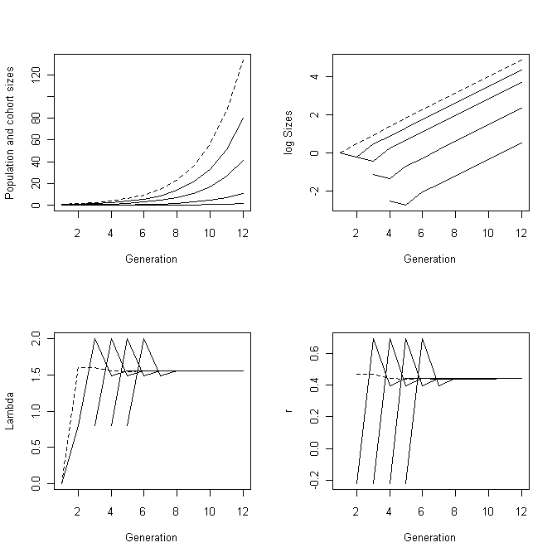

Figure 3.2
rm(list=ls()) # Clear workspace
par(mfrow=c(3,2)) # Divide page into 6 panels
BH.FUNCTION <- function(n,c1,c2) {c1/(1+c2*n)}
RICKER.FUNCTION <- function(n, ALPHA, BETA){ALPHA*exp(-BETA*n)}
################### MAIN PROGRAM ###################
########## Beverton Holt function ##########
c1 <- 100; c2 <- 2*10^-3 # B-H parameters
# Plot N(t) on t
Maxgen <- 20; N.t <- matrix(0,Maxgen); N.t[1] <- 1
for ( i in 2:Maxgen)
{N.t[i] <- N.t[i-1]*BH.FUNCTION(N.t[i-1], c1,c2)}
plot(seq(from=1, to=Maxgen), N.t, xlab = 'Generation, t', ylab ='N(t)',type='l')
# Plot N(t+1) on N(t)
MaxN <- 5000; N.t <- matrix(seq(from=1, to=MaxN))
N.tplus1 <- N.t*apply(N.t,1,BH.FUNCTION, c1,c2)
plot(N.t, N.tplus1, xlab = 'N(t)', ylab='N(t+1)', type='l')
########## Ricker function ##########
ALPHA <-c(6, 60); BETA <- .0005 # Parameter values
# Plot N(t) on t for 2 values of ALPHA
Maxgen <- 40
for (j in 1:2)
{
N.t <- matrix(0,Maxgen,1); N.t[1] <- 1
for ( i in 2:Maxgen)
{N.t[i] <- N.t[i-1]*RICKER.FUNCTION(N.t[i-1], ALPHA[j], BETA)}
plot(seq(from=1, to=Maxgen), N.t, xlab = 'Generation, t', ylab ='N(t)', type='l')
# Plot N(t+1) on N(t)
MaxN <- 10000; N.t <- matrix(seq(from=1, to=MaxN))
N.tplus1 <- N.t*apply(N.t, 1, RICKER.FUNCTION, ALPHA[j],BETA)
plot(N.t, N.tplus1, xlab='N(t)', ylab='N(t+1)', type='l')
lines(N.t, N.t)
} # End of j loop
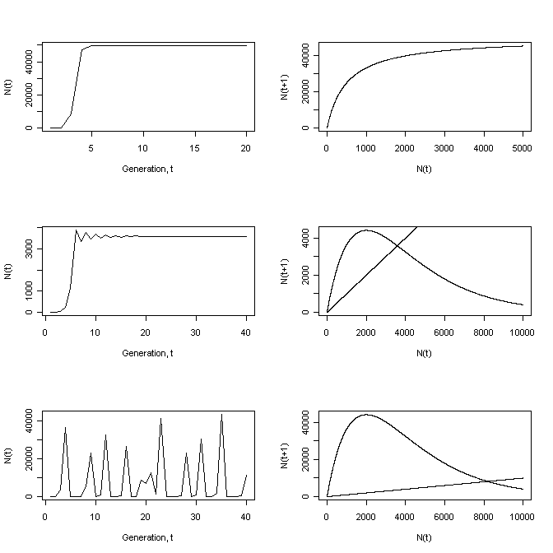

Scenario 1 : Solving using the methods of chapter 2
rm(list=ls()) # Clear workspace
RCALC <- function(x) # Function to calculate r
{
Af <-0; Bf<-16; As<-1; Bs<-0.5 # parameter values
r <- log(Af+Bf*x+1)-(As+Bs*x) # r
return(r) # return value
}
# Call optimize to find best x
optimize(f=RCALC,interval= c(0.1,3), maximum=TRUE)$maximum

Scenario 1 : Solving using a numerical method
rm(list=ls()) # Clear workspace
# Define function to sum characteristic eqn given r and x
SUMMATION <- function(r,x)
{
Maxage <- 50 # Maximum age
age <- seq( from=1, to=Maxage) # Vector of ages
Af <- 0; Bf <- 16; As <- 1 ; Bs <- 0.5 # Parameter values
m <- rep(Af+Bf*x, times= Maxage) # number of female offspring
l <- exp(-(As+Bs*x)*age) # Survival to age
Sum <- sum(exp(-r*age)*l*m) # Characteristic eqn sum
return(1-Sum) # Subtract 1 and return
}
# Define function to find r given x
RCALC <- function(x){uniroot(SUMMATION, interval=c(-1,2),x)$root}
# Calculate the best x by calling optimize, which calls RCALC
optimize(f=RCALC,interval= c(0.1,3), maximum=TRUE)

Scenario 1 : Solving using the eigenvalue
rm(list=ls()) # Clear workspace
RCALC <- function(x) # Function to generate Lelsie matrix and eigenvalue
{
Maxage <- 50 # Maximum age
M <- Maxage-1 # 1 less than the maximum age
age <- seq( from=1, to=Maxage) # vector of ages
Af <- 0 ;Bf <- 16; As <-1 ; Bs <- 0.5 # Parameter values
m <- rep(Af+Bf*x, times=Maxage) # number of female offspring
l <- exp(-(As+Bs*x)*age) # Survival to age
S <- matrix(0,Maxage,1) # Pre-assign space for age-specific survival
S[1] <- l[1] # Survival to age 1
# Calculate the survival from t to t+1
for ( i in 2:M) {S[i] <- l[i]/l[i-1]}
Fertility <- m*S # Top row of Leslie matrix
Dummy <- matrix(0,M,M) # Create a temporary matrix
diag(Dummy) <- S[1:M] # Assign survivals to diagonal
Leslie.matrix <- matrix(0, Maxage, Maxage) # Pre-assign space
Leslie.matrix[1,] <- Fertility # Add fertilities to top row
Leslie.matrix[2:Maxage,1:M] <- Dummy # Add dummy to appropriate space
# An alternate approach using a loop is shown below
#j <- 0; for (i in 2:Maxage){j <- j+1 ;Leslie.matrix[i,j] <- S[i-1]}
Eigen.data <- eigen(Leslie.matrix) # Call eigen
Lambda <- Eigen.data$values[1] # Get first eigenvalue
return(abs(log(Lambda))) # Return r
}
Optimum <- optimize(RCALC, interval= c(1,3), maximum=TRUE)
Best.X <- Optimum$maximum # Optimum body size
Best.r <- Optimum$objective # Maximum r
# Print out results to 6 significant digits
print(c('Best x = ', signif(Best.X, 6), 'Best r = ', signif(Best.r,6)))
# Plot r.est vs x
n <- 50 # Nos of increments
x <- matrix(seq(from=1, to=2.5, length=n)) # Values of x
r.est <- apply(x,1,RCALC) # Get values of r
plot(x, r.est,xlab="Body size, x", ylab="r.est", type='l')
points( Best.X, Best.r, cex=2) # Add point to graph at optimum
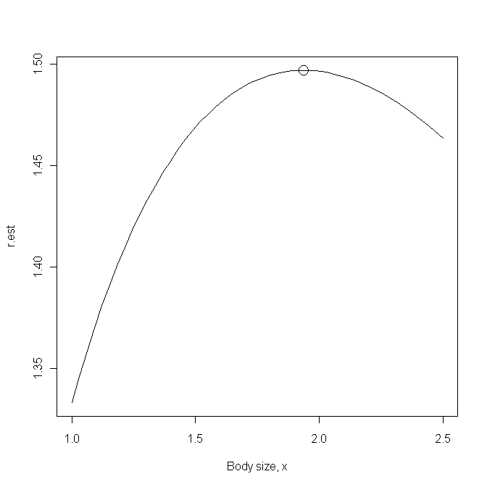
Scenario 2: Solving using R₀
rm(list=ls()) # Clear workspace
RCALC <- function(x) # Function to calculate r
{
Af <-0; Bf<-16; As<-1; Bs<-0.5 # parameter values
A <- Af+Bf*x; B <- As+Bs*x # For convenience
R0 <- A*exp(-B)/(1-exp(-B)) # R0
return(R0) # return value
}
# Call optimize to find best x
optimize(f=RCALC,interval= c(0.1,3), maximum=TRUE)$maximum

Scenario 2: Pairwise invasibility analysis
rm(list=ls()) # Clear workspace
LESLIE <- function(x,Maxage) # Function to generate Leslie matrix
{
M <- Maxage-1 # 1 less than the maximum age
age <- seq( from=1, to=Maxage) # vector of ages
Af <- 0 ;Bf <- 16; As <-1 ; Bs <- 0.5 # Parameter values
m <- rep(Af+Bf*x, times=Maxage) # number of female offspring
l <- exp(-(As+Bs*x)*age) # Survival to age
S <- matrix(0,Maxage,1) # Space for age-specific survival
S[1] <- l[1] # Survival to age 1
# Calculate the survival from t to t+1
for ( i in 2:M) {S[i] <- l[i]/l[i-1]}
Fertility <- m*S # Top row of Leslie matrix
Dummy <- matrix(0,M,M) # Create a temporary matrix
diag(Dummy) <- S[1:M] # Assign survivals to diagonal
Leslie.matrix <- matrix(0, Maxage, Maxage) # Pre-assign space
Leslie.matrix[1,] <- Fertility # Add fertilities to top row
Leslie.matrix[2:Maxage,1:M] <- Dummy # Add dummy to appropriate space
return(Leslie.matrix)
} # End of Leslie function
############### Density-dependence function ###############
DD.FUNCTION <- function(ALPHA,BETA,Fi,n) {Fi*ALPHA*exp(-BETA*n)}
###############Population dynamics function ###############
POP.DYNAMICS <- function(X)
{
X.Resident <- X[1] # Body size of resident population
X.invader <- X[2] # Body size of invader
ALPHA <- 1 ; BETA <- 2*10^-5 # Density dependence parameters
Maxage <- 50 # Maximum age
Resident.matrix <- LESLIE(X.Resident, Maxage) # Resident Leslie matrix
Invader.matrix <- LESLIE(X.invader, Maxage) # Invader leslie matrix
F.resident <- Resident.matrix[1,] # Resident DI fertility
F.invader <- Invader.matrix[1,] # Invader DI fertility
Maxgen <- 30 # Nos of gens to run
n.resident <- matrix(0,Maxage,1) # Resident population vector
n.resident[1] <- 1 # Initial resident popn size
for ( Igen in 2:Maxgen) # Iterate over generations
{
N <- sum(n.resident) # Total popn size
# Get DD fertility for resident population at time Igen
Resident.matrix[1,] <- DD.FUNCTION(ALPHA, BETA, F.resident, N)
n.resident <- Resident.matrix%*%n.resident # Resident popn
} # End of first Igen loop
### Introduce invader ####
Maxgen <- 100 # Number of generations to run
# Pre-allocate space for storage of invader population numbers
Pop.invader <- matrix(0,Maxgen,1)
# Pre-allocate space for invader vector
n.invader <- matrix(0,Maxage,1)
n.invader[1] <- 1 # Initial number of invaders
Pop.invader[1,1] <- n.invader[1] # Store initial numbers of invaders
for (Igen in 2:Maxgen) # Iterate over generations
{
# Total number in population.
N <- sum(n.resident) + sum(n.invader)
# DD fertility of resident
Resident.matrix[1,] <- DD.FUNCTION(ALPHA, BETA, F.resident, N)
# New resident vector
n.resident <- Resident.matrix%*%n.resident
# DD fertility of invader
Invader.matrix[1,] <- DD.FUNCTION(ALPHA, BETA, F.invader, N)
# New invader vector
n.invader <- Invader.matrix%*%n.invader
Pop.invader[Igen] <- sum(n.invader) # Store invader popn size
} # End of second Igen loop
# Now do linear regression of log(Pop.invader) on Generation
Generation <- seq(from=1, to=Maxgen) # Generate generation vector
Nstart <- 20 # Generations to ignore
# Linear regression
Invasion.model <- lm(log(Pop.invader[Nstart:Maxgen])~Generation[Nstart:Maxgen])
# Elasticity value = regression slope
Elasticity <- Invasion.model$coeff[2]
} # End of POP.DYNAMICS function
######################### MAIN PROGRAM #########################
N1 <- 30 # Nos of increments
X.Resident <- seq(from=1, to= 3, length=N1) # Resident body sizes
X.Invader <- X.Resident # Invader body sizes
d <- expand.grid(X.Resident, X.Invader) # Combinations
# Generate values at combinations
z <- apply(d,1,POP.DYNAMICS)
z.matrix <- matrix(z, N1, N1) # Convert to a matrix
# Plot contours
contour(X.Resident, X.Invader,z.matrix, xlab="Resident", ylab="Invader")
# Place circle at predicted optimal body size
points( 1.68703, 1.68703, cex=3) # cex triples size of circle
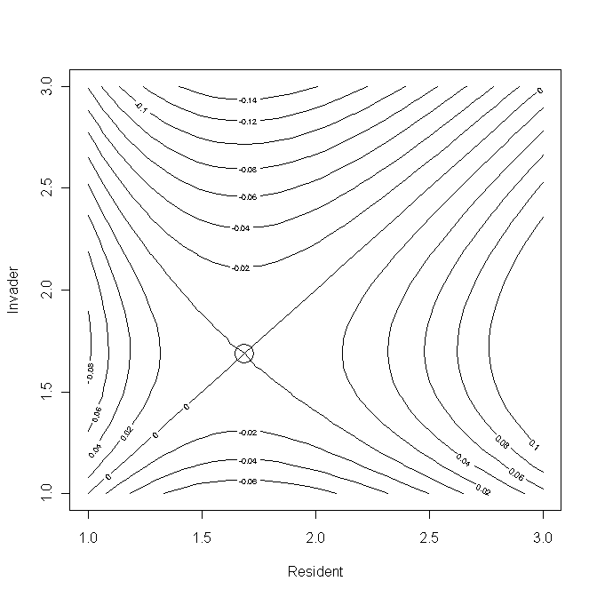

Scenario 2: Elasticity analysis
rm(list=ls()) # Clear workspace
LESLIE <- function(x,Maxage) # Function to generate Leslie matrix
{
M <- Maxage-1 # 1 less than the maximum age
age <- seq( from=1, to=Maxage) # vector of ages
Af <- 0 ;Bf <- 16; As <-1 ; Bs <- 0.5 # Parameter values
m <- rep(Af+Bf*x, times=Maxage) # number of female offspring
l <- exp(-(As+Bs*x)*age) # Survival to age
S <- matrix(0,Maxage,1) # Space for age-specific survival
S[1] <- l[1] # Survival to age 1
# Calculate the survival from t to t+1
for ( i in 2:M) {S[i] <- l[i]/l[i-1]}
Fertility <- m*S # Top row of Leslie matrix
Dummy <- matrix(0,M,M) # Create a temporary matrix
diag(Dummy) <- S[1:M] # Assign survivals to diagonal
Leslie.matrix <- matrix(0, Maxage, Maxage) # Pre-assign space
Leslie.matrix[1,] <- Fertility # Add fertilities to top row
Leslie.matrix[2:Maxage,1:M] <- Dummy # Add dummy to appropriate space
return(Leslie.matrix)
} # End of Leslie function
############### Density-dependence function ###############
DD.FUNCTION <- function(ALPHA,BETA,Fi,n) {Fi*ALPHA*exp(-BETA*n)}
###############Population dynamics function ###############
POP.DYNAMICS <- function(X, Coeff)
{
X.Resident <- X # Body size of resident population
X.invader <- X.Resident*Coeff # Body size of invader
ALPHA <- 1 ; BETA <- 2*10^-5 # Density dependence parameters
Maxage <- 50 # Maximum age
Resident.matrix <- LESLIE(X.Resident, Maxage) # Resident Leslie matrix
Invader.matrix <- LESLIE(X.invader, Maxage) # Invader leslie matrix
F.resident <- Resident.matrix[1,] # Resident DI fertility
F.invader <- Invader.matrix[1,] # Invader DI fertility
Maxgen <- 30 # Nos of gens to run
n.resident <- matrix(0,Maxage,1) # Resident population vector
n.resident[1] <- 1 # Initial resident popn size
for ( Igen in 2:Maxgen) # Iterate over generations
{
N <- sum(n.resident) # Total popn size
# Get DD fertility for resident population at time Igen
Resident.matrix[1,] <- DD.FUNCTION(ALPHA, BETA, F.resident, N)
n.resident <- Resident.matrix%*%n.resident # Resident popn
} # End of first Igen loop
### Introduce invader ####
Maxgen <- 100 # Number of generations to run
# Pre-allocate space for storage of invader population numbers
Pop.invader <- matrix(0,Maxgen,1)
# Pre-allocate space for invader vector
n.invader <- matrix(0,Maxage,1)
n.invader[1] <- 1 # Initial number of invaders
Pop.invader[1,1] <- n.invader[1] # Store initial numbers of invaders
for (Igen in 2:Maxgen) # Iterate over generations
{
# Total number in population.
N <- sum(n.resident) + sum(n.invader)
# DD fertility of resident
Resident.matrix[1,] <- DD.FUNCTION(ALPHA, BETA, F.resident, N)
# New resident vector
n.resident <- Resident.matrix%*%n.resident
# DD fertility of invader
Invader.matrix[1,] <- DD.FUNCTION(ALPHA, BETA, F.invader, N)
# New invader vector
n.invader <- Invader.matrix%*%n.invader
Pop.invader[Igen] <- sum(n.invader) # Store invader popn size
} # End of second Igen loop
# Now do linear regression of log(Pop.invader) on Generation
Generation <- seq(from=1, to=Maxgen) # Generate generation vector
Nstart <- 20 # Generations to ignore
# Linear regression
Invasion.model <- lm(log(Pop.invader[Nstart:Maxgen])~Generation[Nstart:Maxgen])
# Elasticity value = regression slope
Elasticity <- Invasion.model$coeff[2]
} # End of POP.DYNAMICS function

######################### MAIN PROGRAM #########################
par(mfrow=c(2,2)) # Divide graphics page into quarters
# Plot elasticity vs x
N.int <- 20 # Number of ncrements
X <- matrix(seq(from=.5, to=3, length=N.int)) # Sequence of body sizes
# Calculate elasticities for sequence
Elasticity <- apply(X,1,POP.DYNAMICS,0.995)
plot(X, Elasticity, type='l') # Plot elasticity as a function of X
lines(c(.5,3), c(0,0)) # Add horizontal line at zero
# Calculate the optimum by calling uniroot
Optimum <- uniroot(POP.DYNAMICS, interval=c(0.5,3),0.995)
Best.X <- Optimum$root # Save optimum X
print(c("Optimum body size =",signif(Best.X,6))) # Print out value
# Now plot Invasion exponent when resident is optimal
# Note that because of order in call cannot use apply here
# Convert the X sequence to coefficients for call to POP.DYNAMICS
Coeff <- X/Best.X
Invasion.exponent <- matrix(0,N.int,1) # Pre-allocate space
# Loop through values of X comparing to Best.X
for (i in 1:N.int){Invasion.exponent[i] <- POP.DYNAMICS(Best.X, Coeff[i]) }
plot(X, Invasion.exponent, type='l') # Plot invasion exponent vs x
points(Best.X, 0, cex=2) # Plot point at predicted optimum

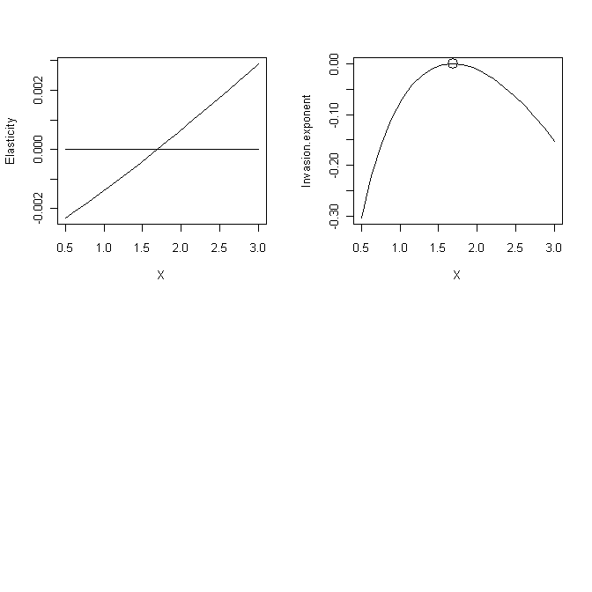

Scenario 3: Fig. 3.7
rm(list=ls()) # Clear workspace
par(mfrow=c(3,2)) # Divide graphics page into 3x2 panels
DD.FUNCTION <- function(n,ALPHA, BETA) {ALPHA*exp(-BETA*n)}
# main program
A <- c(2,10,20) # Values of alpha
for( j in 1:3) # Iterate over values of alpha
{
N.t <- seq(from=0, to=1000) # Population sizes
ALPHA <-A[j] # alpha
BETA <- ALPHA*0.001 # Beta
# Plot N(t+1) vs N(t)
N <- length(N.t) # Nos of values of N(t)
N.tplus1 <- matrix(0,N) # Pre-allocate space for N(t+1)
for ( i in 1:N) # Iterate over values of N
{
N.tplus1[i] <- N.t[i]*DD.FUNCTION(N.t[i],ALPHA,BETA)
} # End of N(t+1) on N(t) calculation
plot(N.t, N.tplus1, type='l', xlab='N(t)',ylab='N(t+1)')
lines(N.t, N.t) # Plot the line of equality
# Plot N(t) vs t
Maxgen <- 100 # Number of generations
N <- matrix(0, Maxgen) # Pre-allocate space for N(t)
N[1] <- 1 # Initial vale of N
for ( Igen in 2:Maxgen) # Iterate over generations
{
N[Igen] <- N[Igen-1]*DD.FUNCTION(N[Igen-1],ALPHA,BETA)
} # End of Igen loop
Generation <- seq(1,Maxgen) # Vector of generation numbers
plot(Generation, N, type='l') # Plot population trajectory
} # End of j loop
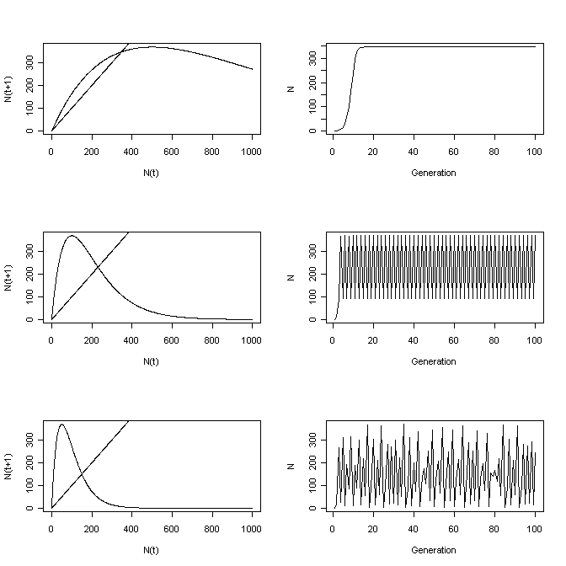

Scenario 3: Invasibility analysis
rm(list=ls()) # Clear memory
DD.FUNCTION <- function(ALPHA,N1,N2) # Density-dependence function
{
BETA <- ALPHA*0.001 # Set value of beta
N <- N1*ALPHA*exp(-BETA*N2) # New population size
return(N)
} # End of DD.FUNCTION
#### Function specifying population dynamics ####
POP.DYNAMICS <- function(ALPHA)
{
ALPHA.resident <- ALPHA[1] # Alpha for resident
ALPHA.invader <- ALPHA[2] # Alpha for invader
Maxgen1 <- 50 # Generations when only invader present
Maxgen2 <- 300 # Generations after invader introduced
Tot.Gen <- Maxgen1+Maxgen2 # Total number of generations
N.resident <- N.invader <- matrix(0,Tot.Gen) # Allocate space
N.resident[1] <- 1 # Initial number of resident
N.invader[Maxgen1]<- 1 # Initial number of invader
for (Igen in 2:Maxgen1) # Iterate over only resident
{
N.resident[Igen] <- DD.FUNCTION(ALPHA.resident, N.resident[Igen-1], N.resident[Igen-1])
} # End of resident only period
# Now add invader
J <- Maxgen1+1 # Staring generation of this period
for (Igen in J:Tot.Gen) # Iterate after introduction of invader
{
N.total <- N.resident[Igen-1]+ N.invader[Igen-1] # Total popn size
# Resident population size
N.resident[Igen] <- DD.FUNCTION(ALPHA.resident, N.resident[Igen-1],N.total)
# Invader population size
N.invader[Igen] <- DD.FUNCTION(ALPHA.invader, N.invader[Igen-1],N.total)
} # End of invasion period
Generation <- seq(from=1, to=Tot.Gen) # Generation sequence
Nstart <- 10 + Maxgen1 # Starting point for regression
# Regression model
Invasion.model <- lm(log(N.invader[Nstart:Tot.Gen])~ Generation[Nstart:Tot.Gen])
Elasticity <- Invasion.model$coeff[2] # Elasticity
return(Elasticity)
} # End of POP.DYNAMICS function
############# MAIN PROGRAM #############
N1 <- 30 # Nos of increments
A.Resident <- seq(from=2, to= 4, length=N1) # Resident alpha
A.Invader <- A.Resident # Invader alpha
d <- expand.grid(A.Resident, A.Invader) # Combinations
# Generate values at combinations
z <- apply(d,1,POP.DYNAMICS)
z.matrix <- matrix(z, N1, N1) # Convert to a matrix
# Plot contours
contour(A.Resident, A.Invader,z.matrix, xlab="Resident", ylab="Invader")
# Place circle at predicted optimal body size
points(2.725109, 2.725109, cex=3) # cex triples size of circle
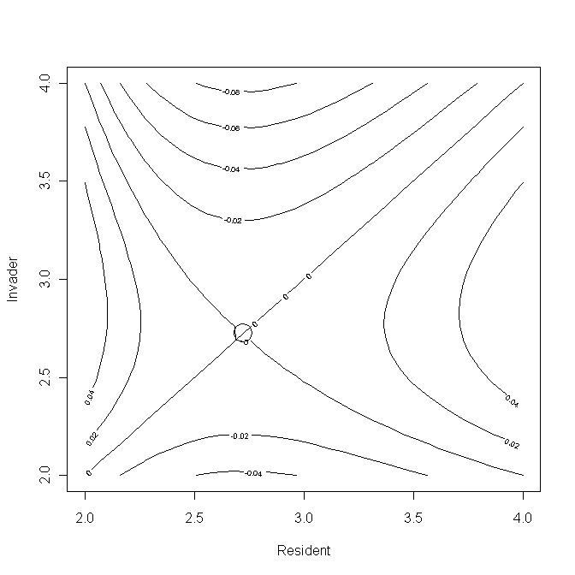
Scenario 3: Elasticity analysis
rm(list=ls()) # Clear memory
DD.FUNCTION <- function(ALPHA,N1,N2) # Density-dependence function
{
BETA <- ALPHA*0.001 # Set value of beta
N <- N1*ALPHA*exp(-BETA*N2) # New population size
return(N)
} # End of DD.FUNCTION
#### Function specifying population dynamics ####
POP.DYNAMICS <- function(ALPHA, Coeff)
{
ALPHA.resident <- ALPHA # Alpha for resident
ALPHA.invader <- ALPHA.resident*Coeff # Alpha for invader
Maxgen1 <- 50 # Generations when only invader present
Maxgen2 <- 300 # Generations after invader introduced
Tot.Gen <- Maxgen1+Maxgen2 # Total number of generations
N.resident <- N.invader <- matrix(0,Tot.Gen) # Allocate space
N.resident[1] <- 1 # Initial number of resident
N.invader[Maxgen1]<- 1 # Initial number of invader
for (Igen in 2:Maxgen1) # Iterate over only resident
{
N.resident[Igen] <- DD.FUNCTION(ALPHA.resident, N.resident[Igen-1], N.resident[Igen-1])
} # End of resident only period
# Now add invader
J <- Maxgen1+1 # Staring generation of this period
for (Igen in J:Tot.Gen) # Iterate after introduction of invader
{
N.total <- N.resident[Igen-1]+ N.invader[Igen-1] # Total popn size
# Resident population size
N.resident[Igen] <- DD.FUNCTION(ALPHA.resident, N.resident[Igen-1],N.total)
# Invader population size
N.invader[Igen] <- DD.FUNCTION(ALPHA.invader, N.invader[Igen-1],N.total)
} # End of invasion period
Generation <- seq(from=1, to=Tot.Gen) # Generation sequence
Nstart <- 10 + Maxgen1 # Starting point for regression
# Regression model
Invasion.model <- lm(log(N.invader[Nstart:Tot.Gen])~ Generation[Nstart:Tot.Gen])
Elasticity <- Invasion.model$coeff[2] # Elasticity
return(Elasticity)
} # End of POP.DYNAMICS function
############### MAIN PROGRAM ###############
par(mfrow=c(2,2)) # Divide graphics page into quadrats
# Call uniroot to find optimum
minA <-1; maxA <-10 # Limits for search
Optimum <- uniroot(POP.DYNAMICS, interval=c(minA,maxA),0.995)
Best.Alpha <- Optimum$root # Store optimum Alpha
print(Best.Alpha) # Print out optimum
# Plot Elasticity vs alpha
N.int <- 30 # Nos of intervals for plot
Alpha <- matrix(seq(from=minA, to=maxA, length=N.int), N.int,1)
Elasticity <- apply(Alpha,1,POP.DYNAMICS, 0.995) # Get elasticities
plot(Alpha, Elasticity, type='l')
lines(c(minA,maxA), c(0,0)) # Add horizontal line at zero
# Plot Invasion exponent when resident is optimal
Coeff <- Alpha/Best.Alpha # Convert alpha to coefficient
Invasion.coeff <- matrix(0,N.int,1) # Allocate space
# Calculate invasion coefficient
for (i in 1:N.int){ Invasion.coeff[i] <- POP.DYNAMICS(Best.Alpha, Coeff[i]) }
plot(Alpha, Invasion.coeff, type='l') # Plot invasion coeff on alpha
points(Best.Alpha,0, cex=2) # Plot optimum alpha on graph
# Plot N(t+1) on N(t) for optimum alpha
maxN <- 1000 # Number of N
N.t <- seq(from=1, to=maxN) # Values of N(t)
N.tplus1 <- matrix(0,maxN) # Allocate space for N(t+1)
for ( i in 1:maxN) # Iterate over values of N
{
N.tplus1[i] <- DD.FUNCTION(Best.Alpha, N.t[i], N.t[i])
} # End of i loop
plot(N.t, N.tplus1, type='l', xlab='N(t)', ylab='N(t+1)')
# Plot N(t) on t
N <- matrix(1,100) # Allocate space. Note reuse of N
for (i in 2:100){N[i]<- DD.FUNCTION(Best.Alpha, N[i-1], N[i-1])}
plot(seq(from=1, to=100), N, type='l', xlab='Generation', ylab='Population')

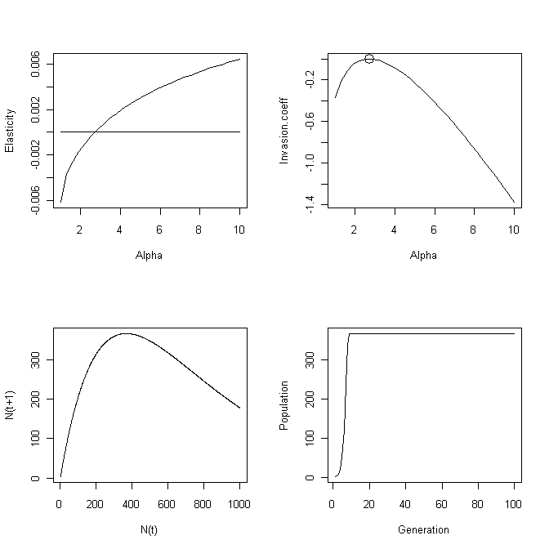

Scenario 3: Multiple invasibility analysis
rm(list=ls()) # Clear memory
DD.FUNCTION<- function(X, N.total) # Density-dependence function
{
# Set parameter values
ALPHA <- X[1] # Set alpha
N <- X[2] # Population size for this alpha
BETA <- ALPHA*0.001 # Set value of beta
N <- N*ALPHA*exp(-BETA*N.total) # New cohort size
return(N)
} # End of function
############## MAIN PROGRAM ##############
set.seed(10) # Initialize the random number seed
Maxgen <- 5000 # Number of generations run
Stats <- matrix(0,Maxgen,3)# Allocate space for statistics
MaxAlpha <- 4 # maximum value of alpha
Ninc <- 50 # Number of classes for alpha
# Allocate space to store data for each generation
Store <- matrix(0,Maxgen, Ninc)
# Allocate space for alpha class and population size
Data <- matrix(0,Ninc,2)
Data[24,2] <- 1 # Initial population size and alpha class
ALPHA <- matrix(seq(from=2, to=MaxAlpha, length=Ninc),Ninc,1) # Set Alpha
Data[,1] <- ALPHA # Place alpha in 1st column
for (Igen in 1:Maxgen) # Iterate over generations
{
N.total <- sum(Data[,2]) # Total population size
Data[,2] <- apply(Data,1,DD.FUNCTION, N.total) # New cohort
Store[Igen,] <- Data[,2] # Store values for this generation
# Keep track of population size, mean trait value and SD of trait value
Stats[Igen,2] <- sum(Data[,1]*Data[,2])/sum(Data[,2]) # Mean
S <- sum(Data[,2]) # Population size
Stats[Igen,1] <- S # Population size
SX1 <- sum(Data[,1]^2*Data[,2])
SX2 <- (sum(Data[,1]*Data[,2]))^2/S
Stats[Igen,3] <- sqrt((SX1-SX2)/(S-1)) # SD of trait
# Introduce a mutant by picking a random integer between 1 and 50
Mutant <- ceiling(runif(1, min=0, max=50))
Data[Mutant,2] <- Data[Mutant,2]+1 # Add mutant to class
} # End of Igen loop
par(mfrow=c(2,2)) # Split graphics page into quadrats
# Plot last row of Store
plot(ALPHA, Store[Maxgen,], type='l', xlab='Alpha', ylab='Number')
# plot(Data.out[,1], Data.out[,2],
Generation <- seq(from=1, to=Maxgen)
N0 <- 1
plot(Generation[N0:Maxgen], Stats[N0:Maxgen,1], ylab='Population size', type='l')
plot(Generation[N0:Maxgen], Stats[N0:Maxgen,2], ylab='Mean', type='l')
plot(Generation[N0:Maxgen], Stats[N0:Maxgen,3], ylab='SD', type='l')
print(c('Mean alpha in last gen = ',Stats[Maxgen,2]))
print(c('SD of alpha in last gen = ',Stats[Maxgen,3]))

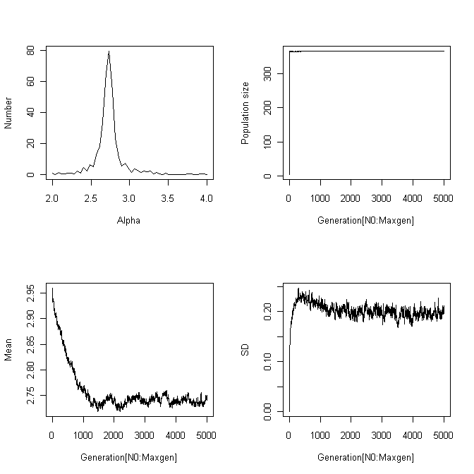

Scenario 4: Pairwise invasibility analysis
rm(list=ls()) # Clear workspace
# Density-dependent function
DD.FUNCTION <- function(ALPHA, BETA, F.DI, Ei, n)
{Ei*F.DI*ALPHA*exp(-BETA*n)}
# Function to calculate dynamics of invasion
POP.DYNAMICS <- function(E)
{
E.resident <- E[1] # E for resident
E.invader <- E[2] # E for invader
F.DI <- c(4, 10) # DI Fertilities
S.DI <- c(0.6,0.85) # DI Survivals
ALPHA <- 1; BETA <- 2*10^-5 # DD parameter values
z <- 6 # RE survival parameter value
# Preallocate space for matrices
Resident.matrix <- matrix(0,2,2) # Pre-assign space for matrix
Invader.matrix <- matrix(0,2,2) # Pre-assign space for matrix
# Apply reproductive effort to F
Resident.matrix[1,]<- E.resident*F.DI
Invader.matrix[1,] <- E.invader*F.DI
# Apply reproductive effort to S
Resident.matrix[2,] <- (1-E.resident^z)*S.DI
Invader.matrix[2,] <- (1-E.invader^z)*S.DI
# Run Maxgen generation with resident only
Maxgen <- 20 # Nos of generations
n.resident <- c(1,0) # Initial population vector
for ( Igen in 2:Maxgen) # Iterate over generations
{
# Calculate the new entries
N <- sum(n.resident) # Pop size of residents
Resident.matrix[1,]<- DD.FUNCTION(ALPHA, BETA, F.DI, E.resident, N) # New Fs
n.resident <- Resident.matrix%*%n.resident # New pop vector
} # End of first Igen loop
# Introduce invader
Maxgen <- 100 # Set nos of generations to run
Pop.invader <- matrix(0,Maxgen,1) # pre-allocate space of pop size
Pop.invader[1,1] <- 1 # Initial population size
n.invader <- c(1,0) # Initiate invader pop vector
for (Igen in 2:Maxgen) # Iterate over generations
{
N <- sum(n.resident) + sum(n.invader) # Total pop
# Apply density dependence to fertilities
Resident.matrix[1,] <- DD.FUNCTION(ALPHA, BETA, F.DI, E.resident, N)
Invader.matrix[1,] <- DD.FUNCTION(ALPHA, BETA, F.DI, E.invader, N)
# Calculate new population vectors
n.resident <- Resident.matrix%*%n.resident
n.invader <- Invader.matrix%*%n.invader
Pop.invader[Igen] <- sum(n.invader) # Store pop size of invader
} # End of second Igen loop
Generation <- seq(from=1, to=Maxgen) # Create vector of generations
# Get growth of invader starting at generation 20
Invasion.model <- lm(log(Pop.invader[20:Maxgen])~Generation[20:Maxgen])
# Elasticity = slope of regression
Elasticity <- Invasion.model$coeff[2]
return(Elasticity)
} # End of function
######################### MAIN PROGRAM #########################
par(mfrow=c(1,1))
N1 <- 30 # Nos of increments
E.Resident <- seq(from=.2, to= .9, length=N1) # Resident body sizes
E.Invader <- E.Resident # Invader body sizes
d <- expand.grid(E.Resident, E.Invader) # Combinations
# Generate values at combinations
z <- apply(d,1,POP.DYNAMICS)
z.matrix <- matrix(z, N1, N1) # Convert to a matrix
# Plot contours
contour(E.Resident, E.Invader,z.matrix, xlab="Resident", ylab="Invader")
# Place circle at predicted optimal body size
points( 0.5651338, 0.5651338, cex=3) # cex triples size of circle

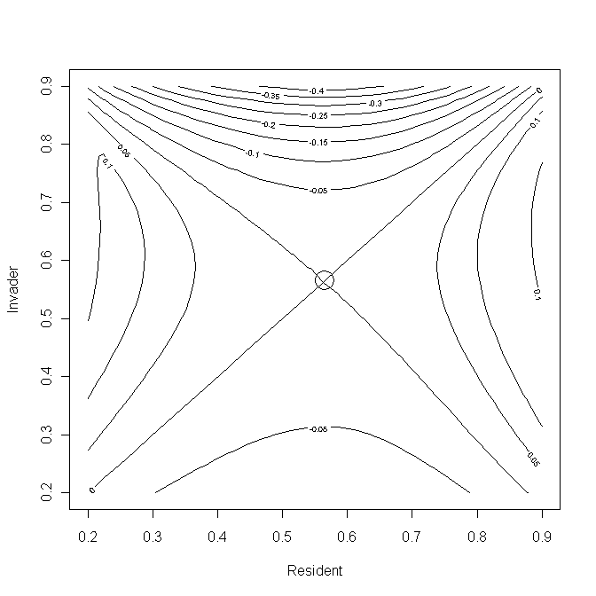

Scenario 4: Elasticity analysis
rm(list=ls()) # Clear workspace
# Density-dependent function
DD.FUNCTION <- function(ALPHA, BETA, F.DI, Ei, n)
{Ei*F.DI*ALPHA*exp(-BETA*n)}
# Function to calculate dynamics of invasion
POP.DYNAMICS <- function(E, Coeff)
{
E.resident <- E # E for resident
E.invader <- E*Coeff # E for invader
F.DI <- c(4, 10) # DI Fertilities
S.DI <- c(0.6,0.85) # DI Survivals
ALPHA <- 1; BETA <- 2*10^-5 # DD parameter values
z <- 6 # RE survival parameter value
# Preallocate space for matrices
Resident.matrix <- matrix(0,2,2) # Pre-assign space for matrix
Invader.matrix <- matrix(0,2,2) # Pre-assign space for matrix
# Apply reproductive effort to F
Resident.matrix[1,]<- E.resident*F.DI
Invader.matrix[1,] <- E.invader*F.DI
# Apply reproductive effort to S
Resident.matrix[2,] <- (1-E.resident^z)*S.DI
Invader.matrix[2,] <- (1-E.invader^z)*S.DI
# Run Maxgen generation with resident only
Maxgen <- 20 # Nos of generations
n.resident <- c(1,0) # Initial population vector
for ( Igen in 2:Maxgen) # Iterate over generations
{
# Calculate the new entries
N <- sum(n.resident) # Pop size of residents
Resident.matrix[1,]<- DD.FUNCTION(ALPHA, BETA, F.DI, E.resident, N) # New Fs
n.resident <- Resident.matrix%*%n.resident # New pop vector
} # End of first Igen loop
# Introduce invader
Maxgen <- 100 # Set nos of generations to run
Pop.invader <- matrix(0,Maxgen,1) # pre-allocate space of pop size
Pop.invader[1,1] <- 1 # Initial population size
n.invader <- c(1,0) # Initiate invader pop vector
for (Igen in 2:Maxgen) # Iterate over generations
{
N <- sum(n.resident) + sum(n.invader) # Total pop
# Apply density dependence to fertilities
Resident.matrix[1,] <- DD.FUNCTION(ALPHA, BETA, F.DI, E.resident, N)
Invader.matrix[1,] <- DD.FUNCTION(ALPHA, BETA, F.DI, E.invader, N)
# Calculate new population vectors
n.resident <- Resident.matrix%*%n.resident
n.invader <- Invader.matrix%*%n.invader
Pop.invader[Igen] <- sum(n.invader) # Store pop size of invader
} # End of second Igen loop
Generation <- seq(from=1, to=Maxgen) # Create vector of generations
# Get growth of invader starting at generation 20
Invasion.model <- lm(log(Pop.invader[20:Maxgen])~Generation[20:Maxgen])
# Elasticity = slope of regression
Elasticity <- Invasion.model$coeff[2]
return(Elasticity)

} # End of function
##################### MAIN PROGRAM #####################
par(mfrow=c(2,2)) # Divide graphics page into quarters
# Locate value at which elasticity equals zero
Optimum <- uniroot(POP.DYNAMICS, interval=c(0.01,0.9),0.995)
Best.E <- Optimum$root # Store the optimum reproductive effort
print(Best.E) # Print optimum E
# Create plot of elasticity vs E
N.int <- 30 # Nos of increments
# Create sequence of E from .1 to 0.9 in N.int increments
E <- matrix(seq(from=0.2, to=.9, length=N.int), N.int,1)
# Create vector of elasticities using apply function
Elasticity <- apply(E,1,POP.DYNAMICS, 0.995)
plot(E, Elasticity, type='l') # Plot elasticity vs E
lines(c(.2,.9), c(0,0)) # Add horizontal line at zero
# Now plot Invasion exponent when resident is optimal
Coeff <- E/Best.E # Coefficient of invader DD function
Invasion.exponent <- matrix(0,N.int,1) # pre-allocate space
# Iterate and calculate invasion exponent
# Note that a loop is used rather than apply because it is coefficient that
# is changing
for (i in 1:N.int){ Invasion.exponent[i] <- POP.DYNAMICS(Best.E, Coeff[i]) }
plot(E, Invasion.exponent, ylab ='Invasion exponent', type='l')
points(Best.E,0, cex=2) # Plot point at previously estimated optimum E
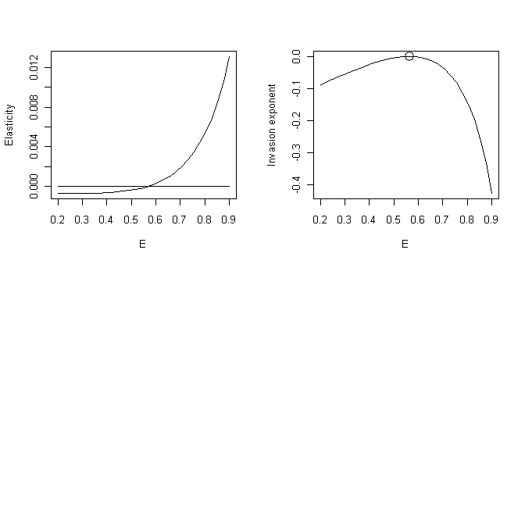
Scenario 5: Fig. 3.13
rm(list=ls()) # Clear workspace
par(mfrow=c(2,2)) # Divide graphics page into quarters
ALPHA <- 18 ; BETA <- 0.01; S <- 0.8 # Parameter values
Ps <- c(.1,.5,.7,.9) # Values of P
for ( Ith.P in 1:4) # Iterate over P values
{
P <- Ps[Ith.P] # Select P value
Stage <- c(0,1) # Start with one Adult
# Initialize matrix
Stage.matrix <- matrix(c(S*P, S*(1-P), ALPHA*exp(-BETA*Stage[2]),0),2,2)
Maxgen <- 100 # Nos of generations to run simulation
Store.Stage <- matrix(0,Maxgen,2) # Preallocate space for storage
Store.Stage[1,] <- Stage # Store generation 1
for (Igen in 2:Maxgen) # Iterate over generations
{
Stage <- Stage.matrix%*%Stage # New matrix
Stage.matrix[1,2] <- ALPHA*exp(-BETA*Stage[2]) # Apply DD function
Store.Stage[Igen,] <- Stage # Store data
} # End of Igen loop
plot(seq(from=1, to=Maxgen), Store.Stage[,2],xlab='Generation', ylab='Adults', type='l')
} # End of Ith.P loop

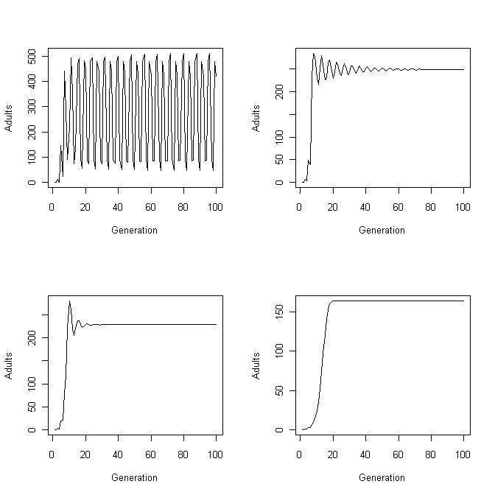
Scenario 5: Elasticity analysis
rm(list=ls()) # Clear workspace
par(mfrow=c(1,1)) # Divide graphics page into quarters
POP.DYNAMICS <- function(P, P.invader.coeff)
{
P.resident <- P # Resident delay
P.invader <- P*P.invader.coeff # Invader delay
ALPHA <- 18; BETA <- 0.01; S <- 0.8 # parameter values
Resident.Stage <- c(1,1) # Initial resident population
Invader.Stage <- c(1,1) # Initial invader population
# Initiate resident and invader matrices
Resident.matrix <- matrix(c(S*P.resident, S*(1-P.resident), ALPHA*exp(-BETA*Resident.Stage[2]),0),2,2)
Invader.matrix <- matrix(c(S*P.invader, S*(1-P.invader), ALPHA*exp(-BETA*Invader.Stage[2]),0),2,2)
Maxgen <- 100 # Generations with resident alone
Store.Invader <- matrix(0,Maxgen,2)
Store.Invader[1,] <- Invader.Stage
for (Igen in 2:Maxgen) # Iterate until resident is stable
{
Resident.Stage <- Resident.matrix%*%Resident.Stage # New matrix
Resident.matrix[1,2] <- ALPHA*exp(-BETA*Resident.Stage[2]) # DD effect
} # End of 1st Igen loop
# Now enter invader
Pop.invader <- matrix(0,Maxgen,1)
Maxgen <- 100 # Set number of generations for invasion
for (Igen in 1:Maxgen) # Iterate over generations after invasion
{
N <- Resident.Stage[2]+ Invader.Stage[2] # Adult population size
Resident.matrix[1,2] <- ALPHA*exp(-BETA*N) # Apply DD to resident
Invader.matrix[1,2] <- ALPHA*exp(-BETA*N) # Apply DD to invader
# New matrices
Resident.Stage <- Resident.matrix%*%Resident.Stage
Invader.Stage <- Invader.matrix%*%Invader.Stage
Pop.invader[Igen] <- Invader.Stage[2] # Store invader adult pop
} # End of 2nd Igen loop
Generation <- seq(from=20, to=Maxgen) # Generation vector
# Get invasion exponent from linear regression
Invasion.model <- lm(log(Pop.invader[20:Maxgen])~Generation[20:Maxgen])
Elasticity <- Invasion.model$coeff[2]
} # End of POP.DYNAMICS
#################### MAIN PROGRAM ####################
par(mfrow=c(2,2)) # Divide graphics page into 4 quadrats
# Call uniroot to find optimum
Optimum <- uniroot(POP.DYNAMICS, interval=c(0.1,0.6),0.995)
Best.P <- Optimum$root # Store optimum P
print(Best.P) # Print out optimum
N.int <- 30 # Nos of intervals for plot
P <- matrix(seq(from=0.1, to=.6, length=N.int), N.int,1)
Elasticity <- apply(P,1,POP.DYNAMICS, 0.995)
plot(P, Elasticity, type='l')
lines(c(.01,.9), c(0,0)) # Add horizontal line at zero
# Now plot Invasion exponent when resident is optimal
Coeff <- P/Best.P # Convert P to coefficient
Invasion.coeff <- matrix(0,N.int,1)
for (i in 1:N.int){ Invasion.coeff[i] <- POP.DYNAMICS(Best.P, Coeff[i]) }
plot(P, Invasion.coeff, type='l')
points(Best.P,0, cex=2)
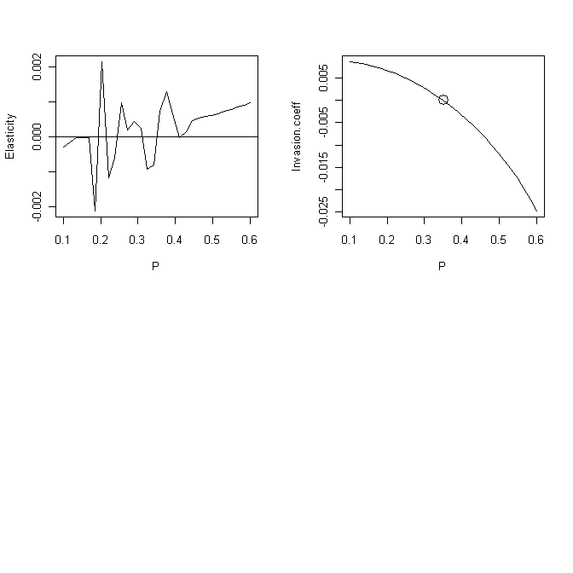
Scenario 6: Pairwise invasibility analysis
rm(list=ls()) # Clear memory
DD.FUNCTION<- function(ALPHA,N1,N2) # Density-dependence function
{
# Set parameter values
Amin <- 1; Amax <- 50; Bmin <- 0; Bmax <- 0.9; a <- 20; BETA <- 0.01
AA <- (ALPHA-Amin)/(Amax-Amin) # For convenience
S <- (Bmax-Bmin)*(1-AA)/(1+a*AA) # Survival
N <- N1*(ALPHA*exp(-BETA*N2)+S) # new population
return(N)
} # End of function
################ POP.DYNAMICS FUNCTION ################
POP.DYNAMICS <- function(ALPHA)
{
ALPHA.resident <- ALPHA[1] # Resident value
ALPHA.invader <- ALPHA[2] # Invader value
Maxgen1 <- 50 # Nos of generations for resident only
Maxgen2 <- 300 # Nos of generations after invasion
Tot.Gen <- Maxgen1+Maxgen2 # Total number of generations
N.resident <- N.invader <- matrix(0,Tot.Gen) # Allocate space
N.resident[1] <- 1 # Initial pop size of resident
N.invader[Maxgen1]<- 1 # Initial pop size of invader
for (Igen in 2:Maxgen1) # Iterate over generations with resident only
{
N <- N.resident[Igen-1]
N.resident[Igen] <- DD.FUNCTION(ALPHA.resident, N, N)
} # End of 1st Igen loop
# Now add invader
J <- Maxgen1+1 # Starting generation
for (Igen in J:Tot.Gen) # Iterate over generations with invader
{
N <- N.resident[Igen-1]+ N.invader[Igen-1] # Total pop size
N.resident[Igen] <- DD.FUNCTION(ALPHA.resident, N.resident[Igen-1], N)
N.invader[Igen] <- DD.FUNCTION(ALPHA.invader, N.invader[Igen-1], N)
} # End of 2nd Igen loop
Generation <- seq(from=1, to=Tot.Gen) # Vector of generation numbers
N0 <- 10+Maxgen1 # Gen at which to start regression analysis
Invasion.model <- lm(log(N.invader[N0:Tot.Gen])~ Generation[N0:Tot.Gen])
Elasticity <- Invasion.model$coeff[2] # Elasticity coefficient
return(Elasticity)
} # End of function
##################### MAIN PROGRAM #####################
N1 <- 30 # Nos of increments
A.Resident <- seq(from=5, to= 45, length=N1) # Resident alphas
A.Invader <- A.Resident # Invader alphas
d <- expand.grid(A.Resident, A.Invader) # Combinations
# Generate values at combinations
z <- apply(d,1,POP.DYNAMICS)
z.matrix <- matrix(z, N1, N1) # Convert to a matrix
# Plot contours
contour(A.Resident, A.Invader, z.matrix, xlab="Resident", ylab="Invader")
# Place circle at predicted optimal alpha
points( 24.21837, 24.21837, cex=3) # cex triples size of circle
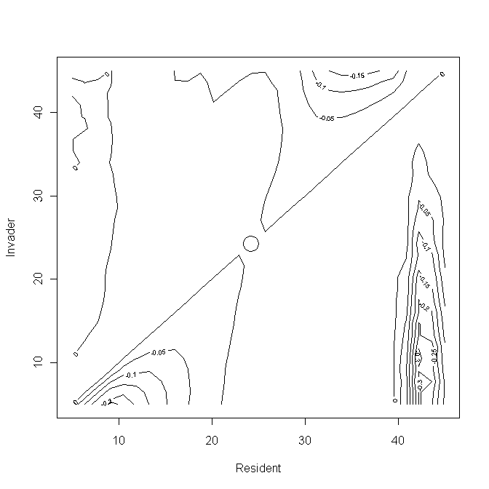

Scenario 6: Elasticity analysis
rm(list=ls()) # Clear memory
DD.FUNCTION<- function(ALPHA,N1,N2) # Density-dependence function
{
# Set parameter values
Amin <- 1; Amax <- 50; Bmin <- 0; Bmax <- 0.9; a <- 20; BETA <- 0.01
AA <- (ALPHA-Amin)/(Amax-Amin) # For convenience
S <- (Bmax-Bmin)*(1-AA)/(1+a*AA) # Survival
N <- N1*(ALPHA*exp(-BETA*N2)+S) # new population
return(N)
} # End of function
################ POP.DYNAMICS FUNCTION ################
POP.DYNAMICS <- function(ALPHA, Coeff)
{
ALPHA.resident <- ALPHA # Resident value
ALPHA.invader <- ALPHA*Coeff # Invader value
Maxgen1 <- 50 # Nos of generations for resident only
Maxgen2 <- 300 # Nos of generations after invasion
Tot.Gen <- Maxgen1+Maxgen2 # Total number of generations
N.resident <- N.invader <- matrix(0,Tot.Gen) # Allocate space
N.resident[1] <- 1 # Initial pop size of resident
N.invader[Maxgen1]<- 1 # Initial pop size of invader
for (Igen in 2:Maxgen1) # Iterate over generations with resident only
{
N <- N.resident[Igen-1]
N.resident[Igen] <- DD.FUNCTION(ALPHA.resident, N, N)
} # End of 1st Igen loop
# Now add invader
J <- Maxgen1+1 # Starting generation
for (Igen in J:Tot.Gen) # Iterate over generations with invader
{
N <- N.resident[Igen-1]+ N.invader[Igen-1] # Total pop size
N.resident[Igen] <- DD.FUNCTION(ALPHA.resident, N.resident[Igen-1], N)
N.invader[Igen] <- DD.FUNCTION(ALPHA.invader, N.invader[Igen-1], N)
} # End of 2nd Igen loop
Generation <- seq(from=1, to=Tot.Gen) # Vector of generation numbers
N0 <- 10+Maxgen1 # Gen at which to start regression analysis
Invasion.model <- lm(log(N.invader[N0:Tot.Gen])~ Generation[N0:Tot.Gen])
Elasticity <- Invasion.model$coeff[2] # Elasticity coefficient
return(Elasticity)
} # End of function
################# MAIN PROGRAM #################
par(mfrow=c(2,2)) # Divide graphics page into quadrats
# Call uniroot to find optimum
minA <-10; maxA <-40 # Limits of search for alpha
Optimum <- uniroot(POP.DYNAMICS, interval=c(minA,maxA),0.995)
Best.A <- Optimum$root # Store optimum Alpha
print(Best.A) # Print out optimum
N.int <- 30 # Nos of intervals for plot
A <- matrix(seq(from=minA, to=maxA, length=N.int), N.int,1)
Elasticity <- apply(A,1,POP.DYNAMICS, 0.995)
plot(A, Elasticity, type='l')
lines(c(minA, maxA), c(0,0)) # Add horizontal line at zero
# Now plot Invasion exponent when resident is optimal
Coeff <- A/Best.A # Convert A to coefficient
Invasion.coeff <- matrix(0,N.int,1) # Allocate space
# Calcualte invasion coefficient
for (i in 1:N.int){ Invasion.coeff[i] <- POP.DYNAMICS(Best.A, Coeff[i]) }
plot(A, Invasion.coeff, type='l') # Plot invasion coeff vs alpha
points(Best.A,0, cex=2) # Add predicted optimum
# Plot N(t+1) on N(t) for best model
N <- 1000 # Nos of data points
N.t <- seq(from=1, to=N) # Values of N(t)
N.tplus1 <- matrix(0,N) # Allocate space
# Iterate to get N(t+1) on N(t)
for ( i in 1:N){N.tplus1[i] <- DD.FUNCTION(Best.A, N.t[i], N.t[i])}
plot(N.t, N.tplus1, type='l') # Plot N(t+1) on N(t)
# Plot N(t) on t
N <- matrix(0,100) # Allocate space
N[1] <- 1 # Initial value of N(t)
for (i in 2:100){N[i]<- DD.FUNCTION(Best.A, N[i-1], N[i-1])}
plot(seq(from=1, to=100), N, type='l', xlab='Generation', ylab='Population')

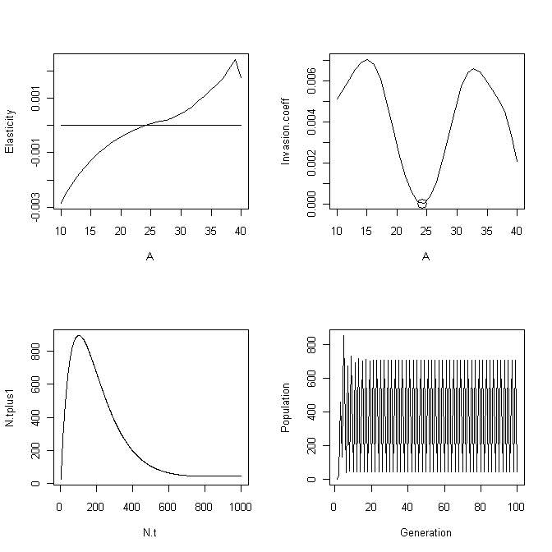

Scenario 6: Population dynamics (Fig. 3.18)
rm(list=ls()) # Clear memory
DD.FUNCTION<- function(ALPHA,N1,N2) # Density-dependence function
{
# Set parameter values
Amin <- 1; Amax <- 50; Bmin <- 0; Bmax <- 0.9; a <- 20; BETA <- 0.01
AA <- (ALPHA-Amin)/(Amax-Amin) # For convenience
S <- (Bmax-Bmin)*(1-AA)/(1+a*AA) # Survival
N <- N1*(ALPHA*exp(-BETA*N2)+S) # new population
return(N)
} # End of function
################ POP.DYNAMICS FUNCTION ################
POP.DYNAMICS <- function(ALPHA, Coeff)
{
ALPHA.resident <- ALPHA # Resident value
ALPHA.invader <- ALPHA*Coeff # Invader value
Maxgen1 <- 50 # Nos of generations for resident only
Maxgen2 <- 300 # Nos of generations after invasion
Tot.Gen <- Maxgen1+Maxgen2 # Total number of generations
N.resident <- N.invader <- matrix(0,Tot.Gen) # Allocate space
N.resident[1] <- 1 # Initial pop size of resident
N.invader[Maxgen1]<- 1 # Initial pop size of invader
for (Igen in 2:Maxgen1) # Iterate over generations with resident only
{
N <- N.resident[Igen-1]
N.resident[Igen] <- DD.FUNCTION(ALPHA.resident, N, N)
} # End of 1st Igen loop
# Now add invader
J <- Maxgen1+1 # Starting generation
for (Igen in J:Tot.Gen) # Iterate over generations with invader
{
N <- N.resident[Igen-1]+ N.invader[Igen-1] # Total pop size
N.resident[Igen] <- DD.FUNCTION(ALPHA.resident, N.resident[Igen-1], N)
N.invader[Igen] <- DD.FUNCTION(ALPHA.invader, N.invader[Igen-1], N)
} # End of 2nd Igen loop
Generation <- seq(from=1, to=Tot.Gen) # Vector of generation numbers
plot (Generation, N.resident, xlab='Generation', ylab='Resident N', type='l')
plot (Generation, N.invader, xlab='Generation', ylab='Invader N', type='l')
} # End of function
############## MAIN PROGRAM ##############
par(mfrow=c(2,2)) # Divide graphics page into quadrats
Best.A <- 24.21635 # Best alpha from elasticity analysis
Invader.A <- 10 # Alpha for invader
Coeff <- Invader.A/Best.A # Calculate relevant coefficient
POP.DYNAMICS( Best.A,Coeff) # Call functiom
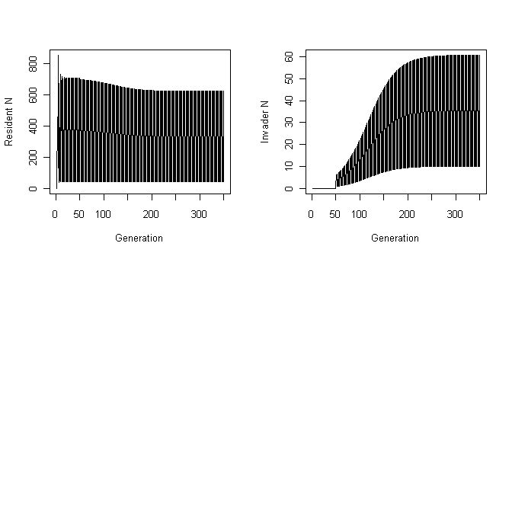

Scenario 6: Multiple invasibility analysis
rm(list=ls()) # Clear memory
DD.FUNCTION<- function(X, N.total) # Density-dependence function
{
# Set parameter values
ALPHA <- X[1]; N <- X[2]
Amin <- 1; Amax <- 50; Bmin <- 0; Bmax <- 0.9; a <- 20; BETA <- 0.01
AA <- (ALPHA-Amin)/(Amax-Amin) # For convenience
S <- (Bmax-Bmin)*(1-AA)/(1+a*AA) # Survival
N <- N*(ALPHA*exp(-BETA*N.total)+S) # new population
N <- max(0,N) # N cannot be negative
return(N)
} # End of function
############## MAIN PROGRAM ##############
set.seed(10) # Initialize the random number seed
Maxgen <- 10000 # Number of generations run
Stats <- matrix(0,Maxgen,3)# Allocate space for statistics
MaxAlpha <- 50 # maximum value of alpha
Ninc <- 50 # Number of classes for alpha
# Allocate space to store data for each generation
Store <- matrix(0,Maxgen, Ninc)
# Allocate space for alpha class and population size
Data <- matrix(0,Ninc,2)
Data[24,2] <- 1 # Initial population size and alpha class
ALPHA <- matrix(seq(from=1, to=MaxAlpha, length=Ninc),Ninc,1) # Set Alpha
Data[,1] <- ALPHA # Place alpha in 1st column
for (Igen in 1:Maxgen) # Iterate over generations
{
N.total <- sum(Data[,2]) # Total population size
Data[,2] <- apply(Data,1,DD.FUNCTION, N.total) # New cohort
Store[Igen,] <- Data[,2] # Store values for this generation
# Keep track of population size, mean trait value and SD of trait value
Stats[Igen,2] <- sum(Data[,1]*Data[,2])/sum(Data[,2]) # Mean
S <- sum(Data[,2]) # Population size
Stats[Igen,1] <- S # Population size
SX1 <- sum(Data[,1]^2*Data[,2])
SX2 <- (sum(Data[,1]*Data[,2]))^2/S
Stats[Igen,3] <- sqrt((SX1-SX2)/(S-1)) # SD of trait
# Introduce a mutant by picking a random integer between 1 and 50
Mutant <- ceiling(runif(1, min=0, max=50))
Data[Mutant,2] <- Data[Mutant,2]+1 # Add mutant to class
} # End of Igen loop
par(mfrow=c(3,2)) # Split graphics page into 3 x 2 panels
for (Row in 9998:Maxgen) # Select rows to be plotted
{
plot(ALPHA, Store[Row,], type='l', xlab='Alpha', ylab='Number')
} # End of frequency polygon plots
Generation <- seq(from=1, to=Maxgen) # Vector of generations
N0 <- 9900 # Starting value for plots
plot(Generation[N0:Maxgen], Stats[N0:Maxgen,1], ylab='Population size',xlab='Generation', type='l')
plot(Generation[N0:Maxgen], Stats[N0:Maxgen,2], ylab='Mean', xlab='Generation', type='l')
plot(Generation[N0:Maxgen], Stats[N0:Maxgen,3], ylab='SD', xlab='Generation', type='l')
print(c('Mean alpha in last gen = ',Stats[Maxgen,2]))
print(c('SD of alpha in last gen = ',Stats[Maxgen,3]))

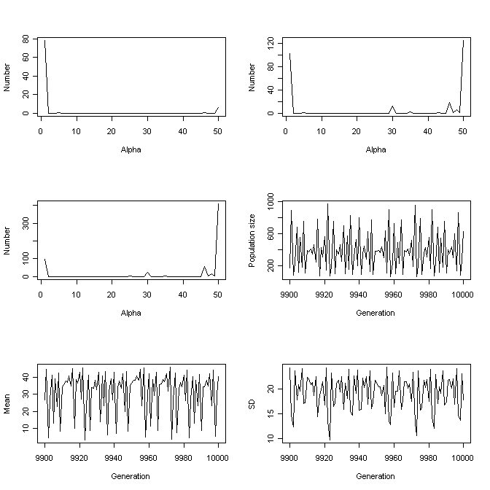
CHAPTER 4: GENETIC MODELS
Figure 4.1
rm(list=ls()) # Remove all objects from memory
RG <- function(P,n,nc){nc*P[2]*(1-P[2])/(n*P[1]*(1-P[1])+nc*P[2]*(1-P[2]))}
TRAIT <- function(P,n,nc){2*(P[1]*n+P[2]*nc)}
ninc <- 20 # Number of increments in which frequency range is divided
P.unique <- seq(0.01, 0.99, length=ninc) # Loci unique to a trait
P.common <- seq(0.01,0.99, length=ninc) # Loci common to both traits
# Create all combinations
Combinations <- expand.grid(P.unique, P.common)
N.unique <- 30 # Nos of unique loci per trait
N.common <- 25 # Nos of common loci per trait
# Calculate Rg for all combinations
Rg <- apply(X=Combinations,MARGIN=1,FUN=RG, N.unique, N.common)
# Create matrix of Rg for contour plotting
# Columns = changing P.common, Rows = changing P.unique
Rg.matrix <- matrix(Rg,ninc,ninc)
par(mfrow=c(2,2)) # Divide graphics page
contour(P.unique, P.common, Rg.matrix, xlab="Freq of unique alleles", ylab ="Freq of common alleles")
# Calculate trait values
Trait <- apply(X=Combinations,MARGIN=1,FUN=TRAIT, N.unique, N.common)
Trait.matrix <- matrix(Trait,ninc,ninc) # Convert to matrix
contour(P.unique, P.common, Trait.matrix, xlab="Freq of unique alleles", ylab ="Freq of common alleles")
h <- cbind(Combinations, Rg, Trait) # Combine combinations and Rg
y <- order(Rg) # Get order for Rg
x <- h[y,] # Create an ordered set
x # Print set

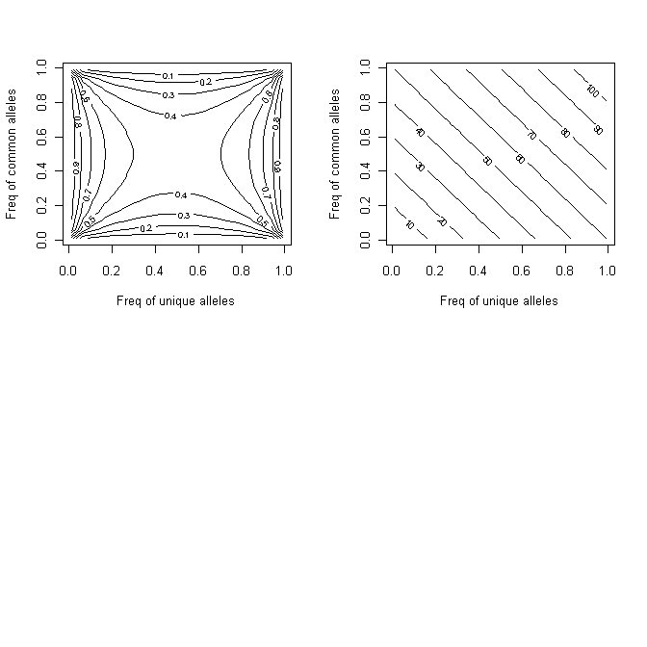

Scenario 1
rm(list=ls()) # Clear workspace
h2 <- c(0.2,0.4) # Set heritabilities
Vp <- c(1,2) # Set phenotypic variances
Rp <- 0.4 # Set phenotypic correlation
Ra <- 0.15 # Set genetic correlation
# Check that Re is possible
Re <- (Rp-Ra*sqrt(h2[1]*h2[2]))/sqrt((1-h2[1])*(1-h2[2]))
if(abs(Re) >1 )
{
print (c("problem with Re", Re))
stop
}
Va <- h2*Vp # Using h2 =Va/Vp
Covp <- Rp*sqrt(Vp[1]*Vp[2]) # Using r = Cov/SD1SD2
Cova <- Ra*sqrt(Va[1]*Va[2]) # Using r = Cov/SD1SD2
Gmatrix <- matrix( c(Va[1],Cova,Cova,Va[2]),2,2) # G matrix
Pmatrix <- matrix(c(Vp[1],Covp,Covp,Vp[2]),2,2) # P matrix
Theta <- c(2,2) # Optimum trait values
Maxgen <- 100 # Number of generations
par(mfrow=c(2,2)) # Divide graphic page
Wmatrix <- matrix(c(2,0,0,3), 2,2) # Set the W matrix
Trait <- matrix(0,Maxgen,2) # Pre-assign space for trait values
Trait[1,] <- 10 # Initial trait values
for (Igen in 2:Maxgen) # Iterate over generations
{
# Delta z
Delta.Z <- Gmatrix%*%solve(Wmatrix+Pmatrix)%*%(Trait[Igen-1,]-Theta)
Trait[Igen,] <- Trait[Igen-1,]- Delta.Z # New trait value
} # End of Igen loop
# Set axis values for graphing
min.y <- min.x <- min(Trait); max.y <- max.x <- max(Trait)
# Plot by generation
Generation <- seq(from=1, to=Maxgen)
plot(Generation, Trait[,1], ylim <- c(min.y, max.y), xlim=c(0,Maxgen), ylab='Trait', type='l')
lines(seq(from=1,to=Maxgen),Trait[,2],lty=2)
# Plot Trait 2 on Trait 1
plot(Trait[,1], Trait[,2])
lines(Trait[,1],Trait[,2])
print( c(Rp,Ra,Re))
eigen(Wmatrix)$values
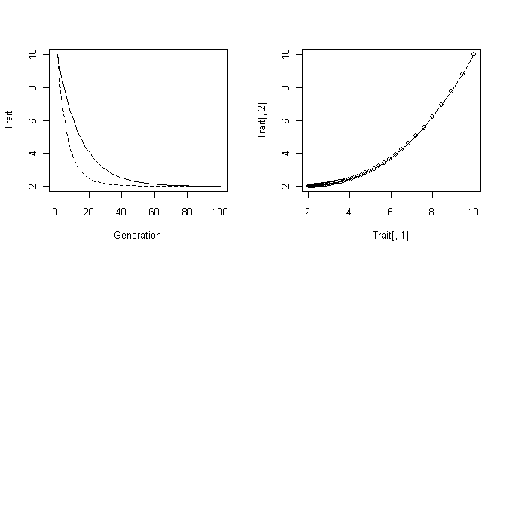

Scenario 2
rm(list=ls()) # Remove all objects from memory
SELECTION <- function(X) # Function to calculate new mean value
{
As <- 1; Bs <- 0.5; Af <- 0; Bf <- 4 # Parameter values
Survival <- As-Bs*X[,1] # Survival
Survival[Survival<0] <- 0 # Check on sign
Fecundity <- Af+Bf*X[,1] # Fecundity
Fecundity[Fecundity<0] <- 0 # Check on sign
X.Fitness <- Survival*Fecundity # Fitness
mu <- sum(X.Fitness*X[,2])/sum(X.Fitness)
return(mu)
} # End of selection function
################# Main program #################
set.seed(100) # Initialize random number generator
N <- 100 # Set population size
MaxGen <- 2000 # Number of generations
Output <- matrix(0,MaxGen,2) # Create file for output
h2 <- 0.5 # Set heritability
Vp <- (.1)^2 # Set Phenotypic variance
Va <- Vp*h2 # Calculate Additive genetic variance
Ve <- Vp-Va # Calculate Environmental variance
mu <- 1.5 # Initial trait mean genetic value
SDa <- sqrt(Va) # SD of Va
SDe <- sqrt(Ve) # SD of Ve
for (Igen in 1:MaxGen) # Iterate over generations
{
# Generate Genetic and environmental values using normal distribution
GX <- rnorm(N, mean=mu, sd=SDa) # Genetic values
EX <- rnorm(N, mean=0, sd=SDe) # Environmental values
PX <- GX + EX # Phenotypic values
# Combine phenotypic and genetic values
X <- cbind(PX,GX)
Output[Igen,1] <- Igen # Store generation
Output[Igen,2] <- mean(PX) # Store mean phenotype
# Calculate new mean genetic value by applying fitness criterion
mu <- SELECTION(X) # apply SELECTION
} # End of Igen loop
# Plot trajectory over generations
plot(Output[1:MaxGen,1], Output[1:MaxGen,2], type='l', xlab='Generation', ylab='Trait value')
mean(Output[500:MaxGen,2]) # Mean phenotype
sd(Output[500:MaxGen,2]) # SD of mean
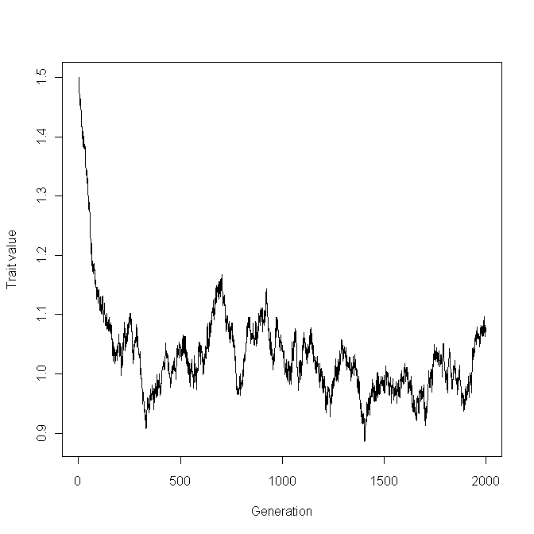
Scenario 3
rm(list=ls()) # Remove all objects from memory
SELECTION <- function(Male, Female) # Function to calculate new mean value
{
# Mean genetic value of males, mu.M, and females, mu.F
# Col1 = Phenotypic value, col 2 = Genetic value, col 3 = Morph code
mu.M <- sum(Male[,3]*Male[,2])/sum(Male[,3])
mu.F <- sum(Female[,3]*Female[,2])/sum(Female[,3])
mu <- (mu.M + mu.F)/2 # New population mean
return(mu)
}
######################## Main program ########################
set.seed(100) # Initialize random number generator
N <- 100 # Set population size
Prop.LW <- 0.85 # Set initial proportion LW
Z.LW <- -qnorm(Prop.LW) # Threshold. Values greater are LW
MaxGen <- 10 # Number of generations
Output <- matrix(0,MaxGen,4) # Create file for output
h2 <- 0.5 # Set heritability of liability
Vp <- 1 # Set Phenotypic variance
Va <- Vp*h2 # Calculate Additive genetic variance
Ve <- Vp-Va # Calculate Environmental variance
mu <- 0 # Initial mean genetic liability
SDa <- sqrt(Va) # SD of Va
SDe <- sqrt(Ve) # SD of Ve
for (Igen in 1:MaxGen) # Iterate over generations
{
# Generate Genetic and environmental values using normal distribution
GM <- rnorm(N, mean=mu, sd=SDa) # Genetic values of males
GF <- rnorm(N, mean=mu, sd=SDa) # Genetic values of females
EM <- rnorm(N, mean=0, sd=SDe) # Environmental values of males
EF <- rnorm(N, mean=0, sd=SDe) # Environmental value of females
PM <- GM + EM # Phenotypic value of males
PF <- GF + EF # Phenotypic value of females
# Calculate wing morphs by comparing liability to threshold
Male.Morph <- matrix(1,N) # Set all initially to SW (=1)
Male.Morph[PM > Z.LW] <- 0 # Set LW to 0
Female.Morph <- matrix(1,N) # Set all initially to SW (=1)
Female.Morph[PF > Z.LW] <- 0 # Set LW to 0
# Combine phenotypic and genetic values
Male <- cbind(PM, GM, Male.Morph )
Female <- cbind(PF, GF, Female.Morph)
# Store data
Output[Igen,1] <- Igen # Generation
Output[Igen,2] <- mean(PM+PF)/2 # Mean liability
Output[Igen,3] <- sum(Male.Morph)/N # Proportion of SW males
Output[Igen,4] <- sum(Female.Morph)/N # Proportion of SW females
# Calculate new mean genetic value by applying fitness criterion
mu <- SELECTION(Male,Female)
} # End of Igen loop
par(mfrow=c(2,2)) # Divide graphics page into quadrats
# Plot proportion of SW males, and SW females over generation on same graph
plot(Output[,1], Output[,3],pch="M", xlab='Generation',ylab='Proportion Short Wings')
lines(Output[,1], Output[,3]) # Males
points(Output[,1],Output[,4], pch="F") # Females
lines(Output[,1], Output[,4]) # Females
plot(Output[,1], Output[,2], xlab='Generation',ylab='Mean liability')
lines(Output[,1], Output[,2])
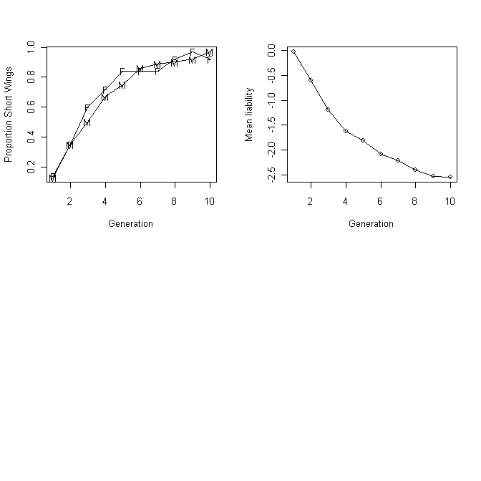

Scenario 4
rm(list=ls()) # Clear memory
SELECTION <- function(Morph, Genotype)
{
Selected <- Genotype[Morph==1,] # 1=SW, 0=LW
return(Selected)
} # End function
################## Function Mutation ##################
MUTATION <- function(X, N.mutations, Total.loci, N.ind)
{
# Apply mutation by randomly selecting N.mutations
Row <- ceiling(runif(N.mutations, min=0, max=Total.loci))
Temp <- matrix(X)
Temp[Row] <- (abs(Temp[Row]-1))
X <- matrix(Temp,N.ind,N.loci)
return(X)
} # End function
################## Function Gamete ##################
GAMETE <- function(X, G.loci, N.loci) # Pick loci for gamete
{
Y <- sample(x=X, size=G.loci, replace=FALSE) # Random G.loci from N.loci
return(Y)
}
##################### Main Program ######################
set.seed(100) # Initialize random number generator
P <- 0.0001 # Probability of mutation at a locus
N.Pop <- 1000 # Population size at each generation
G.loci <- 100 # Loci per gamete
N.loci <- G.loci*2 # Loci per individual
Total.loci <- N.Pop*N.loci # Total number of loci in population
H2 <- 0.5 # Heritability
Vg <- 0.5*G.loci # Additive genetic variance
Ve <- (1-H2)*Vg/H2 # Environmental variance
SD.E <- sqrt(Ve) # Environmental SD
Prop.LW <- 0.85 # Set initial proportion LW
# Set Threshold value. Values greater than Z.LW are LW
Z.LW <- qnorm(1-Prop.LW, mean=G.loci, sd=sqrt(Vg+Ve))
# Generate matrix of individuals in which
# rows hold individuals while columns hold loci. Allelic values are 1 and 0
# Randomly generate Total.loci number of loci with values of 0 & 1
Dl <- round(runif(Total.loci))
# Genetic composition of individuals
Genotype <- matrix(Dl, N.Pop, N.loci)
Maxgen <- 30 # Number of generations simulation runs
Output <- matrix(0,Maxgen,5) # Allocate space for output
Output[,1] <- seq(from=1, to=Maxgen) # First col=generation
for (Igen in 1:Maxgen) # Iterate over generations
{
Env.X <- rnorm(N.Pop, mean=0, sd=SD.E) # Environmental deviations
# Phenotypic values of liability
Phenotype <- rowSums(Genotype) + Env.X
Vg <- var(rowSums(Genotype)) # Calculate the genetic variance
Vp <- var(Phenotype) # Phenotypic variance
H2 <- Vg/Vp # heritability
Morph <- matrix(1,N.Pop) # Set morphs initially to SW
Morph[Phenotype > Z.LW] <- 0 # Change relevant individuals to LW
Prop.SW <- sum(Morph)/N.Pop # Proportion SW
Output[Igen,2] <- Prop.SW # Store proportion SW
Output[Igen,3] <- H2 # Store heritability
#################### Apply Selection ####################
if (Igen < 10) # No selection until after generation 10
{
Parents <- Genotype # No selection
}else
{
Parents <- SELECTION(Morph, Genotype) # Apply selection
}
N.Parents <- nrow(Parents) # Number of parents
# Form next Generation
# Apply Mutation
# Mean number of mutations in population
lambda <- P*N.Parents*N.loci
# Number of mutations using a Poisson distribution
N.mutations <- rpois(1,lambda)
Output[Igen,4] <- N.mutations # Store number of mutations this generation
# Apply function MUTATION to generate mutant loci
Genotype <- MUTATION(Genotype, N.mutations, Total.loci, N.Pop)
# Mating
# Produce gametes for female offspring
# Select from each row G.loci at random
# We do not distinguish individual loci
# Note that this creates a matrix of G.loci rows and N.Females columns
# The matrix is transposed to produce the required matrix
Gametes <- apply(Parents, 1, GAMETE, G.loci, N.loci)
Gametes <- t(Gametes) # Convert to proper matrix
# Produce N.Pop offspring by selecting at random with replacement
Output [Igen,5]<- N.Parents
# Get N.Pop gametes from "females"
n <- seq(1, N.Parents)
G.Index <- sample(x=n, size= N.Pop, replace=TRUE)
F.Gametes <- Gametes[G.Index,]
# Get N.Pop gametes from "males"
G.Index <- sample(x=n, size= N.Pop, replace=TRUE)
M.Gametes <- Gametes[G.Index,]
# New Genotypes
Genotype <- cbind(F.Gametes, M.Gametes) # Combine gametes
}
par(mfrow=c(2,2)) # Divide graph page into four quadrats
plot(Output[,1], Output[,2], xlab='Generation', ylab='Proportion SW', type='l')
plot(Output[,1], Output[,3], xlab='Generation', ylab='Heritability',type='l')
plot(Output[,1], Output[,4], xlab='Generation', ylab='Nos of mutations',type='l')
plot(Output[,1], Output[,5], xlab='Generation', ylab='Nos of Parents',type='l')
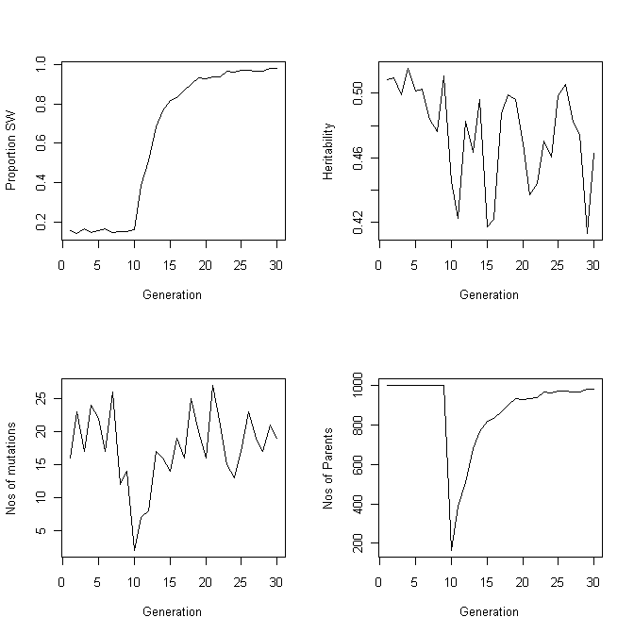
Scenario 5
rm(list=ls()) # Remove all objects from memory
SELECTION <- function(X,N) # Function to calculate new mean value
{
BETA <- X[,1]*0.001 # Beta
X.Fitness <- X[,1]*exp(-BETA*N) # Fitness
mu <- sum(X.Fitness*X[,2])/sum(X.Fitness) # New mu
N <- round(sum(X.Fitness)) # Popn size
return(c(mu, N)) # Return values
} # End of selection function
##################### Main program #####################
set.seed(100) # Initialize random number generator
N <- 100 # Set population size
MaxGen <- 10000 # Number of generations
Output <- matrix(0,MaxGen,3) # Create file for output
h2 <- 0.5 # Set heritability
Vp <- .1 # Set Phenotypic variance
Va <- Vp*h2 # Calculate Additive genetic variance
Ve <- Vp-Va # Calculate Environmental variance
mu <- 10 # Trait mean genetic value
SDa <- sqrt(Va) # SD of Va
SDe <- sqrt(Ve) # SD of Ve
for (Igen in 1:MaxGen) # Iterate over generations
{
# Generate Genetic and environmental values using normal distribution
GX <- rnorm(N, mean=mu, sd=SDa) # Genetic values
EX <- rnorm(N, mean=0, sd=SDe) # Environmental values
PX <- GX + EX # Phenotypic values
# Combine phenotypic and genetic values
X <- cbind(PX,GX)
Output[Igen,1] <- Igen # Store generation
Output[Igen,2] <- mean(PX) # Store mean phenotype
Output[Igen,3] <- N # Store popn size
# Calculate new mean genetic value by applying fitness criterion
B <- SELECTION(X,N)
mu <- B[1] # New mu
N <- B[2] # New population size
} # End of Igen loop
par(mfrow=c(2,2)) # Divide graphics page into quadrats
plot(Output[10:MaxGen,1], Output[10:MaxGen,2], type='l', xlab='Generation', ylab='Trait value')
plot(Output[10:MaxGen,1], Output[10:MaxGen,3],type='l', xlab='Generation',ylab='Population Size, N')
# Print out mean trait value and mean population size
c(mean(Output[2000:MaxGen,2]), mean(Output[1000:MaxGen,3]))
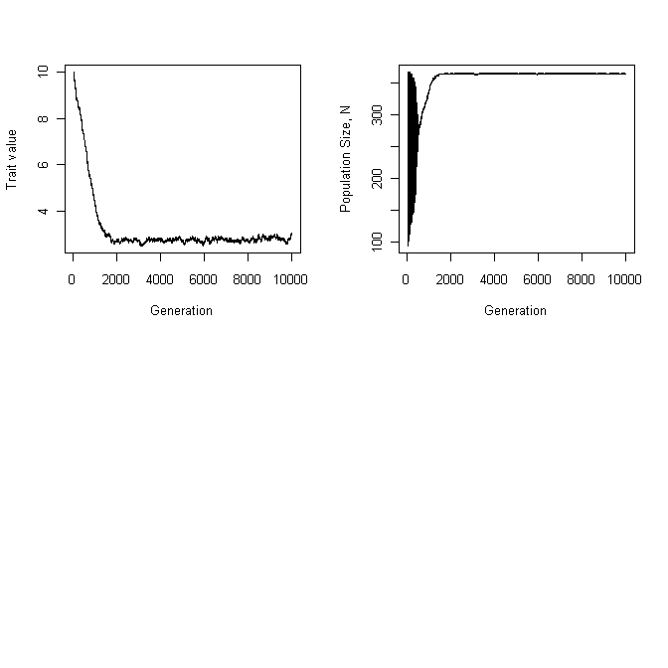
Scenario 6
rm(list=ls()) # Clear workspace
library(MASS) # Load library MASS
SELECTION <- function(Trait.P, Trait.A)
{
# Determine fitness from trait X (=trait 1)
# Traits with negative value have zero fitness, e.g. zero fecundity
Fec <- Trait.P[,1] # Preliminary fecundities
Fec[Trait.P[,1]<0] <- 0 # Adjust fecundity of individuals
Total.Fec <- sum(Fec) # Total fecundity of popn
NewX1 <- sum(Fec*Trait.A[,1])/Total.Fec # New mean X
NewX2 <- sum(Fec*Trait.A[,2])/Total.Fec # New mean Y
Mean.A <- c(NewX1, NewX2) # Combine
return(Mean.A)
} # End of function
####################### MAIN PROGRAM #######################
set.seed(100) # Initialize random number generator
Npop <- 1000 # Population size
MaxGen <- 10 # Nos of generations for simulation
Output <- matrix(0,MaxGen,3) # Allocate storage for trait
####################### Create initial matrices #######################
# In this version the sexes are ignored
# This assumes that selection acts equally
# Give.Hmatrix is a dataframe with genetic correlations in upper diagonal
# heritabilities along the diagonal and phenotypic correlations in the lower diagonal
NX <- 2 # Number of traits
# Matrix of heritabilities and correlations
H2 <- matrix(c(0.4,-0.8,
-0.7, 0.5), 2,2, byrow=TRUE)
Mean.A <- c(3, 3) # Initial additive genetic means
Mean.E <- c(0,0) # Environmental means
Var.P <- c(1, 0.5) # Phenotypic variances
# Phenotypic Covariance matrix
# Note that initial covariances set to 1 (arbitrary)
CovP <- matrix(1,NX,NX) # Phenotypic variances
diag(CovP)<- Var.P # Diagonal elements = variances
# Establish CovA from h2 and CovP and CovE from CovA and CovP
CovA <- matrix(0,NX,NX) # Allocate memory for genetic matrix
CovE <- matrix(0,NX,NX) # Allocate memory for envir. matrix
for ( i in 1:NX) # Iterate over components of (co)variance matrix
{
CovA[i,i] <- CovP[i,i]*H2[i,i] # Genetic variance = Vp*h2
CovE[i,i] <- CovP[i,i]-CovA[i,i] # Environmental covariances
if(CovE[i,i] < 0) stop (print(c("CovE cannot be",i,j,CovE[i,i])))
}
# Phenotypic and genetic covariances
N.minus.1 <- NX-1
for( i in 1:N.minus.1)
{
jj <- i+1
for(j in jj:NX)
{
CovP[i,j] <- H2[j,i]*sqrt(CovP[i,i]*CovP[j,j]) # Phenotypic covariance
CovP[j,i] <- CovP[i,j] # Matrix symmetrical
CovA[i,j] <- H2[i,j]*sqrt(CovA[i,i]*CovA[j,j]) # Genetic covariance
CovA[j,i] <- CovA[i,j] # Matrix symmetrical
CovE[i,j] <- CovP[i,j]-CovA[i,j] # Environ. covariance
CovE[j,i] <- CovE[i,j]
} # End of j loop
} # End of i loop
############################### Start Simulation ############################
for (Igen in 1:MaxGen) # Iterate to MaxGen
{
# Generate additive and environmental values
Trait.E <- mvrnorm(Npop, mu=Mean.E, Sigma=CovE) # Environ.
Trait.A <- mvrnorm(Npop, mu=Mean.A, Sigma=CovA) # Genetic
Trait.P <- Trait.A + Trait.E # Phenotypic
# Store data
Output[Igen,1] <- Igen
Output[Igen,2] <- mean(Trait.P[,1]) # X
Output[Igen,3] <- mean(Trait.P[,2]) # Y
Mean.A <- SELECTION(Trait.P, Trait.A) # New X and Y
} # End of Igen loop
# Plot results
ymin <- min(Output[,2:3]); ymax <- max(Output[,2:3]) # Trait X
plot(Output[,1], Output[,2], xlab="Generations", ylab="Trait X (solid) and Y (dotted)", type='l', ylim = c(ymin, ymax)) # Trait X on generation
lines(Output[,1], Output[,3], lty=2) # Trait Y on generation

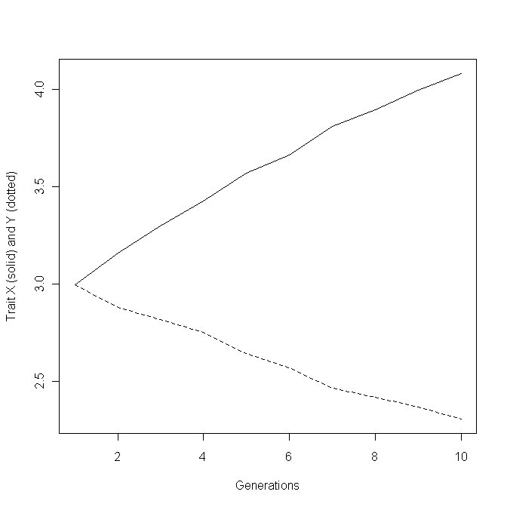
Scenario 7 Error corrected in ASSIGN.LOCI
rm(list=ls()) # Remove all objects from memory
ASSIGN.LOCI <- function(G.loci, N.Pop, P)
{
Total.loci <- N.Pop*2*G.loci # Total number of loci in population
Alleles <- runif(Total.loci) # Generate random number 0-1
Alleles[Alleles < P] <- 0 # Allocate to 0s
Alleles[Alleles > P] <- 1 # Allocate to 1s
Temp <- Alleles # Assign values to temporary vector
Alleles[Temp<P] <- 1 # Assign 1
Alleles[Temp>P] <- 0 # Assign 0
return(Alleles)
} # End of function
####################### SELECTION #######################
SELECTION <- function(Phenotype, Genotype, T0) # Selection function
{
Selected <- Genotype[Phenotype >T0 ,] # Selection
return(Selected) # Return selected genotypes
} # End function
####################### GAMETE #######################
GAMETE <- function(X, G.loci) # Pick loci for gamete pool
{
Y <- sample(x=X, size=G.loci, replace=FALSE) # Randomly select G.loci
return(Y)
}
################## Function Mutation ##################
MUTATION <- function(X, Pmut, G.loci, N.inds)
{
T.loci <- N.inds*2*G.loci
lambda <- Pmut*T.loci # Mean number of mutations in population
# Number of mutations using a Poisson distribution
N.mutations <- rpois(1,lambda)
# Randomly select N.mutations rows
Row <- ceiling(runif(N.mutations, min=0, max=T.loci))
Temp <- matrix(X) # Convert to a vector
Temp[Row] <- (abs(Temp[Row]-1)) # Convert mutated rows
X <- matrix(Temp, N.inds, 2*G.loci) # Convert back to matrix
return(X)
} # End function
####################### Main Program #######################
set.seed(10) # Initialize random number generator
N.Pop <- 1000 # Population size at each generation
X.loci <- Y.loci<- 30 # Loci per gamete unique to X
C.loci <- 25 # Loci per gamete common to X and Y
h2.X <- 0.4 # heritability of X
h2.Y <- 0.5 # Heritability of Y
S <- -1 # Sign of genetic correlation
Rp <- -0.7 # Phenotypic correlation
Pxy <- 0.68 # Proportion at x or y loci
Pc <- 0.47 # Proportion of c loci
TraitX <- 2*(Pxy*X.loci+Pc*C.loci) # Initial mean trait value of X
TraitY <- 2*(Pxy*X.loci+S*Pc*C.loci) # Initial mean trait value of Y
VarGX <- 2*(X.loci*Pxy*(1-Pxy)+ C.loci*Pc*(1-Pc)) # Vg of X
VarGY <- VarGX # Vg of Y
CovGXY <- 2*C.loci*Pc*(1-Pc) # Genetic covariance
Rg <- S*CovGXY/sqrt(VarGX*VarGY) # Genetic correlation
print(c(Rg, TraitX, TraitY)) # Print values
# Calculate the environmental correlation
Re <- (Rp - Rg*sqrt(h2.X*h2.Y))/sqrt((1-h2.X)*(1-h2.Y))
# Check that this Re is possible
if (abs(Re)>1) stop (c("Re not possible"))
# Environmental Variances and Standard deviations
Ve.X <- (1-h2.X)*VarGX/h2.X # Environmental variance for X
SDe.X <- sqrt(Ve.X) # Environmental SD for X
Ve.Y <- (1-h2.Y)*VarGY/h2.Y # Environmental variance for Y
SDe.Y <- sqrt(Ve.Y) # Environmental SD for Y
CovE <- Re*SDe.X*SDe.Y # Environmental covariance
Ematrix <- matrix(c(Ve.X,CovE,CovE,Ve.Y),2,2) # Covariance matrix
# Nos of loci in each category
Nx.Alleles <- ASSIGN.LOCI(X.loci, N.Pop, Pxy) # Alleles unique to X
Ny.Alleles <- ASSIGN.LOCI(Y.loci, N.Pop, Pxy) # Alleles unique to Y
Nc.Alleles <- ASSIGN.LOCI(C.loci, N.Pop, Pc) # Alleles common to X & Y
# Now make three matrices for loci in individuals
G.Xmatrix <- matrix(Nx.Alleles, N.Pop, 2*X.loci) # X composition
G.Ymatrix <- matrix(Ny.Alleles, N.Pop, 2*Y.loci) # Y composition
G.Cmatrix <- matrix(Nc.Alleles, N.Pop, 2*C.loci) # C composition
####################### Iterate over generations #######################
Maxgen <- 40 # Number of generations simulation runs
Output <- matrix(0, Maxgen,9) # Allocate space for output
T0 <- matrix(TraitX,Maxgen,1) # Set T0 for generations
T0[1:5] <- -100 # Set t0 so that 1st 5 gens there is no selection
for (Igen in 1:Maxgen) # Iterate over generations
{
# Get actual genotypic values
G.X <- rowSums(G.Xmatrix) + rowSums(G.Cmatrix) # X Genotypic values
VarGX <- var(G.X) # Vg for X
G.Y <- rowSums(G.Ymatrix) + S*rowSums(G.Cmatrix) # Y Genotypic values
VarGY <- var(G.Y) # Vg for Y
# Create phenotypic values
Env <- mvrnorm(n=N.Pop, mu=c(0,0), Sigma=Ematrix) # Environmental values
P.X <- G.X + Env[,1] # Vector of X phenotypes
P.Y <- G.Y + Env[,2] # Vector of Y phenotypes
VarPX <- var(P.X) # Phenotypic variance of X
VarPY <- var(P.Y) # Phenotypic variance of Y
h2.X <- VarGX /VarPX # Heritability of X
h2.Y <- VarGY/VarPY # Heritability of Y
Rg <- cor(G.X, G.Y) # Genetic correlation
Rp <- cor(P.X, P.Y) # Phenotypic correlation
# Store results
Output[Igen,1:9] <- c(Igen, VarGX, VarGY, mean(P.X), mean(P.Y), h2.X, h2.Y, Rg, Rp)
# Apply Selection. Note that selection here is only a function of X
ParentX <- SELECTION(P.X, G.Xmatrix, T0[Igen])
ParentY <- SELECTION(P.X, G.Ymatrix, T0[Igen])
ParentC <- SELECTION(P.X, G.Cmatrix, T0[Igen])
# Form Gamete pool
GameteX <- apply(ParentX, 1, GAMETE, X.loci)
GameteX <- t(GameteX) # Convert to proper matrix
GameteY <- apply(ParentY, 1, GAMETE, Y.loci)
GameteY <- t(GameteY) # Convert to proper matrix
GameteC <- apply(ParentC, 1, GAMETE, C.loci)
GameteC <- t(GameteC) # Convert to proper matrix
N.Parents <- nrow(ParentX) # Number of available parents
n <- seq(1, N.Parents) # sequence 1 to N.Parents
# Get 2*N.Pop random indices with replacement
G.Index <- sample(x=n, size=2*N.Pop, replace=TRUE)
# Get gametes from gamete pool
S.GameteX <- GameteX[G.Index,]
S.GameteY <- GameteY[G.Index,]
S.GameteC <- GameteC[G.Index,]
# Form next generation
n1 <- N.Pop+1
n2 <- 2*N.Pop
G.Xmatrix <- cbind(S.GameteX[1:N.Pop,], S.GameteX[n1:n2,])
G.Ymatrix <- cbind(S.GameteY[1:N.Pop,], S.GameteY[n1:n2,])
G.Cmatrix <- cbind(S.GameteC[1:N.Pop,], S.GameteC[n1:n2,])
# Mutations
Pmut <- 0.0001 # Mutation probability
G.Xmatrix <- MUTATION(G.Xmatrix, Pmut, X.loci, N.Pop)
G.Ymatrix <- MUTATION(G.Ymatrix, Pmut, Y.loci, N.Pop)
G.Cmatrix <- MUTATION(G.Cmatrix, Pmut, C.loci, N.Pop)
} # Next generation
par(mfrow=c(2,2))
# Plot phenotypic value on generation
ymin <- min(Output[,4:5]); ymax <- max(Output[,4:5]) # Limits on y
plot( Output[,1], Output[,4], xlab='Generation', ylab='Phenotypes', type='l', ylim=c(ymin,ymax))
lines(Output[,1], Output[,5], lty=2)
# Plot genetic variances on generation
ymin <- min(Output[,2:3]); ymax <- max(Output[,2:3]) # Limits on y
plot( Output[,1], Output[,2], xlab='Generation', ylab='Genetic variances', type='l', ylim=c(ymin,ymax))
lines(Output[,1], Output[,3], lty=2)
# Plot heritabilities on generation
ymin <- min(Output[,6:7]); ymax <- max(Output[,6:7]) # Limits on y
plot( Output[,1], Output[,6], xlab='Generation', ylab='Heritabilities', type='l', ylim=c(ymin,ymax))
lines(Output[,1], Output[,7], lty=2)
# Plot correlations on generation
ymin <- min(Output[,8:9]); ymax <- max(Output[,8:9]) # Limits on y
plot( Output[,1], Output[,8], xlab='Generation', ylab='Correlations', type='l', ylim=c(ymin,ymax))
lines(Output[,1], Output[,9], lty=2)
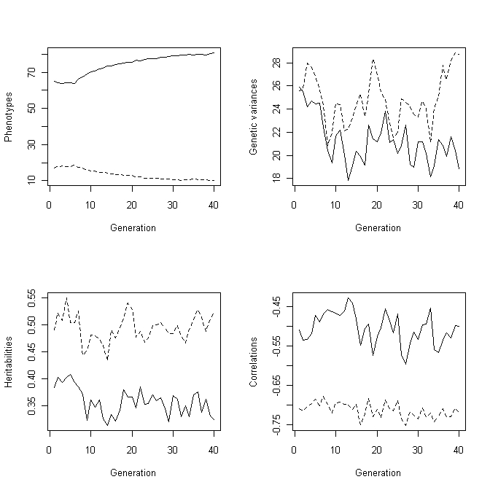

CHAPTER 5: GAME-THEORETIC MODELS
Scenario 1: Plotting the fitness curves
rm(list=ls())
PAYOFF <- function(X) # Function to calculate the payoff
{
# Set constants. Note that these could be passed to the function
alpha <- 3; Pl <- 0.25; Ph <- 1
# Note that X[2] is the first height to ensure that payoff matrix
# corresponds to the shape shown in Table 5.1
f <- (1-X[2]^alpha) # Calculate f
g <- Pl + (Ph-Pl)/(1+exp(-5*(X[2]-X[1]))) # Calculate g
Pay <- f*g # Calculate payoff
return(Pay) # Return payoff
}
################ Main Program ##############
n <- 200 # Number of divisions
Height <- seq(0,1, length=n) # Vector of heights for each tree
d <- expand.grid(Height, Height) # Create matrix of all combinations
Paytemp <- apply(d,1,PAYOFF) # Get payoff matrix for tree
Payoff <- matrix(Paytemp, n, n, byrow=T) # Convert to a matrix
BestResponse <- matrix(0,n,1) # Create a vector to take best response
for (i in 1:n) # Iterate over each value of Height
{
# Get order of indexes (Highest first) for Payoffs to Tree B for a
# given Height of tree A. Get order by column
Index <- order(Payoff[,i], na.last=TRUE, decreasing=TRUE)
# Store best Payoff for Tree B against tree A
BestResponse[i] <- Height[Index[1]]
}
# Plot the best response of tree B against tree A as a solid line
plot(Height, BestResponse, type='l', xlab='Height of tree A', ylab='Height of tree B', xlim=c(0,1), ylim=c(0,1))
# Plot the best response of tree A against tree B as a dashed line
# Note that because of symmetry this is done by reversing the axes
lines(BestResponse, Height, lty=2)
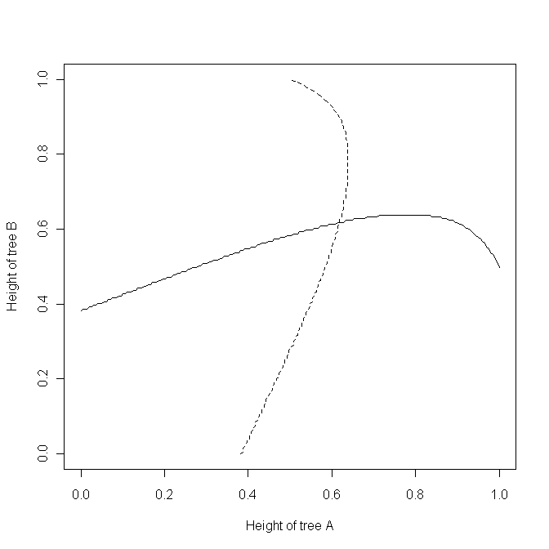
Scenario1: Finding the ESS using the calculus - using the derivative directly
rm(list=ls()) # Clear workspace
# Function to calculate payoff Note that we pass the absolute value
# of the payoff because nlm seeks the minimum
PAYOFF <- function(x) {abs(-1.875*x^2+(1-x^3)*0.9375 )}
nlm(PAYOFF, p=.5) # Call nlm to find minimum with starting guess at 0.5

Scenario1: Finding the ESS using the calculus - Getting the derivative using R
rm(list=ls()) # Clear workspace
# Function to obtain the gradient at a value w
FUNC <- function(w)
{
# Get the derivative with respect to hA and assign to y
y <- deriv(~(1-hA^3)*(0.25+(1-0.25)/(1+exp(-5*(hA-hB)))),"hA")
hA <- w # Set hA to w
hB <- w # Set hB to w
Z <- eval(y) # Evaluate the derivative at w
grad <- attr(Z, "gradient") # Assign gradient value to grad
return(grad)
}
############ MAIN PROGRAM ##############
# Call uniroot setting limits from 0 to 1
uniroot(FUNC, interval=c(0, 1))

Scenario 1: Finding the ESS using a numerical approach
rm(list=ls())
PAYOFF <- function(X) # Function to calculate the payoff
{
# Set constants. Note that these could be passed to the function
alpha <- 3; Pl <- 0.25; Ph <- 1
# Note that X[2] is the first height to ensure that payoff matrix
# corresponds to the shape shown in Table 5.1
f <- (1-X[2]^alpha) # Calculate f
g <- Pl + (Ph-Pl)/(1+exp(-5*(X[2]-X[1]))) # Calculate g
Pay <- f*g # Calculate payoff
return(Pay) # Return payoff
}
################ Main Program ##############
n <- 200 # Number of divisions
Height <- seq(0,1, length=n) # Vector of heights for each tree
d <- expand.grid(Height, Height) # Create matrix of all combinations
Paytemp <- apply(d,1,PAYOFF) # Get payoff matrix for tree
Payoff <- matrix(Paytemp, n, n, byrow=T) # Convert to a matrix
BestResponse <- matrix(0,n,1) # Create a vector to take best response
for (i in 1:n) # Iterate over each value of Height
{
# Get order of indexes (Highest first) for Payoffs to Tree B for a
# given Height of tree A. Get order by column
Index <- order(Payoff[,i], na.last=TRUE, decreasing=TRUE)
# Store best Payoff for Tree B against tree A
BestResponse[i] <- Height[Index[1]]
}
# Plot the best response of tree B against tree A as a solid line
#plot(Height, BestResponse, type='l', xlab='Height of tree A', ylab='Height of tree B', xlim=c(0,1), ylim=c(0,1))
# Plot the best response of tree A against tree B as a dashed line
# Note that because of symmetry this is done by reversing the axes
#lines(BestResponse, Height, lty=2)
DIFF <- abs(Height-BestResponse)# Make vector of absolute differences
Index <- order(DIFF) # Find index value for smallest DIFF
Best.Height <- Height[Index[1]] # Find Height at Index[1]
Best.Height

Scenario 2:
rm(list=ls()) # Remove all objects from memory
# Function to calculate new proportion of Hawks
FITNESS <- function(Morph, Npop, PayoffMatrix)
{
# Match males up to find fitness for each male
# Create a randomized vector of opponents
Opponent <- sample(Morph)
Fitness <- matrix(0,Npop,1) # Preassign space for Fitness vector
# Iterate over the Payoff matrix
for (Receiver in 1:2 ) # Individual receiving payoff
{
for (I.Opponent in 1:2) # Opponent
{
Fitness[Morph==Receiver & Opponent==
I.Opponent]<- 3 + PayoffMatrix[Receiver,I.Opponent]
} # End of I.opponent loop
} # End of Receiver loop
# Now calculate the relative fitness of hawks = New proportion of Hawks
P.Hawk <- sum(Fitness[Morph==1])/sum(Fitness) # Mean fitness of Hawk males
return(P.Hawk)
}
############################ Main program ############################
set.seed(100) # Initialize random number generator
Npop <- 100 # Set population size
MaxGen <- 100 # Number of generations
Output <- matrix(0,MaxGen,2) # Create file for output
P.Hawk <- 0.5 # Initial proportion of Hawks
Nos.of.Hawks <- Npop*P.Hawk # Initial number of Hawks
# Set up morph vector initially with all doves
Morph <- matrix(2,Npop,1)
# Convert first Nos.of.Hawks rows to Hawks
Morph[1:Nos.of.Hawks] <- 1
PayoffMatrix <- matrix(c(-1,0,8,4),2,2) # Set up fitness matrix
# Calculate theoretical frequency
a <- PayoffMatrix[1,1]
b <- PayoffMatrix[1,2]
c <- PayoffMatrix[2,1]
d <- PayoffMatrix[2,2]
P.Hawks <- (b-d)/(b+c-a-d)
for (Igen in 1:MaxGen) # Iterate over generations
{
Output[Igen,1] <- Igen # Store Generation number in 1st column
# Calculate the proportion of each type
Nos.of.Hawks <- length(Morph[Morph==1]) # Number of hawks
Output[Igen,2] <- Nos.of.Hawks/Npop # Proportion of Hawks
# Calculate new proportion of hawks by applying fitness criterion
P.Hawk <- FITNESS(Morph, Npop, PayoffMatrix)
# Calculate the new population, making sure Nos.of.Hawks is an integer
Nos.of.Hawks <- round(Npop*P.Hawk)
Morph[1:Npop,1] <- 2 # Initially set rows to Dove
Morph[1:Nos.of.Hawks,1] <- 1 # Convert first Nos.of.Hawks rows to hawks
} # End of Igen loop
# Plot Output
plot(Output[,1], Output[,2],type='l', xlab='Generation', ylab='Proportion of hawks')
lines(Output[,1], rep(P.Hawks,MaxGen)) # Plot theoretical expectation
# Do t test on proportion after generation 20 to see if it conforms
# to the expected value
print(c(mean(Output[20:MaxGen,2]), sd(Output[20:MaxGen,2]), P.Hawks))
t.test(Output[20:MaxGen,2], mu=P.Hawks) # Test for variation from P.Hawks

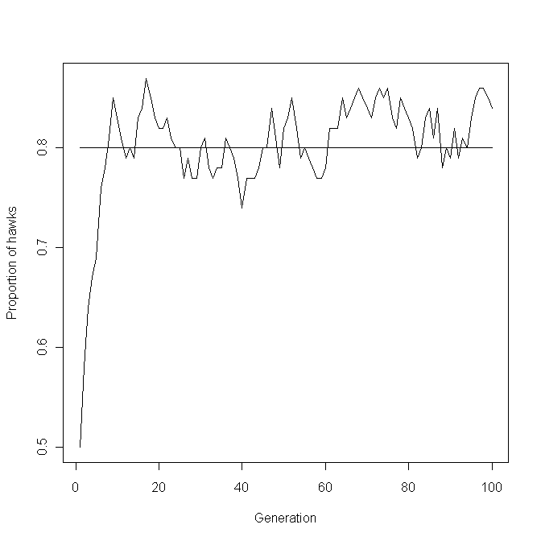

Scenario 3: A graphical analysis
rm(list=ls()) # Remove all objects from memory
# Function to calculate new frequency of H allele
FITNESS <- function(Morph, PayoffMatrix, HH, HD, Npop)
{
# HH = number of HH genotypes HD = Number of Heterozygotes
# Npop = Population size
# Match males up to find fitness for each male
# Create a randomized vector of opponents
Opponent <- sample(Morph)
Fitness <- matrix(0,Npop,1) # Pre-assign space to Fitness
# Iterate over the Payoff matrix
for (Receiver in 1:2 ) # Individual receiving payoff
{
for (I.Opponent in 1:2) # Opponent
{
Fitness[Morph==Receiver & Opponent==
I.Opponent]<- 3 + PayoffMatrix[Receiver,I.Opponent]
}} # End of the two loops

# Now we know that 1-HH are hawks
# Calculate range for heterozygotes
n1 <- HH+1 # Starting row of heterozygotes
n2 <- n1+HD-1 # Ending row of heterozygotes
# Number of H alleles
H.alleles <- 2*sum(Fitness[1:HH]) + sum(Fitness[n1:n2])
n3 <- n2+1 # Starting row of DD homozygotes
# Number of D alleles
D.alleles <- sum(Fitness[n1:n2]) + 2*sum(Fitness[n3:Npop])
Prop.H <- H.alleles/(H.alleles + D.alleles) # Proportion H alleles
return(Prop.H)
} # End of function
####################### Main program #######################
set.seed(100) # Initialize random number generator
Npop <- 2000 # Set population size
Morph <- matrix(2,Npop,1) # Set up matrix initially with doves
MaxProp <- 100 # Nos of divisions for proportions
Data <- matrix(0,MaxProp,4) # Create file for output
# Col 1=Prop.H, col 2=Delta Prop.H, col3=P.Hawks, 3=Delta P.Hawks
PayoffMatrix <- matrix(c(-1,0,8,4),2,2) # Set up Payoff matrix
# Calculate theoretical frequency
a <- PayoffMatrix[1,1]
b <- PayoffMatrix[1,2]
c <- PayoffMatrix[2,1]
d <- PayoffMatrix[2,2]
P.Hawks <- (b-d)/(b+c-a-d) # Expected proportion of hawks
Data[,1] <- seq(from=0.01, to=0.95, length=MaxProp) # Propn of H allele
for (Prop in 1:MaxProp) # Iterate over Proportions
{
# Calculate the number of each genotype as integers
Prop.H <- Data[Prop,1] # Get Proportion of H allele
HH <- round(Prop.H^2*Npop) # Number of HH genotypes
HD <- round(2*Prop.H*(1-Prop.H)*Npop)# Number of HD genotypes
Morph[1:Npop] <- 2 # Set initially to doves
Nos.of.Hawks <- HH + HD # Assuming that HD is a Hawk
Morph[1:Nos.of.Hawks] <- 1 # Set rows 1 to Nos.of.Hawks to hawks
Nos.of.Hawks <- sum(Morph[Morph==1]) # The nos of Hawks
# Calculate new proportion of H allele by applying fitness criterion
New.Prop.H <- FITNESS(Morph, PayoffMatrix, HH, HD, Npop)
Data[Prop,2] <- New.Prop.H - Prop.H # Change in propn of H allele
Data[Prop,3] <- Prop.H^2+ 2*Prop.H*(1-Prop.H) # P.Hawks
New.Hawks <- New.Prop.H^2+ 2*New.Prop.H*(1-New.Prop.H) # New P.Hawks
Data[Prop,4] <- New.Hawks - Data[Prop,3] # Delta P.Hawks
} # End of Prop loop
# Plot Change in proportions as a function of P.Hawks
Ymax <- max(Data[,2],Data[,4]) # Maximum Y value
Ymin <- min(Data[,2],Data[,4]) # Minimum Y value
# Plot Change in Proportion of H allele
plot(Data[,1], Data[,2], type='l',lty=2, xlab='Initial Proportion (P or P.Hawks)', ylab='Change (in P or P.Hawks)', ylim=c(Ymin,Ymax))
lines(Data[,3], Data[,4], type='l') # Plot change in proportion of Hawks
lines(Data[,1], rep(0,MaxProp)) # Plot theoretical ESS as horizontal line
points(P.Hawks, 0, pch="X", cex=2) # Plot X at ESS. cex sets size of X
# Apply smooth spline to smooth out curves
lines(smooth.spline(Data[,1],Data[,2]))
lines(smooth.spline(Data[,3],Data[,4]))

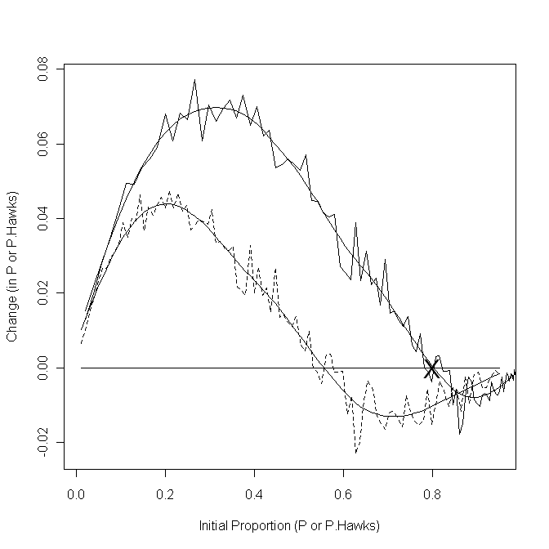
Scenario 3: Finding the ESS using a numerical approach
rm(list=ls()) # Remove all objects from memory
# Function to calculate new frequency of H allele
FITNESS <- function(Morph, PayoffMatrix, HH, HD, Npop)
{
# Morph = Vector of morphs (1s and 2s) with hawks first
# HH = number of HH genotypes HD = Number of Heterozygotes
# Npop = Population size
# Match individuals up to find fitness for each individual
Opponent <- sample(Morph) # Create a randomized vector of opponents
Fitness <- matrix(0,Npop,1) # Pre-assign space to Fitness
# Iterate over the Payoff matrix
for (Receiver in 1:2 ) # Individual receiving payoff
{
for (I.Opponent in 1:2) # Opponent
{
Fitness[Morph==Receiver & Opponent==
I.Opponent]<- 3 + PayoffMatrix[Receiver,I.Opponent]
}} # End of the two loops
# Now we know that 1-HH are hawks
# Calculate range for heterozygotes
n1 <- HH+1 # Starting row of heterozygotes
n2 <- n1+HD-1 # Ending row of heterozygotes (note -1)
# Number of H alleles
H.alleles <- 2*sum(Fitness[1:HH]) + sum(Fitness[n1:n2])
n3 <- n2+1 # Starting row of DD homozygotes
# Number of D alleles
D.alleles <- sum(Fitness[n1:n2]) + 2*sum(Fitness[n3:Npop])
Prop.H <- H.alleles/(H.alleles + D.alleles) # Proportion H alleles
return(Prop.H)
} # End of function
####################### Main program #######################
set.seed(100) # Initialize random number generator
Npop <- 100 # Set population size
MaxGen <- 100 # Number of generations
Output <- matrix(0,MaxGen,2) # Create file for output
Prop.H <- 0.5 # Initial Propn of H alleles in popn
Morph <- matrix(2,Npop,1) # Set up matrix initially with doves
PayoffMatrix <- matrix(c(-1,0,8,4),2,2) # Set up Payoff matrix
# Calculate theoretical frequency
a <- PayoffMatrix[1,1]
b <- PayoffMatrix[1,2]
c <- PayoffMatrix[2,1]
d <- PayoffMatrix[2,2]
P.Hawks <- (b-d)/(b+c-a-d) # Expected proportion of hawks
for (Igen in 1:MaxGen) # Iterate over generations
{
# Calculate the number of each genotype as integers
HH <- round(Prop.H^2*Npop) # Number of HH genotypes
HD <- round(2*Prop.H*(1-Prop.H)*Npop) # Number of HD genotypes
Morph[1:Npop] <- 2 # Set initially to doves
Nos.of.Hawks <- HH + HD # Assuming that HD is a Hawk
Morph[1:Nos.of.Hawks] <- 1 # Set rows 1 to Nos.of.Hawks to hawks
Output[Igen,1] <- Igen # Store generation number
# Calculate and store the proportion of Hawks
Nos.of.Hawks <- sum(Morph[Morph==1])
Output[Igen,2] <- Nos.of.Hawks/Npop # Proportion of Hawks
# Calculate new proportion of H allele by applying fitness criterion
Prop.H <- FITNESS(Morph, PayoffMatrix, HH, HD, Npop)
} # End of Igen loop
# Plot time trace
plot(Output[,1], Output[,2], type='l', xlab='Generation', ylab='Proportion of hawks')
lines(Output[,1], rep(P.Hawks,MaxGen)) # Plot theoretical expectation
# Print out mean proportion hawks, SD and expected proportion
# starting at gen 20
print(c(mean(Output[20:MaxGen,2]), sd(Output[20:MaxGen,2]), P.Hawks))
# t test against expected proportion
t.test(Output[20:MaxGen,2], mu=P.Hawks)

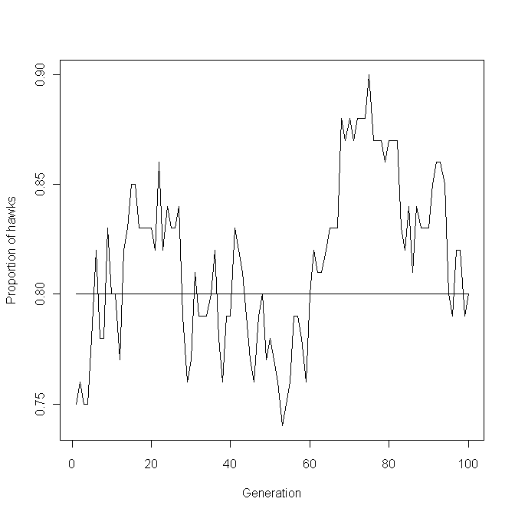

Scenario 4: A graphical analysis
rm(list=ls()) # Remove all objects from memory
# Function to calculate new mean value
FITNESS <- function(GM, GF, PM.Morph, PayoffMatrix, N)
{
# Match males up to find fitness for each male
# Create a randomized vector of opponents
Opponent <- sample(PM.Morph)
Fitness <- matrix(0,N,1)
# Iterate over the Payoff matrix
for (Receiver in 1:2 ) # Individual receiving payoff
{
for (I.Opponent in 1:2) # Opponent
{
Fitness[PM.Morph==Receiver & Opponent==
I.Opponent]<- 3 + PayoffMatrix[Receiver,I.Opponent]
}} # End Of two loops
mu.M <- sum(Fitness*GM)/sum(Fitness)# Mean genetic value of males
mu.F <- mean(GF) # Mean genetic value of females
mu <- (mu.M + mu.F)/2 # New population mean
return(mu)
}
######################### Main program #########################
set.seed(100) # Initialize random number generator
N <- 10000 # Set population size
PM.Morph <- matrix(0,N,1) # Create file for male phenotypes
h2 <- 0.5 # Set heritability
Vp <- 1 # Set Phenotypic variance
Va <- Vp*h2 # Calculate Additive genetic variance
Ve <- Vp-Va # Calculate Environmental variance
mu <- 0 # Trait mean value
# Note that mu is both the genetic mean and the phenotypic mean
# because the mean environmental value is by definition zero
SDa <- sqrt(Va) # SD of Va
SDe <- sqrt(Ve) # SD of Ve
PayoffMatrix <- matrix(c(-1,0,8,4),2,2) # Set up Payoff matrix
# Calculate theoretical frequency
a <- PayoffMatrix[1,1]
b <- PayoffMatrix[1,2]
c <- PayoffMatrix[2,1]
d <- PayoffMatrix[2,2]
P.Hawks <- (b-d)/(b+c-a-d)
MaxProp <- 20 # Nos of divisions for proportions
Data <- matrix(0,MaxProp,2) # Create file for output
Data[,1] <- seq(from=0.01, to=0.95, length=MaxProp) # Propn of Hawks
for (Prop in 1:MaxProp) # Iterate over Proportions
{
P.Hawk <- Data[Prop,1] # Initial proportion of Hawks
T.zero <- -qnorm(P.Hawk, mean=0, sd=1) # Threshold. Hawks > T.zero
# Generate Genetic and environmental values using normal distribution
mu <- 0
GM <- rnorm(N, mean=mu, sd=SDa) # Genetic values of males
GF <- rnorm(N, mean=mu, sd=SDa) # Genetic values of females
EM <- rnorm(N, mean=0, sd=SDe) # Environmental values of males
PM <- GM + EM # Phenotypic value of males
# Combine phenotypic and genetic values
PM.Morph[PM > T.zero] <- 1 # Hawks
PM.Morph[PM <= T.zero ] <- 2 # Doves
# Calculate the proportion of each type
Nos.of.Hawks <- sum(PM.Morph[PM.Morph==1])
# Calculate new mean genetic value by applying fitness criterion
mu <- FITNESS(GM, GF, PM.Morph, PayoffMatrix, N)
# Store change in proportion
Data[Prop,2] <- 1-pnorm(q=T.zero, mean=mu, sd=1)-Data[Prop,1]
} # End of Prop loop
# Plot Change in Proportion of Hawks
plot(Data[,1], Data[,2], type='l',lty=2, xlab='Initial proportion of Hawks', ylab='Change in proportion of Hawks')
lines(Data[,1], rep(0,MaxProp)) # Plot theoretical ESS as horizontal line
points(P.Hawks, 0, pch="X", cex=2) # Plot X at ESS. cex sets size of X
# Apply smooth spline to smooth out curves
lines(smooth.spline(Data[,1],Data[,2]))

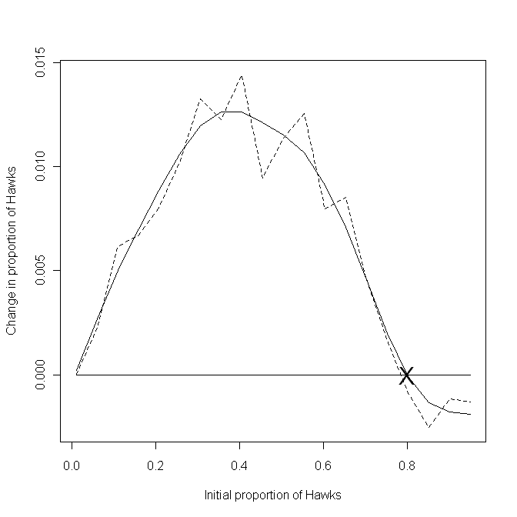
Scenario 4: Finding the ESS using a numerical approach
set.seed(100) # Initialize random number generator
N <- 100 # Set population size
PM.Morph <- matrix(0,N,1) # Create file for male phenotypes
P.Hawk <- 0.5 # Initial proportion of Hawks
T.zero <- -qnorm(P.Hawk) # Threshold. Hawks > T.zero
h2 <- 0.5 # Set heritability
Vp <- 1 # Set Phenotypic variance
Va <- Vp*h2 # Calculate Additive genetic variance
Ve <- Vp-Va # Calculate Environmental variance
mu <- 0 # Trait mean value
# Note that mu is both the genetic mean and the phenotypic mean
# because the mean environmental value is by definition zero
SDa <- sqrt(Va) # SD of Va
SDe <- sqrt(Ve) # SD of Ve
PayoffMatrix <- matrix(c(-1,0,8,4),2,2) # Set up Payoff matrix
# Calculate theoretical frequency
a <- PayoffMatrix[1,1]
b <- PayoffMatrix[1,2]
c <- PayoffMatrix[2,1]
d <- PayoffMatrix[2,2]
P.Hawks <- (b-d)/(b+c-a-d)
MaxGen <- 200 # Number of generations
Output <- matrix(0,MaxGen,2) # Create file for output
for (Igen in 1:MaxGen) # Iterate over generations
{
# Generate Genetic and environmental values using normal distribution
GM <- rnorm(N, mean=mu, sd=SDa) # Genetic values of males
GF <- rnorm(N, mean=mu, sd=SDa) # Genetic values of females
EM <- rnorm(N, mean=0, sd=SDe) # Environmental values of males
PM <- GM + EM # Phenotypic value of males
# Combine phenotypic and genetic values
PM.Morph[PM > T.zero] <- 1 # Hawks
PM.Morph[PM <= T.zero ] <- 2 # Doves
Output[Igen,1] <- Igen # Initial generation
# Calculate the proportion of each type
Nos.of.Hawks <- sum(PM.Morph[PM.Morph==1])
Output[Igen,2] <- Nos.of.Hawks/N # Proportion of Hawks
# Calculate new mean genetic value by applying fitness criterion
mu <- FITNESS(GM, GF, PM.Morph, PayoffMatrix, N)
} # End of Igen loop
Start <- 100 # Starting row for calculating mean proportion
plot(Output[,1], Output[,2],type='l', xlab='Generation', ylab='Proportion of hawks')
lines(Output[,1], rep(P.Hawks,MaxGen)) # Plot theoretical expectation
print(c(mean(Output[Start:MaxGen,2]), sd(Output[Start:MaxGen,2]), P.Hawks)) # Mean proportion, SD, Expected proportion
t.test(Output[Start:MaxGen,2], mu=P.Hawks)
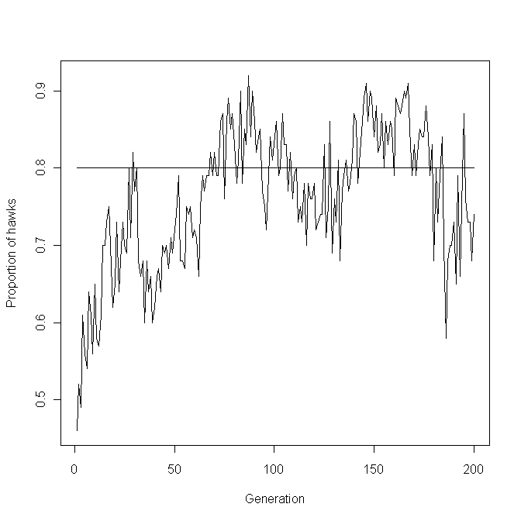
Scenario 5: Finding the ESS using a numerical approach
rm(list=ls()) # Remove all objects from memory
# Function to calculate new fitness values and morph proportions
FITNESS <- function(Morph,PayoffMatrix,Npop)
{
# Match individuals up to find fitness for each male
Opponent <- sample(Morph) # Create a randomized vector of opponents
Fitness <- matrix(0,Npop,1) # Allocate space for fitness vector
# Iterate over the Payoff matrix
# Individual receiving payoff 1=Rock 2 = Scissors 3=Paper
for (Receiver in 1:3 )
{
for (I.Opponent in 1:3) # Opponent 1=Rock 2 = Scissors 3=Paper
{
Fitness[Morph==Receiver & Opponent==
I.Opponent]<- 5 + PayoffMatrix[Receiver,I.Opponent]
}}
# Mean fitness of Rocks
Prop.Rocks <- sum(Fitness[Morph==1])/sum(Fitness)
# Mean fitness of Scissors
Prop.Scissors <- sum(Fitness[Morph==2])/sum(Fitness)
return(c(Prop.Rocks, Prop.Scissors))
}
##################### Main program #####################
set.seed(100) # Initialize random number generator
Npop <- 1000 # Set population size
MaxGen <- 1000 # Number of generations
Output <- matrix(0,MaxGen,4) # Create file for output
# Set up threshold values for Rocks and Scissors
Prop.Rocks <- 0.33 # Initial proportion Rocks
Nos.of.Rocks <- Prop.Rocks*Npop # Nos of rocks
Prop.Scissors <- 0.33 # Initial proportion Scissors
Nos.of.Scissors <- Prop.Scissors*Npop # Nos of Scissors
# Set up morph vector initially with all Papers (=3s)
Morph <- matrix(3,Npop,1)
# Set up fitness matrix. Note column-wise fill
Epsilon <- 0.1 # Deficit when the same morph types interact
PayoffMatrix <- matrix(c(-Epsilon,-1,1,1,-Epsilon,-1,-1,1,-Epsilon),3,3)
for (Igen in 1:MaxGen) # Iterate over generations
{
Output[Igen,1] <- Igen # Store Generation number( 1st column)
# Calculate the proportion of each type
Morph[1:Npop] <- 3 # First put 3 in all rows
# Convert first Nos.of.Rocks rows to Rocks
Morph[1:Nos.of.Rocks] <- 1
# Fill in rows corresponding to Scissors
n1 <- Nos.of.Rocks+1
n2 <- n1+ Nos.of.Scissors
Morph[n1:n2] <- 2
Nos.of.Rocks <- length(Morph[Morph==1]) # Number of Rocks
Nos.of.Scissors <- length(Morph[Morph==2]) # Number of Scissors
Nos.of.Papers <- length(Morph[Morph==3]) # Number of Papers
Output[Igen,2] <- Nos.of.Rocks/Npop # Proportion of Rocks
Output[Igen,3] <- Nos.of.Scissors/Npop # Proportion of Scissors
Output[Igen,4] <- Nos.of.Papers/Npop # Proportion of Papers
# Calculate new proportion of each morph by applying fitness criterion
Propns <- FITNESS(Morph,PayoffMatrix,Npop)
Nos.of.Rocks <- round(Npop*Propns[1]) # Nos.of.Rocks is an integer
Nos.of.Scissors <- round(Npop*Propns[2]) # Nos.of.Scissors is an integer
} # End of Igen loop
par(mfrow=c(2,2)) # 4 plots per page
plot(Output[,1], Output[,2],type='l', xlab='Generation',ylab='Propns (+X)',ylim=c(0.0,1.0)) # Plot Rocks
lines( Output[,1], Output[,3]+0.25) # Add Scissors+0.25 to plot
lines( Output[,1], Output[,4]+0.55) # Add Papers+0.55 to plot
# Add predicted lines to plots
lines(Output[,1], rep(0.3333,MaxGen)) # Predicted Rocks
lines(Output[,1], rep(0.3333+0.25,MaxGen)) # Predicted Scissors
lines(Output[,1], rep(0.3333+0.55,MaxGen)) # Predicted Papers
# Phase plots showing proportion of two morphs
plot(Output[400:MaxGen,2],Output[400:MaxGen,3],type='l', xlab='Rocks',
ylab='Scissors')
plot(Output[,2],Output[,4],type='l', xlab='Rocks', ylab='Papers')
plot(Output[,3],Output[,4],type='l', xlab='Scissors', ylab='Papers')
print(' Mean proportions (R,P,S) from Generation 400 to MaxGen')
# Print mean proportions starting at generation 400
print(' Mean proportions (R,P,S) from Generation 400 to MaxGen')
c(mean(Output[400:MaxGen,2]),mean(Output[400:MaxGen,3]),
mean(Output[400:MaxGen,4]))

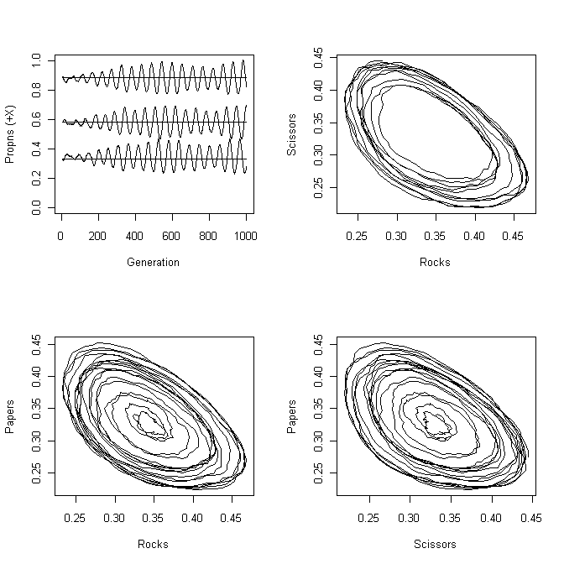
Scenario 6: A graphical analysis
rm(list=ls()) # Remove all objects from memory
# Function to calculate new proportions
FITNESS <- function(Morph, PayoffMatrix, Genotypes)
{
# To take account of integer values Npop is recalculated here
Npop <- sum(Genotypes)
# Match individuals up to find fitness for each
# Create a randomized vector of opponents
Opponent <- sample(Morph)
Fitness <- matrix(0,Npop,1) # Allocate space for Fitness vector
# Iterate over the Payoff matrix
for (Receiver in 1:3 ) # Ind receiving payoff 1=Rock 2 = Scissors 3=Paper
{
for (I.Opponent in 1:3) # Opponent 1=Rock 2 = Scissors 3=Paper
{
Fitness[Morph==Receiver & Opponent==
I.Opponent]<- 5 + PayoffMatrix[Receiver,I.Opponent]
}}
# Calculate ranges for genotypes to count alleles
n0 <- Genotypes[1] # Nos of RR. This is for completness
n1 <- n0+1 # Starting row of RS
n2 <- n1+Genotypes[2]-1 # Ending row of RS
n3 <- n2+1 # Starting row of RP
n4 <- n3+Genotypes[3]-1 # Ending row of RP
# Sum R alleles RR RS RP
R.alleles <- 2*sum(Fitness[1:n0])+sum(Fitness[n1:n2])+sum(Fitness[n3:n4]) # Number of S alleles
R.alleles <- 2*sum(Fitness[1:n0])+sum(Fitness[n1:n2])+sum(Fitness[n3:n4]) # Number of S alleles
n5 <- n4+1 # Starting row of SS
n6 <- n5+Genotypes[4]-1 # Ending row of SS
n7 <- n6+1 # Staring row of SP
n8 <- n7+Genotypes[5]-1 # Ending row of SP
# Sum S alleles SS RS SP
S.alleles <- 2*sum(Fitness[n5:n6])+sum(Fitness[n1:n2])+sum(Fitness[n7:n8])
# Number of P alleles
n9 <- n8+1 # Starting row of PP
# Number of P alleles PP RP SP
P.alleles <- 2*sum(Fitness[n9:Npop])+sum(Fitness[n3:n4])+ sum(Fitness[n7:n8])
# Proportion of each allele
Prop.R <- R.alleles/(R.alleles + S.alleles + P.alleles) # Propn R allele
Prop.S <- S.alleles/(R.alleles + S.alleles + P.alleles) # Propn S allele
Prop.P <- P.alleles/(R.alleles + S.alleles + P.alleles) # Propn P allele
return(c(Prop.R, Prop.S, Prop.P)) # Return proportion of alleles
} # End of function
###################### FUNCTION GENOTYPE ######################
GENOTYPE <- function(Prop.R, Prop.S, Prop.P, Npop)
{
# Calculate the genotypes
# First all genotypes that have Rock phenotype
RR <- round(Prop.R^2*Npop) # Number of RR genotypes
RS <- round(2*Prop.R*Prop.S*Npop) # Number of RS genotypes
RP <- round(2*Prop.R*Prop.P*Npop) # Number of RP genotypes
# Genotypes that have Scissors phenotype
SS <- round(Prop.S^2*Npop) # Number of SS genotypes
SP <- round(2*Prop.S*Prop.P*Npop) # Number of SP genotypes
# Genotypes that have Paper phenotype
PP <- round(Prop.P^2*Npop) # Number of PP genotypes
N <- RR+RS+RP+SS+SP+PP # To account for rounding effects
P.Rocks <- (RR+RS+RP)/N # Proportion of Rocks
P.Scissors <- (SS+SP)/N # Proportion of Scissors
P.Paper <- PP/N # Proportion of Paper
return( c(RR, RS, RP, SS, SP, PP, P.Rocks, P.Scissors, P.Paper))
} # End of function
###################### FUNCTION ISOCLINE ######################
ISOCLINE <- function(X, ADD, LTY) # Function to plot zero isoclines
{
# X is the matrix of changes in proportion
# ADD is a flag. ADD=0 tells function to start a new plot
# LTY is the type of line to be drawn
# Call R function contourLines to get xy coordinates of zero isoclines
Data <- contourLines(Proportion, Proportion, X, levels=0)
b <- data.frame(unlist(Data)) # Unlist Data and convert to a data frame
N.zeros <- length(b[b==0]) # Number of zero isoclines
for ( i in 1:N.zeros) # Iterate over isoclines
{
Prop.R <- Data[[i]]$x # Proportion R allele
Prop.S <- Data[[i]]$y # Proportion S allele
Prop.P <- 1- Prop.R - Prop.S # Proportion P allele
RR <- Prop.R^2 # Frequency of RR genotypes
RS <- 2*Prop.R*Prop.S # Frequency of RS genotypes
RP <- 2*Prop.R*Prop.P # Frequencyof RP genotypes
P.Rocks <- RR+RS+RP # Proportion of Rocks
SS <- Prop.S^2 # Frequency of SS genotypes
SP <- 2*Prop.S*Prop.P # Frequency of SP genotypes
P.Scissors <- SS+SP # Proportion of Scissors
# Plot lines (Have to check if new plot is requested)
if(i==1 && ADD==0) {plot(P.Rocks,P.Scissors, type='l', xlab="Proportion of Rock", ylab="Proportion of Scissors", xlim=c(0,1), ylim=c(0,1),lty=LTY)}
else{ lines(P.Rocks,P.Scissors, lty=LTY) }
}
} # end of function
##################### MAIN PROGRAM #####################
set.seed(100) # Initialize random number generator
Npop <- 2000 # Set population size
# Create a sequence of proportions for the two R and S alleles
Nos.P <- 30 # Number of divisions
Proportion <- seq(from=0.01, to=0.95, length=Nos.P)
# Use expand.grid to generate all possible combinations
RxS <- expand.grid(Proportion, Proportion)
Data.Rocks <- matrix(9,Nos.P*Nos.P,1) # Allocate space for R output
Data.Scissors <- Data.Rocks # Allocate space for S output
Data.Paper <- Data.Rocks # Allocate space for P output
Morph <- matrix(0,Npop,1) # Allocate space for Phenotype vector
# Set up fitness matrix. Note column-wise fill
Epsilon <- 0.1 # Deficit when the same morph types interact
PayoffMatrix <- matrix(c(-Epsilon,-1,1,1,-Epsilon,-1,-1,1,-Epsilon),3,3)
# Iterate over all possible combinations
Total.Combinations <- Nos.P*Nos.P # Total number of combinations
for (Ith.comb in 1:Total.Combinations)
{
Prop.R <- RxS[Ith.comb,1] # Proportion of R allele
Prop.S <- RxS[Ith.comb,2] # Proportion of S allele
Prop.P <- 1-Prop.R-Prop.S # Proportion of P allele
Total <- Prop.R+Prop.S+Prop.P # Sum of proportions
if(Total > 0) # Check that combination is permissable
{
D1 <- GENOTYPE(Prop.R, Prop.S, Prop.P, Npop) # Calculate the genotypes
Genotypes <- D1[1:6] # Numbers of each genotype
Prop.Morphs <- D1[7:9] # Proportions of each morph
Morph[1:Npop] <- 3 # Set initially to Paper
Nos.of.Rocks <- sum(Genotypes[1:3]) # RR+RS+RP
Nos.of.Scissors <- sum(Genotypes[4:5]) # SS+SP
Nos.of.Papers <- Genotypes[6] # PP genotype
Morph[1:Nos.of.Rocks] <- 1 # Set rows 1 to Nos.of.Rocks to Rocks
n1 <- Nos.of.Rocks+1 # Starting row for Scissors
n2 <- n1+Nos.of.Scissors-1 # Ending row for Scissors
Morph[n1:n2] <- 2 # Set these rows to Scissors (=2)
# Calculate new proportions by applying fitness criterion
Propns <- FITNESS(Morph,PayoffMatrix,Genotypes)
D2 <- GENOTYPE(Propns[1], Propns[2], Propns[3], Npop)
Data.Rocks[Ith.comb] <- D1[7]-D2[7] # Change in proportion of Rocks
Data.Scissors[Ith.comb] <- D1[8]-D2[8] # Change in proportion of Scissors
Data.Paper[Ith.comb] <- D1[9]-D2[9] # Change in proportion of Paper
} # End of if statement
} # End of Ith.comb loop
# Convert vectors to matrices Note that fill is by column not row
Delta.Rocks <- matrix(Data.Rocks, Nos.P, Nos.P, byrow=F)
Delta.Scissors <- matrix(Data.Scissors, Nos.P, Nos.P, byrow=F)
Delta.Paper <- matrix(Data.Paper, Nos.P, Nos.P, byrow=F)
par(mfrow=c(2,2)) # 4 plots per page
# Plot zero isoclines for alellic frequencies
contour(Proportion, Proportion, Delta.Rocks, xlab="Proportion of R allele", ylab="Proportion of S allele", levels=0, drawlabels=FALSE)
contour(Proportion, Proportion, Delta.Scissors,lty=2,levels=0, add=TRUE, drawlabels=FALSE)
contour(Proportion, Proportion, Delta.Paper, lty=3, levels=0, add=TRUE, drawlabels=FALSE)
# Get zero isoclines for proportion of each morph
ISOCLINE(Delta.Rocks, 0, 1) # Plot Rock zero isocline
ISOCLINE(Delta.Scissors, 1, 2) # Plot Scissors zero isocline
ISOCLINE(Delta.Paper, 1, 3) # Plot Paper zero isocline
points(0.333,0.333, cex=2) # Add predicted ESS. cex = large symbol

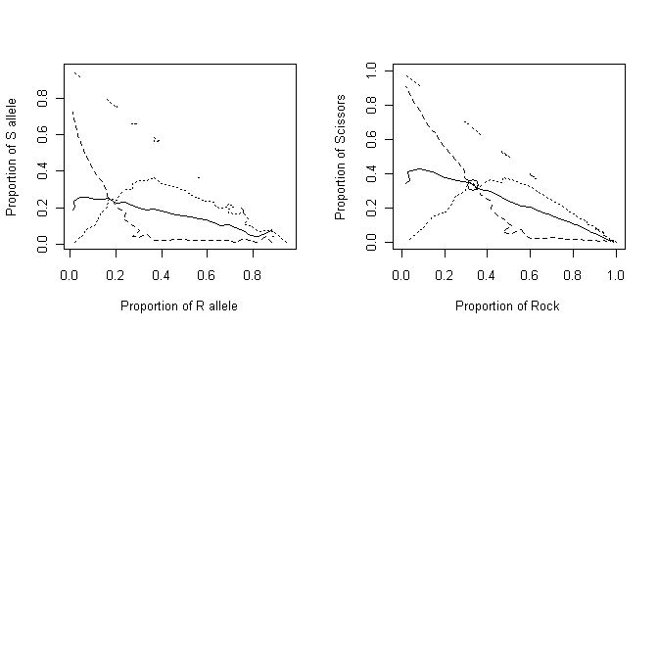
Scenario 6: Finding the ESS using a numerical approach
rm(list=ls()) # Remove all objects from memory
# Function to calculate new proportions
FITNESS <- function(Morph, PayoffMatrix, Genotypes)
{
# To take account of integer values Npop is recalculated here
Npop <- sum(Genotypes)
# Match individuals up to find fitness for each
# Create a randomized vector of opponents
Opponent <- sample(Morph)
Fitness <- matrix(0,Npop,1) # Allocate space for Fitness vector
# Iterate over the Payoff matrix
for (Receiver in 1:3 ) # Ind receiving payoff 1=Rock 2 = Scissors 3=Paper
{
for (I.Opponent in 1:3) # Opponent 1=Rock 2 = Scissors 3=Paper
{
Fitness[Morph==Receiver & Opponent==
I.Opponent]<- 5 + PayoffMatrix[Receiver,I.Opponent]
}}
# Calculate ranges for genotypes to count alleles
n0 <- Genotypes[1] # Nos of RR. This is for completness
n1 <- n0+1 # Starting row of RS
n2 <- n1+Genotypes[2]-1 # Ending row of RS
n3 <- n2+1 # Starting row of RP
n4 <- n3+Genotypes[3]-1 # Ending row of RP
# Sum R alleles RR RS RP
R.alleles <- 2*sum(Fitness[1:n0])+sum(Fitness[n1:n2])+sum(Fitness[n3:n4]) # Number of S alleles
R.alleles <- 2*sum(Fitness[1:n0])+sum(Fitness[n1:n2])+sum(Fitness[n3:n4]) # Number of S alleles
n5 <- n4+1 # Starting row of SS
n6 <- n5+Genotypes[4]-1 # Ending row of SS
n7 <- n6+1 # Staring row of SP
n8 <- n7+Genotypes[5]-1 # Ending row of SP
# Sum S alleles SS RS SP
S.alleles <- 2*sum(Fitness[n5:n6])+sum(Fitness[n1:n2])+sum(Fitness[n7:n8])
# Number of P alleles
n9 <- n8+1 # Starting row of PP
# Number of P alleles PP RP SP
P.alleles <- 2*sum(Fitness[n9:Npop])+sum(Fitness[n3:n4])+ sum(Fitness[n7:n8])
# Proportion of each allele
Prop.R <- R.alleles/(R.alleles + S.alleles + P.alleles) # Propn R allele
Prop.S <- S.alleles/(R.alleles + S.alleles + P.alleles) # Propn S allele
Prop.P <- P.alleles/(R.alleles + S.alleles + P.alleles) # Propn P allele
return(c(Prop.R, Prop.S, Prop.P)) # Return proportion of alleles
} # End of function
###################### FUNCTION GENOTYPE ######################
GENOTYPE <- function(Prop.R, Prop.S, Prop.P, Npop)
{
# Calculate the genotypes
# First all genotypes that have Rock phenotype
RR <- round(Prop.R^2*Npop) # Number of RR genotypes
RS <- round(2*Prop.R*Prop.S*Npop) # Number of RS genotypes
RP <- round(2*Prop.R*Prop.P*Npop) # Number of RP genotypes
# Genotypes that have Scissors phenotype
SS <- round(Prop.S^2*Npop) # Number of SS genotypes
SP <- round(2*Prop.S*Prop.P*Npop) # Number of SP genotypes
# Genotypes that have Paper phenotype
PP <- round(Prop.P^2*Npop) # Number of PP genotypes
N <- RR+RS+RP+SS+SP+PP # To account for rounding effects
P.Rocks <- (RR+RS+RP)/N # Proportion of Rocks
P.Scissors <- (SS+SP)/N # Proportion of Scissors
P.Paper <- PP/N # Proportion of Paper
return( c(RR, RS, RP, SS, SP, PP, P.Rocks, P.Scissors, P.Paper))
} # End of function
###################### FUNCTION ISOCLINE ######################
ISOCLINE <- function(X, ADD, LTY) # Function to plot zero isoclines
{
# X is the matrix of changes in proportion
# ADD is a flag. ADD=0 tells function to start a new plot
# LTY is the type of line to be drawn
# Call R function contourLines to get xy coordinates of zero isoclines
Data <- contourLines(Proportion, Proportion, X, levels=0)
b <- data.frame(unlist(Data)) # Unlist Data and convert to a data frame
N.zeros <- length(b[b==0]) # Number of zero isoclines
for ( i in 1:N.zeros) # Iterate over isoclines
{
Prop.R <- Data[[i]]$x # Proportion R allele
Prop.S <- Data[[i]]$y # Proportion S allele
Prop.P <- 1- Prop.R - Prop.S # Proportion P allele
RR <- Prop.R^2 # Frequency of RR genotypes
RS <- 2*Prop.R*Prop.S # Frequency of RS genotypes
RP <- 2*Prop.R*Prop.P # Frequencyof RP genotypes
P.Rocks <- RR+RS+RP # Proportion of Rocks
SS <- Prop.S^2 # Frequency of SS genotypes
SP <- 2*Prop.S*Prop.P # Frequency of SP genotypes
P.Scissors <- SS+SP # Proportion of Scissors
# Plot lines (Have to check if new plot is requested)
if(i==1 && ADD==0) {plot(P.Rocks,P.Scissors, type='l', xlab="Proportion of Rock", ylab="Proportion of Scissors", xlim=c(0,1), ylim=c(0,1),lty=LTY)}
else{ lines(P.Rocks,P.Scissors, lty=LTY) }
}
} # end of function
##################### Main program #####################
set.seed(100) # Initialize random number generator
Npop <- 2000 # Set population size
MaxGen <- 2000 # Number of generations
Output <- matrix(0,MaxGen,7) # Create file for output
Prop.R <- 0.33 # Proportion Rocks
Prop.S <- 0.33 # Proportion Scissors
Prop.P <- 1-Prop.R-Prop.S # Proportion Papers
Morph <- matrix(0,Npop,1) # Allocate space for Phenotype vector
# Set up fitness matrix. Note column-wise fill
Epsilon <- 0.1 # Deficit when the same morph types interact
PayoffMatrix <- matrix(c(-Epsilon,-1,1,1,-Epsilon,-1,-1,1,-Epsilon),3,3)
for (Igen in 1:MaxGen) # Iterate over generations
{
D1 <- GENOTYPE(Prop.R, Prop.S, Prop.P, Npop) # Calculate the genotypes
Genotypes <- D1[1:6] # Numbers of each genotype
Prop.Morphs <- D1[7:9] # Proportions of each morph
Morph[1:Npop] <- 3 # Set initially to Paper
Nos.of.Rocks <- sum(Genotypes[1:3]) # RR+RS+RP
Nos.of.Scissors <- sum(Genotypes[4:5]) # SS+SP
Nos.of.Papers <- Genotypes[6] # PP genotype
Morph[1:Nos.of.Rocks] <- 1 # Set rows 1 to Nos.of.Rocks to Rocks
n1 <- Nos.of.Rocks+1 # Starting row for Scissors
n2 <- n1+Nos.of.Scissors-1 # Ending row for Scissors
Morph[n1:n2] <- 2 # Set these rows to Scissors(=2)
Output[Igen,1] <- Igen # Store Generation number
N <- sum(Genotypes) # To avoid rounding problems
Output[Igen,2] <- Nos.of.Rocks/N # Proportion of Rocks
Output[Igen,3] <- Nos.of.Scissors/N # Proportion of Scissors
Output[Igen,4] <- Nos.of.Papers/N # Proportion of Papers
Output[Igen,5] <- Prop.R # Frequency of allele R
Output[Igen,6] <- Prop.S # Frequency of allele S
Output[Igen,7] <- Prop.P # Frequency of allele P
# Calculate new proportion of Rocks by applying fitness criterion
Propns <- FITNESS(Morph,PayoffMatrix,Genotypes)
Prop.R <- Propns[1] # Frequency of allele R
Prop.S <- Propns[2] # Frequency of allele R
Prop.P <- Propns[3] # Frequency of allele R
} # End of Igen loop
par(mfrow=c(2,2)) # 4 plots per page
plot(Output[,1], Output[,2], type='l', xlab='Generation', ylab='Morph Proportions + X', ylim=c(0.0,1.8)) # Plot Rocks
lines( Output[,1], Output[,3]+0.5, lty=2) # Add Scissors to plot
lines( Output[,1], Output[,4]+1.0, lty=3) # Add Papers to plot
# Add predicted line to plots
lines(Output[,1], rep(0.3333,MaxGen)) # "Predicted" ESS
lines(Output[,1], rep(0.3333+0.5,MaxGen)) # "Predicted" ESS
lines(Output[,1], rep(0.3333+1,MaxGen)) # "Predicted" ESS
# Plot Allele frquencies
plot(Output[,1], Output[,5], type='l', xlab='Generation', ylab='Allele Proportions', ylim=c(0.0,1)) # Plot Rocks
lines( Output[,1], Output[,6], lty=2) # Add Scissors to plot
lines( Output[,1], Output[,7], lty=3) # Add Papers to plot
# Phase plots showing proportion of two morphs
plot(Output[,2],Output[,3],type='l', xlab='Rocks', ylab='Scissors')
plot(Output[,2],Output[,4],type='l', xlab='Rocks', ylab='Papers')
# plot(Output[,3],Output[,4],type='l', xlab='Scissors', ylab='Papers')
# Print mean proportions starting at generation 400
print(' Mean proportions (R,P,S) from Generation 400 to MaxGen')
c(mean(Output[400:MaxGen,2]),mean(Output[400:MaxGen,3]),
mean(Output[400:MaxGen,4]))
print(' Mean allele freqs (R,P,S) from Generation 400 to MaxGen')
c(mean(Output[400:MaxGen,5]),mean(Output[400:MaxGen,6]),
mean(Output[400:MaxGen,7]))
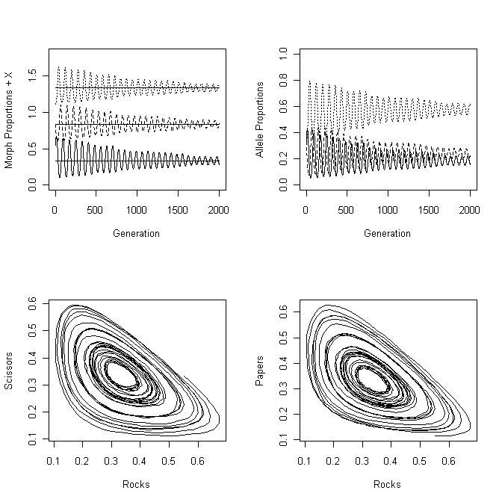
Scenario 7: Finding the ESS using a numerical approach
rm(list=ls()) # Remove all objects from memory
library(MASS) # Make sure MASS library is loaded
FITNESS <- function(Morph, Trait.A, Npop, PayoffMatrix)
{
Opponent <- sample(Morph) # Create a randomized vector of opponents
Fitness <- matrix(0,Npop,1) # Allocate space for fitnesses
# Iterate over the Payoff matrix
for (Receiver in 1:3 ) # Ind receiving payoff 1=Rock 2 = Scissors 3=Paper
{
for (I.Opponent in 1:3) # Opponent 1=Rock 2 = Scissors 3=Paper
{
Fitness[Morph==Receiver & Opponent==
I.Opponent]<- 3 + PayoffMatrix[Receiver,I.Opponent]
}} # End of loops
# Calculate mean genetic values
mu.X1 <- sum(Fitness*Trait.A[,1])/sum(Fitness) # Mean Rock
mu.X2 <- sum(Fitness*Trait.A[,2])/sum(Fitness) # Mean Scissors
mu.X3 <- sum(Fitness*Trait.A[,3])/sum(Fitness) # Mean Paper
return(c(mu.X1,mu.X2,mu.X3)) # Return new mean genetic values
}
########################## MAIN PROGRAM ##############################
set.seed(10) # Set seed for random number generator
Npop <- 500 # Population size
MaxGen <- 1000 # maximum number of generations
Output <- matrix(0,MaxGen,4) # Allocate space for output
NX <- 3 # Number of traits
# Matrix of heritabilities and correlations all h2=0.5, all r=0
H2 <- matrix(c(0.5, 0, 0, 0, 0.5, 0, 0, 0,0.5), 3,3)
mu <- c(0,0,0) # Genetic means. Set initially to zero
vars <- c(1,1,1) # Variances. Set and remain at 1
Mean.A <- c(mu[1], mu[2], mu[3]) # Initial Additive genetic means
Mean.E <- c(0,0,0) # Environmental means
# Phenotypic Covariance matrix
# Note that initial covariances are set to 1 (arbitrary)
CovP <- matrix(1,NX,NX) # Phenotypic variances
# Set diagonal elements = variances
diag(CovP)<- c(vars[1], vars[2], vars[3])
# Establish CovA from h2 and CovP and CovE from CovA and CovP
CovA <- matrix(0, NX, NX) # Allocate space for CovA
CovE <- matrix(0, NX, NX) # Allocate space for CovE
# Calculate environmental and genetic variances
for ( i in 1:NX) # Iterate over traits
{
CovA[i,i] <- CovP[i,i]*H2[i,i] # = Vp*h2
CovE[i,i] <- CovP[i,i]-CovA[i,i] # Environmental Variance
if(CovE[i,i] < 0) stop (print(c("CovE cannot be",i,j,CovE[i,i])))
} # end of i 1:NX loop
# Calculate phenotypic, environmental and genetic covariances
N.minus.1 <- NX-1
for( i in 1:N.minus.1)
{
jj <- i+1
for(j in jj:NX)
{
CovP[i,j] <- H2[j,i]*sqrt(CovP[i,i]*CovP[j,j]) # Phenotypic covariance
CovP[j,i] <- CovP[i,j] # Phenotypic covariance
CovA[i,j] <- H2[i,j]*sqrt(CovA[i,i]*CovA[j,j]) # Genetic covariance
CovA[j,i] <- CovA[i,j] # Genetic covariance
CovE[i,j] <- CovP[i,j]-CovA[i,j] # Environmental covariance
CovE[j,i] <- CovE[i,j] # Environmental covariance
} # End of j jj:NX loop
} # End of i 1:N.minus.1 loop
Epsilon <- 0.5 # Decrement in fitness for same morph interaction
# Set up fitness matrix. Note column-wise fill
PayoffMatrix <- matrix(c(-Epsilon,-1,1,1,-Epsilon,-1,-1,1,-Epsilon),3,3)
Morph <- matrix(3,Npop,1) # Set up initial morphs as all Paper
for (Igen in 1:MaxGen) # Iterate over generations
{
Output[Igen,1] <- Igen # Store generation
# Generate additive and environmental values by calling mvrorm
Trait.E <- mvrnorm(Npop, mu=Mean.E, Sigma=CovE) # Envir. value
Trait.A <- mvrnorm(Npop, mu=Mean.A, Sigma=CovA) # Genetic value
Trait.P <- Trait.A + Trait.E # Phenotype
# Determine morphs from trait with maximum value
Morph[Trait.P[,1]>Trait.P[,2] & Trait.P[,1]>Trait.P[,3]] <- 1 # Rock
Morph[Trait.P[,1]>Trait.P[,2] & Trait.P[,1]<Trait.P[,3]] <- 3 # Paper
Morph[Trait.P[,1]<Trait.P[,2] & Trait.P[,1]>Trait.P[,3]] <- 2 # Scissors
Morph[Trait.P[,2]>Trait.P[,1] & Trait.P[,2]>Trait.P[,3]] <- 2 # Scissors
Morph[Trait.P[,2]>Trait.P[,1] & Trait.P[,2]<Trait.P[,3]] <- 3 # Paper
Morph[Trait.P[,2]<Trait.P[,1] & Trait.P[,2]>Trait.P[,3]] <- 1 # Rock
Morph[Trait.P[,3]>Trait.P[,1] & Trait.P[,3]>Trait.P[,2]] <- 3 # Paper
Morph[Trait.P[,3]>Trait.P[,1] & Trait.P[,3]<Trait.P[,2]] <- 2 # Scissors
Morph[Trait.P[,3]<Trait.P[,1] & Trait.P[,3]>Trait.P[,2]] <- 1 # Rock
Nos.of.Rocks <- length(Morph[Morph==1]) # Number of Rocks
Nos.of.Scissors <- length(Morph[Morph==2]) # Number of Scissors
Nos.of.Papers <- length(Morph[Morph==3]) # Number of Papers
Output[Igen,2] <- Nos.of.Rocks/Npop # Proportion of Rocks
Output[Igen,3] <- Nos.of.Scissors/Npop # Proportion of Scissors
Output[Igen,4] <- Nos.of.Papers/Npop # Proportion of Papers
# Apply selection
Mean.A <- FITNESS(Morph, Trait.A, Npop, PayoffMatrix)
} # End of generation loop
par(mfrow=c(2,2)) # 4 plots per page
plot(Output[,1], Output[,2], type='l', xlab='Generation', ylab='Propn + X', ylim=c(0,2)) # Plot Rocks
lines( Output[,1], Output[,3]+0.5) # Plot Scissors + 0.5
lines( Output[,1], Output[,4]+1.0) # Plot Papers + 1
# Add "predicted" lines to plots
lines(Output[,1], rep(0.3333,MaxGen)) # Predicted Rocks
lines(Output[,1], rep(0.3333+0.5,MaxGen)) # Predicted Scissors
lines(Output[,1], rep(0.3333+1.0,MaxGen)) # Predicted Papers
# Phase plots
plot(Output[400:MaxGen,2], Output[400:MaxGen,3], type='l', xlab='Rocks', ylab='Scissors')
plot(Output[,2],Output[,4],type='l', xlab='Rocks', ylab='Papers')
plot(Output[,3],Output[,4],type='l', xlab='Scissors', ylab='Papers')
# Print mean proportions starting at generation 400
print(' Mean proportions (R,P,S) from Generation 400 to MaxGen')
c(mean(Output[400:MaxGen,2]),mean(Output[400:MaxGen,3]),
mean(Output[400:MaxGen,4]))
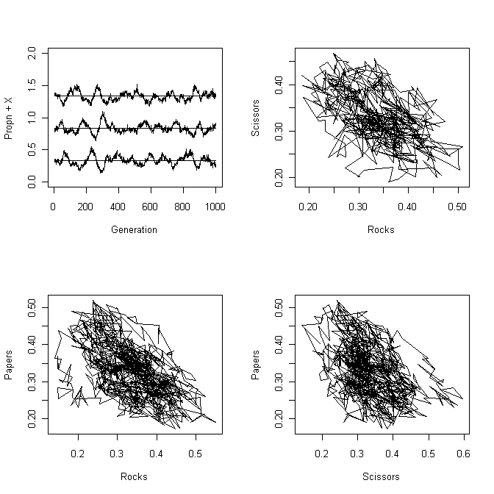
Scenario 8: Finding the ESS analytically – equal number of males
rm(list=ls()) # Remove all objects from memory
FUNC <- function(P.T) # Function to calculate the change in rho
{
N <- 1000 # Population size
N.T <- P.T*N # Number of territorial males
N.S <- (1-P.T)*N # Number of satellite males
N.S.per.T <- N.S/N.T # Satellite males per territorial male
Sat.Fitness <- 5/N.S.per.T # Fitness of satellite
F.S <- N.T*Sat.Fitness # Total Fitness of satellites
F.T <- 0.8*N.T # Total Fitness of territorials
Delta <- P.T - F.T/(F.T+F.S) # Change in rho
return(Delta)
}
##################### MAIN PROGRAM #####################
# First plot change in rho against rho
P <- matrix(seq(from=0.01, to=0.99, length=20),20,1) # Propn satellites
# Using a loop
#FF <- matrix(0,20,1): for (i in 1:20){FF[i] <- FUNC(P[i])}
FF <- apply(P,1,FUNC) # Using the apply function
# Plot the change in rho against rho
plot(P,FF, xlab=’Proportion territorial males, rho’, ylab=’Change in rho’)
lines(c(0,1),c(0,0) ) # Draw a horizontal line at zero
uniroot(FUNC,interval=c(.01,.99))$root # Get solution using uniroot
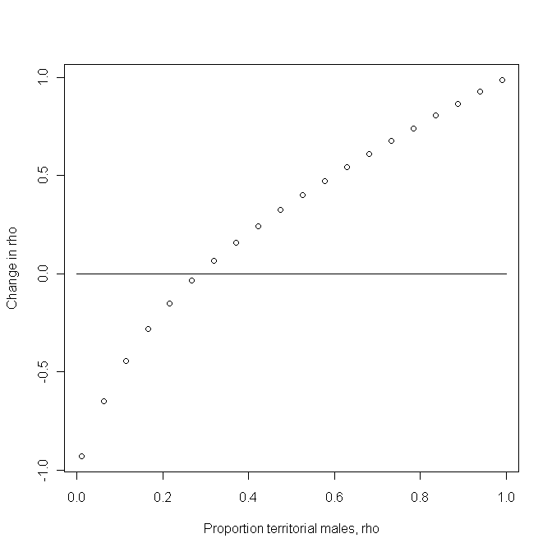
Scenario 8: Finding the ESS analytically – binomial distribution of males
rm(list=ls()) # Remove all objects from memory
rm(list=ls()) # Remove all objects from memory
# Set up a function for the binomial
BINOM <- function(x, NN, probty) {dbinom(x, size=NN, probty)}
FUNC <- function(P.T) # Function to calculate the change in rho
{
N <- 1000 # Population size
N.T <- round(P.T*N) # Integer number of territorials
N.S <- N-N.T # Number of satllites
probty <- 1/N.T # Probability for binomial model
P.zero <- dbinom(x=0, size=N.S, probty) # Probty of no satellites
N.T.zero <- N.T*P.zero # Nos of territorials without satellites
# Iterate over all territorial male counts > 0
# Line below shows how to do it using a loop
#Prob.x <- matrix(0, N.S,1);for (x in 1:N.S){ Prob.x[x] <- dbinom(x, size=N.S, probty) }
# Better approach is to use the apply function
# Generate a vector with number of satellites per territorial 1…N.S
Sat.nos <- matrix(seq(from=1, to=N.S), N.S, 1 )
# Probability of 1,2,3..N.S satellites
Prob.x <- apply(Sat.nos,1, BINOM, N.S, probty)
# Fitness of satellite for each number per territorial
Sat.Fitness <- 5/Sat.nos
# Frequency distribution of satellites per territorial
Freq <- (Prob.x*(N.T-N.T.zero))/(1-P.zero)
F.S <- sum(Freq*Sat.Fitness) # Fitness of satellites
F.T <- (1*N.T*P.zero + 0.8*N.T*(1-P.zero)) # Fitness of territorials
Delta <- P.T - F.T/(F.T+F.S) # Change in proportion of territial males
return(Delta)
}

##################### MAIN PROGRAM #####################
# First plot change in rho against rho
P <- matrix(seq(from=0.01, to=0.99, length=20),20,1) # Propn satellites
# Using a loop
#FF <- matrix(0,20,1): for (i in 1:20){FF[i] <- FUNC(P[i])}
FF <- apply(P,1,FUNC) # Using the apply function
# Plot the change in rho against rho
plot(P,FF, xlab='Proportion territorial males, rho', ylab='Change in rho')
lines(c(0,1),c(0,0) ) # Draw a horizontal line at zero
uniroot(FUNC,interval=c(.01,.99))$root # Get solution using uniroot

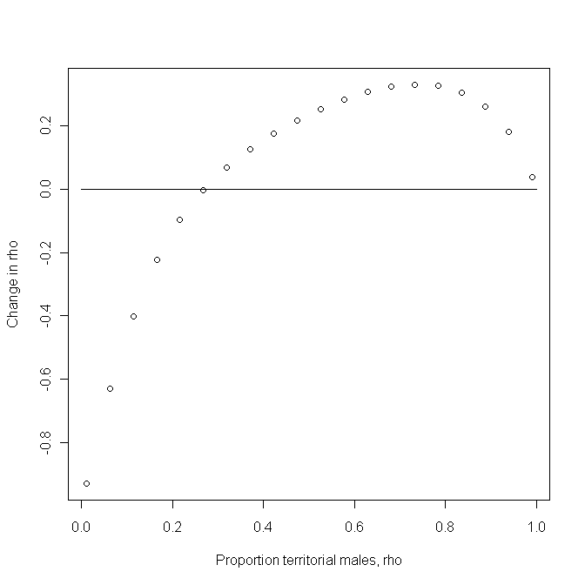

Scenario 8: Finding the ESS using a numerical approach
rm(list=ls()) # Remove all objects from memory
# Function to calculate the fitness of satellite and territorial males
FITNESS <- function(P.T, Npop )
{
N.T <- round(Npop*P.T) # Integral nos of territorial males
N.S <- Npop - N.T # Nos of satellite males
X <- seq(from=1, to=N.T) # Label Territorial males
# Draw at random with replacement N.S integers of vector X. This represents
# the territorial males assigned to the satellite males
Matches <- sample(X, N.S, replace=TRUE)
# Now have to find out how many satellites for each territorial
# Use function table to find number of satellites of territorial males
TABLE <- table(Matches)
# Get number of satellite matings = number of picked territorial males
N.T.S <- length(TABLE)
TABLE <- matrix(TABLE,,1) # Convert TABLE to vector
W.S <- sum(5/TABLE) # Calculate total fitness of satellite males
W.T <- (N.T-N.T.S)*1 + N.T.S*0.8 # Total fitness of territorial males
W <- W.T + W.S # Total fitness
P.T <- W.T/W # Frequency of Territorial males
return(P.T) # Return frequency of territorial males
}
########################### MAIN PROGRAM #######################
set.seed(1000) # Set seed for random number generator
Npop <- 1000 # Population size
P.T <- 0.25 # Initial proportion of territorial males
Maxgen <- 100 # Number of generations simulation runs
Output <- matrix(0,Maxgen,2) # Pre-assign space for output
Output[,1] <- seq(from=1, to=Maxgen) # Store generation number
for ( Igen in 1: Maxgen) # Iterate over generations
{
# Call function FITNESS to find new proportion of territorial males
P.T <- FITNESS(P.T, Npop)
Output[Igen,2] <- P.T # Store result
} # End of Igen loop
# Plot frequency of territorial males against generation number
plot(Output[,1], Output[,2], type='l', xlab='Generation', ylab='Proportion Territorials') # Plot output
mean(Output[40:Maxgen,2]) # Mean frequency averaged from generation 40

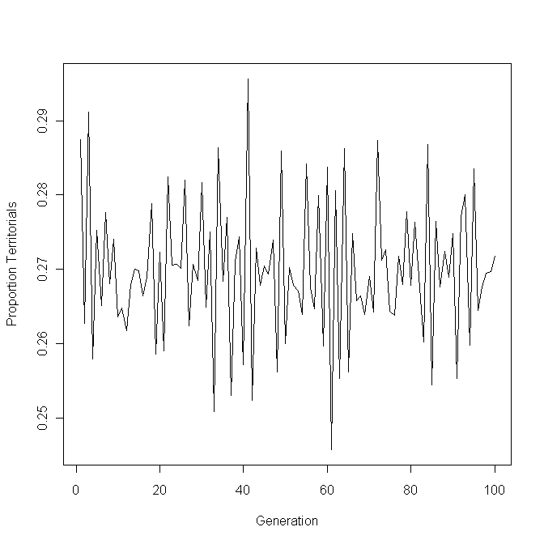
Scenario 9: Learning the ESS
MORPH <- function(P1.t, Npop) # Function to determine behaviors
{
# Set up morph vector initially with all doves
Morph <- rep(2,Npop)
# Calculate behavior adopted by using random number generator
Flag <- runif(Npop, min=0, max=1)
# Values of Flag < P1.t become Hawks
Morph[P1.t > Flag] <- 1
return( Morph)
} # End of function
FITNESS <- function(Morph, PayoffMatrix, Npop) # Function to generate payoffs
{
# Match males up to find fitness for each male
# Create a randomized vector of opponents
Opponent <- sample(Morph)
# Iterate over the Payoff matrix
Fitness <- rep(0,Npop) # Assign space for fitness
for (Receiver in 1:2 ) # Individual receiving payoff
{
for (I.Opponent in 1:2) # Opponent
{
Fitness[Morph==Receiver & Opponent==I.Opponent]<- PayoffMatrix[Receiver,I.Opponent]
} # End of I.opponent loop
} # End of Receiver loop
return(Fitness)
} # End of function
######################## MAIN PROGRAM ################################
set.seed(100) # Initialize random number generator
Npop <- 30 # Set population size
MaxTrial <- 200 # Number of generations
r <- 14.4 # Residual value
m <- 0.99 # Memory coefficient
# Set up a matrix for the output
# Rows = trial number Col 1 = trial number, Cols 2- Npop+1 = Individuals
Nplus1 <- Npop+1 # Extra col for trial number
Output <- matrix(0,MaxTrial,Nplus1)# Create file for output
P1.t <- matrix(0.5,Npop,1) # Vector of Learned Probabilities
Mean.P1.t <- matrix(0,MaxTrial,1) # matrix for Mean of Pi(t)
# Set up array for payoffs
# 1st dimension = trial, 2nd dimension = Behavior, 3rd dimension = Individual
Payoff <- array(0, c(MaxTrial,2,Npop)) # Array of payoffs
PayoffMatrix <- matrix(c(0,12,18,15),2,2) # Set up payoff matrix P=0.2
################## Calculate Payoffs for first trial ################## Output[1,1] <- 1 # Store Trial number in first column
Output[1,2:Nplus1] <- P1.t # Store Probability for each individual
Morph <- MORPH(P1.t, Npop) # Call function to determine behaviors
Fitness <- FITNESS(Morph, PayoffMatrix, Npop) # Determine payoffs
# Move Payoffs into Payoff matrix
for ( Ind in 1:Npop) # Iterate over individuals
{
Payoff[1, Morph[Ind], Ind] <- Fitness[Ind] # Store fitnesses in array
} # End of Ind loop
Mean.P1.t[1] <- mean(P1.t) # Save mean Pi(t)
######################## Subsequent Trials ########################
for (Trial in 2:MaxTrial) # Iterate over trials
{
Morph <- MORPH(P1.t, Npop) # Call function to determine behaviors
Fitness <- FITNESS(Morph, PayoffMatrix, Npop) # Determine payoffs
MaxT <- Trial-1 # Set t-1
for ( Ind in 1:Npop) # Iterate over individuals
{
Payoff[Trial, Morph[Ind], Ind] <- Fitness[Ind] # Pass payoffs to array
} # End of Ind loop
# Calculate the new P1.t
for (Ind in 1:Npop) # Iterate over individuals
{
Hawk <- 0; Dove <- 0 # Set sums initially to zero
for (Time in 1: MaxT) # Iterate from 1 to t-1
{
Hawk <- Hawk + m^(Trial-Time-1)*Payoff[Time,1,Ind] # Hawk sum
Dove <- Dove + m^(Trial-Time-1)*Payoff[Time,2,Ind] # Dove sum
} # End of Time loop
P1.t[Ind] <- (r + Hawk)/(2*r + Hawk + Dove)
} # End of Individual loop
# Store Data
Output[Trial,1] <- Trial # Store Generation number in 1st column
Output[Trial,2:Nplus1] <- P1.t # Store Probability for each individual
Mean.P1.t[Trial] <- mean(P1.t) # Store mean Pi(t)
} # End of Trial loop
###### Plot Output ######
# Plot first individual
plot(Output[,1], Output[,2],type='l', xlab='Trial number',ylab='Hawk P1.t', ylim =c(0,1))
for (i in 3: Nplus1) # Plot all remaining individuals
{
lines(Output[,1], Output[,i],type='l')
}
points(Output[,1], Mean.P1.t) # Plot trajectory of mean probty of hawk

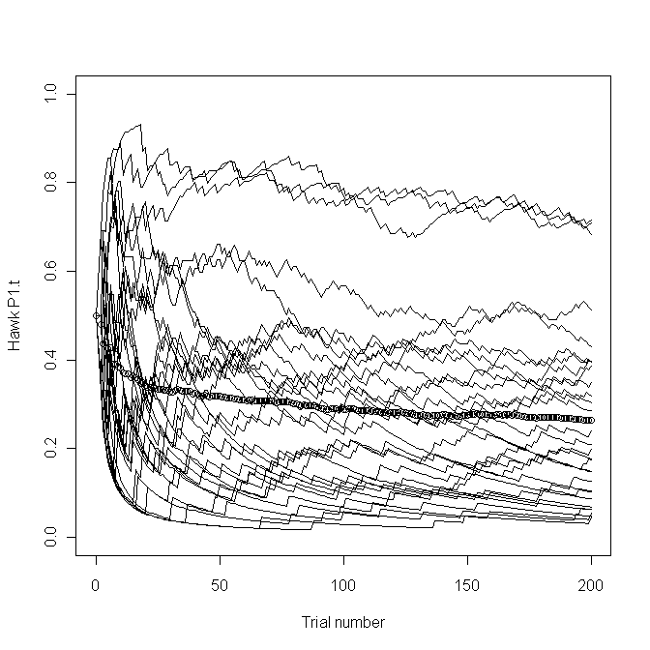
CHAPTER 6 DYNAMIC PROGRAMMING
An algorithm for constructing the Decision Matrix
rm(list=ls()) # Remove all objects from memory
# Function to calculate fitness when organism is in state X
FITNESS <- function(X, Xcritical, Xmax, Xmin, Cost, Benefit, Pbenefit, Pmortality, F.vectors)
{
# State in patch if forager finds food
X.Food <- X - Cost + Benefit
# If X.Food greater than Xmax then X.Food must be set to Xmax
X.Food <- min(X.Food, Xmax)
# If X.Food less than or equal to Xcritical then set to Xcritical
X.Food <- max( X.Food, Xcritical)
# State in patch if forager does not find food
X.NoFood <- X - Cost
# If X.NoFood is less than Xcritical set X.NoFood to Xcritical
X.NoFood <- max(X.NoFood, Xcritical)
Term1 <- Pbenefit*F.vectors[X.Food,2] # If food is found
Term2 <- (1-Pbenefit)*F.vectors[X.NoFood,2] # If food is not found
W <- (1 - Pmortality)*(Term1 + Term2) # Survival in patch
return(W) # Return Fitness
} # End of function
#.........................................................................
# Function to iterate over patches
OVER.PATCHES <- function(X, F.vectors, Xcritical,Xmax, Xmin, Npatch, Cost, Benefit, Pbenefit, Pmortality)
{
RHS <- matrix(0,Npatch,1) # Pre-allocate Right Hand Side of equn
for (i in 1: Npatch) # Cycle over patches
{
# Call Fitness function
RHS[i] <- FITNESS(X, Xcritical, Xmax, Xmin, Cost, Benefit[i], Pbenefit[i], Pmortality[i], F.vectors)
} # End of i loop
# Now find optimal patch Best row is in Best[1]
Best <- order(RHS, na.last=TRUE, decreasing=TRUE)
F.vectors[X,1] <- RHS[Best[1]]
Best.Patch <- Best[1]
# Concatenate F(x,t) and the optimal patch number
Temp <- c(F.vectors[X,1], Best.Patch)
# Add Temp to bottom of F.vectors and rename to Temp
Temp <- rbind(F.vectors, Temp)
return (Temp)
} # End of function
#.........................................................................
# Function to iterate over states of X
OVER.STATES <- function(F.vectors, Xcritical, Xmax, Xmin, Npatch, Cost, Benefit, Pbenefit, Pmortality)
{
Store <- matrix(0,Xmax,2) # Create matrix for output
for ( X in Xmin : Xmax) # Iterate over states of X
{
# For given X call Over.Patches to determine F(x,t) and best patch
Temp <- OVER.PATCHES(X, F.vectors, Xcritical, Xmax, Xmin, Npatch, Cost, Benefit, Pbenefit, Pmortality)
# Extract components. Last row is F(x,t) and best patch
n <- nrow(Temp)-1
F.vectors <- Temp[1:n,]
Store[X,] <- Temp[n+1,] # Save F(x,t) and best patch
} # End of X loop
# Add Store values to end of F.vectors for pass back to main program
Temp <- cbind(F.vectors, Store) # Combined by columns
return(Temp) # Return F.vectors and Store
} # End of function
#.........................................................................
# MAIN PROGRAM
# Initialize parameters
Xmax <- 10 # Maximum value of X
Xcritical <- 3 # Value of X at which death occurs
Xmin <- Xcritical+1 # Smallest value of X allowed
Cost <- 1 # Cost per period
Pmortality <- c(0, 0.004, 0.02) # Probability of mortality
Pbenefit <- c(1, 0.4, 0.6) # Probability of finding food
Benefit <- c(0, 3, 5) # Benefit if food is discovered
Npatch <- 3 # Number of patches
Horizon <- 20 # Number of time steps
# Set up matrix for fitnesses
# Column 1 is F(x, t). Column 2 is F(x,t+1)
F.vectors <- matrix(0, Xmax,2) # Set all values to zero
F.vectors[Xmin:Xmax,2] <- 1 # Set values > Xmin equal 1
# Create matrices for output
FxtT <- matrix(0,Horizon,Xmax) # F(x,t)
Best.Patch <- matrix(0,Horizon,Xmax) # Best patch number
# Start iterations
Time <- Horizon # Initialize Time
while ( Time > 1)
{
Time <- Time -1 # Decrement Time by 1 unit
# Call OVER.STATES to get best values for this time step
Temp <- OVER.STATES(F.vectors, Xcritical, Xmax, Xmin, Npatch, Cost, Benefit, Pbenefit, Pmortality)
# Extract F.vectors
TempF <- Temp[,1:2]
# Update F1
for ( J in Xmin: Xmax) { F.vectors[J,2] <- TempF[J,1]}
# Store results
Best.Patch[Time,] <- Temp[,4]
FxtT[Time,] <- Temp[,3]
} # End of Time loop
# Output information. For display add states (=wts) to last row of matrices
X <- seq(from=1, to=Xmax)
Best.Patch[Horizon,] <- X
FxtT[Horizon,] <- X
Best.Patch[,Xmin:Xmax] # Print Decision matrix
signif(FxtT[,Xmin:Xmax],3)# Print Fxt of Decision matrix: 3 sig places

Using the Decision Matrix: Individual prediction
# Initialize parameters
set.seed(10) # Set random number seed
Xmax <- 10 # Maximum value of X
Xcritical <- 3 # Value of X at which death occurs
Xmin <- Xcritical+1 # Smallest value of X allowed
Cost <- 1 # Cost per period
Pmortality <- c(0, 0.004, 0.02) # Probability of mortality
Pbenefit <- c(1, 0.4, 0.6) # Probability of finding food
Benefit <- c(0, 3, 5) # Benefit if food is discovered
Npatch <- 3 # Number of patches
Horizon <- 15 # Number of time steps
Output <- matrix(0,Horizon,10) # Matrix to hold output
Time <- seq(1, Horizon) # Values for x axis in plot
par(mfrow=c(5,2)) # Divide graph page into 5x2 panels
for (Replicate in 1: 10) # Iterate over 10 replicates
{
X <- 4 # Animal starts in state 4
for (i in 1:Horizon) # Iterate over time
{
if(X > Xcritical) # Check that animal still alive
{
Patch <- Best.Patch[i,X] # Select patch
# Check if animal survives predation
# Generate random number
if(runif(1) < Pmortality[Patch]) print("Dead from predator")
# Now find new weight
# Set multiplier to zero, which corresponds to no food found
Index <- 0
if (runif(1) < Pbenefit[Patch]) Index <- 1 # food is discovered
X <- X - Cost + Benefit[Patch]*Index
# If X greater than Xmax then X must be set to Xmax
X <- min(X, Xmax)
# If X less than X then animal dies
if( X< Xmin) print("Dead from starvation")
Output[i,Replicate] <- Patch # Store data
} # End of if(X > Xcritical)
} # End of time loop
plot(Time, Output[,Replicate], type='l', ylab='Patch selected')
} # End of replicate loop
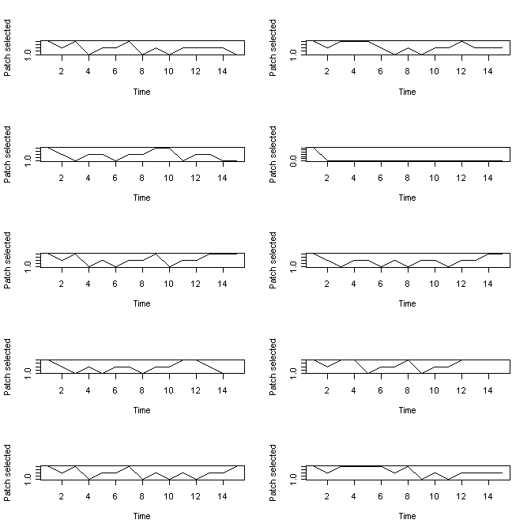

Using the Decision Matrix: Expected State
# Set initial parameter values
Xmax <- 10 # Maximum value of state
Xcritical <- 3 # Critical value of state
Xmin <- Xcritical+1 # Lowest value of state
Cost <- 1 # Metabolic cost
Time <- 2 # Current state to be considered
Npatch <- 3 # Npatch is number of patches
Pmortality <- c(0, 0.004, 0.02) # Probability of mortality Beta
Pbenefit <- c(1, 0.4, 0.6) # Probability of finding food Lambda
Benefit <- c(0, 3, 5) # Benefit if food is discovered Y
# Set transition density matrix to zero
Trans.density <- matrix(0, Xmax, Xmax)
# Step 1 Cycle over all values of z from Xmin to Xmax
for ( z in Xmin : Xmax) # Iterate over states
{
# Select the best patch from the Decision matrix at row Time
K <- Best.Patch[Time,z] # Decision matrix is called Best.Patch
# Calculate w(x,t|z)
# Found food and survives predator
x <- min(z - Cost + Benefit[K], Xmax)
# Assign probability
Trans.density[z,x]<- (1-Pmortality[K])*Pbenefit[K]
# Food not found
x <- z - Cost
# State exceeds the critical value
if(x > Xcritical)
{
# Animal survives
Trans.density[z,x]<- (1-Pmortality[K])*(1-Pbenefit[K])
# Animal does not survive
Trans.density[z,Xcritical]<- Pmortality[K]
} # end of if statement
# State is less than critical
else{ # Note that in R the { immediately follows else
Trans.density[z,Xcritical]<- Pmortality[K]+(1-Pmortality[K])*(1-Pbenefit[K]) } # End of else statement
} # end of z loop
Trans.density # Write out matrix

[,1] [,2] [,3] [,4] [,5] [,6] [,7] [,8] [,9] [,10]
[1,] 0 0 0.000 0.000 0.000 0.000 0.0000 0.0000 0.000 0.0000
[2,] 0 0 0.000 0.000 0.000 0.000 0.0000 0.0000 0.000 0.0000
[3,] 0 0 0.000 0.000 0.000 0.000 0.0000 0.0000 0.000 0.0000
[4,] 0 0 0.412 0.000 0.000 0.000 0.0000 0.5880 0.000 0.0000
[5,] 0 0 0.020 0.392 0.000 0.000 0.0000 0.0000 0.588 0.0000
[6,] 0 0 0.020 0.000 0.392 0.000 0.0000 0.0000 0.000 0.5880
[7,] 0 0 0.020 0.000 0.000 0.392 0.0000 0.0000 0.000 0.5880
[8,] 0 0 0.004 0.000 0.000 0.000 0.5976 0.0000 0.000 0.3984
[9,] 0 0 0.004 0.000 0.000 0.000 0.0000 0.5976 0.000 0.3984
[10,] 0 0 0.000 0.000 0.000 0.000 0.0000 0.0000 0.000 0.0000

Scenario 2
rm(list=ls()) # Remove all objects from memory
# Function to calculate fitness when organism is in state X
FITNESS <- function(X, Xcritical, Xmax, Xmin, Cost, Benefit, Pbenefit, Pmortality, F.vectors)
{
# Benefit gained
# State in patch if "Benefit" gained. Note that "Benefit" can be -1
X.Food <- X + Benefit # Note that Cost is omitted
# If X.Food greater than Xmax then X.Food must be set to Xmax
X.Food <- min(X.Food, Xmax)
# If X.Food less than or equal to Xcritical then set to Xcritical
X.Food <- max(X.Food, Xcritical)
# State in patch if forager does not gain "Benefit"
X.NoFood <- X # Note that Cost is omitted
# If X.NoFood is less than Xcritical set X.NoFood to Xcritical
X.NoFood <- max(X.NoFood, Xcritical)
# Now gather terms together
Term1 <- Pbenefit*F.vectors[X.Food,2] # If benefit gained
Term2 <- (1-Pbenefit)*F.vectors[X.NoFood,2] # If no benefit gained
W <- (1 - Pmortality)*(Term1 + Term2) # Fitness in patch
return(W) # Return Fitness
} # End of function
#.........................................................................
# Function to iterate over patches
OVER.PATCHES <- function(X, F.vectors, Xcritical,Xmax, Xmin, Npatch, Cost, Benefit, Pbenefit, Pmortality)
{
RHS <- matrix(0,Npatch,1) # Set matrix for Right Hand Side of equn
for (i in 1: Npatch) # Cycle over patches
{
# Call Fitness function. Note that mortality a function of patch and X
RHS[i] <- FITNESS(X, Xcritical, Xmax, Xmin, Cost, Benefit[i], Pbenefit[i], Pmortality[i,X], F.vectors)
} # End of i loop
# Now find optimal patch Best row is in Best[1]
Best <- order(RHS, na.last=TRUE, decreasing=TRUE)
F.vectors[X,1] <- RHS[Best[1]]
Best.Patch <- Best[1]
# Concatenate F(x,t,T) and the optimal patch number
Temp <- c(F.vectors[X,1], Best.Patch)
# Add Temp to bottom of F.vectors and rename to Temp
Temp <- rbind(F.vectors, Temp)
return (Temp)
} # End of function
#.........................................................................
# Function to iterate over states of X
OVER.STATES <- function(F.vectors, Xcritical, Xmax, Xmin, Npatch, Cost, Benefit, Pbenefit, Pmortality)
{
Store <- matrix(0,Xmax,2) # Create matrix for output
for ( X in Xmin : Xmax) # Iterate over states of X
{
# For given X call Over.Patches to determine F(x,t) and best patch
Temp <- OVER.PATCHES(X, F.vectors, Xcritical, Xmax, Xmin, Npatch, Cost, Benefit, Pbenefit, Pmortality)
# Extract components. Last row is F(x,t) and best patch
n <- nrow(Temp)-1
F.vectors <- Temp[1:n,]
Store[X,] <- Temp[n+1,] # Save F(x,t) and best patch
} # End of X loop
# Add Store values to end of F.vectors for pass back to main program
Temp <- cbind(F.vectors, Store) # Combined by columns
return(Temp) # Return F.vectors and Store
} # End of function
#.........................................................................
# MAIN PROGRAM
# Initialize parameters
Xmax <- 7 # Maximum value of X
Xcritical <- 1 # Value of X at which death occurs
Xmin <- Xcritical+1 # Smallest value of X allowed
Cost <- 0.0 # Dummy not required but kept
# Probability of mortality if foraging
Pmin <- 0
Pmax <- 0.01
# Create mortality function. Make Pmin at state 2
# Probability of mortality if not foraging
Pnoforage <- rep(0,Xmax)
# Foraging mortality
Pforage <- c(0,seq(from=Pmin, to=Pmax, length=Xmax-1))
Pmortality <- rbind(Pnoforage,Pforage) # Mortality function
# Probability of foraging
Pbenefit <- c(0.4,0.8) # Probability of "Benefit"
Benefit <- c(-1,1) # "Benefit"
Npatch <- 2 # Number of patches = resting or foraging
Horizon <- 6 # Number of time steps
# Set up matrix for fitnesses
# Column 1 is F(x,t+1). Column 2 is F(x,t)
F.vectors <- matrix(0, Xmax,2)
F.vectors[Xmin:Xmax,2] <- seq(from=Xmin, to=Xmax) # Final wts
# Create matrices for output
FxtT <- matrix(0,Horizon,Xmax) # F(x,t,T)
Best.Patch <- matrix(0,Horizon,Xmax) # Best patch number
# Start iterations
Time <- Horizon # Initialize Time
while ( Time > 1)
{
Time <- Time -1 # Decrement Time by 1 unit
# Call OVER.STATES to get best values for this time step
Temp <- OVER.STATES(F.vectors, Xcritical, Xmax, Xmin, Npatch, Cost, Benefit, Pbenefit, Pmortality)
# Extract F.vectors
TempF <- Temp[,1:2]
# Update F1
for ( J in Xmin: Xmax) { F.vectors[J,2] <- TempF[J,1]}
# Store results
Best.Patch[Time,] <- Temp[,4]
FxtT[Time,] <- Temp[,3]
} # End of Time loop
# Output information. For display add wts to last row of matrices
X <- seq(from=1, to=Xmax)
Best.Patch[Horizon,] <- X
FxtT[Horizon,] <- X
Best.Patch[,Xmin:Xmax] # Print Decision matrix
signif(FxtT[,Xmin:Xmax],3)# Print Fxt of Decision matrix: 3 sig places

[,1] [,2] [,3] [,4] [,5] [,6]
[1,] 2 2 2 2 1 1
[2,] 2 2 2 2 2 1
[3,] 2 2 2 2 2 1
[4,] 2 2 2 2 2 2
[5,] 2 2 2 2 2 2
[6,] 2 3 4 5 6 7
> signif(FxtT[,Xmin:Xmax],3)# Print Fxt of Decision matrix: 3 sig places
[,1] [,2] [,3] [,4] [,5] [,6]
[1,] 5.90 6.50 6.69 6.74 6.77 6.81
[2,] 5.15 6.09 6.62 6.75 6.79 6.83
[3,] 4.38 5.34 6.29 6.73 6.80 6.85
[4,] 3.59 4.57 5.55 6.51 6.84 6.86
[5,] 2.80 3.79 4.78 5.77 6.75 6.93
[6,] 2.00 3.00 4.00 5.00 6.00 7.00
Scenario 3: Calculating the Decision Matrix
rm(list=ls()) # Remove all objects from memory
# Function to calculate fitness when organism is in state X
FITNESS <- function(X, Xcritical, Xmax, Xinc, Cost, Benefit, Pbenefit, F.vectors)
{
# Note that the state value X is passed
# Note also that in this function Benefit and Pbenefit are vectors
# Iterate over the four kill values (0,1,2,3)
Max.Index <- 1 + (Xmax-Xcritical)/Xinc # Get maximum index value
W <- 0 # Set Fitness to zero
Xstore <- X # Set X to Xstore to preserve value through loop
for (I.Kill in 1:4) # Begin loop
{
X <- Xstore - Cost + Benefit[I.Kill] # Calculate new state value
# If X greater than Xmax then X must be set to Xmax
X <- min(X, Xmax)
# If X less than or equal to Xcritical then set to Xcritical
X <- max(X, Xcritical)
# Convert to Index value
Index <- 1+(X-Xcritical)/Xinc
# Index value probably not an integer
# So consider two integer values on either size of X
Index.lower <- floor(Index) # Choose lower integer
Index.upper <- Index.lower + 1 # Upper integer
# Must stop index exceeding Max.Index. Not that Qx=0 in this case
Index.upper <- min(Index.upper, Max.Index)
Qx <- X - floor(X) # qx for linear interpolation
W <- W + Pbenefit[I.Kill]*(Qx*F.vectors[Index.upper,2]+(1-Qx)*F.vectors[Index.lower,2])
} # End of I.Kill loop
return(W) # Return Fitness
} # End of function
#.........................................................................
# Function to iterate over patches i.e. over PACKS
OVER.PATCHES <- function(X, F.vectors, Xcritical,Xmax, Xinc, Npatch, Cost, Benefit, Pbenefit)
{
RHS <- matrix(0,Npatch,1) # Set matrix for Right Hand Side of equn
for (i in 1: Npatch) # Cycle over patches = pack sizes
{
# Call Fitness function. Pass Benefit and Pbenefit as vectors
RHS[i] <- FITNESS(X, Xcritical, Xmax, Xinc, Cost, Benefit[i,], Pbenefit[i,], F.vectors)
} # End of i loop
# Now find optimal patch Best row is in Best[1]
Best <- order(RHS, na.last=TRUE, decreasing=TRUE)
Index <- 1+(X-Xcritical)/Xinc # Get Index value
F.vectors[Index,1]<- RHS[Best[1]] # Get best W = F(x,t,T)
# Get best patch (=pack). Remember to convert from index value
Best.Patch <- Best[1]
# Concatenate F(x,t) and the optimal patch (=pack) number
Temp <- c(F.vectors[Index,1], Best.Patch)
# Add Temp to bottom of F.vectors and rename to Temp
Temp <- rbind(F.vectors, Temp)
# Create 1x2 vector to hold decision on more than one choice
# We only need one cell but it is convenient to use 2 for concatenation
# onto Temp, as indicated below
Choice <- c(0,0)
if(RHS[Best[1]]==RHS[Best[2]]) Choice <- c(1,1) # Equal fitnesses
Temp <- rbind(Temp,Choice) # Bind to bottom of matrix
return (Temp)
} # End of function
#.........................................................................
# Function to iterate over states of X
OVER.STATES <- function(F.vectors, Xcritical, Xmax, Xinc, Npatch, Cost, Benefit, Pbenefit, Max.Index)
{
Store <- matrix(0,Max.Index,3) # Create matrix for output
for ( Index in 2 : Max.Index) # Iterate over states of X
{
# For given X call Over.Patches to determine F(x,t) and best patch
X <- (Index-1)*Xinc + Xcritical
Temp <- OVER.PATCHES(X, F.vectors, Xcritical, Xmax, Xinc, Npatch, Cost, Benefit, Pbenefit)
# Extract components. Penultimate row is F(x,t,T) and best patch
n <- nrow(Temp)-2
F.vectors <- Temp[1:n,]
Store[Index,1:2] <- Temp[n+1,] # Save F(x,t,T) and best patch
Store[Index,3] <- Temp[n+2,1] # Save Flag for several choices
} # End of X loop
# Add Store values to end of F.vectors for pass back to main program
Temp <- cbind(F.vectors, Store) # Combined by columns
return(Temp) # Return F.vectors and Store
} # End of function
#.........................................................................
# MAIN PROGRAM
# Initialize parameters
Xmax <- 30 # Maximum value of X = gut capacity
Xcritical <- 0 # Value of X at which death occurs
Xinc <- 1 # Increment in state variable
Max.Index <- 1 + (Xmax-Xcritical)/Xinc # Maximum index value
Cost <- 6 # Cost = Daily food requirement
Npatch <- 4 # Number of patches= packs
# Calculate benefit as a function of pack size (rows)
# and number of kills (columns)
Benefit <- matrix(0,4,4) # Rows = pack size, Columns = number of kills+1
Pbenefit <- matrix(0,4,4) # Rows = pack size, Columns = number of kills+1
# Probability of single kill for pack size
Pi <- c(0.15, 0.31, 0.33, 0.33)
Y <- 11.25 # Size of single prey
k <- c(0,1,2,3) # Number of kills
for ( PackSize in 1:4) # Iterate over pack sizes
{
# Calculate binomial probabilities using function dbinom
Pbenefit[PackSize,] <- dbinom(x=k, size=3, prob=Pi[PackSize])
# Calculate benefits = amount per individual
Benefit[PackSize, 2:4] <- Y*k[2:4]/PackSize
}
Horizon <- 31 # Number of time steps
# Set up matrix for fitnesses
# Column 1 is F(x, t). Column 2 is F(x, t+1)
F.vectors <- matrix(0, Max.Index,2)
F.vectors[2:Max.Index,2] <- 1 # Cell 1,2 = 0 = Dead
# Create matrices for output
FxtT <- matrix(0,Horizon,Max.Index) # F(x,t,T)
Best.Patch <- matrix(0,Horizon,Max.Index) # Best patch number
# Matrix for flag indicating multiple equivalent choices
# 0 = only one choice, 1 = more than one choice
CHOICES <- matrix(0,Horizon,Max.Index)
# Start iterations
Time <- Horizon # Initialize Time
while ( Time > 1)
{
Time <- Time - 1 # Decrement Time by 1 unit
# Call OVER.STATES to get best values for this time step
Temp <- OVER.STATES(F.vectors, Xcritical, Xmax, Xinc, Npatch, Cost, Benefit, Pbenefit, Max.Index)
# Extract F.vectors
TempF <- Temp[,1:2]
# Update F1
for ( J in 2: Max.Index) { F.vectors[J,2] <- TempF[J,1]}
# Store results
Best.Patch[Time,] <- Temp[,4]
FxtT[Time,] <- Temp[,3]
CHOICES[Time,] <- Temp[,5]
} # End of Time loop
# Output information. For display add states to last row of matrices
# Note that state variable conversion from index value
Index <- seq(from=1, to=Max.Index)
Best.Patch[Horizon,] <- (Index-1)*Xinc+Xcritical
FxtT[Horizon,] <- (Index-1)*Xinc+Xcritical
Best.Patch[,1:Max.Index] # Print Decision matrix
signif(FxtT[,1:Max.Index],3)# Print Fxt of Decision matrix: 3 sig places
CHOICES[,1:Max.Index] # Print matrix indicating choice flag
# Plot data
y <- Best.Patch[Horizon,2:Max.Index]
x <- seq(from=1, to=Horizon-1)
par(mfrow=c(2,2))
persp(x, y, Best.Patch[1:30,2:Max.Index], xlab='Time', ylab='x = Gut contents', zlab='Optimal Pack size', theta=20, ph=25, lwd=1) # 3D plot
image(x, y, Best.Patch[1:30,2:Max.Index], col=terrain.colors(50), xlab='Time', ylab='x = Gut contents', las=1) # Colored grid
image(x, y, CHOICES[1:30,2:Max.Index], col=terrain.colors(50), xlab='Time', ylab='x = Gut contents', las=1) # Colored grid

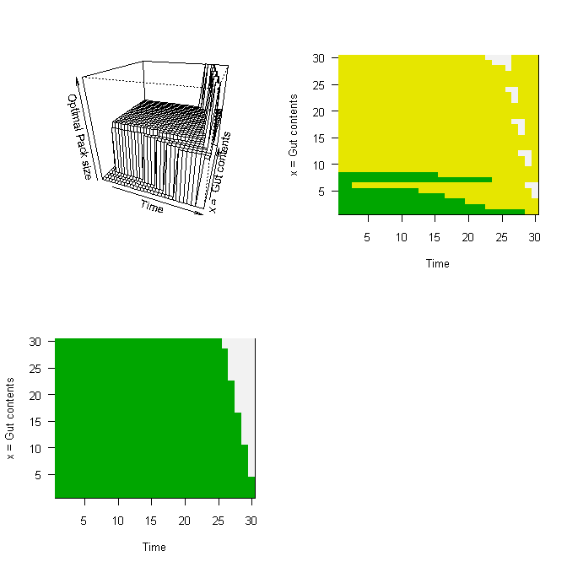

Scenario 4: Figure 6.4.
rm(list=ls()) # Remove all objects from memory
Xmax <- 40 # Maximum value of X = eggs
Xcritical <- 0 # Lowest value of X = 0 eggs
Xinc <- 1 # Increment in state variable
Max.Index <- 1 + (Xmax-Xcritical)/Xinc # Max Index value
# Create host coefficient matrix from which to get Benefits
Host.coeff <- matrix(0,4,4)
Host.coeff[1,] <- c(-0.2302, 2.7021, -0.2044, 0.0039)
Host.coeff[2,] <- c(-0.1444, 2.2997, -0.1170, 0.0013)
Host.coeff[3,] <- c(-0.1048, 2.2097, -0.0878, 0.0004222)
Host.coeff[4,] <- c(-0.0524, 2.0394, -0.0339, -0.0003111)
# Calculate benefit as a function of
# clutch size (rows) and Host type (columns)
Clutch <- seq(from = 0, to = Xmax)
Benefit <- matrix(0, Max.Index, 4) # Zero to Xmax
for (I.Host in 1:4) # Iterate over host types
{
Benefit[,I.Host] <- Host.coeff[I.Host,1] + Host.coeff[I.Host,2]*Clutch + Host.coeff[I.Host,3]*Clutch^2 + Host.coeff[I.Host,4]*Clutch^3
}
# Plot data
plot(Clutch, Benefit[,1],type='l', xlab='Clutch size',ylab="Female Fitness", las=1, lwd=4)
# lwd = line width, lty = line type,1=solid, 2=dashed, 3=dotted, 4=dotdash,
for (i in 2:4){lines(Clutch, Benefit[,i],type='l', lwd=4,lty=i)}
SHM <- c(9,12,14,23) # Set single host maximum. See text for derivation
# Make all values > than SHM=0. Note that we use 1 because of zero class
for (i in 1:4){Benefit[(SHM[i]+1):Max.Index,i] <- 0}
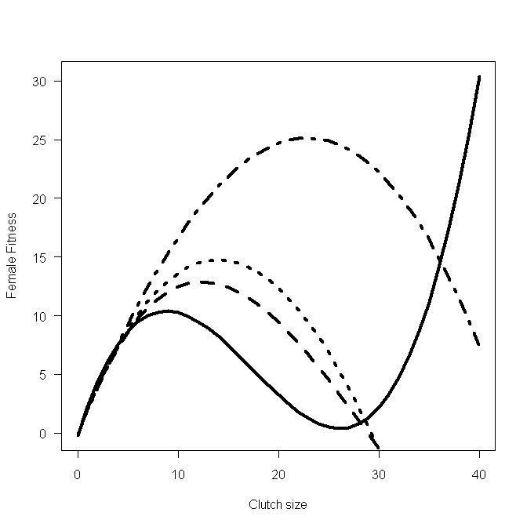
Scenario 4: Calculating the Decision matrix
rm(list=ls()) # Remove all objects from memory
# Set up path for output of text files
setwd("C:/Documents and Settings/Derek Roff/My Documents/ Modelling Evolution/DYNAMIC PROGRAMMING") # This will have to be changed for specific paths
# Function to iterate over patches i.e. over Hosts
OVER.PATCHES <- function(X, F.vectors, Xcritical, Xmax, Xinc, Npatch, Benefit, Pbenefit, Psurvival)
{
# Create matrix for storing best clutch size for each host type
Best.Clutch <- matrix(0,Npatch)
Index <- 1 + (X-Xcritical)/Xinc # Index for X is X+1
# Vector of clutch sizes to Index-1
Clutch <- seq(from =1, to = Index-1)
# Start fitness accumulation with component for case of not finding a host
W <- Psurvival*(1-sum(Pbenefit))*F.vectors[Index,2]
for (i in 1: Npatch) # Cycle over patches = Hosts
{
# Calculate "partial" fitness, W.partial for each clutch size
W.partial <- Benefit[2:Index,i] + Psurvival*F.vectors[Index-Clutch,2]
# Find largest W.partial and hence best clutch size
Best <- order(W.partial, na.last=TRUE, decreasing=TRUE)
Best.Clutch[i] <- Best[1] # Store value of best clutch for host i
# Increment fitness
W <- W + Pbenefit[i]*W.partial[Best[1]]
# Test for several equal optimal choices
# Only examine W.partial that contain more than one entry
if(length(W.partial)>1 & W.partial[Best[1]]==W.partial[Best[2]]) {print("Several possible equal choices")}
} # End of i loop
F.vectors[Index,1] <- W # Update F(x,t)
# Concatenate F(x,t,T) and the optimal clutch values for host type 2
Temp <- c(F.vectors[Index,1], Best.Clutch[2])
# Add Temp to bottom of F.vectors and rename to Temp
Temp <- rbind(F.vectors, Temp)
return (Temp)
} # End of function
#.........................................................................
# Function to iterate over states of X
OVER.STATES <- function(F.vectors, Xcritical, Xmax, Xinc, Npatch, Benefit, Pbenefit, Psurvival, Max.Index)
{
Store <- matrix(0,Max.Index,2) # Create matrix for output
for ( Index in 2 : Max.Index) # Iterate over states of X
{
# For given X call Over.Patches to determine F(x,t,T) and best patch
X <- (Index-1)*Xinc + Xcritical
Temp <- OVER.PATCHES(X, F.vectors, Xcritical, Xmax, Xinc, Npatch, Benefit, Pbenefit, Psurvival)
# Extract components. Last row is F(x,t) and best clutch size for host 2
n <- nrow(Temp)-1
F.vectors <- Temp[1:n,]
Store[Index,] <- Temp[n+1,] # Save F(x,t,T) and best clutch size
} # End of X loop
# Add Store values to end of F.vectors for pass back to main program
Temp <- cbind(F.vectors, Store) # Combined by columns
return(Temp) # Return F.vectors and Store
} # End of function
#.........................................................................
# MAIN PROGRAM
# Initialize parameters
Xmax <- 40 # Maximum value of X = eggs
Xcritical <- 0 # Lowest value of X = 0 eggs
Xinc <- 1 # Increment in state variable
Max.Index <- 1 + (Xmax-Xcritical)/Xinc # Max Index value
Psurvival <- 0.99 # Survival probty per time increment
Npatch <- 4 # Number of patches= hosts
# Create host coefficient matrix from which to get Benefits
Host.coeff <- matrix(0,4,4)
Host.coeff[1,] <- c(-0.2302, 2.7021, -0.2044, 0.0039)
Host.coeff[2,] <- c(-0.1444, 2.2997, -0.1170, 0.0013)
Host.coeff[3,] <- c(-0.1048, 2.2097, -0.0878, 0.0004222)
Host.coeff[4,] <- c(-0.0524, 2.0394, -0.0339, -0.0003111)
# Calculate benefit as a function of
# clutch size (rows) and Host type (columns)
Clutch <- seq(from = 0, to = Xmax)
Benefit <- matrix(0, Xmax+1, 4) # Zero to Xmax
for (I.Host in 1:4) # Iterate over host types
{
Benefit[,I.Host] <- Host.coeff[I.Host,1] + Host.coeff[I.Host,2]*Clutch + Host.coeff[I.Host,3]*Clutch^2 + Host.coeff[I.Host,4]*Clutch^3
}
Benefit[1,] <- 0 # Reset first row to zero
SHM <- c(9,12,14,23) # Set single host maximum. See text for derivation
# Make all values > than SHM=0. Note that we use 2 because of zero class
for (i in 1:4){Benefit[(SHM[i]+2):Max.Index,i] <- 0}
# Probability of encountering host type
Pbenefit <- c(0.05, 0.05, 0.1, 0.8)
Horizon <- 21 # Number of time steps
# Set up matrix for fitnesses
# Column 1 is F(x, t). Column 2 is F(x, t+1) Both are zero
F.vectors <- matrix(0, Max.Index,2)
# Create matrices for output
FxtT <- matrix(0,Horizon,Max.Index) # F(x,t,T)
# Best clutch size for host 2
Best.Patch <- matrix(0,Horizon,Max.Index)
# Start iterations
Time <- Horizon # Initialize Time
while ( Time > 1)
{
Time <- Time -1 # Decrement Time by 1 unit
# Call OVER.STATES to get best values for this time step
Temp <- OVER.STATES(F.vectors, Xcritical, Xmax, Xinc, Npatch, Benefit, Pbenefit, Psurvival, Max.Index)
# Extract F.vectors
TempF <- Temp[,1:2]
# Update F1
for ( J in 2: Max.Index) { F.vectors[J,2] <- TempF[J,1]}
# Store results
Best.Patch[Time,]<- Temp[,4]
FxtT[Time,] <- Temp[,3]
} # End of Time loop
# Output information. For display add states to last row of matrices
Index <- seq(from=1, to=Max.Index)
Best.Patch[Horizon,] <- (Index-1)*Xinc+Xcritical
FxtT[Horizon,] <- (Index-1)*Xinc+Xcritical
Best.Patch[,1:Max.Index] # Print Decision matrix
signif(FxtT[,1:Max.Index],3)# Print Fxt of Decision matrix: 3 sig places
# Plot data as 3d plot and colored grid
y <- Best.Patch[Horizon,2:Max.Index]
x <- seq(from=1, to=Horizon-1)
par(mfrow=c(2,2))
persp(x, y, Best.Patch[1:20,2:Max.Index], xlab='Time', ylab='x', zlab='Optimal clutch size', theta=20, ph=25, lwd=1) # 3D plot
image(x, y, Best.Patch[1:20,2:Max.Index], col=terrain.colors(50), xlab='Time', ylab='x', las=1) # Colored grid
# Output text file for future plotting to test predictions
DATA <- cbind(x, Best.Patch[1:Horizon-1,41])
DATA <- t(DATA)
write(DATA,file="OVIPOSITION.txt",nc=2)
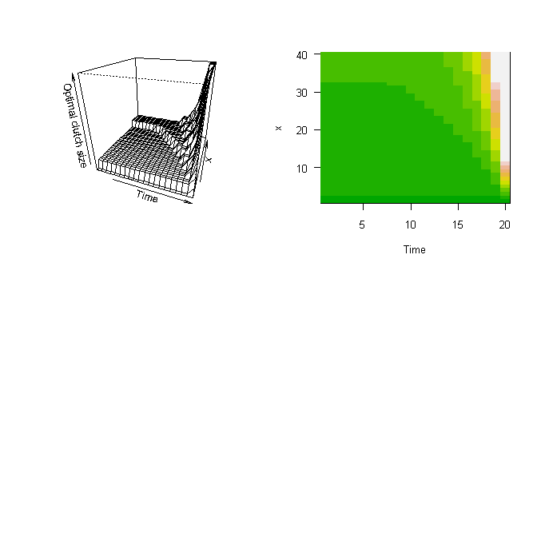

Scenario 4: Using the Decision Matrix: Individual Prediction
rm(list=ls()) # Remove all objects from memory
setwd("C:/Documents and Settings/Derek Roff/My Documents/Modelling Evolution/DYNAMIC PROGRAMMING")
Xmax <- 40 # Maximum value of X = eggs
DM1 <- read.table(file="DM1.txt") # Cols = x rows=time
DM2 <- read.table(file="DM2.txt")
DM3 <- read.table(file="DM3.txt")
DM4 <- read.table(file="DM4.txt")
# Create an array for Decision matrix
DM <- array(0,c(20,Xmax,4)) # time, state, host
for (i in 1:20)
{
for ( j in 1:Xmax)
{
DM[i,j,1] <- DM1[i,j]; DM[i,j,2] <- DM2[i,j]
DM[i,j,3] <- DM3[i,j];DM[i,j,4] <- DM4[i,j]
}}
# Probability of encountering host type
Pbenefit <- c(0.05, 0.05, 0.1, 0.8)
Times <- c(5,5,10,80)
# Create Vector for Host type probability
Host.Type <- c(rep(1,Times[1]),rep(2,Times[2]),rep(3,Times[3]), rep(4,Times[4]))
Psurvival <- 0.99 # Survival probability per time increment
Horizon <- 10 # Number of time steps
set.seed(10) # Initialise random number generator
N.Ind <- 1000 # Number of individuals
Output <- matrix(0,N.Ind,Horizon) # Allocate space for output
# Generate initial values of x from normal distribution
x.init <- ceiling(rnorm(N.Ind, mean=20, sd=5))
for (Ind in 1:N.Ind) # Iterate over individuals
{
# Generate vectors for choosing the Host type and probability of survival
Host <- ceiling(100*runif(Horizon)) # Vector of host types
Survival <- runif(Horizon) # Vector of survival probabilities
# Set all values of Survival > Psurvival = 0
Survival[Survival>Psurvival] <- 0
Survival[Survival!=0] <- 1 # Set all other values to 1
x <- x.init[Ind] # Initial value of x
for (Time in 1:Horizon) # Iterate over time periods
{
if( x>0) # If eggs remaining calculate clutch size using DM
{
Clutch.Size <- DM[Time,x,Host.Type[Host[Time]]]
Output[Ind,Time] <- Clutch.Size # Store clutch size
# Compute new value of x
x <- x-Clutch.Size
}
x <- x*Survival[Time] # Set x=0 if female does not survive
} # end of Time loop
} # End of Ind loop
par(mfcol=c(5,2)) # Set graphics page to 5 rows and 2 columns
# Iterate over time and plot bar graphs of clutch size
for (i in 1:10 )
{
Data <- Output[,i]; Data <- Data[Data>0] # Eliminate zeroes
xbar <- mean(Data) # Mean clutch size
print(c(i, mean(Data))) # Time, Output mean clutch size
Data <- table(Data) # Tabulate data
# Plot data using a bar graph, because x is integral
barplot(Data, xlab="Clutch Size", space=0, xlim=c(0,5), main = paste("Time = ",i), col=1)
}
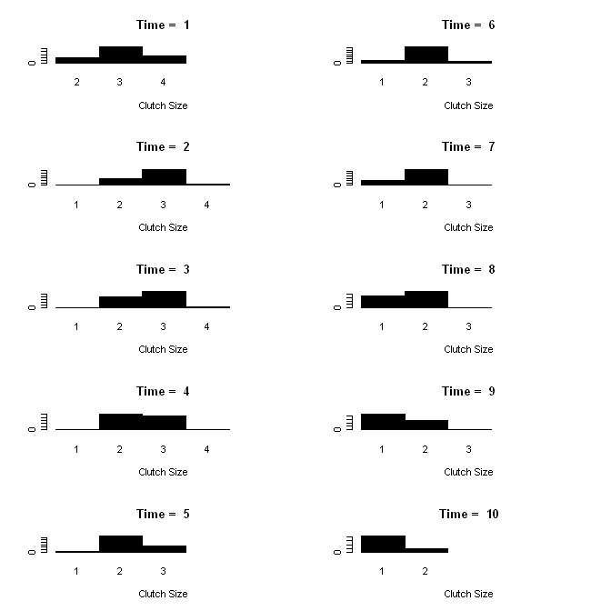

Scenario 5: Figure 6.9
rm(list=ls()) # Remove all objects from memory
# Function to calculate fitness, passing parameters to it
FITNESS <- function(X, Wmax, Xegg, Xclutch, ax, ay)
{
W <- Wmax-sqrt(ax*(X[1]-Xegg)^2 + ay*(X[2]-Xclutch)^2)
}
# MAIN PROGRAM
# Parameter values
Wmax <- c(10,20); Xegg <- c(2,1); Xclutch <- c(5,10); ax <- 100; ay <- 1
n <- 20 # Number of intervals for egg and clutch sizes
x <- seq(from=0, to=3 , length=n)# Generate egg sizes
y <- seq(from=0, to=30, length=n)# Generate clutch size
d <- expand.grid(x,y) # Expand to all combinations
# Set plotting page to put graphs side by side and not distorted
# Make plotting surface consist of four panels
par(mfrow=c(2,2))
for ( i in 1:2)
{
# Create a vector of fitness values for all combinations
Wtemp <- apply(d,1, FITNESS,Wmax[i], Xegg[i],Xclutch[i],ax,ay)
# Convert into matrix
W <- matrix(Wtemp,n,n,byrow=F)
# Plot contour. las=orientation of axis labels
# lwd= line width, labcex=size of contour labels
contour(x,y,W, xlab='Egg size, x', ylab='Clutch size,y', las=1, lwd=3, labcex=1)
#Plot perspective plot
persp(x,y,W,xlab='Egg size, x', ylab='Clutch size, y', zlab='Fitness, W',theta = 50, phi = 25,lwd=2)
}
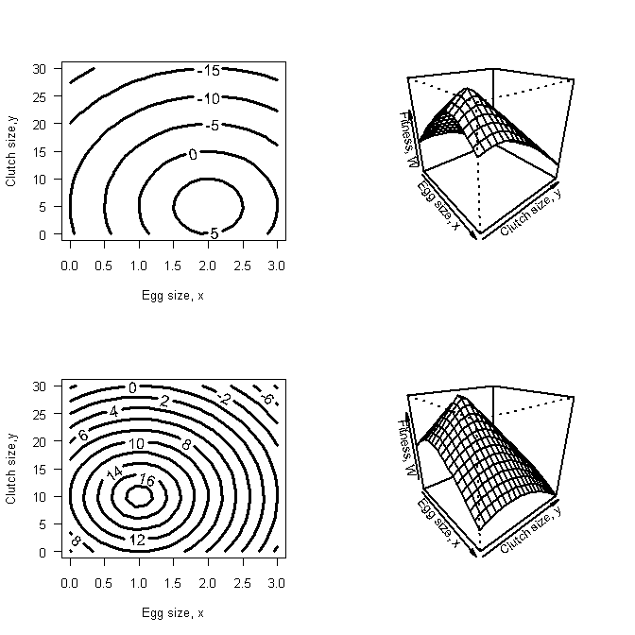

Scenario 5: Calculating the Decision matrix
rm(list=ls()) # Remove all objects from memory
FITNESS <- function (Egg, Clutch, X, F.vectors, Xcritical, Xmax, Xinc, Psurvival, Wmax, A, Xegg, Xclutch, Ith.Patch)
{
W <- 0 # Set fitness to zero
Biomass <- Clutch*Egg # Biomass of clutch/Egg size combination
if( Biomass < X) # Continue only if Biomass < X
{
Max.Index <- 1 + (Xmax-Xcritical)/Xinc # Get maximum index value
# Index value for biomass
Index <- 1+(Biomass-Xcritical)/Xinc
# Get fitness at lower and upper integer value of Biomass
Index.lower <- floor(Index)
Index.upper <- Index.lower + 1
# Must stop index exceeding Max.Index. Note that Qx = 0 in this case
Index.upper <- min(Index.upper, Max.Index)
Qx <- Biomass - floor(Biomass)
Fxt.lower <- F.vectors[Index.lower,2]
# Get fitness at upper integer value of
Fxt.upper <- F.vectors[Index.upper,2]
Fxt.interpolated <- Qx*Fxt.upper + (1-Qx)*Fxt.lower # Iterpolated value
# Calculate the fitness for this particular egg-clutch size combination
W <- Wmax[Ith.Patch]-sqrt(A[1]*(Egg-Xegg[Ith.Patch])^2 + A[2]*(Clutch-Xclutch[Ith.Patch])^2)
W <- max(0, W) # Set to zero if negative
W <- W + Psurvival*Fxt.interpolated # Fitness
W <- max(0, W) # Set to zero if negative
} # End of if
return(W)
} # End of function
#.........................................................................
# Function to iterate over patches i.e. over Hosts
OVER.PATCHES <- function(X, F.vectors, Xcritical, Xmax, Xinc, Npatch, Psurvival, Wmax, A, Xegg, Xclutch,P1)
{
# X is the total biomass available Get index value for X
Index <- 1+(X-Xcritical)/Xinc
# Allocate storage of best combinations for each patch
# Columns will contain
# Fitness, Clutch, Egg
Choice.Flag <- matrix(0,2) # Store information on number of choices
Best.in.Patch <- matrix(0,2,3) # Allocate storage for Best Decision
# Iterate over patches
for ( Ith.Patch in 1:Npatch) # Iterate over the two hosts (= patches)
{
# Make a matrix called W.host with the following 3 columns:
# Fitness, Egg size, Clutch size
W.host <- matrix(0,11 ,3)
for ( Clutch in 1:11) # Iterate over clutch size
{
W.host[Clutch,2] <- Clutch # Store clutch size
# Call optimize to find best egg size
B <- optimize(f =FITNESS, interval =c(0.01,3),Clutch, X,F.vectors, Xcritical, Xmax, Xinc, Psurvival, Wmax, A, Xegg, Xclutch,Ith.Patch, maximum=TRUE)
W.host[Clutch,1] <- B$objective # Fitness
W.host[Clutch,3] <- B$maximum # Egg size
} # End of clutch size loop
# Get best combination for this host
R <- W.host[,1]
Best <- order(R, na.last=TRUE, decreasing=TRUE)
Best.in.Patch[Ith.Patch,] <- W.host[Best[1],] # Store best choice
# Test for several equal optimal choices
if(W.host[Best[1],1]==W.host[Best[2],1])Choice.Flag[Ith.Patch] <- 2
} # Next host
# Overall fitness
W <- P1*Best.in.Patch[1,1] +(1-P1)*Best.in.Patch[2,1]
F.vectors[Index,1]<- W # Update F(x,t,T)
# Concatenate F(x,t) and the optimal egg and clutch values for both hosts
# We add to the bottom of the two column matrix F.vectors the following
# F.vectors[Index,1], 1 The second entry is simply a dummy variable
# Best.in.Patch[1,2] Best.in.Patch[1,3] # Host 1 Egg size Clutch size
# Best.in.Patch[2,2] Best.in.Patch[2,3] # Host 2 Egg size Clutch size
# Choice.Flag[1:2] # Flag for multiple optima
Temp1 <- c(F.vectors[Index,1], 1)
Temp2 <- c( Best.in.Patch[1,2], Best.in.Patch[1,3])
Temp3 <- c( Best.in.Patch[2,2], Best.in.Patch[2,3])
# Add Temp1, Temp2, Temp3 & Choice to bottom of F.vectors and rename to Temp
Temp <- rbind(F.vectors, Temp1, Temp2, Temp3, Choice.Flag[1:2])
return (Temp)
} # End of function
#.........................................................................
# Function to iterate over states of X
OVER.STATES <- function(F.vectors, Xcritical, Xmax, Xinc, Npatch, Psurvival, Max.Index, Wmax, A, Xegg, Xclutch, P1)
{
# Create matrix for output. Note that we use seven columns
Store <- matrix(0, Max.Index,7)
# Iterate over X = Biomass X[1] is zero so skip
for ( Index in 2 : Max.Index) # Iterate over states of X
{
# For given X call Over.Patches to determine F(x,t) and best patch
X <- (Index-1)*Xinc + Xcritical
Temp <- OVER.PATCHES(X, F.vectors, Xcritical, Xmax, Xinc, Npatch, Psurvival,Wmax, A, Xegg, Xclutch, P1)
# Extract components. Last row-2 is F(x,t) and dummy variable
# Last row-1 is best clutch and egg size for host type 1
# Last row is best clutch and egg size for host type 2
# Last row is flage indicating multiple equal choices
n <- nrow(Temp)-4
F.vectors<- Temp[1:n,] # Extracting F.vectors
# Add the seven output values (omit dummy) to storage
Store[Index,] <- c(Temp[n+1,1], Temp[n+2,1:2], Temp[n+3,1:2], Temp[n+4, 1:2])
} # End of X loop
# Add Store values to end of F.vectors for pass back to main program
Temp <- cbind(F.vectors, Store) # Combined by columns
return(Temp) # Return F.vectors and Store
} # End of function
#.........................................................................
# MAIN PROGRAM
# Initialize parameters
# Create the state variable (X=reproductive biomass)
Xmax <- 10; Xcritical <- 0; Xinc <- 1
Max.Index <- 1 + (Xmax-Xcritical)/Xinc
# Parameter values on the two hosts
Wmax <- c(10, 20) # Maximum fitness
A <- c(100, 1) # a coefficients
Xegg <- c( 2, 1) # "optimum" egg size
Xclutch <- c(5, 10) # "Optimum" clutch size
P1 <- 0.5 # Probability of host 1
Psurvival <- 0.90 # Survival probability per time increment
Npatch <- 2 # Number of patches= hosts
Horizon <- 10 # Number of time steps
# Set up matrix for fitnesses
# Column 1 is temporary F(x, t+1). Column 2 is F(x, t+1) Both are zero
F.vectors <- matrix(0, Max.Index,2)
# Create matrices for output
FxtT <- matrix(0,Horizon,Max.Index)# F(x,t)
Best.Clutch1 <- matrix(0,Horizon,Max.Index)# Best clutch size for host 1
Best.Clutch2 <- matrix(0,Horizon,Max.Index)# Best clutch size for host 2
Best.Egg1 <- matrix(0,Horizon,Max.Index)# Best egg size for host 1
Best.Egg2 <- matrix(0,Horizon,Max.Index)# Best egg size for host 2
Choice.H1 <- matrix(1,Horizon,Max.Index)# 1 or 2 choices for host type 1
Choice.H2 <- matrix(1,Horizon,Max.Index)# 1 or 2 choices for host type 2
# Start iterations
Time <- Horizon # Initialize Time
while ( Time > 1)
{
Time <- Time - 1 # Decrement Time by 1 unit
# Call OVER.STATES to get best values for this time step
Temp <- OVER.STATES(F.vectors, Xcritical, Xmax, Xinc, Npatch, Psurvival, Max.Index, Wmax, A, Xegg, Xclutch, P1)
# Extract F.vectors
TempF <- Temp[,1:2]
# Update F1
for ( J in 2: Max.Index) { F.vectors[J,2] <- TempF[J,1]}
# Store results
FxtT[Time,] <- Temp[,3]
Best.Clutch1[Time,] <- Temp[,4]
Best.Egg1[Time,] <- Temp[,5]
Best.Clutch2[Time,] <- Temp[,6]
Best.Egg2[Time,] <- Temp[,7]
Choice.H1[Time,] <- Temp[,8]
Choice.H2[Time,] <- Temp[,9]
} # End of Time loop
# Output information. For display add states to last row of matrices
Index <- seq(from=1, to=Max.Index)
FxtT[Horizon,] <- (Index-1)*Xinc+Xcritical
Best.Clutch1[Horizon,] <- (Index-1)*Xinc+Xcritical
Best.Clutch2[Horizon,] <- (Index-1)*Xinc+Xcritical
Best.Egg1[Horizon,] <- (Index-1)*Xinc+Xcritical
Best.Egg2[Horizon,] <- (Index-1)*Xinc+Xcritical
Choice.H1[Horizon,] <- (Index-1)*Xinc+Xcritical
Choice.H2[Horizon,] <- (Index-1)*Xinc+Xcritical
# Print Best clutch, best egg choice flag and decision matrix
Best.Clutch1[,1:Max.Index] # Best clutch on host 1
Best.Clutch2[,1:Max.Index] # Best clutch on host 2
signif(Best.Egg1[,1:Max.Index],3) # Best egg on host 1
signif(Best.Egg2[,1:Max.Index],3) # Best egg on host 2
Choice.H1[,1:Max.Index] # 1=only 1 choice 2 =1+
Choice.H2[,1:Max.Index] # 1=only 1 choice 2 =1+
signif(FxtT[,1:Max.Index],3)# Print Fxt of Decision matrix: 3 sig places

> Best.Clutch1[,1:Max.Index] # Best clutch on host 1
[,1] [,2] [,3] [,4] [,5] [,6] [,7] [,8] [,9] [,10] [,11]
[1,] 0 1 1 2 2 3 3 4 4 4 5
[2,] 0 1 1 2 2 3 3 4 4 4 5
[3,] 0 1 1 2 2 3 3 4 4 4 5
[4,] 0 1 1 2 2 3 3 4 4 4 5
[5,] 0 1 1 2 2 3 3 4 4 4 5
[6,] 0 1 1 2 2 3 3 4 4 4 5
[7,] 0 1 1 2 2 2 3 3 4 4 5
[8,] 0 1 1 1 2 2 3 3 4 4 5
[9,] 0 1 1 1 2 2 3 3 4 4 5
[10,] 0 1 2 3 4 5 6 7 8 9 10
> Best.Clutch2[,1:Max.Index] # Best clutch on host 2
[,1] [,2] [,3] [,4] [,5] [,6] [,7] [,8] [,9] [,10] [,11]
[1,] 0 1 1 2 3 4 5 6 6 7 8
[2,] 0 1 1 2 3 4 5 6 6 7 8
[3,] 0 1 1 2 3 4 5 6 6 7 8
[4,] 0 1 1 2 3 4 5 6 6 7 8
[5,] 0 1 1 2 3 4 5 6 6 7 8
[6,] 0 1 1 2 3 4 5 6 6 7 8
[7,] 0 1 1 2 3 4 5 6 6 7 8
[8,] 0 1 1 2 3 4 5 6 6 7 8
[9,] 0 1 1 2 3 4 5 6 6 7 8
[10,] 0 1 2 3 4 5 6 7 8 9 10
> signif(Best.Egg1[,1:Max.Index],3) # Best egg on host 1
[,1] [,2] [,3] [,4] [,5] [,6] [,7] [,8] [,9] [,10] [,11]
[1,] 0 3 2 1.50 2 1.67 2 1.75 2 2.04 2
[2,] 0 3 2 1.50 2 1.67 2 1.75 2 2.04 2
[3,] 0 3 2 1.50 2 1.67 2 1.75 2 2.04 2
[4,] 0 3 2 1.50 2 1.67 2 1.75 2 2.04 2
[5,] 0 3 2 1.50 2 1.67 2 1.75 2 2.04 2
[6,] 0 3 2 1.50 2 1.67 2 1.75 2 2.04 2
[7,] 0 3 2 1.50 2 2.05 2 2.04 2 2.03 2
[8,] 0 3 2 2.02 2 2.03 2 2.03 2 2.02 2
[9,] 0 3 2 2.00 2 2.00 2 2.00 2 2.00 2
[10,] 0 1 2 3.00 4 5.00 6 7.00 8 9.00 10
> signif(Best.Egg2[,1:Max.Index],3) # Best egg on host 2
[,1] [,2] [,3] [,4] [,5] [,6] [,7] [,8] [,9] [,10] [,11]
[1,] 0 3 2 1.50 1.33 1.25 1.2 1.17 1.33 1.26 1.25
[2,] 0 3 2 1.50 1.33 1.25 1.2 1.17 1.33 1.26 1.25
[3,] 0 3 2 1.50 1.33 1.25 1.2 1.17 1.33 1.26 1.25
[4,] 0 3 2 1.50 1.33 1.25 1.2 1.17 1.33 1.25 1.25
[5,] 0 3 2 1.50 1.33 1.25 1.2 1.17 1.33 1.24 1.25
[6,] 0 3 2 1.50 1.33 1.24 1.2 1.17 1.33 1.22 1.25
[7,] 0 3 2 1.45 1.33 1.20 1.2 1.17 1.24 1.16 1.25
[8,] 0 3 2 1.07 1.20 1.11 1.2 1.11 1.11 1.10 1.21
[9,] 0 3 1 1.00 1.00 1.00 1.0 1.00 1.00 1.00 1.00
[10,] 0 1 2 3.00 4.00 5.00 6.0 7.00 8.00 9.00 10.00
> Choice.H1[,1:Max.Index]# 1=only 1 choice 2 =1+
[,1] [,2] [,3] [,4] [,5] [,6] [,7] [,8] [,9] [,10] [,11]
[1,] 0 2 0 0 0 0 0 0 0 0 0
[2,] 0 2 0 0 0 0 0 0 0 0 0
[3,] 0 2 0 0 0 0 0 0 0 0 0
[4,] 0 2 0 0 0 0 0 0 0 0 0
[5,] 0 2 0 0 0 0 0 0 0 0 0
[6,] 0 2 0 0 0 0 0 0 0 0 0
[7,] 0 2 0 0 0 0 0 0 0 0 0
[8,] 0 2 0 0 0 0 0 0 0 0 0
[9,] 0 2 0 0 0 0 0 0 0 0 0
[10,] 0 1 2 3 4 5 6 7 8 9 10
> Choice.H2[,1:Max.Index]# 1=only 1 choice 2 =1+
[,1] [,2] [,3] [,4] [,5] [,6] [,7] [,8] [,9] [,10] [,11]
[1,] 0 2 0 0 0 0 0 0 0 0 0
[2,] 0 2 0 0 0 0 0 0 0 0 0
[3,] 0 2 0 0 0 0 0 0 0 0 0
[4,] 0 2 0 0 0 0 0 0 0 0 0
[5,] 0 2 0 0 0 0 0 0 0 0 0
[6,] 0 2 0 0 0 0 0 0 0 0 0
[7,] 0 2 0 0 0 0 0 0 0 0 0
[8,] 0 2 0 0 0 0 0 0 0 0 0
[9,] 0 2 0 0 0 0 0 0 0 0 0
[10,] 0 1 2 3 4 5 6 7 8 9 10
> signif(FxtT[,1:Max.Index],3)# Print Fxt of Decision matrix: 3 sig places
[,1] [,2] [,3] [,4] [,5] [,6] [,7] [,8] [,9] [,10] [,11]
[1,] 0 0 39.4 46.4 59.1 60.6 69.3 70.7 73.3 74.3 82.3
[2,] 0 0 36.8 43.4 55.0 56.4 64.5 65.8 68.2 69.2 76.6
[3,] 0 0 33.9 40.0 50.4 51.8 59.1 60.3 62.5 63.6 70.2
[4,] 0 0 30.7 36.3 45.3 46.6 53.1 54.2 56.3 57.3 63.1
[5,] 0 0 27.1 32.1 39.7 40.9 46.4 47.5 49.3 50.3 55.3
[6,] 0 0 23.2 27.5 33.4 34.5 39.0 40.0 41.6 42.6 46.5
[7,] 0 0 18.8 22.4 26.4 27.5 30.8 31.7 33.0 33.9 36.8
[8,] 0 0 13.9 16.7 18.7 19.6 21.7 22.4 23.4 24.1 26.0
[9,] 0 0 8.5 9.0 10.0 10.5 11.5 12.0 12.5 13.0 14.0
[10,] 0 1 2.0 3.0 4.0 5.0 6.0 7.0 8.0 9.0 10.0
MATLAB CODES
MATLAB CODE FOR CHAPTER 2
18.1 Scenario 1: Plotting the Fitness Function
clear all
ezplot('-2*x^2+4*x',[0,2]) % the [0,2] defines the min and max values of x
xlabel('Body size'); ylabel('Fitness')
OR
clear all
x = 0:0.01:2; % Create vector from 0 to .2 in steps of 0.01
plot(x,-2*x.^2+4*x) % Plot function using vector notation
xlabel('Body size'); % Label x axis
ylabel('Fitness'); % Label y axis

18.2 Scenario 1: Finding the Maximum using the Calculus
Symbolic differentiation can be done in MATLAB with the command diff:

% To differentiate the function and store the result in y
syms x; y=diff(-2*x^2+4*x);

% Print solution
y

OUTPUT: y = -4*x+4

The value at which the derivative is zero (i.e. y = 0) can now be found using the command solve
% Find value at which y = 0
solve(y)

OUTPUT: ans = 1

18.3 Scenario 1: Finding the Maximum using a Numerical Approach

% Find minimum using the routine fminbnd setting the search limits at -2, 4
% Define function such that minimum is turning point
% and pass function directly to fminbnd
fminbnd('-(-2*x^2+4*x)', -2,4) % search limits at -2, 4
OR

% Define the anonymous function such that minimum is turning point
FITNESS =@(x)(-(-2*x^2+4*x));
fminbnd(FITNESS,-2,4) % search limits at -2, 4
OR

% Define the inline function such that minimum is turning point
FITNESS = inline('-(-2*x^2+4*x)','x');
fminbnd(FITNESS, -2,4) % search limits at -2, 4

18.4 Scenario 3: Plotting the Fitness Function
All commands are placed into the main program and summation done using the symbolic summation routine symsum. In this case a loop is used to calculate the summed value for each value of n
clear all % Clear workspace
syms t; % Define t as a symbol for the summation routine
nmax=20; % Set the maximum number of ages
n = 1:nmax; % Create a vector of n from 1 to nmax
% Create an equal length vector to store the sums.
% Present values will be replaced
s = 1: nmax; % Vector called s
x = 1; % Set value of x to 1
for n1 = 1:nmax; %Iterate from n=1 to n=nmax
% Call symsum for summation 1,n1
s(n1)= symsum(4*x*exp(-(1+0.5*x)*t),1,n1);
end
plot(n,s) % Plot results
xlabel('MAXIMUM AGE'); ylabel('SUM') % Label axes
The plot is, of course, identical to the previous, from which we concluded that n=20 would be a sufficient interval of summation. To plot fitness, W, as a function of size, x, we proceed as follows:

1) Create a function that makes use of the symbolic summation routine symsum and store this in an M file called FITNESS.m.
function w=FITNESS(x) % Function to do symbolic summation
syms t; % Define t as a symbol
w=symsum(4*x*exp(-(1+0.5*x)*t),1,20); % Sum over ages 1 to 20
OR

Create a function that makes use of sum to do the summation explicitly and store this in an M file called FITNESS.m.
function w=FITNESS(x) % Function to do summation
Age = 1:20; % Create a vector of ages 1 to 20
w = sum(4*x*exp(-(1+0.5*x)*Age)); % Create vector of fitness and sum it

2) Use fplot to increment over values of x and plot the result
clear all % Clear the workspace
fplot(@FITNESS,[0,5])% call FITNESS function lower and upper limits=0,5
xlabel('SIZE'); ylabel('FITNESS'); % Label axes

18.5 Scenario 3: Finding the Maximum by the Calculus
Because the right hand side of the equation is zero it can be omitted in solve
solve('(4)+(0+4*x)*(-0.5)+(0+4*x)*(-1)*(0.5*exp(-(1+0.5*x)))/(1-exp(-(1+0.5*x)))')

OUTPUT: ans = 1.6828113208739212756932093160250
-4.2923864412411651704741220570427

18.6 Scenario 3: Finding the Maximum using a Numerical Approach
We shall the explicit summation function. Note that, as above, because we will be using a minimization routine, we take the negative value of the sum
function w=FITNESS(x) % Function to do summation
Age = 1:20; % Create a vector of ages 1 to 20
w = -sum(4*x*exp(-(1+0.5*x)*Age)); % Create vector of fitness and sum it
We now use the previously used minimization routine fminbnd,setting the limits at 0.5 and 2, as found from the graph (Fig 2.3)
fminbnd(@FITNESS,0.5,2) % Note the @ placed before the function name

OUTPUT: ans = 1.6828

18.7 Scenario 4: Plotting the Fitness Function

MATLAB has a symbolic integration routine int
int('(Af+Bf*x)*exp(-(As+Bs*x)*t)','t')
OUTPUT: ans =-1/(As+Bs*x)*(Af+Bf*x)*exp(-(As+Bs*x)*t)
To obtain a somewhat nicer looking output we can use the command pretty
pretty(int('(Af+Bf*x)*exp(-(As+Bs*x)*t)','t'))
OUTPUT
ans = (Af + Bf x) exp(-(As + Bs x) t)
- -------------------------------

As + Bs x
To use int to plot W versus x we first make a function stored in FITNESS.m
function w=FITNESS(x)% Function to evaluate fitness
syms t % Make t a symbol
f = (0+4*x)*exp(-(1+0.5*x)*t); % Create function
w=int(f,1,100); % Call function that calculates integral 1 to 100
We then call this function in the following program
clear all % Clear the workspace
x = linspace(0,5,100); % 100 equal spaced values from 0 to 5
% Create a vector of fitnesses the same length as x
% Note that these initial entries are replaced
W = x; % Preallocate space to W
for i =1:100 % iterate over all values of x
W(i)=FITNESS(x(i));
end; % End of loop
plot(x, W) % Plot W as a function of size
xlabel('SIZE'); ylabel('FITNESS'); % Label axes
If the integral is one that cannot be integrated symbolically then one can use one of the numerical integration functions, such as quad. First create the fitness function FITNESS stored in an m file:
function w=FITNESS(x) % Function to evaluate fitness numerically
% Call function that calculates integral 1 to 100
w=quad(@(t)(0+4*x)*exp(-(1+0.5*x)*t),1,100);
Then to plot we use
clear all % Clear the workspace
fplot(@FITNESS,[0,5])% Call fplot to plot FITNESS function
xlabel('SIZE'); ylabel('FITNESS'); % Label axes

18.8 Scenario 4: Finding the Maximum using the Calculus
syms x;
y = diff((0+4*x)*exp(-(1+0.5*x))/(1+0.5*x))
OUTPUT:
y = 4*exp(-1-1/2*x)/(1+1/2*x)-2*x*exp(-1-1/2*x)/(1+1/2*x)-2*x*exp(-1-1/2*x)/(1+1/2*x)^2
The above expression is formidable looking but, as with the R code, it can be stored in y and need not be shown.
As with the R code two routes are possible, supplying the derivative directly and letting MATLAB calculate it. The roots are then found using solve.
solve('4-0.5*(0+4*x)-(0+4*x)*0.5/(1+0.5*x)') % Finding the roots
OR
syms x;

y = diff((0+4*x)*exp(-(1+0.5*x))/(1+0.5*x))
vpa(solve(y),5) % Find the roots, outputting value to 5 decimal places

OUTPUT (from first code, second code giving only 5 decimal places)
ans = -3.2360679774997896964091736687313

1.2360679774997896964091736687313
As before, only the second answer is physically possible.
18.9 Scenario 4: Finding the Maximum using a Numerical Approach
First create the function FITNESS
function w=FITNESS(x)
w=-quad(@(t)(0+4*x)*exp(-(1+0.5*x)*t),1,100); % Numerical integration
We now use the previously used minimization routine fminbnd setting the limits at 0.5 and 2, as found from the graph (Fig 2.4)
fminbnd(@FITNESS, 0.5, 2)
OUTPUT: ans = 1.2361

18.10 Scenario 5: Plotting the Fitness Function

Using the program to do the integration
We use the function quad to do the numerical integration of the characteristic (also called the Euler) function and pass 1 minus its value back. This function does not accept infinity and so we set the upper integration limit at a large value, here 100. Note that we pass x and r:
function y=EULER(r,x) % Function to evaluate 1-Euler equation
Af=0;Bf=16;As=1;Bs=0.5; % Set parameter values
y=1-quad(@(t)(Af+Bf*x)*exp(-(As+Bs*x+r)*t),1,100); % 1-integral
Now we iterate over values of x using fzero to find value of r (=fitness= W) for each value of x
clear all % Clear the workspace
x=linspace(0.5,3,100); % Generate 100 values between 0 and 3
W=x; % Preallocate values to w. Will be changed
for i = 1:100; % Iterate over values of x
% 1-Euler value is in function Euler
W(i)=fzero(@(r) EULER(r,x(i)),0.5); % Use fzero to calculate r
end;
plot(x,W); % Plot fitness=r on x
xlabel('SIZE'); ylabel('FITNESS'); % Label axes

User supplied solution to the integral
function y=EULER(r,x) % Function to evaluate fitness
Af=0;Bf=16;As=1;Bs=0.5; % Set parameter values
y =1-exp(-(r+As+Bs*x))*(Af+Bf*x)/(As+Bs*x+r);% 1-RHS of equation
As with the R commands, the MATLAB main program is not changed.
18.11 Scenario 5: Finding the Maximum using the Calculus
First define a function called FITNESS to calculate equation
function w=FITNESS(x); % Function to evaluate fitness
Af=0;Bf=16;As=1;Bs=0.5; % Set parameter values
r = Bs*(Af+Bf*x)/(Bf-Bs*Af-Bs*Bf*x)-Bs*x-As; % r from eqn
w =(log(Af+Bf*x)-(As+Bs*x+r)-log(As+Bs*x+r)); % equation
Call function with
clear all % Clear the workspace
x=fzero(@FITNESS,[1.2,1.8]) % Use fzero to calculate r
OUTPUT: x = 1.3899

18.12 Scenario 5: Finding the Maximum using a Numerical Approach
We define two functions, EULER, which calculates 1-characteristic equation given r and x (two versions given below) and RFUNC which calculate the value of r using fzero calling EULER. The optimal value of x is found by calling fminbind.
function y=EULER(r,x) % Function to evaluate 1-Euler equation
Af=0;Bf=16;As=1;Bs=0.5; % Set parameter values
y=1-quad(@(t)(Af+Bf*x)*exp(-(As+Bs*x+r)*t),1,100); % 1-integral
OR using the integrated function
function y=EULER(r,x) % Function to evaluate fitness
Af=0;Bf=16;As=1;Bs=0.5; % Set parameter values
y =1-exp(-(r+As+Bs*x))*(Af+Bf*x)/(As+Bs*x+r);% 1-RHS of equation
Above called by
function Rvalue=RFUNC(x)
Rvalue = fzero(@(r) EULER(r,x),0.5); % Use fzero to calculate r
Rvalue = -Rvalue; % Pass –r back
Main program
clear all; % Clear the workspace
fminbnd(@RFUNC,1.2,1.8); % Use fminbnd to find minimum of –fitness
OUTPUT: ans = 1.3899

18.13 Scenario 6: Plotting the Fitness Function

This is essentially the same as the R code
clear all; % Clear the workspace
Af = 2; Bf = 2; % Invariant parameter values
Amin = 0.3; Amax = 1; % Min and max values of aS
Bmin = 0; Bmax = 0.2; % Min and max values of bS
Amean = (Amax+Amin)/2; % Mean value of aS
Bmean = (Bmax+Bmin)/2; % Mean value of bS
% Calculate n parameter combinations
n = 1000; % Number of values of aS and bS to generate
% We are assuming a uniform distribution of values
rand('twister', 10); % Set the random number seed
% Generate n random numbers from Bmin to Bmax
Bs = Bmin+(Bmax-Bmin)*rand(n,1);
% Generate n random numbers from Amin to Amax
As = Amin+(Amax-Amin)*rand(n,1);
x = linspace(0,6,100); % Body sizes from 0 to 6
W = zeros(100,2); % Matrix to take fitness values
for i = 1: 100 % Iterate over x values
Surv = As-Bs*x(i); % Vector of survivals
% Check that no survival < 0. If so then set to zero
Surv(Surv<0) = 0;
% Check that no survival > 1. If so then set to 1
Surv(Surv>1) = 1;
% Column 1 contains fitness for variable parameters
W(i,1) = mean((Af+Bf*x(i))*Surv);
% Col 2 contains fitness using mean parameter values
W(i,2) = (Af+Bf*x(i))*(Amean-Bmean*x(i));
end
% Plot fitness=W vs x for both columns on same graph
plot(x,W(:,1)) % Plot first line
xlabel('Body size, x');ylabel('Fitness, W');
hold on % Keep plot for next line
plot(x,W(:,2),':') % Plot second line with dashes

18.14 Scenario 6: Finding the Maximum using the Calculus
As with the R code there is a function, INTEGRAND, to generate the fitness value for a given x and a function, FITNESS, that calls the numerical integration routine dblquad which takes INTEGRAND as its input. Two points are worth noting. First, we have to pass an extra parameter, x to the integration routine and second we have to compress the fitness equation given in INTEGRAND into a single line. This is done by making use of the routines min and max. The survival equation is As-Bs*x, except that it is bounded at 0 and 1. This is specified by nesting the min and max routines: min(max((As-Bs*x),0),1). The inner routine ensures that survival does not go below 0 and the outer routine ensures that it does not exceed 1 (we could have used the same code in R but it is not as clear and makes little difference to the speed of execution).
function f=INTEGRAND(As,Bs,x) % Function to integrate function
Af = 2; Bf = 2; Ca = 1/0.7; Cb = 5; % Invariant parameter values
f=(Af+Bf*x)*min(max((As-Bs*x),0),1)*Cb*Ca;% Fitness vector
Function to calculate fitness
function W=FITNESS(x) % Function to evaluate fitness
Amin = 0.3; Amax = 1; % Min and max values of As
Bmin = 0; Bmax = 0.2; % Min and max values of Bs
% Double integral. Note that x is passed also
W =dblquad(@(As,Bs) INTEGRAND(As,Bs,x),Amin,Amax,Bmin,Bmax);
W=-W; % Negative of fitness
Main program
clear all; % Clear the workspace
fminsearch(@FITNESS,2) % Find minimum, starting with 2
OUTPUT: ans = 3.3703
The answer given by MATLAB agrees with that obtained using optimize in R.

18.15 Scenario 6: Finding the Maximum using a Numerical Approach

The fitness function uses the same general structure as previously used in INTEGRAND
function W=FITNESS(x,As,Bs) % Function to evaluate fitness given Alpha
Af=2; Bf=2; Ca=1/0.7; Cb=5; % Invariant parameter values
W = mean((Af+Bf*x)*min(max((As-Bs*x),0),1)*Cb*Ca); % Fitness vector
W = -W; % Return negative of fitness
Main program
clear all; % Clear the workspace
Amin = 0.3; Amax = 1; % Min and max values of As
Bmin = 0; Bmax = 0.2; % Min and max values of Bs
% Calculate n parameter combinations
n = 10000; % Number of values of As and Bs to generate
% We are assuming a uniform distribution of values
% Make several runs. Here we use 10
REP = zeros(10,1); % Create matrix to hold replicate
% We are assuming a uniform distribution of values
rand('twister', 100); % Set the random number seed
for i = 1:10 % Iterate over replicates
Bs = Bmin+(Bmax-Bmin)*rand(n,1); % Vector of values of Bf
As = Amin+(Amax-Amin)*rand(n,1); % Vector of values of As
REP(i)= fminsearch(@(x) FITNESS(x,As,Bs), 2); % Pass As,Bs as well as x
end
[mean(REP) std(REP)] % Print mean and standard deviation
OUTPUT: ans = 3.3786 0.0516
18.16 Scenario 7: Plotting the Fitness Function
Differs slightly from R code in that W rather than -log W is returned
function W=FITNESS(x) % Function to evaluate fitness
Af = 2; Bf = 2 ; As = 0.6; % Parameter values
pBs = [0.1,0.3,0.4,0.2]; % Vector of probabilities for Bs
Bs = [0.1,0.12,0.14,0.2]; % Vector of Bs values
W_ind = (Af+Bf*x)*(As-Bs*x); % Fitness values for each Bs value
% log Fitness. Note use of "." to denote element by element multiply
log_W = -sum(pBs.*log(W_ind));
W = exp(-log_W); % Send back fitness
Main program
clear all; % Clear the workspace
fplot(@FITNESS, [0,2.999]) % Plot. Note W =INF at x=3
xlabel('SIZE'); ylabel('FITNESS');
18.17 Scenario 7: Finding the Maximum using the Calculus
Calculating the optimum using equation
function D=DERIV(x) % Function to calculate value of derivative
Af = 2; Bf = 2 ; As = 0.6; % Parameter values
pBs = [0.1,0.3,0.4,0.2]; % Vector of probabilities for Bs
Bs = [0.1,0.12,0.14,0.2]; % Vector of Bs values
% Derivative Note "." for multiplying element by element
D = sum(pBs.*(As*Bf-Af*Bs-Bf*Bs*2*x)./((Af+Bf*x)*(As-Bs*x)));
Main program
clear all; % Clear the workspace
fzero(@DERIV,2) % Call fzero to find root
OUTPUT
ans = 1.5457
Computing the derivative using the fitness function directly
First we get the derivative with respect to x with pBs and Bs entered as symbolic,
clear all; % Clear the workspace
Af = 2; Bf = 2 ; As = 0.6; % Parameter values
syms x; syms pBs; syms Bs; % Make symbolic parameters
dx = diff(pBs*log((Af+Bf*x)*(As-Bs*x)),x) % Get differential
OUTPUT: dx =pBs*(6/5-2*Bs*x-(2+2*x)*Bs)/(2+2*x)/(3/5-Bs*x)
We can now use the previous code to find the solution, except that vector notation is not used (it will supply an answer but not the correct one).
function D=DERIV(x) % Function to calculate value of derivative
Af = 2; Bf = 2 ; As = 0.6; % Parameter values
pBs = [0.1,0.3,0.4,0.2]; % Vector of probabilities for Bs
Bs = [0.1,0.12,0.14,0.2]; % Vector of Bs values
D=0; % Set D to zero and sum derivative values
for i=1:4 % Iterate over Bs values
D = D+ pBs(i)*(6/5-2*Bs(i)*x-(2+2*x)*Bs(i))/(2+2*x)/(3/5-Bs(i)*x);
end
Main program
clear all; % Clear the workspace
fzero(@DERIV,2) % Find root
OUTPUT: ans = 1.5457
18.18 Scenario 7: Finding the Maximum using Numerical Methods
function W=FITNESS(x) % Function to evaluate fitness
Same as function used in plotting except last line is changed to return the negative of the fitness
W = -exp(-log_W); % Send back negative of fitness
Main program
clear all; % Clear the workspace
fminsearch(@FITNESS,2) % Call fminsearch giving 2 as starting estimate
OUTPUT: ans = 1.5457
18.19 Scenario 8: Plotting the Fitness Function
There are two approaches, depending on the fitness function:
Approach 1: Fitness function can be integrated

The above fitness function can be simplified for the purposes of integration by rewriting equation as

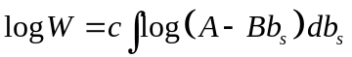

where 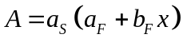 and 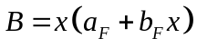. Now using MATLAB code

int('log((A-B*Bs))','Bs')

gives the output

ans = -1/B*log(A-B*Bs)*A+log(A-B*Bs)*Bs+1/B*A-Bs
The definite integral of equation is readily obtained from the above using the following function:
function y=INTEGRAND(x) % Function to integrate function
Af = 2; Bf = 2 ; As = 0.6; c=5; % Parameter values
A=As*(Af+Bf*x);B=x*(Af+Bf*x); % Define A and B
Bmin = 0.0; Bmax=0.2; % Set limits of integration
% Get upper and lower values of integral
Wmin=c*(-1/B*log(A-B*Bmin)*A+log(A-B*Bmin)*Bmin+1/B*A-Bmin);
Wmax=c*(-1/B*log(A-B*Bmax)*A+log(A-B*Bmax)*Bmax+1/B*A-Bmax);
y = exp(Wmax-Wmin); % Fitness
Main Program
clear all; % Clear the workspace
fplot(@INTEGRAND, [1 3]); % Plot function
xlabel('Body size'); ylabel('Fitness'); % Add axis labels
Approach 2: Fitness function cannot be integrated symbolically.
In this case we use the numerical integration routine quad:
function W=INTEGRAND(x) % Function to integrate function
Af = 2; Bf = 2 ; As = 0.6; c=5; % Parameter values
Bmin = 0.0; Bmax=0.2; % Set limits of integration
syms Bs; % Define Bs to be symbolic
y=quad(@(Bs) c*log((Af+Bf*x)*(As-Bs*x)), Bmin, Bmax); % integrate
W=exp(y)
Main program
clear all; % Clear the workspace
fplot(@INTEGRAND, [1 3]); % Call plotting routine
xlabel('Body size'); ylabel('Fitness');

18.20 Scenario 8: Finding the Maximum using a Numerical Approach
Fitness is calculated using the function INTEGRAND previously used in plotting, except that the last line is changed to pass the negative of the fitness value: W = -exp(y). The main program is then
clear all; % Clear the workspace
fminsearch(@INTEGRAND,2) % Find minimum
OUTPUT: ans = 2.0323

18.21 Scenario 9: The derivative can also be determined using MATLAB
clear all % Clear the workspace

% Designate parameters and variables as symbolic
syms Axy; syms A0; syms Bxy;
syms Cxy; syms Byx; syms Cyx;
syms x; syms y;
f = Axy*x*y-A0+Bxy*x-Cxy*x^2+Byx*y-Cyx*y^2 % Function
diff(f,x) % Differentiate with respect to x
diff(f,y) % Differentiate with respect to y
OUTPUT : ans = Axy*y+Bxy-2*Cxy*x
ans = Axy*x+Byx-2*Cyx*y

18.22 Scenario 9: Plotting the Fitness Function
clear all % Clear the workspace
x = linspace(1, 3, 20); % x from 1 to 3 length 20
y = linspace(1, 3, 20); % y from 1 to 3 length 20
[xx,yy]=meshgrid(x,y); % Create a grid
A0=0.8;Bxy=0.8;Byx=0.8; % parameter values
Axy=0.4;Cxy=0.4;Cyx=0.4; % Parameter values
% Fitness values at each x y coordinate
% Note use of "." to denote vectors
zz=(Axy.*xx.*yy-A0)-(-Bxy.*xx+Cxy.*xx.^2)-(-Byx.*yy+Cyx.*yy.^2);
subplot(2,2,1); % Divide graph sheet into 4 and plot contour in top left
[C,h]=contour(x,y,zz); % Create contour plot
%clabel(C,h) rotates the labels and inserts them in the contour lines.
clabel(C,h);
xlabel('Foraging'); ylabel('Vigilance'); % Add text
subplot(2,2,2);% Divide graph sheet into 4 and plot 3D in top right
surfc(xx,yy,zz); % Plot a 3D surface
xlabel('Foraging'); ylabel('Vigilance'); zlabel('Fitness') % Add text

18.23 Scenario 9: Finding the Maximum using the Calculus
Create function FUNC as in R
function b=FUNC(v) % Create same function as in R
x=v(1);y=v(2); % Set two values
b=abs( 0.4.*y+0.8-2*0.4*x)+abs((0.4*x+0.8-2*0.4*y)); % Value
Now call fminsearch
clear all; % Clear the workspace
v=[1,1]; % Initial estimates
fminsearch(@FUNC,v) % Call fminsearch

OUTPUT: ans = 2.0000 2.0000

18.24 Scenario 9: Finding the Maximum using a Numerical Approach
function w=FITNESS(v) % Function to evaluate fitness
A0=0.8;Bxy=0.8;Byx=0.8; % parameter values
Axy=0.4;Cxy=0.4;Cyx=0.4; % Parameter values
x=v(1); y=v(2); % Set two variables
% Remember to pass minus fitness
w=-((Axy.*x.*y-A0)-(-Bxy.*x+Cxy.*x.^2)-(-Byx.*y+Cyx.*y.^2));
Call above function
clear all; % Clear the workspace
v=[1,1]; % Initial values
fminsearch(@FITNESS,v) % Call search routine
OUTPUT: Ans = 2.0000 2.0000

18.25 Scenario 11: Plotting the Fitness Function
First create fitness function
function w=FITNESS(x1) % Function to evaluate fitness
% Parameter values
S1=0.005; S2 = 0.002; Fmax = 2; a = 1; N = 100; R = 400;
ExpFec1 = Fmax*(1-exp(-a*x1)); % Expected fecundity from 1st clutch
x2 = (R/N)-x1; % Propagule size in 2nd clutch
x2 = max(x2,0); % If x2 <0 set x2=0
ExpFec2 = Fmax*(1-exp(-a*x2)); % Expected fecundity from 2nd clutch
w = N*(S1*ExpFec1+S2*ExpFec2); % Fitness
% Check to see if x1 is acceptable size
Xmax = N*x1;
if(Xmax>R)
w = 0; % if x1 too big set fitness to zero
end;
Call plotting function
clear all; % Clear the workspace
fplot(@FITNESS,[0,4]); % Plot fitness function
xlabel('Propagule size'); ylabel('Fitness'); % Label axes

18.26 Scenario 11: Finding the Optimum using the Calculus

Using the derivative directly
function y=DFUNC(x) % Derivative function
% Parameter values
S1 = 0.005; S2 = 0.002; a = 1; N = 100; R = 400;
y=(S1*exp(-a*x)-S2*exp(-a*(R/N-x))); % Return deriv value

Call function DFUNC with fzero to locate optimum x
clear all; % Clear the workspace
fzero(@DFUNC,1) % Call root-finding function with initial value at 1
OUTPUT: ans = 2.4581

Getting the derivative using R or MATLAB
clear all; % Clear the workspace
S1 = 0.005; S2 = 0.002;a = 1; N = 100; R = 400; Fmax= 2;
syms x; % make x symbolic
y=diff(N*(S1*Fmax*(1-exp(-a*x))+S2*Fmax*(1-exp(-a*(R/N-x))))); % Differential
x1 = vpa(solve(y),5); % x1 to 5 decimal places
% Calculate x2 for optimum x1
x2= (R/N)-x1 ; % Size of 2nd propagule
x1 % print x1
x2 % Print x2
OUTPUT: x1 = 2.4581
x2 = 1.5419
18.27 Scenario 11: Finding the Optimum using a Numerical Approach
The fitness function routine is the same as used for plotting except that we add a final line to return minus fitness: w=-w.
We then use fminsearch
clear all; % Clear the workspace
N = 100; R = 400; Fmax= 2; % Set parameter values
x1=fminsearch(@FITNESS,1); % Call fminsearch with initial estimate of 1
% Calculate x2 for optimum x1
x2= (R/N)-x1 ; % Size of 2nd propagule
x1 % print x1
x2 % print x2
OUTPUT: x1 = 2.4581
x2 = 1.5419

18.28 Scenario 12: Plotting the Fitness Function
Fitness function
function W=FITNESS(v) % Function to evaluate fitness
x1=v(1); % x1 = Propagule size in 1st clutch
x2=v(2); % x2 = Propagule size in 2nd clutch
% Set parameter values
N = 100; R = 400;
S1 = 0.035; S2 = 0.030; S3 = 0.025;
Fmax = 2; a = 0.1;
W1=0; W2=0; W3=0; % Initial values
% Check if first clutch mass exceeds reserves
if N*x1>R
W = 0; % Propagule too large
else
% Calculate first fecundity
W1 = N*S1*Fmax*(1-exp(-a*x1));
% Calculate size of propagules in 2nd clutch and see if reserves exceeded
if N*(x1+x2)>R
W = W1; % Propagules in 2nd clutch too large
else
W2 = N*S2*Fmax*(1-exp(-a*x2)); % Calculate 2nd fecundity
% Calculate the size of Propagules in 3rd clutch
% Note that there must be reserves remaining at this stage
x3 = (R-N*(x1+x2))/N;
W3 = N*S3*Fmax*(1-exp(-a*x3)); % Calculate 3rd fecundity
W = W1+W2+W3;
end % End 2nd else
end % End 1st else
W=-W; % Return negative of fitness
MATLAB code to call Fitness function and make plots
clear all; % Clear the workspace
n=20; % Number of divisions to be made
x1 = linspace(1, 5, n); % x1 from 1 to 5 length 20
x2 = linspace(1, 5, n); % x2 from 1 to 5 length 20
z = zeros(n); % Preallocate z matrix
% Fitness values at each x1 x2 coordinate
for i = 1:n
for j = 1:n
z(j,i)=-FITNESS([x1(i),x2(j)]); % Convert to positive fitness
end
end
subplot(2,2,1) % Divide graph sheet into 2 x 2 panels, contour top left
[C,h]=contour(x1,x2,z); % Create contour plot
%clabel(C,h) rotates the labels and inserts them in the contour lines.
clabel(C,h);
xlabel('x1'); ylabel('x2'); % Add text
subplot(2,2,2) % Divide graph sheet into 2 x 2 panels, 3D top right
[xx,yy] = meshgrid(x1,x2); % Create grids for 3D plot
surfc(xx,yy,z); % Plot 3D
xlabel('x1'); ylabel('x2'); zlabel('Fitness') % Add text

18.29 Scenario 12: Finding the Maximum using the Calculus

Using R or MATLAB to find the optima given the differential
The MATLAB code does not give any warning or error messages. First we write the fitness function
function W=FITNESS(x2) % Function to evaluate fitness
% Differs from that used in plotting in only a single variable being input
% Set parameter values
N = 100; R = 400;
S1 = 0.035; S2 = 0.030; S3 = 0.025;
Fmax = 2; a = 0.1;
x1 = (1/a)*log(S1/S2)+x2; % x1 given the value of x2
x3 = (R-N*(x1+x2))/N; % Value of x3
if x3<0
W=0; % Check that x3 exists
else
% Check if first clutch mass exceeds reserves
if N*x1 > R
W = 0; % Propagule too large
else
W1 = N*S1*Fmax*(1-exp(-a*x1));% Calculate first fecundity
% Calculate size of propagules in 2nd clutch and see if reserves exceeded
if N*x2 > R
W = W1; % Propagules in 2nd clutch too large
else
W2 = N*S2*Fmax*(1-exp(-a*x2));% Calculate 2nd fecundity
% Calculate the size of Propagules in 3rd clutch
% Note that there must be reserves remaining at this stage
W3 = N*S3*Fmax*(1-exp(-a*x3)); % Calculate 3rd fecundity
W = W1+W2+W3;
end % End 3rd else
end % End 2nd else
end % End 1st else
Propagules =[x1,x2,x3]; % Store sizes
save PROPAGULE.txt Propagules -ASCII % Output sizes
W= -W; % Return negative of fitness
Main MATLAB Program
clear all; % Clear the workspace
% Locate optimum x2 and calculate x1 and x3
fminsearch(@FITNESS,1); % Call fminsearch with estimate at 1
load PROPAGULE.txt % Get optima from file
PROPAGULE % Print out results
OUTPUT: PROPAGULE = 2.7705 1.2290 0.0005
The MATLAB output gives more or less the same answer as the R output for x₁ and x₂ but the slight differences makes a difference to the estimated value of x₃, the MATLAB estimate being larger (9.7x10⁻⁷ in R and 5x10⁻⁴ in MATLAB). Though the difference may seem large, the overall conclusion for the third propagule is that it will be very, very small.
Using R or MATLAB to do the calculus
We do not have to resort to a numerical derivative since we can use diff to find the absolute value of the difference between the partial derivatives as functions of x₁ and x₂
clear all % clear the work space
% Set parameter values
N = 100; R = 400;
S1 = 0.035; S2 = 0.030; S3 = 0.025;
Fmax = 2; a = 0.1;
syms x1;syms x2; % make x1 and x2 symbolic
% Differential with respect to x1
dx1=diff(N*S1*Fmax*(1-exp(-a*x1))+N*S2*Fmax*(1-exp(-a*x2))+N*S3*Fmax*(1-exp(-a*(R/N-(x1+x2)))),x1);
% Differential with respect to x2
dx2=diff(N*S1*Fmax*(1-exp(-a*x1))+N*S2*Fmax*(1-exp(-a*x2))+N*S3*Fmax*(1-exp(-a*(R/N-(x1+x2)))),x2);
dx1-dx2 % output difference
OUTPUT: ans =7/10*exp(-1/10*x1)-3/5*exp(-1/10*x2)
We can now use the same approach as in the R code. First define the function GRADIENT
function d=GRADIENT(x1,x2)
d =abs(7/10*exp(-1/10*x1)-3/5*exp(-1/10*x2)); % Abs value of difference
Next the Fitness function
function W=FITNESS(x2)
% Fitness function given x2, and calling fminsearch to find x1
% Set parameter values
N = 100; R = 400;
S1 = 0.035; S2 = 0.030; S3 = 0.025;
Fmax = 2; a = 0.1;
% Find value of x1 given x2 using fminsearch to set derivatives to zero
% Must pass x2 to GRADIENT as an extra parameter
% The next line is the one that differs from the previous code
x1 = fminsearch(@(x) GRADIENT(x,x2),1); % find x1 using fminsearch
% Now calculate x3 and fitness
x3 = (R-N*(x1+x2))/N ; % Determine x2
if (x3 < 0) % Check if x3 exists(>0)
W=0 ;
else % Check if first clutch mass exceeds reserves
if(N*x1 > R) % Propagule too large
W = 0;
else
W1 = N*S1*Fmax*(1-exp(-a*x1)); % Calculate first fecundity
% Calculate size of propagules in 2nd clutch and see if reserves exceeded
if(N*x2 > R)
W = W1; %Propagules in 2nd clutch too large
else
W2 = N*S2*Fmax*(1-exp(-a*x2)); % Calculate 2nd fecundity
% Calculate the size of Propagules in 3rd clutch
% Note that there must be reserves remaining at this stage
W3 = N*S3*Fmax*(1-exp(-a*x3)); % Calculate 3rd fecundity
W = W1+W2+W3; % Sum fitness components
end % End 3rd else
end % End 2nd else
end % End 1st else
Propagules =[x1,x2,x3]; % Store sizes
save PROPAGULE.txt Propagules –ASCII % Output sizes
W= -W; % Return -fitness
Finally the main program
clear all; % Clear the workspace
% Locate optima
fminsearch(@FITNESS,1); % Call fminsearch with estimate at 1
load PROPAGULE.txt % Get optima from file
PROPAGULE % Print out results
OUTPUT: PROPAGULE = 2.7705 1.2290 0.0005
As with R, MATLAB gives more or less the same answer as before.
18.30 Scenario 12: Finding the Maximum using a Numerical Approach

Using nlm (R) or fminsearch (MATLAB)
function W=FITNESS(v) % Function to evaluate fitness
{ This function is the same as that used in plotting}
Main program
clear all; % Clear the workspace
% MAIN PROGRAM
% Call fminsearch passing fitness function with initial estimates
X = fminsearch(@FITNESS, [0.1,0.1]);% Store estimates in X
% Calculate x3
R = 400; N = 100; % Parameter values
x3 = (R-N*(X(1)+X(2)))/N; % x3
vpa([X(1),X(2), x3],6) % Output propagule sizes
OUTPUT: ans =[ 2.77073, 1.22927, .228709e-7]
Previous results
ans = 2.7705 1.2291 0.0005
ans = 2.7705 1.2291 0.0005
The estimates for x₁ and x₂ are more or less consistent but the estimate for x₃ does differ, though all estimates of x₃ are very small..
The Brute force approach

Where possible, loops are to be avoided: in MATLAB this can generally done using vectorization. However, because of the ”if statements”, this cannot be done simply in the present case ( it is possible to avoid looping by using filters but these make very obscure code). Therefore, we shall employ a loop structure, which in this circumstance runs fast enough not to warrant a more refined approach (clear code is to be preferred unless it impedes speed excessively). The program works in a similar fashion as the R program in generating three vectors, x₁, x₂ and W and then using a MATLAB function, max, to locate the maximum value of W and the associated values of x₁ and x₂.
function W=FITNESS(v) % Function to evaluate fitness
{ This function is the same as that used in plotting}
Main program
clear all; % Clear the workspace
n=100; % Number of divisions to be made
x1 = linspace(0, 5, n); % x1 from 1 to 5 length n
x2 = linspace(0, 5, n); % x2 from 1 to 5 length n
m = n^2;
W = zeros(m,1); x=W;y=W; % Preallocate x,y, W vectors
% Fitness values at each x1 x2 coordinate
row=0; % Set index value to
% Iterate over all combinations of x1 and x2
for i = 1:n
for j = 1:n
row=row+1; % Increment row
x(row)= x1(i); y(row)=x2(j); % store x1 and x2
W(row)=-FITNESS([x1(i),x2(j)]); % Convert to positive fitness & store
end
end
[C,I] = max(W); % C = max W, I = row in vectors
X1 = x(I); X2 = y(I); % Get values of x1 and x2
% Calculate x3
R = 400; N = 100; % Parameter values
x3 = (R-N*(X1+X2))/N; % x3

[X1,X2,x3,C] % print out x1, x2, x3 and Wmax
OUTPUT: ans = 2.7778 1.2121 0.0101 2.3877

Using the brute force results to refine the search (replace with the following lines)
x1 = linspace(2.7, 2.8, n); % x1 from 1 to 5 length n
x2 = linspace(1.0, 1.3, n); % x2 from 1 to 5 length n
gives
ans = 2.7697 1.2303 0 2.3880
Of course the results are the same as obtain in R.
18.31 Scenario 13: Plotting the Fitness Function
The fitness function follows that given in the R code. It is possible to replace the loops doing the recursion with vectorized code using the function filter but the code is so obscure that I would recommend it only if there is a real saving in time, which in this case there certainly isn’t (for an example of using filter to replace a loop see the online MathWorks support function (http://ww.mathworks.com/support/tech-notes/1100/1109.html, p 8).
function W=FITNESS(x) % Function to evaluate fitness given Alpha
G = x(1); % G values
Alpha = x(2); % Alpha value
% Set parameter values
Mj = 0.05; % Background mortality rate
Ma = 0.4; % Constant of mortality function
Agemax = 30; % Maximum age (arbitrary)
a = 0.05; % Fecundity constant
A = 10; % Wt increase/annum without reproduction
Aminus1 = Alpha-1; % Year before first reproduction
S = zeros(Agemax,1); % Pre-allocate vector for annual survival
% Growth prior to reproduction is linear
% To include cases in which growth is more complex I here use a for loop
Wt = zeros(Agemax,1); % Initialize Wt vector
S(1) = exp(-Mj); % Survival to age 1
% Calculate Wt and Survival from age 2 to alpha-1
for i = 2: Aminus1
Wt(i) = Wt(i-1)+ A; % Weight
S(i) = S(i-1)*exp(-Mj); % Annual survival
end
% Now calculate change in wt and survival for age alpha to max age
for i = Alpha: Agemax
Wt(i) = Wt(i-1)+A-G*Wt(i-1); % Weight
S(i) = S(i-1)*exp(-(Mj+Ma*G));% Annual survival
end
% Calculate W=Fitness Note "." for element by element vector multiplication
W = a*sum(S(Alpha:Agemax).*Wt(Alpha:Agemax)*G);
W = -W; % Return negative of fitness
Main program
clear all; % Clear the workspace
nG = 11; % Number of G values
G = linspace(0.01, 0.5, nG); % G from 0.01 to 0.5 length nG
nalpha = 20-3+1; % Number of ages to consider
alpha = linspace(3, 20, nalpha); % x2 from 1 to 5 length 20
z = zeros(nG,nalpha); % Preallocate z matrix
% Fitness values at each G alpha coordinate
for i = 1:nG
for j = 1:nalpha
z(i,j)=-FITNESS([G(i),alpha(j)]); % Convert to positive fitness
end
end
subplot(2,2,1) % Divide graph sheet into 2 x 2 panels, contour top left
[C,h]=contour(alpha,G,z); % Create contour plot
%clabel(C,h) rotates the labels and inserts them in the contour lines.
clabel(C,h);
xlabel('Alpha'); ylabel('G'); % Add text
subplot(2,2,2) % Divide graph sheet into 2 x 2 panels, 3D top right
[xx,yy] = meshgrid(alpha,G); % Create grids for 3D plot
surfc(xx,yy,z); % Plot 3D
xlabel('Alpha'); ylabel('x2'); zlabel('Fitness') % Add text
18.32 Scenario 13: Finding the Maximum using a Numerical Approach
Brute force using many values
Because we want to calculate the optimal G for a given alpha, we must make a slight modification to the fitness function:
Replace
function W=FITNESS(x) % Function to evaluate fitness given Alpha
G = x(1); % G values
Alpha = x(2); % Alpha value
with
function W=FITNESS(G,Alpha) % Function to evaluate fitness given Alpha
The above changes could have also been made in the plotting section. The fitness function is called by the main program:
clear all; % Clear the workspace
% Create vector for alpha values
nalpha = 20-3+1; % Number of ages to consider
alpha = linspace(3, 20, nalpha); % alpha vector from 1 to 5 length 20
G = zeros(nalpha,1); % Create vector to store best G values
W = zeros(nalpha,1); % Create vector to store W values
for i = 1:nalpha % Iterate over alpha vector values
% Find best G for this alpha by calling fminsearch
% alpha(i) is passed as a fixed parameter
G(i) = fminsearch(@(G) FITNESS(G,alpha(i)),0.1); % Store best G
W(i) = -FITNESS(G(i),alpha(i)); % Get W at best G for given alpha
end
% Now locate best combination and write out values
[C,I] = max(W); % C = max W, I = row in vectors
Alpha_best = alpha(I); % Best alpha
G_best = G(I); % Best G
W_best = C; % W at best alpha, best G
[Alpha_best,G_best,W_best] % Print out best alpha, G and max W
OUTPUT: Ans = 8.0000 0.1345 2.6849
Brute force using iteration

The fitness function is the same as in the previous code. We also need another function which I shall call BESTG that calculates the optimal G value for consecutive pairs of alpha. Note that this function passes back a vector.
% Function to get best G for consecutive pairs of alpha
function Wdiff =BESTG(alpha)
% Results for alpha
G1 = fminsearch(@(G) FITNESS(G,alpha),0.1); % Store best G
W1 = -FITNESS(G1,alpha); % Fitness
% Results for alpha+1
G2 = fminsearch(@(G) FITNESS(G,alpha+1),0.1);% Store best G
W2 = -FITNESS(G2,alpha+1); % Fitness
W3 = W2-W1; % Diff between fitnesses
% return Wdiff, W1, G1 % G1 will eventually be the best G
Wdiff = [W3, W1, G1];

The main program code is
clear all; % Clear the workspace
ALPHA = 5; % Set initial alpha
DIFF = BESTG(ALPHA); % Calculate difference between W at two alphas
while DIFF(1)> 0; % If DIFF[1] > 0 then W still increasing
ALPHA = ALPHA+1; % Increment alpha
DIFF = BESTG(ALPHA); % Call BESTG and get difference
end
% Out of loop and thus ALPHA is the best
[ALPHA, DIFF(3),DIFF(2)] % Print out alpha, G, W

OUTPUT (same as before): ans = 8.0000 0.1345 2.6849

18.33 Scenario 14: Finding the Maximum using a Numerical Approach
MATLAB code changes in bold:
function W=FITNESS(G,Alpha,N) % Function to evaluate fitness given Alpha
% G IS NOW A VECTOR WITH N ENTRIES
% Set parameter values
Mj = 0.05; % Background mortality rate
Ma = 0.4; % Constant of mortality function
Age_max = Alpha+1; % Maximum age
a = 0.05; % Fecundity constant
A = 10; % Wt increase/annum without reproduction
A_minus_1 = Alpha-1; % Year before first reproduction
S = zeros(Age_max,1); % Vector of annual survival
% Growth prior to reproduction is linear
% To include cases in which growth is more complex I here use a for loop
Wt = zeros(Age_max,1); % Initialize Wt vector
S(1)= exp(-Mj); % Survival to age 1
% Calculate Wt and Survival from age 2 to alpha-1
for i = 2 : A_minus_1
Wt(i) = Wt(i-1)+ A; % Weight
S(i) = S(i-1)*exp(-Mj);% Annual survival
end
% Now calculate change in wt and survival for age alpha to max age
% Accumulate W. W is now accumulated in the loop rather than after
W = 0;
for J = 1:N % Iterate over the adult ages
i = Alpha + J - 1; % Get age i = Alpha, Alpha+1
Wt(i)= Wt(i-1)+ A- G(J)*Wt(i-1); % Wt
S(i) = S(i-1)*exp(-(Mj+Ma*G(J))); % Annual survival
W = W + a*S(i)*Wt(i)*G(J) ; % Cumulative fitness
end
W= -W; % Return negative of fitness
Now function BESTG
% Function to get best G for consecutive pairs of alpha
function Wdiff = BESTG(alpha)
N = 2; % Nos of mature ages
% Results for alpha Note that G is passed two values
G1 = fminsearch(@(G) FITNESS(G,alpha,N),[0.1,0.1]); % Store best G
W1 = -FITNESS(G1,alpha,N); % Fitness
% Results for alpha+1
G2 = fminsearch(@(G) FITNESS(G,alpha+1,N),[0.1,0.1]); % Store best G
W2 = -FITNESS(G2,alpha+1,N); % Fitness
W3 = W2-W1; % Diff between fitnesses
% return Wdiff,W1,G1 % G1 will eventually be the best G
Wdiff = [W3, W1, G1];
Main program calls BESTG
clear all; % Clear the workspace
ALPHA = 5; % Set initial alpha
DIFF = BESTG(ALPHA); % Calculate difference between W at two alphas
while DIFF(1)> 0; % If DIFF[1] > 0 then W still increasing
ALPHA = ALPHA+1;
DIFF = BESTG(ALPHA);
end
% Out of loop and thus ALPHA is the best
% Print Alpha, Wdif, G1, G2...GN
[ALPHA,DIFF(1),DIFF(3),DIFF(4)] %Print out alpha, G, W
OUTPUT (Same as R): Ans = 19.0000 -0.0003 0.3497 0.4835
To increase the number of ages and hence the number of variables we alter N in function BESTG,and modify the following lines given that we wish to set N=5 (giving 6 variables to be estimated):
N = 6; % Nos of mature ages
G1 = fminsearch(@(G) FITNESS(G,alpha,N),[0.1,0.1,0.1,0.1,0.1,0.1]);
G2 = fminsearch(@(G) FITNESS(G,alpha+1,N),[0.1,0.1,0.1,0.1,0.1,0.1]);
[ALPHA,DIFF(1),DIFF(3),DIFF(4),DIFF(5),DIFF(6)] %Print out
The result is

ans = 18.0000 -0.0042 0.2166 0.2463 0.2917 0.3666

MATLAB CODE FOR CHAPTER 6
9.1 An Algorithm for Constructing the Decision Matrix
% Function to calculate fitness when organism is in state X
function W =FITNESS(X, Xcritical, Xmax, Xmin, Cost, Benefit, Pbenefit, Pmortality, F_vectors)
% State in patch if forager finds food
X_Food = X - Cost + Benefit;
% If X_Food greater than Xmax then X_Food must be set to Xmax
X_Food = min(X_Food, Xmax);
% If X_Food less than or equal to Xcritical then set to Xcritical
X_Food = max( X_Food, Xcritical);
% State in patch if forager does not find food
X_NoFood = X - Cost;
% If X_NoFood is less than Xcritical set X_NoFood to Xcritical
X_NoFood = max(X_NoFood, Xcritical);
Term1 = Pbenefit*F_vectors(X_Food,2); % If food is found
Term2 = (1-Pbenefit)*F_vectors(X_NoFood,2); % If food is not found
W = (1 - Pmortality)*(Term1 + Term2); % Survival in patch
% End of function
% …………………………………………………………………………………………………………………………………………………………
% Function to iterate over patches
function Temp = OVER_PATCHES(X, F_vectors, Xcritical,Xmax, Xmin, Npatch, Cost, Benefit, Pbenefit, Pmortality)
RHS = zeros(Npatch); % Pre-allocate matrix for Right Hand Side of equn
for i = 1: Npatch; % Cycle over patches
% Call Fitness function
RHS(i) = FITNESS(X, Xcritical, Xmax, Xmin, Cost, Benefit(i), Pbenefit(i), Pmortality(i), F_vectors);
end % End of i loop
% Now find optimal patch C=Highest RHS, I=Row=patch number
[C,I] = max(RHS);
F_vectors(X,1) = C(1);
Best_Patch = I(1);
% Concatenate F(x,t,T) and the optimal patch number
Temp = [F_vectors(X,1), Best_Patch];
% Add Temp to bottom of F.vectors and rename to Temp
Temp = vertcat(F_vectors, Temp);
% End of function
% …………………………………………………………………………………………………………………………………………………………..
% Function to iterate over states of X
function Temp=OVER_STATES(F_vectors, Xcritical, Xmax, Xmin, Npatch, Cost, Benefit, Pbenefit, Pmortality)
Store = zeros(Xmax,2); % Create matrix for output
for X = Xmin : Xmax % Iterate over states of X
% For given X call Over_Patches to determine F(x,t) and best patch
Temp = OVER_PATCHES(X, F_vectors, Xcritical, Xmax, Xmin, Npatch, Cost, Benefit, Pbenefit, Pmortality);
% Extract components_ Last row is F(x,t) and best patch
n = size(Temp,1)-1;
F_vectors = Temp(1:n,1:2);
Store(X,1:2) = Temp(n+1,1:2); % Save F(x,t,T) and best patch
end % End of X loop
% Add Store values to end of F_vectors for pass back to main program
Temp = horzcat(F_vectors, Store); % Combined by columns
% End of function
% …………………………………………………………………………………………………………………………………………………………..
% MAIN PROGRAM
% Initialize parameters
Xmax = 10 ; % Maximum value of X
Xcritical = 3; % Value of X at which death occurs
Xmin = Xcritical+1; % Smallest value of X allowed
Cost = 1; % Cost per period
Pmortality = [0, 0.004, 0.02]; % Probability of mortality
Pbenefit = [1, 0.4, 0.6]; % Probability of finding food
Benefit = [0, 3, 5]; % Benefit if food is discovered
Npatch = 3; % Number of patches
Horizon = 20; % Number of time steps
% Set up matrix for fitnesses
% Column 1 is F(x, t+1)_ Column 2 is F(x, t)
F_vectors = zeros(Xmax,2);
F_vectors(Xmin:Xmax,2) = 1;
% Create matrices for output
FxtT = zeros(Horizon,Xmax); % F(x,t,T)
Best_Patch = zeros(Horizon,Xmax); % Best patch number
% Start iterations
Time = Horizon; % Initialize Time
while ( Time > 1);
Time = Time -1; % Decrement Time by 1 unit
% Call OVER_STATES to get best values for this time step
Temp = OVER_STATES(F_vectors, Xcritical, Xmax, Xmin, Npatch, Cost, Benefit, Pbenefit, Pmortality);
% Extract F_vectors
TempF = Temp(:,1:2);
% Update F1
for J = Xmin: Xmax
F_vectors(J,2) = TempF(J,1);
end % End of J loop
% Store results
Best_Patch(Time,:) = Temp(:,4);
FxtT(Time,:) = Temp(:,3);
end % End of Time loop
% Output information_ For display add wts to last row of matrices
X = 1: Xmax;
Best_Patch(Horizon,:) = X;
FxtT(Horizon,:) = X;
Best_Patch(:,Xmin:Xmax) % Print Decision matrix
vpa(FxtT(:,Xmin:Xmax),3) % Print Fxt of Decision matrix: 3 sig places

9.2 Using the Decision Matrix: Individual Prediction
Because the random number generator is not the same, the output will not be exactly the same as for the R output. As with the R coding the Decision matrix is first generated by running the previous program and then the following (do not issue a clear all command):
% Initialize parameters
rand('twister',10); % Set random number seed
Xmax = 10; % Maximum value of X
Xcritical = 3; % Value of X at which death occurs
Xmin = Xcritical+1; % Smallest value of X allowed
Cost = 1; % Cost per period
Pmortality = [0, 0.004, 0.0]; % Probability of mortality
Pbenefit = [1, 0.4, 0.6]; % Probability of finding food
Benefit = [0, 3, 5]; % Benefit if food is discovered
Npatch = 3; % Number of patches
Horizon = 15; % Number of time steps
Output = zeros(Horizon,10);% Matrix to hold output
Time = 1: Horizon; % Values for x axis in plot
for Replicate = 1: 10; % Iterate over 10 replicates
X = 4; % Animal starts in state 4
for i = 1:Horizon; % Iterate over time
if(X > Xcritical); % Check that animal still alive
Patch = Best_Patch(i,X); % Select patch
% Check if animal survives predation
% Generate random number
if rand(1) < Pmortality(Patch)
'Dead from predator at Replicate and time = '
[Replicate, i]
end % end if
% Now find new weight
% Set multiplier to zero, which corresponds to no food found
Index = 0;
if rand(1) < Pbenefit(Patch)
Index = 1; % food is discovered
end % end if
X = X - Cost + Benefit(Patch)*Index;
% If X greater than Xmax then X must be set to Xmax
X = min(X, Xmax);
% If X less than X then animal dies
if( X< Xmin)
'Dead from starvation at Replicate and time ='
[Replicate, i]
end % end if
Output(i,Replicate) = Patch; % Store data
end % End of if(X > Xcritical)
end % End of time loop
% subplot divides the current figure into rectangular panes that are
% numbered row-wise. Each pane contains an axes object.
% Subsequent plots are output to the current pane.
subplot(5,2,Replicate); % Divide graph page into 5x2 panels
plot(Time, Output(:,Replicate))
xlabel('Time'); ylabel('Patch selected')
axis([0 15 0 4])
end % End of replicate loop
9.3 Using the Decision Matrix: Expected State
% Initialize parameters
Xmax = 10; % Maximum value of X
Xcritical = 3; % Value of X at which death occurs
Xmin = Xcritical+1; % Smallest value of X allowed
Cost = 1; % Cost per period
Time = 2; % Current state to be considered
Pmortality = [0, 0.004, 0.02]; % Probability of mortality
Pbenefit = [1, 0.4, 0.6]; % Probability of finding food
Benefit = [0, 3, 5]; % Benefit if food is discovered
% Set transition density matrix to zero
Trans_density = zeros(Xmax, Xmax);
% Step 1 Cycle over all values of z from Xmin to Xmax
for z = Xmin : Xmax % Iterate over states
% Select the best patch from the Decision matrix at row Time
K = Best_Patch(Time,z); % Decision matrix is called Best_Patch
% Calculate w(x,t|z)
% Found food and survives predator
x = min(z - Cost + Benefit(K), Xmax);
% Assign probability
Trans_density(z,x)= (1-Pmortality(K))*Pbenefit(K);
% Food not found
x = z - Cost;
% State exceeds the critical value
if x > Xcritical
% Animal survives
Trans_density(z,x)= (1-Pmortality(K))*(1-Pbenefit(K));
% Animal does not survive
Trans_density(z,Xcritical)= Pmortality(K);
% State is less than critical
else
Trans_density(z,Xcritical)= Pmortality(K)+(1-Pmortality(K))*(1-Pbenefit(K)); % All one line
end % End of if
end % end of z loop
Trans_density % Write out matrix
9.4 Scenario 2: Calculating the Decision Matrix
% Function to calculate fitness when organism is in state X
function W =FITNESS(X, Xcritical, Xmax, Xmin, Cost, Benefit, Pbenefit, Pmortality, F_vectors)
% State in patch if forager finds food
X_Food = X + Benefit; % Eliminate Cost
% If X_Food greater than Xmax then X_Food must be set to Xmax
X_Food = min(X_Food, Xmax);
% If X_Food less than or equal to Xcritical then set to Xcritical
X_Food = max( X_Food, Xcritical);
% State in patch if forager does not find food
X_NoFood = X; % Eliminate Cost
% If X_NoFood is less than Xcritical set X_NoFood to Xcritical
X_NoFood = max(X_NoFood, Xcritical);
Term1 = Pbenefit*F_vectors(X_Food,2); % If food is found
Term2 = (1-Pbenefit)*F_vectors(X_NoFood,2); % If food is not found
W = (1 - Pmortality)*(Term1 + Term2); % Survival in patch
% End of function
% …………………………………………………………………………………………………………………………………………………………
% Function to iterate over patches
function Temp = OVER_PATCHES(X, F_vectors, Xcritical,Xmax, Xmin, Npatch, Cost, Benefit, Pbenefit, Pmortality)
RHS = zeros(Npatch,1); % Pre-allocate matrix for Right Hand Side of eqn
for i = 1: Npatch; % Cycle over patches
% Call Fitness function
RHS(i) = FITNESS(X, Xcritical, Xmax, Xmin, Cost, Benefit(i), Pbenefit(i), Pmortality(i,X), F_vectors);
end % End of i loop
% Now find optimal patch C=Highest RHS, I=Row=patch number
[C,I] = max(RHS);
F_vectors(X,1) = C;
Best_Patch = I;
% Concatenate F(x,t) and the optimal patch number
Temp = [F_vectors(X,1), Best_Patch];
% Add Temp to bottom of F.vectors and rename to Temp
Temp = vertcat(F_vectors, Temp);
% End of function
% …………………………………………………………………………………………………………………………………………………………
% Function to iterate over states of X
function Temp=OVER_STATES(F_vectors, Xcritical, Xmax, Xmin, Npatch, Cost, Benefit, Pbenefit, Pmortality)
These lines remain the same as in the patch foraging model
% End of function
% …………………………………………………………………………………………………………………………………………………………..
% MAIN PROGRAM
% Initialize parameters
Xmax = 7; % Maximum value of X
Xcritical = 1; % Value of X at which death occurs
Xmin = Xcritical+1; % Smallest value of X allowed
Cost = 0; % Not required but kept
% Probability of mortality if foraging
Pmin = 0;
Pmax = 0.01;
% Create mortality function. Make Pmin at state 2
% Probability of mortality if not foraging
Pnoforage = zeros(1,Xmax);
% Foraging mortality
Pforage = [0, linspace(Pmin, Pmax, Xmax-1)];
Pmortality = vertcat(Pnoforage,Pforage); % Mortality function
% Probability of foraging
Pbenefit = [0.4,0.8]; % Probability of "Benefit"
Benefit = [-1, 1]; % "Benefit"
Npatch = 2; % Number of patches = resting or foraging
Horizon = 6; % Number of time steps
% Set up matrix for fitnesses
% Column 1 is F(x, t)_ Column 2 is F(x, t+1)
F_vectors = zeros(Xmax,2);
F_vectors(Xmin:Xmax,2) = Xmin:Xmax; % Final wts
% Create matrices for output
FxtT = zeros(Horizon,Xmax); % F(x,t,T)
Best_Patch = zeros(Horizon,Xmax); % Best patch number
% Start iterations
Time = Horizon; % Initialize Time
while ( Time > 1);
Time = Time -1; % Decrement Time by 1 unit
% Call OVER_STATES to get best values for this time step
Temp = OVER_STATES(F_vectors, Xcritical, Xmax, Xmin, Npatch, Cost, Benefit, Pbenefit, Pmortality);
% Extract F_vectors
TempF = Temp(:,1:2);
% Update F1
for J = Xmin: Xmax
F_vectors(J,2) = TempF(J,1);
end % End of J loop
% Store results
Best_Patch(Time,:) = Temp(:,4);
FxtT(Time,:) = Temp(:,3);
end % End of Time loop
% Output information_ For display add wts to last row of matrices
X = 1: Xmax;
Best_Patch(Horizon,:) = X;
FxtT(Horizon,:) = X;
Best_Patch(:,Xmin:Xmax) % Print Decision matrix
vpa(FxtT(:,Xmin:Xmax),3) % Print Fxt of Decision matrix: 3 sig places
9.5 Scenario 3: Calculating the Decision Matrix
% Function to calculate fitness when organism is in state X
function W=FITNESS(X, Xcritical, Xmax, Xinc, Cost, Benefit, Pbenefit, F_vectors)
% Note that the state value X is passed
% Note also that in this function Benefit and Pbenefit are vectors
% Iterate over the four kill values (0,1,2,3)
Max_Index = 1+(Xmax-Xcritical)/Xinc; % Get maximum index value
W = 0; % Set Fitness to zero
Xstore = X; % Set X to Xstore to preserve value through loop
for I_Kill = 1:4 % Begin loop
X = Xstore - Cost + Benefit(I_Kill); % Calculate new state value
% If X greater than Xmax then X must be set to Xmax
X = min(X, Xmax);
% If X less than or equal to Xcritical then set to Xcritical
X = max(X, Xcritical);
% Convert to Index value
Index = 1+(X-Xcritical)/Xinc;
% Index value probably not an integer
% So consider two integer values on either size of X
Index_lower = floor(Index); % Choose lower integer
Index_upper = Index_lower + 1; % Upper integer
% Must stop index exceeding Max.Index. Note that Qx=0 in this case
Index_upper = min(Index_upper, Max_Index);
Qx = X - Floor(X) % qx for intepolation
W = W + Pbenefit(I_Kill)*(Qx*F_vectors(Index_upper,2)+(1-Qx)*F_vectors(Index_lower,2));
end % End of I.Kill loop
% End of function .......................................................
% Function to iterate over patches i.e. over PACKS
function Temp= OVER_PATCHES(X, F_vectors, Xcritical, Xmax, Xinc, Npatch, Cost, Benefit, Pbenefit)
RHS = zeros(Npatch,1); % Set matrix for Right Hand Side of equn
for i = 1: Npatch % Cycle over patches = pack sizes
% Call Fitness function. Pass Benefit and Pbenefit as vectors
RHS(i) = FITNESS(X, Xcritical, Xmax, Xinc, Cost, Benefit(i,:), Pbenefit(i,:), F_vectors);
end % End of i loop
% Now find optimal patch Sorted_RHS(1)=Highest RHS, I=Row=patch number
[Sorted_RHS,I] = sort(RHS,'descend'); % Sorts into descending col
Index = 1+(X-Xcritical)/Xinc; % Get Index value
F_vectors(Index,1) = Sorted_RHS(1);
Best_Patch = I(1);
% Concatenate F(x,t,T) and the optimal patch number
Temp = [F_vectors(Index,1), Best_Patch];
% Add Temp to bottom of F.vectors and rename to Temp
Temp = vertcat(F_vectors, Temp);
% Create 1x2 vector to hold decision on more than one choice
% We only need one cell but it is convenient to use 2 for concatenation
% onto Temp, as indicated below
Choice =[0,0];
if Sorted_RHS(1)== Sorted_RHS(2) % Equal fitnesses
Choice = [1,1]; % Equal fitnesses
end
Temp = vertcat(Temp, Choice);
% End of function
%.........................................................................
% Function to iterate over states of X
function Temp=OVER_STATES(F_vectors, Xcritical, Xmax, Xinc, Npatch, Cost, Benefit, Pbenefit, Max_Index)
Store = zeros(Max_Index,3); % Create matrix for output
for Index = 2 : Max_Index % Iterate over states of X
% For given X call Over_Patches to determine F(x,t,T) and best patch
X = (Index-1)*Xinc + Xcritical;
Temp = OVER_PATCHES(X, F_vectors, Xcritical, Xmax, Xinc, Npatch, Cost, Benefit, Pbenefit);
% Extract components_ Penultimate row is F(x,t,T) and best patch
n = size(Temp,1)-2;
F_vectors = Temp(1:n,1:2);
Store(Index,1:2) = Temp(n+1,1:2); % Save F(x,t,T) and best patch
Store(Index,3) = Temp(n+2,1); % Save flag indicating choices
end % End of X loop
% Add Store values to end of F_vectors for pass back to main program
Temp = horzcat(F_vectors, Store); % Combined by columns
% End of function
%.........................................................................
clear all % Empty workspace
% MAIN PROGRAM
% Initialize parameters
Xmax = 30; % Maximum value of X = gut capacity
Xcritical = 0; % Value of X at which death occurs
Xinc = 1; % Increment in state variable
Max_Index = 1 + (Xmax-Xcritical)/Xinc; % Maximum index value
Cost = 6; % Cost = Daily food requirement
Npatch = 4; % Number of patches= packs
% Calculate benefit as a function of pack size (rows)
% and number of kills (columns)
Benefit = zeros(4,4); % Rows = pack size, Columns = number of kills+1
Pbenefit = zeros(4,4); % Rows = pack size, Columns = number of kills+1
% Probability of single kill for pack size
Pi = [0.15, 0.31, 0.33, 0.33];
Y = 11.25; % Size of single prey
k = [0,1,2,3]; % Number of kills
for PackSize = 1:4 % Iterate over pack sizes
% Calculate binomial probabilities using function binopdf
Pbenefit(PackSize,:) = binopdf(k, 3, Pi(PackSize));
% Calculate benefits = amount per individual
Benefit(PackSize, 2:4) = Y*k(2:4)/PackSize;
end % End PackSize loop
Horizon = 31; % Number of time steps
% Set up matrix for fitnesses
% Column 1 is F(x, t). Column 2 is F(x, t+1)
F_vectors = zeros(Max_Index,2);
F_vectors(2:Max_Index,2) = 1; % Cell 1,2 = 0 = Dead
% Create matrices for output
FxtT = zeros(Horizon,Max_Index); % F(x,t,T)
Best_Patch = zeros(Horizon,Max_Index); % Best patch number
CHOICES = zeros(Horizon,Max_Index); % Flag for choices
% Start iterations
Time = Horizon; % Initialize Time
while ( Time > 1)
Time = Time - 1; % Decrement Time by 1 unit
% Call OVER.STATES to get best values for this time step
Temp = OVER_STATES(F_vectors, Xcritical, Xmax, Xinc, Npatch, Cost, Benefit, Pbenefit, Max_Index);
% Extract F.vectors
TempF = Temp(:,1:2);
% Update F1
for J = 2: Max_Index
F_vectors(J,2) = TempF(J,1);
end % End J loop
% Store results
Best_Patch(Time,:)= Temp(:,4);
FxtT(Time,:) = Temp(:,3);
CHOICES(Time,:) = Temp(:,5);
end % End of Time loop
% Output information. For display add states to last row of matrices
% Note that state variable conversion from index value
Index = 1 :Max_Index;
Best_Patch(Horizon,:) = (Index-1)*Xinc+Xcritical;
FxtT(Horizon,:) = (Index-1)*Xinc+Xcritical;
Best_Patch(:,1:Max_Index) % Print Decision matrix
vpa(FxtT(:,1:Max_Index),3) % Print Fxt of Decision matrix: 3 sig places
CHOICES(:,1:Max_Index) % Print out matrix for choice flag
% Plot results
% Note that the orientation of the plots different from the R plot
y = Best_Patch(Horizon,2:Max_Index);
x = 1:Horizon-1 ;
[xx,yy] = meshgrid(x,y); % Create grid for 3D plot
subplot(2,2,1); % 4x4 grid with 3D plot in top left
surfc(xx, yy, Best_Patch(1:30,2:Max_Index)) % 3D plot
% Add labels
ylabel('Time'); xlabel('x = Gut contents'); zlabel('Optimal Pack size');
subplot(2,2,2); % 4x4 grid with plot in top right
image(x,y,Best_Patch(1:30,2:Max_Index)) % Image plot
xlabel('x = Gut contents'); ylabel('y = Time'); % Labels
subplot(2,2,3); % 4x4 grid with plot in bottom left
image(x,y,CHOICES(1:30,2:Max_Index)+1) % image plot of choice flag
colormap(flag); % Set color map
xlabel('x = Gut contents'); ylabel('Time'); % Labels
Interestingly, the MATLAB output gives a different decision for those cases in which there are multiple equivalent choices: this is a result of the sort routines handling ties differently. In those cases in which at least two choices are optimal, the R program specifies a pack size of 2, whereas the MATLAB program specifies a pack size of 1.
9.6 Scenario 4: Calculating the Decision Matrix
Before running the program, make sure that the current directory is set for the place you want the output to go.
% Function to iterate over patches i_e_ over Hosts
function Temp=OVER_PATCHES(X, F_vectors, Xcritical, Xmax, Xinc, Npatch, Benefit, Pbenefit, Psurvival)
% Create zeros for storing best clutch size for each host type
Best_Clutch = zeros(Npatch,1);
Index = 1 + (X-Xcritical)/Xinc; % Index for X is X+1
% Vector of clutch sizes to Index-1
Clutch = 1:Index-1;
% Start fitness accumulation with component for case of not finding a host
W = Psurvival*(1-sum(Pbenefit))*F_vectors(Index,2);
for i = 1: Npatch % Cycle over patches = Hosts
W_partial = Benefit(2:Index,i) + Psurvival*F_vectors(Index-Clutch,2);
% Find largest W_partial and hence best clutch size
% Use sort because we need to inspect best two
[Sorted_Clutch,I] = sort(W_partial, 'descend'); % Sorts into descending col
Best_Clutch(i) = I(1); % Store value of best clutch for host i
% Increment fitness
W = W + Pbenefit(i)*Sorted_Clutch(1);
% Test for several equal optimal choices
% Only examine W_partial that contain more than one entry
if length(W_partial) >1 && Sorted_Clutch(1)== Sorted_Clutch(2)
'Several possible equal choices'
end % End if construct
end % End of i loop
F_vectors(Index,1) = W; % Update F(x,t,T) ;
% Concatenate F(x,t) and the optimal clutch values for host type 2
Temp = [F_vectors(Index,1), Best_Clutch(3)];
% Add Temp to bottom of F_vectors and rename to Temp
Temp = vertcat(F_vectors, Temp);
% End of function
%......................................................................
% Function to iterate over states of X
function Temp =OVER_STATES(F_vectors, Xcritical, Xmax, Xinc, Npatch, Benefit, Pbenefit, Psurvival, Max_Index)
Store = zeros(Max_Index,2); % Create zeros for output
for Index = 2 : Max_Index % Iterate over states of X
% For given X call Over_Patches to determine F(x,t) and best patch
X = (Index-1)*Xinc + Xcritical;
Temp = OVER_PATCHES(X, F_vectors, Xcritical, Xmax, Xinc, Npatch, Benefit, Pbenefit, Psurvival);
% Extract components_ Last row is F(x,t,T) and best clutch size for host 2
n = size(Temp,1)-1;
F_vectors = Temp(1:n,:);
Store(Index,1:2) = Temp(n+1,1:2); % Save F(x,t,T) and best clutch size
end % End of X loop
% Add Store values to end of F_vectors for pass back to main program
Temp = horzcat(F_vectors, Store); % Combined by columns
% End of function
%......................................................................
% MAIN PROGRAM
clear all
% Initialize parameters
Xmax = 40; % Maximum value of X = eggs
Xcritical = 0; % Lowest value of X = 0 eggs
Xinc = 1; % Increment in state variable
Max_Index = 1 + (Xmax-Xcritical)/Xinc; % Max Index value
Psurvival = 0.99; % Survival probty per time increment
Npatch = 4; % Number of patches= hosts
% Create host coefficient zeros from which to get Benefits
Host_coeff = zeros(4,4);
Host_coeff(1,1:4) = [-0.2302, 2.7021, -0.2044, 0.0039];
Host_coeff(2,1:4) = [-0.1444, 2.2997, -0.1170, 0.0013];
Host_coeff(3,1:4) = [-0.1048, 2.2097, -0.0878, 0.0004222];
Host_coeff(4,1:4) = [-0.0524, 2.0394, -0.0339, -0.0003111];
% Calculate benefit as a function of
% clutch size (rows) and Host type (columns)
Clutch = 0:Xmax; % Create sequence from 0 to Xmax
Max = Xmax+1; % Number of rows
Benefit = zeros(Xmax+1, 4); % Zero to Xmax
for I_Host = 1:4 % Iterate over host types
for I_Clutch = 1:Max
Benefit(I_Clutch,I_Host) = Host_coeff(I_Host,1) + Host_coeff(I_Host,2)*Clutch(I_Clutch) + Host_coeff(I_Host,3)*Clutch(I_Clutch)^2 + Host_coeff(I_Host,4)*Clutch(I_Clutch)^3;
end % end clutch loop
end % End Benefit loop
Benefit(1,:) = 0; % Reset first row to zero
SHM = [9,12,14,23]; % Set single host maximum_ See text for derivation
% Make all values > than SHM=0_ Note that we use 2 because of zero class
for i = 1:4
Benefit((SHM(i)+2):Max_Index,i) = 0;
end % End I loop
% Probability of encountering host type
Pbenefit = [0.05, 0.05, 0.1, 0.8];
Horizon = 21; % Number of time steps
% Set up zeros for fitnesses
% Column 1 is F(x, t)_ Column 2 is F(x, t+1) Both are zero
F_vectors = zeros(Max_Index,2) ;
% Create matrices for output
FxtT = zeros(Horizon,Max_Index) ; % F(x,t)
% Best clutch size for host 2
Best_Patch = zeros(Horizon,Max_Index);
% Start iterations
Time = Horizon; % Initialize Time
while ( Time > 1)
Time = Time -1; % Decrement Time by 1 unit
% Call OVER_STATES to get best values for this time step
Temp = OVER_STATES(F_vectors, Xcritical, Xmax, Xinc, Npatch, Benefit, Pbenefit, Psurvival, Max_Index);
% Extract F_vectors
TempF = Temp(:,1:2);
% Update F1
for J = 2: Max_Index
F_vectors(J,2) = TempF(J,1);
end % End of J loop
% Store results
Best_Patch(Time,1:Max_Index) = Temp(:,4);
FxtT(Time,:) = Temp(:,3);
end % End of Time loop
% Output information_ For display add states to last row of matrices
Index = 1:Max_Index;
Best_Patch(Horizon,:) = (Index-1)*Xinc+Xcritical;
FxtT(Horizon,:) = (Index-1)*Xinc+Xcritical;
Best_Patch(:,1:Max_Index) % Print Decision zeros
vpa(FxtT(:,1:Max_Index),3)% Print Fxt of Decision zeros: 3 sig places
x = Best_Patch(Horizon,2:Max_Index);
y = 1:Horizon-1 ;
[xx,yy] = meshgrid(x,y); % Create grid for 3D plot
subplot(2,2,1); % Divide page into four an plot in top left
surfc(xx, yy, Best_Patch(1:20,2:Max_Index)) % 3D plot
% Add labels
ylabel('Time'); xlabel('x = Eggs'); zlabel('Optimal Clutch size');
subplot(2,2,2) ; % 4x4 grid with plot in top right
image(x,y,Best_Patch(1:20,2:Max_Index)) % Image plot
xlabel('x = Eggs');ylabel=('Time'); % labels
colormap(flag); % Set color map
% Get components of Decision matrix for saving
Data =Best_Patch(1:Horizon-1,2:41);
save oviposition.txt Data -ASCII % Save to text file
9.7 Scenario 4: Using the Decision Matrix: Individual Prediction
clear all; % Remove all objects from memory
Xmax = 40; % Maximum value of X = eggs
load DM1.txt % Cols = x rows=time
load DM2.txt
load DM3.txt
load DM4.txt
% Create an array for Decision matrix
DM = zeros(20,Xmax,4); % time, state, host
for i = 1:20
for j = 1:Xmax
DM(i,j,1) = DM1(i,j); DM(i,j,2) = DM2(i,j);
DM(i,j,3) = DM3(i,j);DM(i,j,4) = DM4(i,j);
end % end i loop
end % end j loop
% Probability of encountering host type
Pbenefit = [0.05, 0.05, 0.1, 0.8];
Times = [5,5,10,80];
% Create Vector for Host type probability
Host_Type = vertcat(ones(Times(1),1),2*ones(Times(2),1), 3*ones(Times(3),1), 4*ones(Times(4),1));
Psurvival = 0.99; % Survival probability per time increment
Horizon = 10; % Number of time steps
rand('twister',10) % Initialise random number generator
N_Ind = 1000; % Number of individuals
Output = zeros(N_Ind,Horizon,1); % Allocate space for output
% Generate initial values of x from normal distribution
x_init = ceil(random('Normal', 20,5, N_Ind,1));
for Ind = 1:N_Ind % Iterate over individuals
% Generate vectors for choosing the Host type and probability of survival
Host = ceil(100*rand(Horizon,1)); % Vector of host types
Survival = rand(Horizon,1); % Vector of survival probabilities
% Set all values of Survival > Psurvival = 0
Survival(Survival>Psurvival) = 0;
Survival(Survival~=0) = 1; % Set all other values to 1
x = x_init(Ind); % Initial value of x
for Time = 1:Horizon % Iterate over time periods
if( x>0) % If eggs remaining calculate clutch size using DM
Clutch_Size = DM(Time,x,Host_Type(Host(Time)));
Output(Ind,Time) = Clutch_Size; % Store clutch size
x = x-Clutch_Size; % Compute new value of x
end % End of if
x = x*Survival(Time); % Set x=0 if female does not survive
end % end of Time loop
end % End of Ind loop
% Iterate over time and plot bar graphs of clutch size
% Set up vector to plot by columns
Plot_position = [1,3,5,7,9,2,4,6,8,10];
Mean_Clutch = zeros(10,2); % Allocate space for mean clutch size
for i = 1:10
% Set graphics page to 5 rows and 2 columns
subplot(5,2,Plot_position(i))
Data = Output(:,i); Data = Data(Data>0);% Eliminate zeroes
xbar = mean(Data); % Mean clutch size
Mean_Clutch(i,:)= [i, mean(Data)]; % Time, Output mean clutch size
Data = tabulate(Data); % Tabulate data
bar(Data(:,1), Data(:,2)) % Draw bar plots
xlabel('Clutch size') % X label
end % end of i loop
Mean_Clutch % Output data
9.8 Scenario 5: Calculating the Decision Matrix
function W=FITNESS( Egg, Clutch, X, F_vectors, Xcritical, Xmax, Xinc, Psurvival, Wmax, A, Xegg, Xclutch, Ith_Patch)
W = 0; % Set fitness to zero
Biomass = Clutch*Egg; % Biomass of clutch/Egg size combination
if( Biomass < X) % Continue only if Biomass < X
Max_Index = 1 + (Xmax-Xcritical)/Xinc; % Get maximum index value
% Index value for biomass
Index = 1+(Biomass-Xcritical)/Xinc;
% Get fitness at lower and upper integer value of Biomass
Index_lower = floor(Index);
Index_upper = Index_lower + 1;
% Must stop index exceeding Max_Index_ Note that Qx = 0 in this case
Index_upper = min(Index_upper, Max_Index);
Qx = Biomass - floor(Biomass);
Fxt_lower = F_vectors(Index_lower,2);
% Get fitness at upper integer value
Fxt_upper = F_vectors(Index_upper,2);
Fxt_interpolated = Qx*Fxt_upper + (1-Qx)*Fxt_lower; % Iterpolated value
% Calculate the fitness for this particular egg-clutch size combination
W = Wmax(Ith_Patch)-sqrt(A(1)*(Egg-Xegg(Ith_Patch))^2 + A(2)*(Clutch-Xclutch(Ith_Patch))^2);
W = max(0, W); % Set to zero if negative
W = W + Psurvival*Fxt_interpolated; % Fitness
W = max(0, W); % Set to zero if negative
end % End of if
W = -W; % Make Fitness negative for fminbnd function
% _______________________________________________________________________
function Temp=OVER_PATCHES(X, F_vectors, Xcritical, Xmax, Xinc, Npatch, Psurvival, Wmax, A, Xegg, Xclutch,P1)
% Function to iterate over patches i_e_ over Hosts
Index = 1+(X-Xcritical)/Xinc;
% Allocate storage of best combinations for each patch
% Columns will contain
% Fitness, Clutch, Egg
Choice_Flag = zeros(2,1); % Store information on number of choices
Best_in_Patch = zeros(2,3); % Allocate storage for Best Decision
% Iterate over patches
for Ith_Patch = 1:Npatch % Iterate over the two hosts (= patches)
% Make a matrix called W_host with the following 3 columns:
% Fitness, Egg size, Clutch size
W_host = zeros(11 ,3);
for Clutch = 1:11 % Iterate over clutch size
W_host(Clutch,2) = Clutch; % Store clutch size
% Call fminbnd to find best egg size Note that this is finding a minimum
x = fminbnd(@(x) FITNESS(x,Clutch, X,F_vectors, Xcritical, Xmax, Xinc, Psurvival, Wmax, A, Xegg, Xclutch,Ith_Patch),0.01, 3);
W_host(Clutch,1) = -FITNESS(x,Clutch, X,F_vectors, Xcritical, Xmax, Xinc, Psurvival, Wmax, A, Xegg, Xclutch,Ith_Patch); % Fitness
W_host(Clutch,3) = x; % Egg size
end % End of clutch size loop
% Get best combination for this host
% Use sort because we need to inspect best two
R = W_host(:,1);
[Sorted_W_host,I] = sort(R, 'descend'); % Sorts into descending col
Best_in_Patch(Ith_Patch,:) = W_host(I(1),:); % Store best choice
% Test for several equal optimal choices
if(W_host(I(1),1)==W_host(I(2),1))
Choice_Flag(Ith_Patch) = 2;
end % end if
end % Next host
% Overall fitness
W = P1*Best_in_Patch(1,1) +(1-P1)*Best_in_Patch(2,1);
F_vectors(Index,1)= W ; % Update F(x,t,T)
% Concatenate F(x,t) and the optimal egg and clutch values for both hosts
% We add to the bottom of the two column matrix F_vectors the following
% F_vectors(Index,1), 1 The second entry is simply a dummy variable
% Best_in_Patch(1,2) Best_in_Patch(1,3) % Host 1 Egg size Clutch size
% Best_in_Patch(2,2) Best_in_Patch(2,3) % Host 2 Egg size Clutch size
% Choice_Flag(1:2) % Flag for multiple optima
Temp1 = horzcat(F_vectors(Index,1), 1);
Temp2 = horzcat( Best_in_Patch(1,2), Best_in_Patch(1,3));
Temp3 = horzcat( Best_in_Patch(2,2), Best_in_Patch(2,3));
% Add Temp1, Temp2, Temp3 & Choice to bottom of F_vectors and rename to Temp
Choice = Choice_Flag'; % Convert into column matrix
Temp = vertcat(F_vectors, Temp1, Temp2, Temp3, Choice);
% End of function
%_________________________________________________________________________
function Temp=OVER_STATES(F_vectors, Xcritical, Xmax, Xinc, Npatch, Psurvival, Max_Index, Wmax, A, Xegg, Xclutch, P1)
% Function to iterate over states of X
% Create matrix for output. Note that we use seven columns
Store = zeros(Max_Index,7);
% Iterate over X = Biomass X(1) is zero so skip
for Index = 2 : Max_Index % Iterate over states of X
% For given X call Over_Patches to determine F(x,t) and best patch
X = (Index-1)*Xinc + Xcritical;
Temp = OVER_PATCHES(X, F_vectors, Xcritical, Xmax, Xinc, Npatch, Psurvival,Wmax, A, Xegg, Xclutch, P1);
% Extract components_ Last row-2 is F(x,t) and dummy variable
% Last row-1 is best clutch and egg size for host type 1
% Last row is best clutch and egg size for host type 2
% Last row is flage indicating multiple equal choices
n = size(Temp,1)-4;
F_vectors = Temp(1:n,:); % Extracting F_vectors
% Add the seven output values (omit dummy) to storage
Store(Index,:) = horzcat(Temp(n+1,1), Temp(n+2,1:2), Temp(n+3,1:2), Temp(n+4, 1:2));
end % End of X loop
% Add Store values to end of F_vectors for pass back to main program
Temp = horzcat(F_vectors, Store); % Combined by columns
% End of function
%_________________________________________________________________________
% MAIN PROGRAM
clear all % Remove all objects from memory
% Initialize parameters
% Create the state variable (X=reproductive biomass)
Xmax = 10; Xcritical = 0; Xinc = 1;
Max_Index = 1 + (Xmax-Xcritical)/Xinc;
% Parameter values on the two hosts
Wmax = [10, 20]; % Maximum fitness
A = [100, 1]; % a coefficients
Xegg = [2, 1]; % "optimum" egg size
Xclutch = [5, 10]; % "Optimum" clutch size
P1 = 0.5; % Probability of host 1
Psurvival = 0.90; % Survival probability per time increment
Npatch = 2; % Number of patches= hosts
Horizon = 10; % Number of time steps
% Set up matrix for fitnesses
% Column 1 is temporary F(x, t)_ Column 2 is F(x, t+1) Both are zero
F_vectors = zeros(Max_Index,2) ;
% Create matrices for output
FxtT = zeros(Horizon,Max_Index);% F(x,t)
Best_Clutch1 = zeros(Horizon,Max_Index);% Best clutch size for host 1
Best_Clutch2 = zeros(Horizon,Max_Index);% Best clutch size for host 2
Best_Egg1 = zeros(Horizon,Max_Index);% Best egg size for host 1
Best_Egg2 = zeros(Horizon,Max_Index);% Best egg size for host 2
Choice_H1 = ones(Horizon,Max_Index);% 1 or 2 choices for host type 1
Choice_H2 = ones(Horizon,Max_Index);% 1 or 2 choices for host type 2
% Start iterations
Time = Horizon; % Initialize Time
while ( Time > 1)
Time = Time - 1; % Decrement Time by 1 unit
% Call OVER_STATES to get best values for this time step
Temp = OVER_STATES(F_vectors, Xcritical, Xmax, Xinc, Npatch, Psurvival, Max_Index, Wmax, A, Xegg, Xclutch, P1);
% Extract F_vectors
TempF = Temp(:,1:2);
% Update F1
for J = 2: Max_Index
F_vectors(J,2) = TempF(J,1);
end % end j loop
% Store results
FxtT(Time,:) = Temp(:,3);
Best_Clutch1(Time,:) = Temp(:,4);
Best_Egg1(Time,:) = Temp(:,5);
Best_Clutch2(Time,:) = Temp(:,6);
Best_Egg2(Time,:) = Temp(:,7);
Choice_H1(Time,:) = Temp(:,8);
Choice_H2(Time,:) = Temp(:,9);
end % End of Time loop
% Output information_ For display add states to last row of matrices
Index = 1:Max_Index;
FxtT(Horizon,:) = (Index-1)*Xinc+Xcritical;
Best_Clutch1(Horizon,:) = (Index-1)*Xinc+Xcritical;
Best_Clutch2(Horizon,:) = (Index-1)*Xinc+Xcritical;
Best_Egg1(Horizon,:) = (Index-1)*Xinc+Xcritical;
Best_Egg2(Horizon,:) = (Index-1)*Xinc+Xcritical;
Choice_H1(Horizon,:) = (Index-1)*Xinc+Xcritical;
Choice_H2(Horizon,:) = (Index-1)*Xinc+Xcritical;
% Print Best clutch, best egg choice flag and decision matrix
Best_Clutch1(:,1:Max_Index) % Best clutch on host 1
Best_Clutch2(:,1:Max_Index) % Best clutch on host 2
vpa(Best_Egg1(:,1:Max_Index),3) % Best egg on host 1
vpa(Best_Egg2(:,1:Max_Index),3) % Best egg on host 2
Choice_H1(:,1:Max_Index) % 1=only 1 choice 2 =1+
Choice_H2(:,1:Max_Index) % 1=only 1 choice 2 =1+
vpa(FxtT(:,1:Max_Index),3)% Print Fxt of Decision matrix: 3 sig places

